**Preface**

The Rubik's cube is a Combination puzzle in the shape of a cube that is cut two times along each of three axes. It is invented in 1974 by Ernő Rubik, which is the best-selling toy in history. Since 2003, WCA (World Cube Association), the official ruling and organizing entity for speedsolving Rubik's Cube and other puzzles, has organized competitions worldwide and recognize world records. From around 2007 the cubing community has seen the development of speedcubes made in China like Qiyi, GAN, Moyu, Yuxin.

This puzzle consists of 6 faces, each with 9 colored facets. From another aspect, it has 6 fixed centers, 12 edges, 8 corners, and a total of 43,252,003,274,489,856,000 positions. A solved cube has all facets on each face with the same color. The cube move  rotates the front, back, upper, down, left, right face 90 degree turn clockwise, respectively. A letter followed by a prime (') symbol denotes a 90 degree turn counterclockwise. A letter followed by a 2 denotes a double turn of that face.

CFOP method (Cross – F2L – OLL – PLL), the most commonly used speedsolving method for 3x3, heavily relies on algorithms, pattern recognition and muscle memory compared to more intuitive methods such as Roux, ZZ or Petrus method. It was first developed in the early 1980s combining innovations by a number of cubers. Jessica Fridrich popularized it by publishing it online in 1997. Its average number of moves is 56.

God's Number is either used to refer to the diameter of the group of the puzzle (the furthest distance two states can be from each other) or to the furthest distance any position can be from solved. In July 2010, Morley Davidson, John Dethridge, Herbert Kociemba, and Tomas Rokicki proved God's Number for 3x3 to equal 20 in HTM. The superflip is the best-known example of a position which requires 20 moves or more to solve in HTM. In August 2014, Morley Davidson, John Dethridge, and Tomas Rokicki proved God's Number for 3x3 to equal 26 in QTM. The superflip plus four spot is the first proved example of a position which requires 26 moves or more to solve in QTM. The God's number in slice turn metric (STM) is still unknown; there is a lower bound of 18s and an upper bound of 20s.

Our cube tutorials cover almost all the WCA events. We systematically introduce methods for solving these puzzles which may include beginner, intermediate and advance methods to help you learn, solve and finally “crack” them step by step. Although there are many videos and draft tutorials on the Internet, but most of them are sporadically and sometimes you are just hard to find them. Moreover, for a specific type of puzzle you could search many different methods with different algorithms or even different steps. In this book we show popular methods that most top cubers are using, and we adopt efficient algorithms that are finger-friendly but not always the shortest. There are many algorithms which you just need to learn some of them in your speedsolving time. And every algorithm corresponds to a special case using illustrating picture in colorized version. To maximize the quality of hue and make pages be pleasing to the eye, we print this book with coated art paper in every page.

This book is compiled by many authors, top speedsolving cubers and editors who propose scheme to achieve improvement. One of my job is to put the most efficient methods together, and revise them in aspects of words, algorithms and layout. We simplify the text to be easily understood, we change a bunch of algorithms that are not very fingertrick-friendly, and we set the type to seems like compact and artistic. You could check the original resource around title in every stage to contrast it with this book in detail. We try our best to include all the author in every stage. We could not have contact with each of them so if you think any content infringes a copyright please contact us (yrmfxc@gmail.com). Since it is hard to avoid that a few mistakes still exist, we apologize for this and if you have found any of them please contact us, too.

We thank many friends whose support we have relied on during this project. We thank Dylan Wang, Feliks Zemdegs, Andy Klise, Conrad Rider, Shengjie Zhu (朱申杰), Kian Mansour, Christopher Olson, Sebastiano Tronto, Herbert Kociemba, Sarah Strong, Jayden McNeill, Phillip Lewicki, Antoine Cantin, Will Callan, Daniel Rose-Levine, Daniel Karnaukh, Patrick Ponce, Nicolas Naing, Yujian Song (宋雨键), Shanghong Li (李尚鸿), Ziyuan Li (李梓元), Xiaobo Hou (侯晓博), Yu Wang (王宇), Jiaqi Liu (刘家奇), Jinxin Zhang (张靖歆), Jiaqiang Zhang (张家强), An Mu (慕安), Jack Cai, Andrew Nelson, Anthony Brooks, Paris Dorn, Eva Kato, Lars Vandenbergh, Rasmus Stub Detlefsen, Ruohan Qiu (邱若寒), Brandon Lin, Cale Schoon, Samuel Fang, Charlie Stark, Ciarán Beahan, Xin Shi (石欣), Zongyang Li (李宗阳), Yinghao Wang (王鹰豪), Juan Pablo Huanqui, Stefan Pochmann, Jaap Scherphuis, Erik Akkersdijk, Robert Yau, Graham Siggins, James Macdiarmid, Mark Rivers, Max Park, Max Hilliard, Seung Hyuk Nahm, Cornelius Dieckmann, Paris Dorn, Rami Sbahi, Vicenzo Guerino Cecchini, Walker Welch, Xianfeng Gu (顾险峰), Yucheng Ma (马宇骋), Xiaodong Liu (刘晓东), Jiekang Pan (潘杰康), Liangyun Zhang (张赟量), Baiqiang Dong (董百强), Fangyuan Chang (常方圆), Ming Zheng (郑鸣), Jiayang He (何嘉炀), Jiazhou Li (李佳洲), Anyu Zhang (张安宇), Yusheng Du (杜宇生), Zijia Feng (冯子甲), Ziyue Wu (吴子玥), Ruihao Wang (王睿豪), Mulun Yin (阴目仑), Xuming Wang (王旭明), Sheng Cao (曹晟), Hao Cui (崔豪), Mohan Dai (戴墨含). The production of this book would have been impossible without the many individuals who have participate in every aspect of puzzles. Besides, a lot cube images are sourced from Conrad Rider's VisualCube - http://cube.crider.co.uk/visualcube.php.

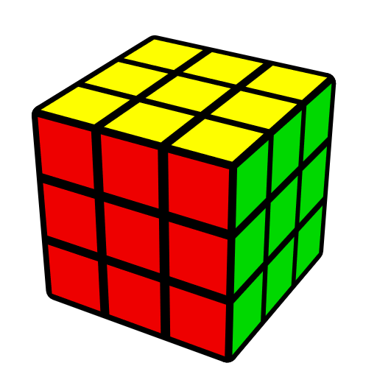

Ruimin Yan

2017/11/11

**Signatures of Rubik's Cube Average TOP 3 Cubers in the World**

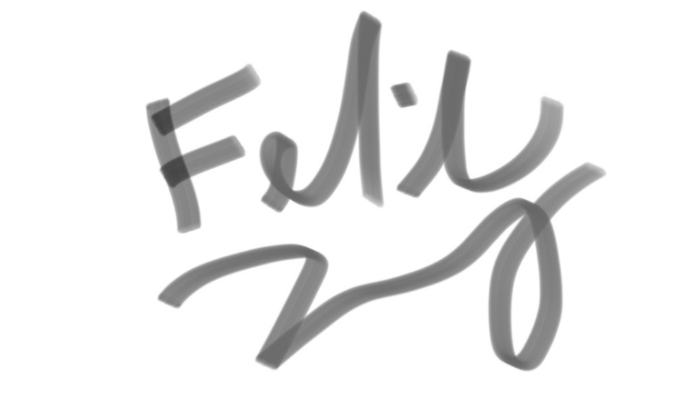

Feliks Zemdegs (3x3 WR avg 5.53, Former WR single 4.22)

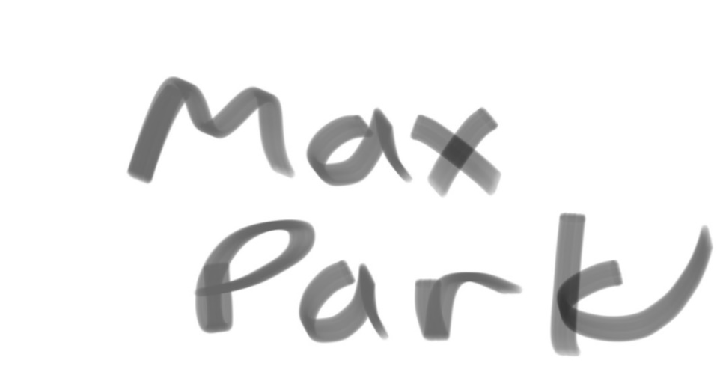

Max Park (3x3 NAR avg 5.95, NAR single 4.40)

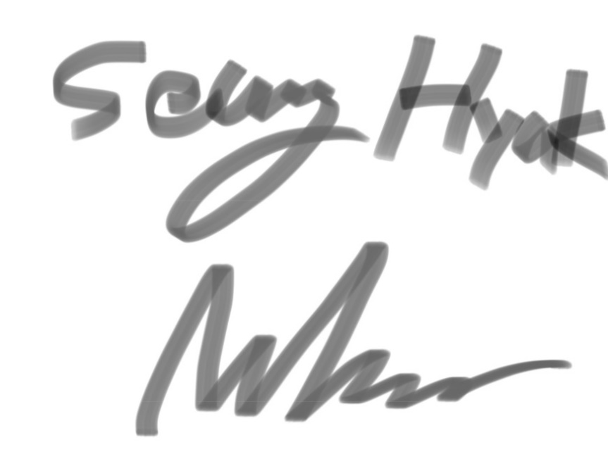

Seung Hyuk Nahm (AsR avg 6.38, AsR single 4.90)

**Quotes**

Don't think, just solve.

-- Max Park

**Photo Albums**

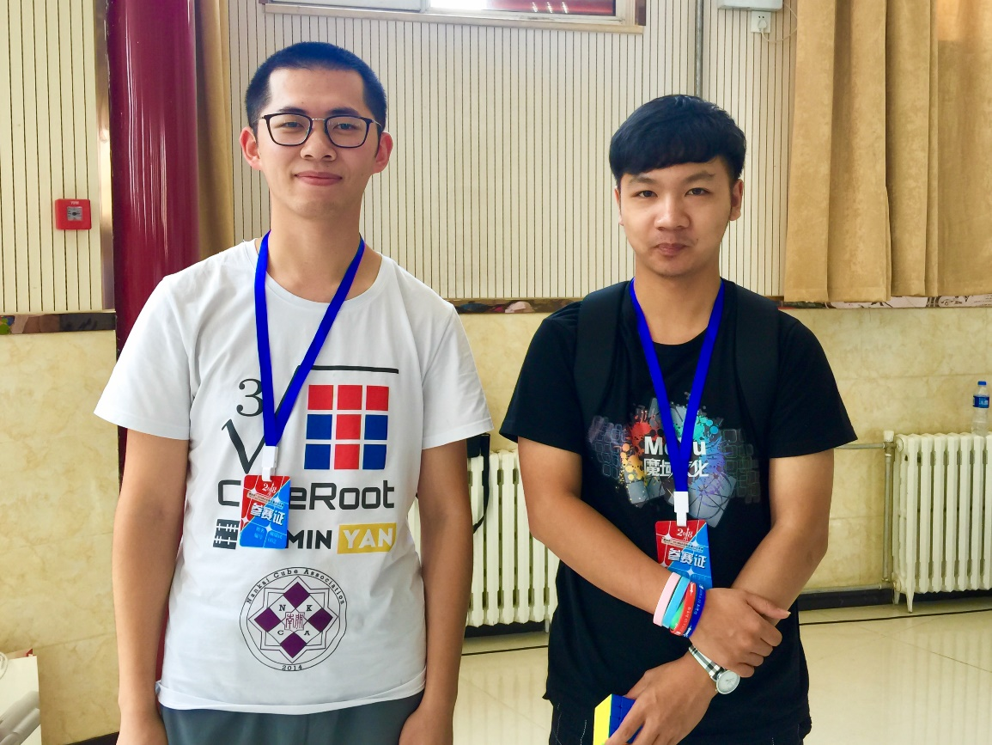

Yusheng Du (杜宇生) –3x3 WR single 3.47

at Shijiazhuang Open 2018 (2018石家庄公开赛)

2018/6/9, Shijiazhuang

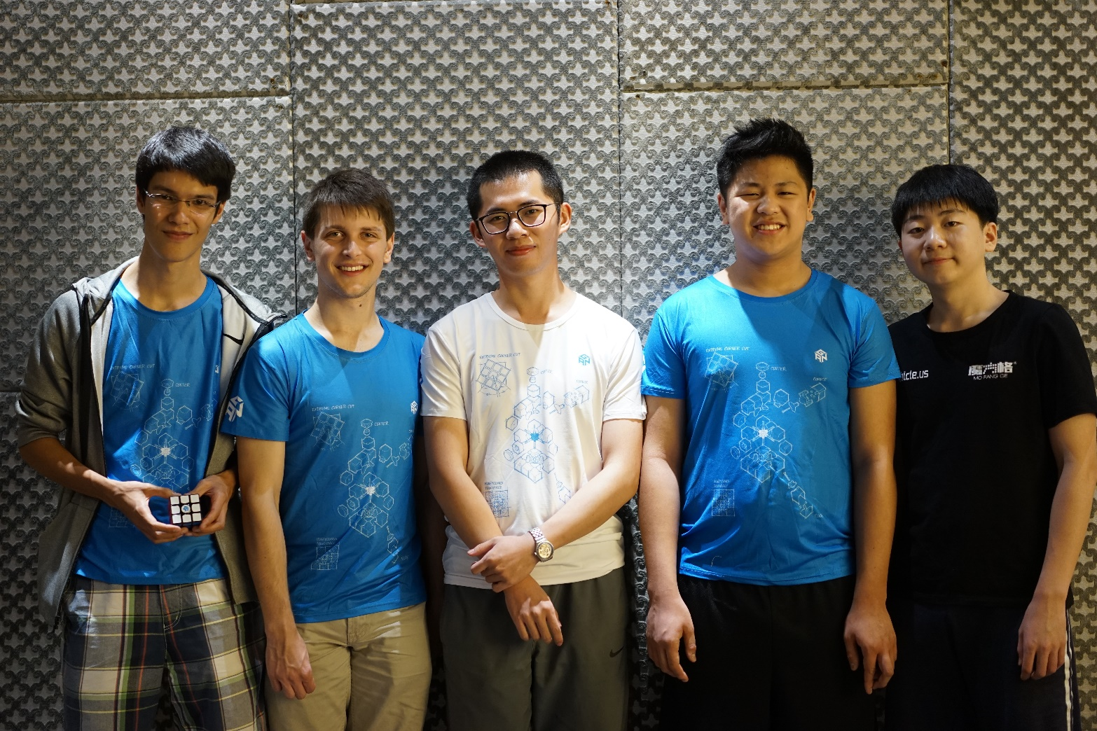

Cornelius Dieckmann, Feliks Zemdegs, Ruimin Yan,

Max Park, Seung Hyuk Nahm

at China's 10th Anniversary Championship 2017

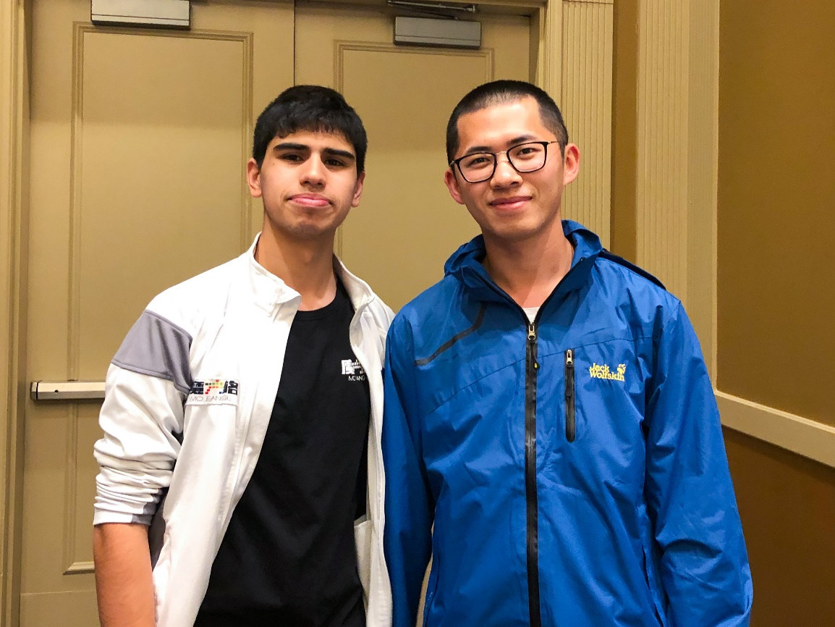

Patrick Ponce—3x3 Former Single WR 4.69

at CubingUSA New Jersey Championship 2018

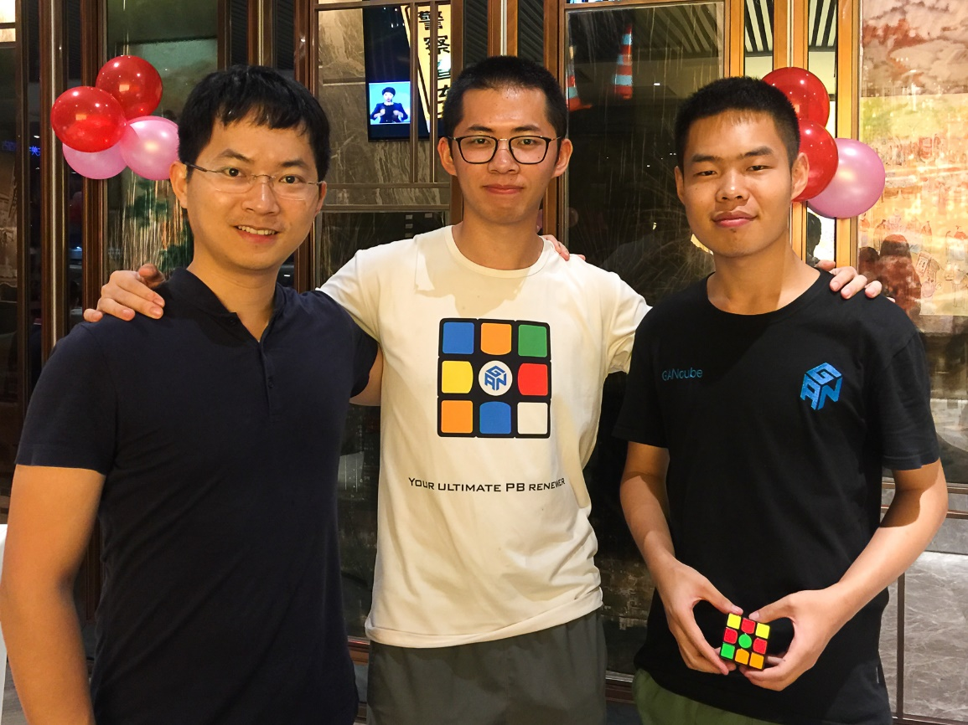

Ganyuan Jiang (江淦源) --

3x3 single and avg NR1 (Former), the Founder of GAN Cube

Mulun Yin (阴目仑) -- 3x3 NR avg (7.19), OH NR2 single (8.83)

at China's 10th Anniversary Championship 2017

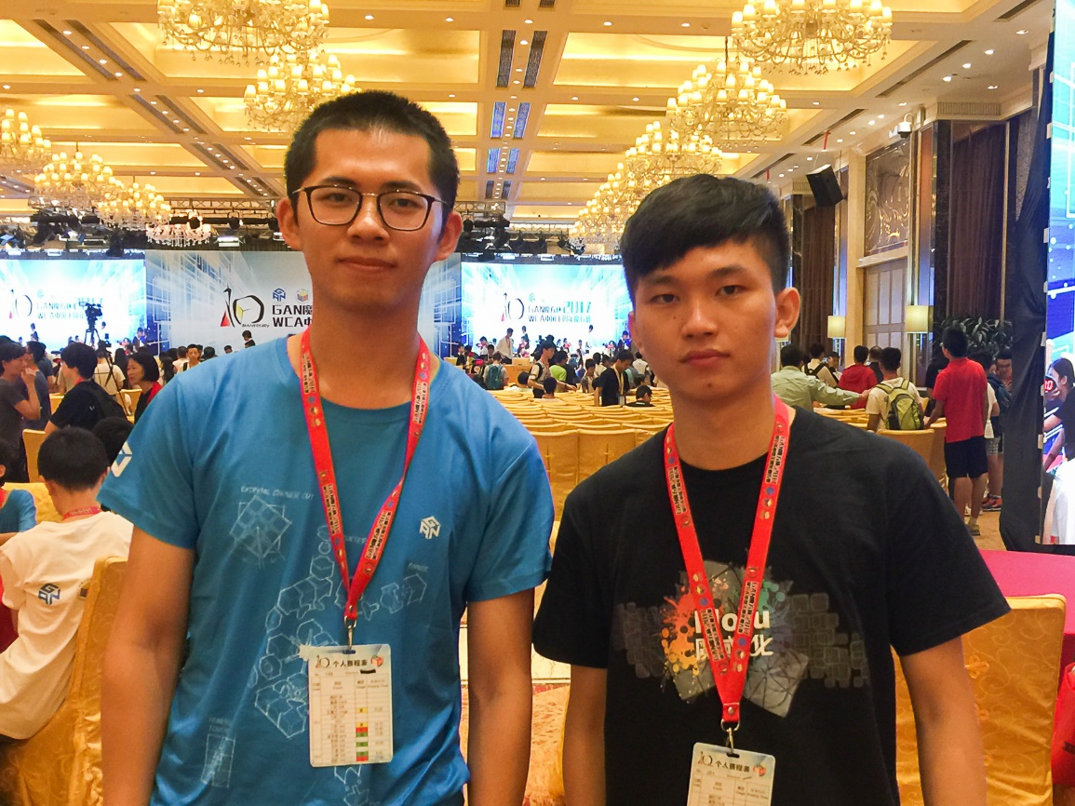

Jiayu Wang (王佳宇) – 3x3 former NR single (5.31)

at China's 10th Anniversary Championship 2017

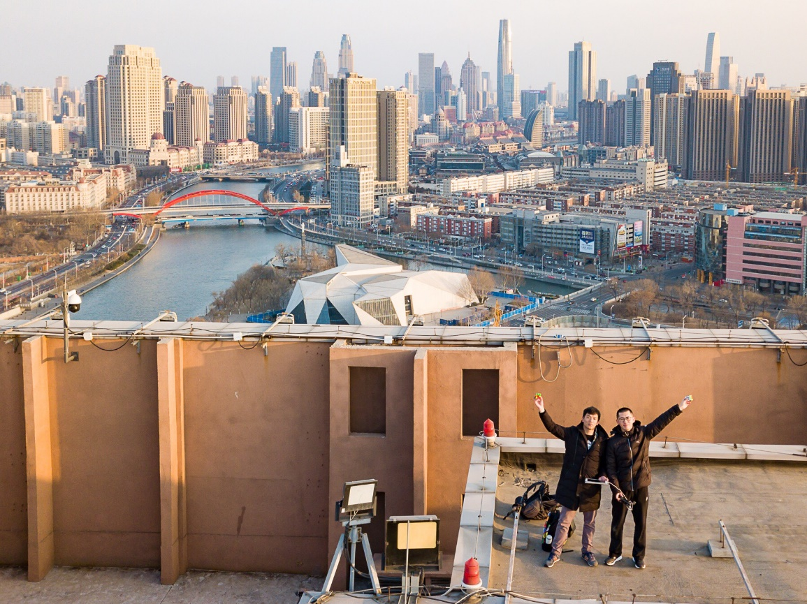

Ruohan QIU (邱若寒) in Tianjin

-- Cube With Feet NR avg 31.04 and former NR single,

former WR2 single 24.53

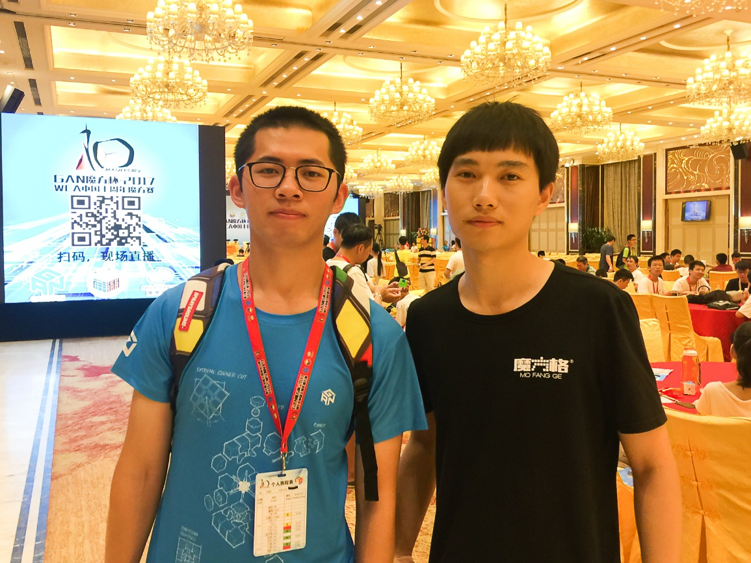

Xin Shi (石欣) -- 4BLD NR4 (3:01.82), 5BLD NR3 (7:20.60)

at China's 10th Anniversary Championship 2017

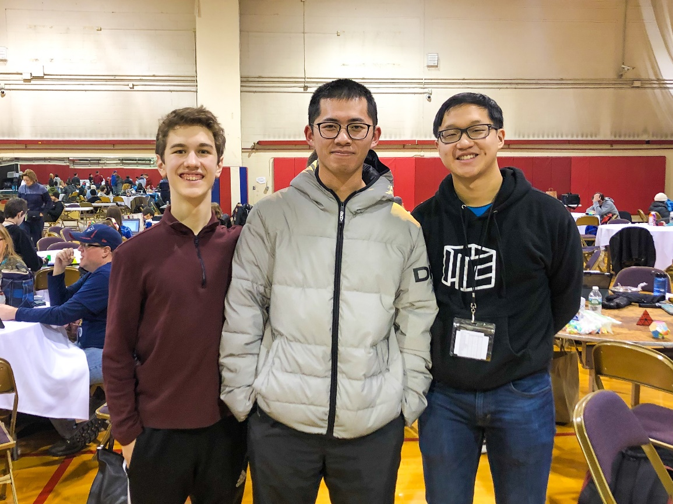

Daniel Karnaukh (SQ1 Single 5.49 WR Former),

Brandon Lin (SQ1 avg WR Former)

at Boston University Winter 2019

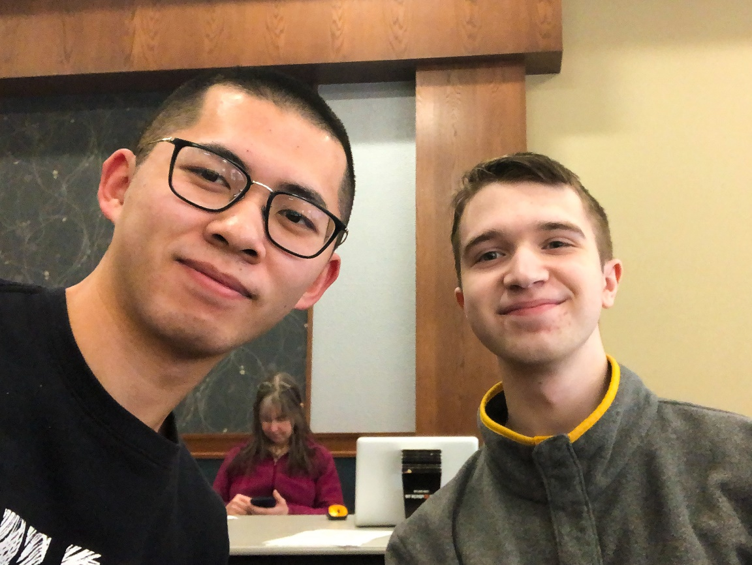

Cale Schoon (4BLD WR9, 5BLD WR8)

at North Star Challenge 2019

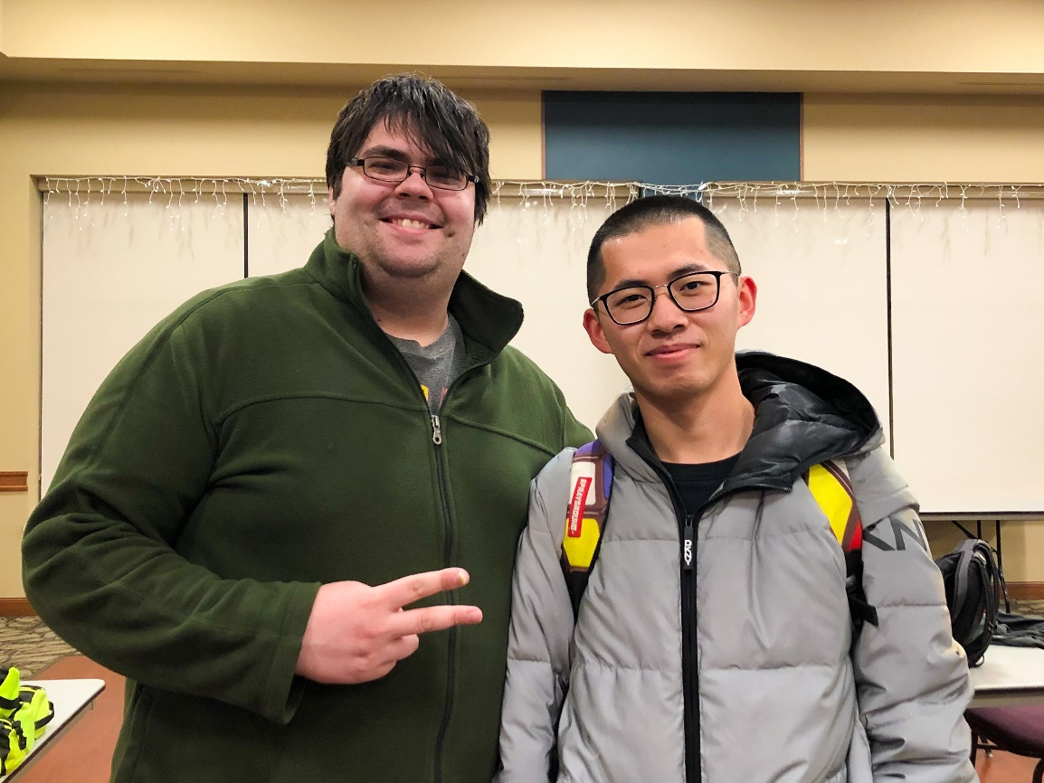

Walker Welch (FMC Avg WR 24.00, Skewb Single, Avg WR)

at North Star Challenge 2019