Megaminx F2L, S2L Algorithms (First, Second Two Layers)

Cases similar to 3x3 F2L are not shown. Many F2L (S2L) cases are equivalent, in the sense of cube rotation. F moves in Megaminx are more fingertrick-friendly and common than F in Rubik's Cube. In some situation, block building is more convenient than standard F2L. Reduce rotation as possible.

Free Pair
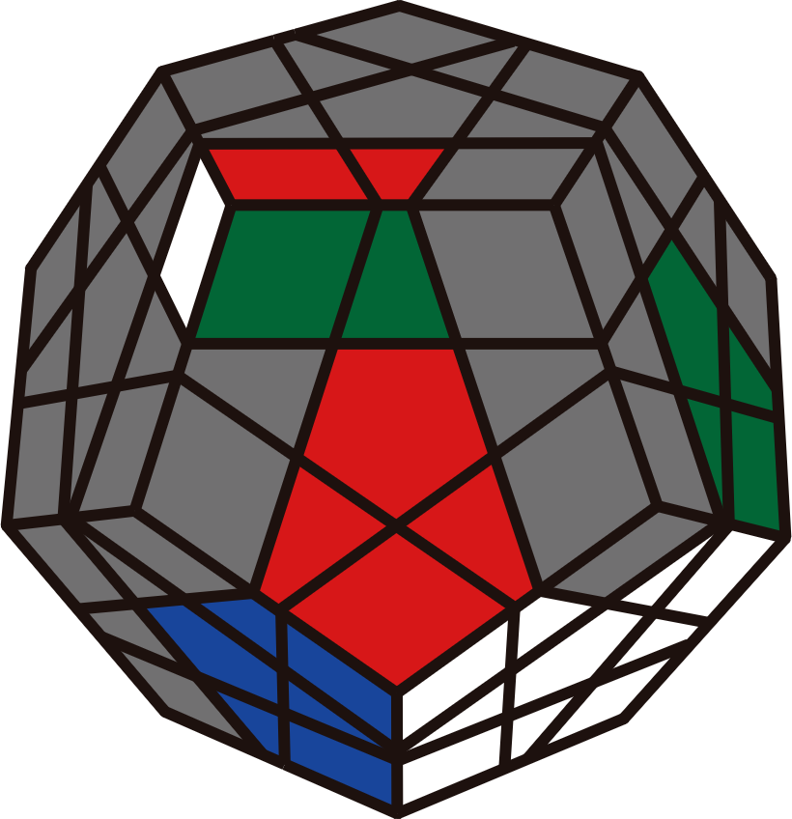 | 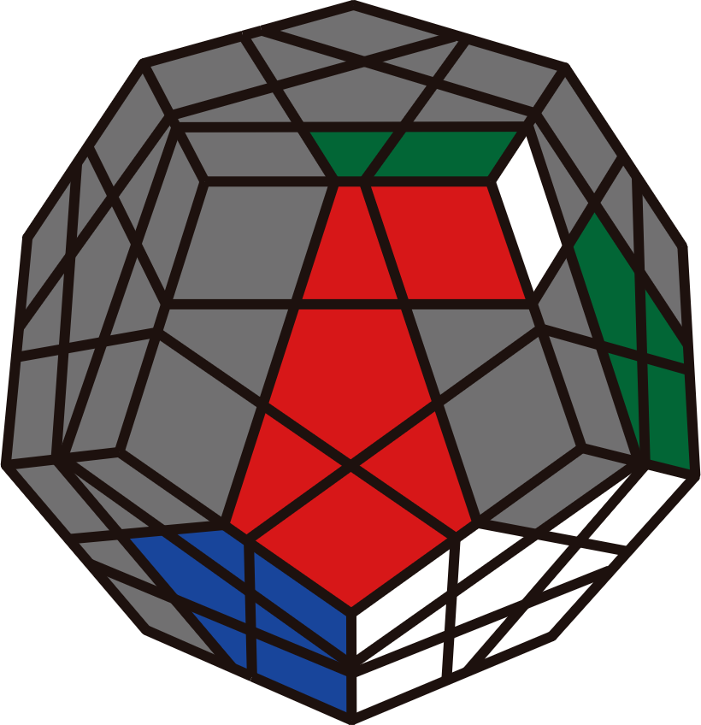 | 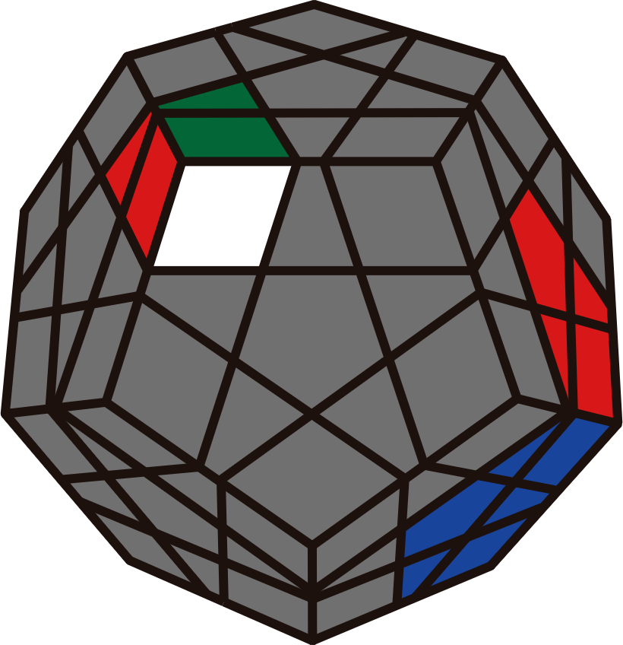 | 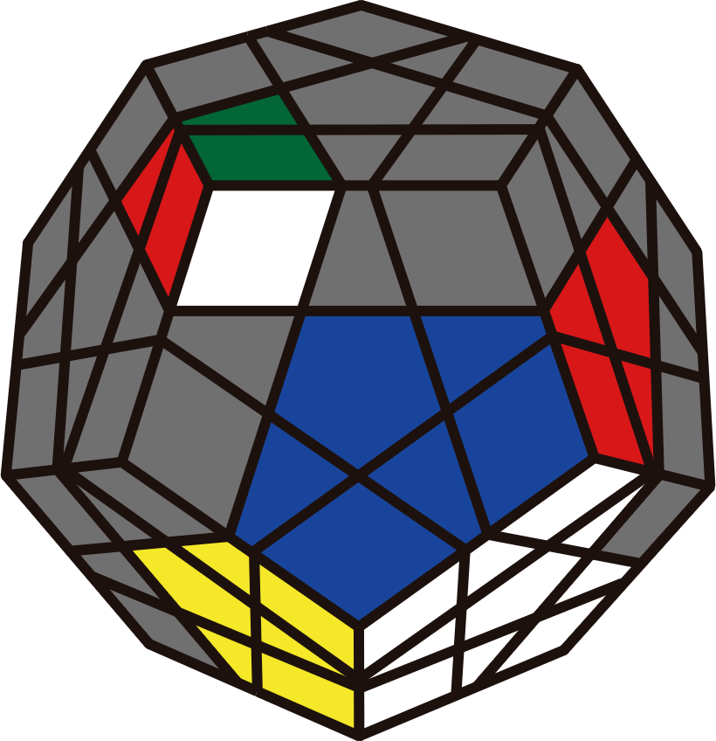
R U' R' / U' R' F R F'  U R U2' R' / U2 R U2 R' | F R' F' R  U' F' U F | R' U2' R | R2' U2' R2  U' R2' U2 R2  U2 R2' U R2
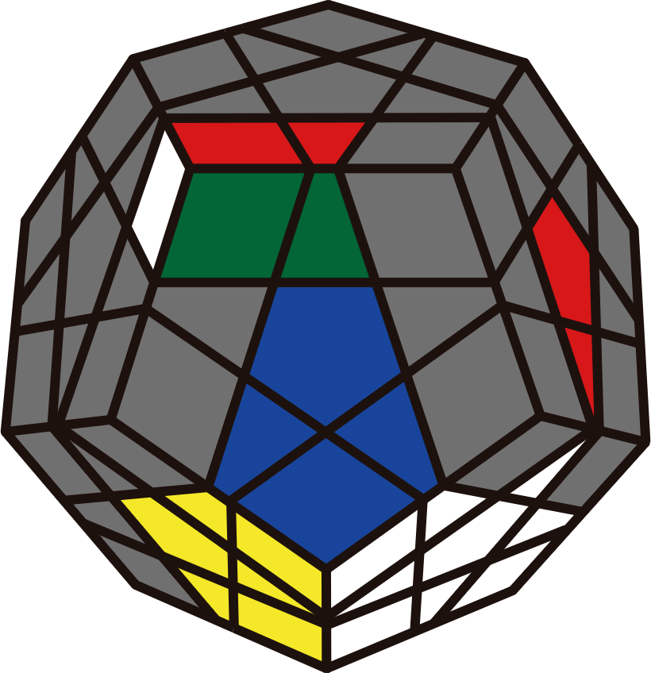 | 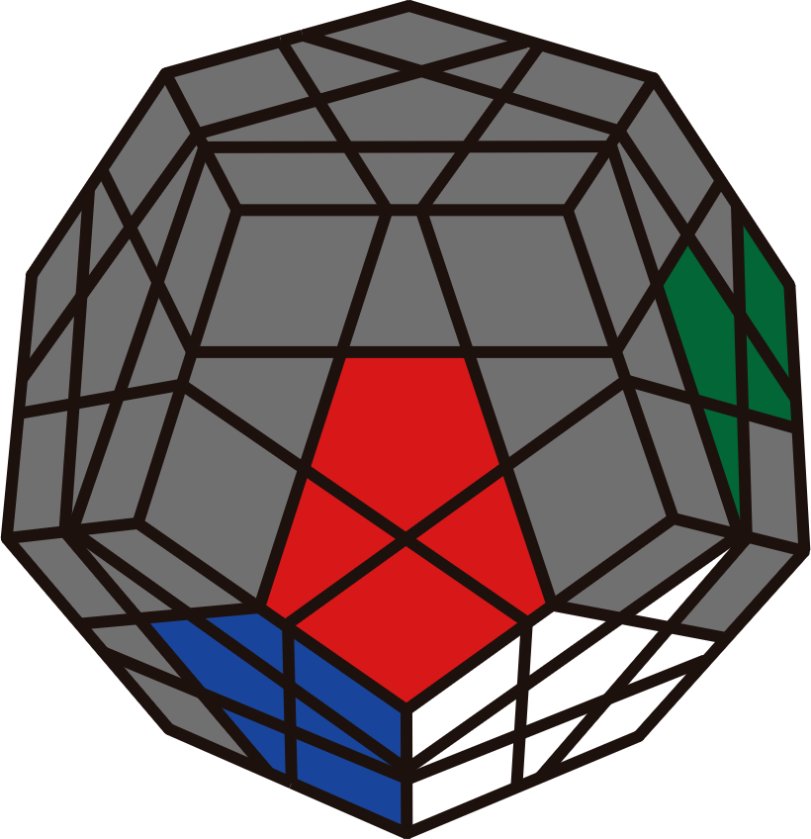 | 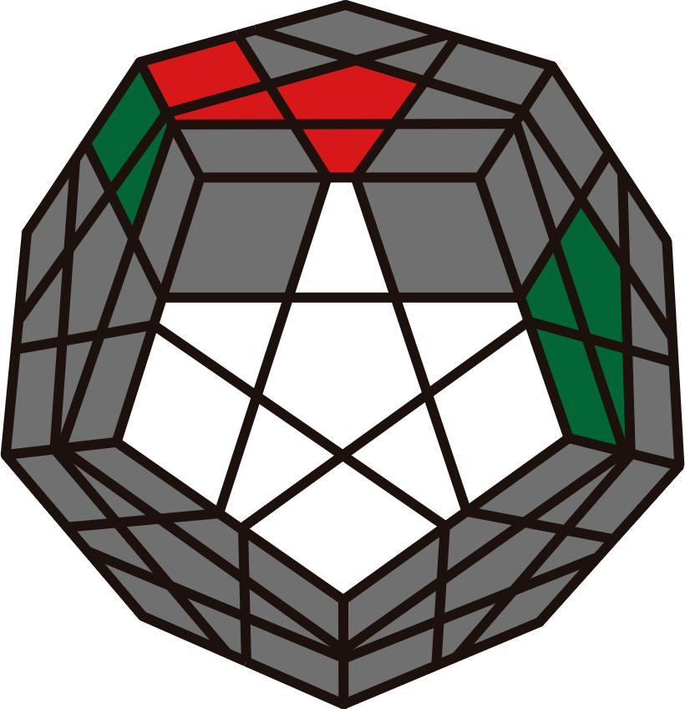 | 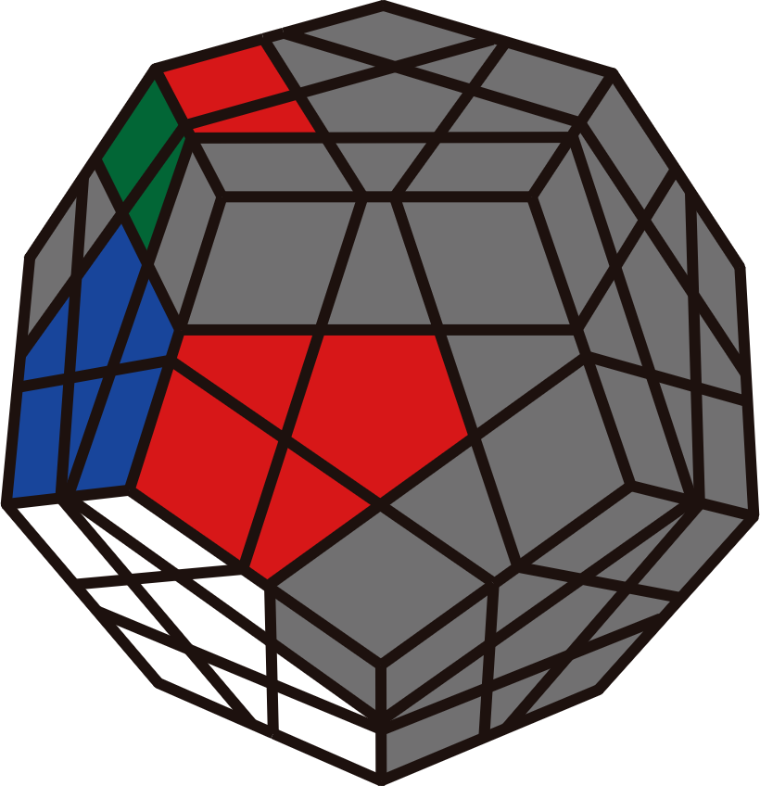
R2 F R2' F' | R2 F R2' F' | U2' R' U2 R | F' (R U2' R') F
To Free Pair
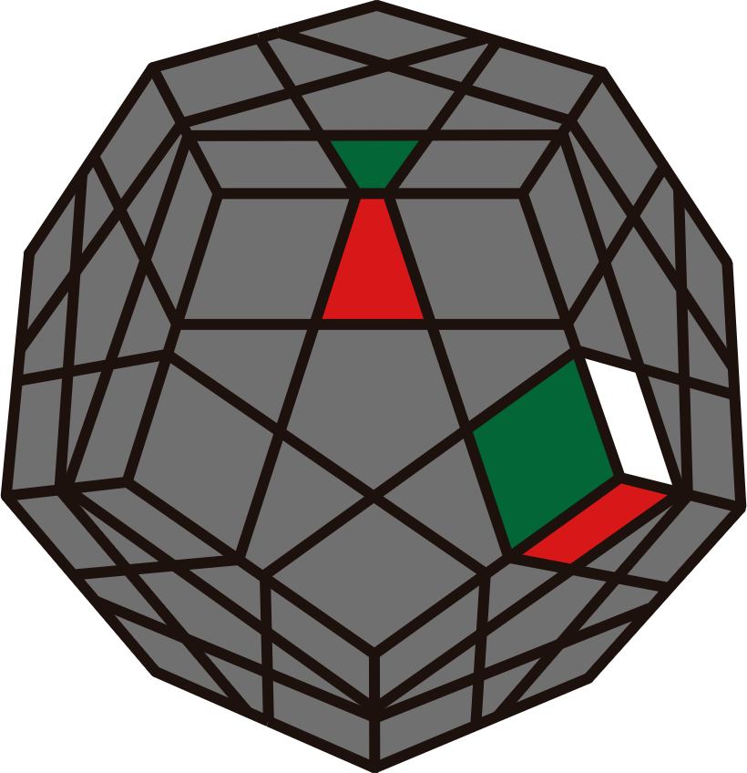 | 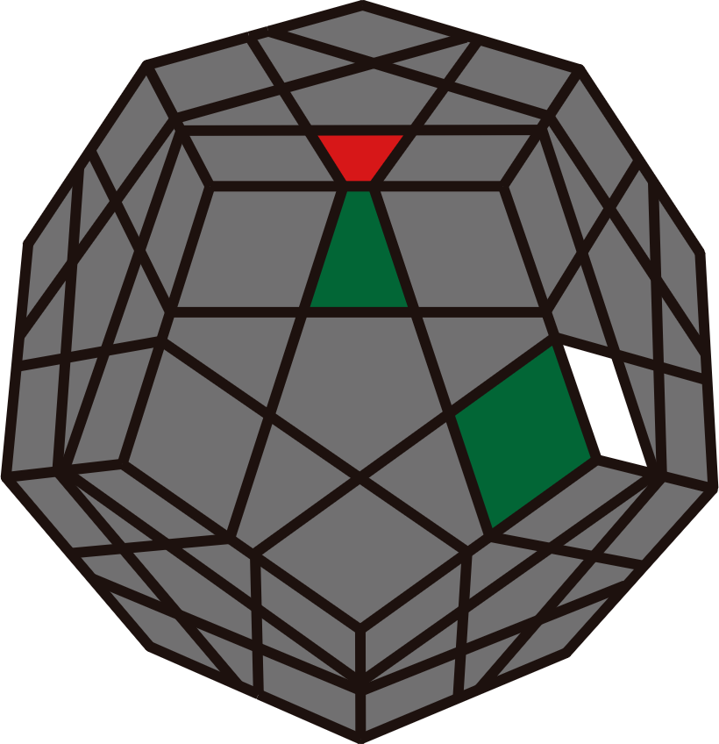 | 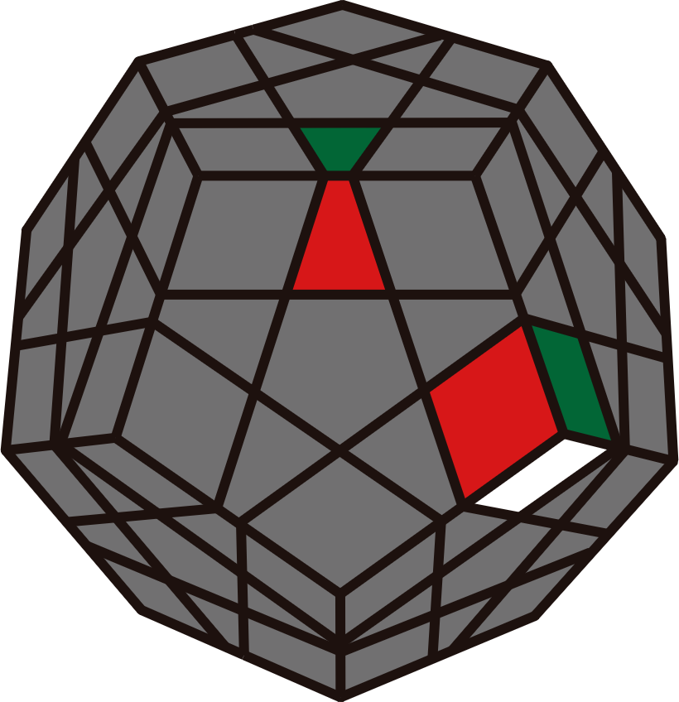 | 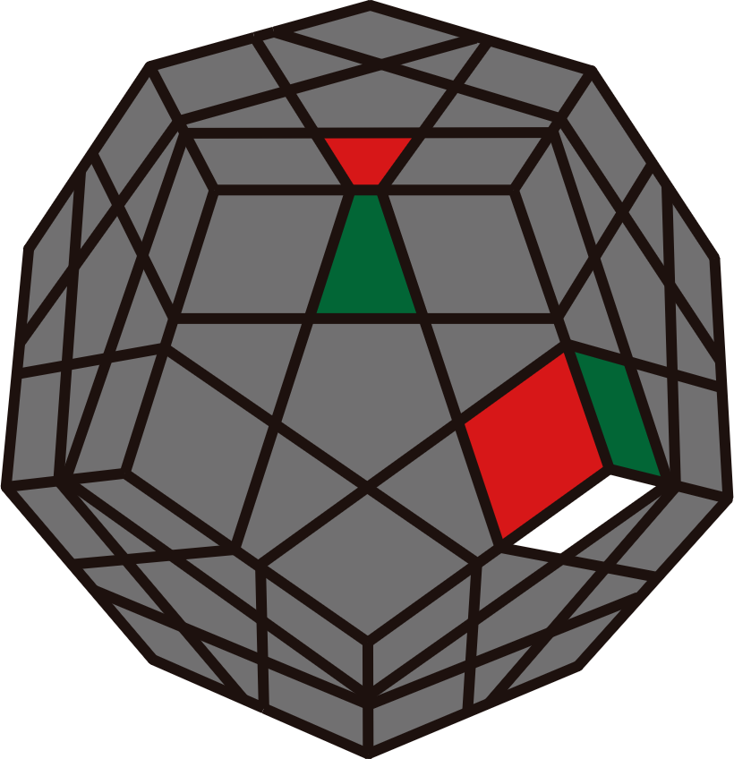
R | U2' R2 | U R | y' U2' R' U  R U' R2' F R
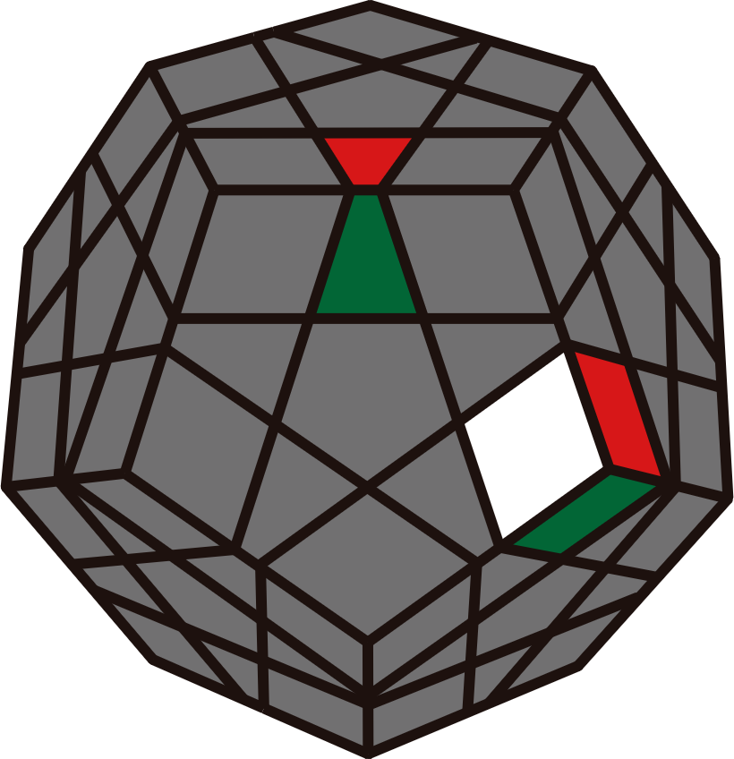 | 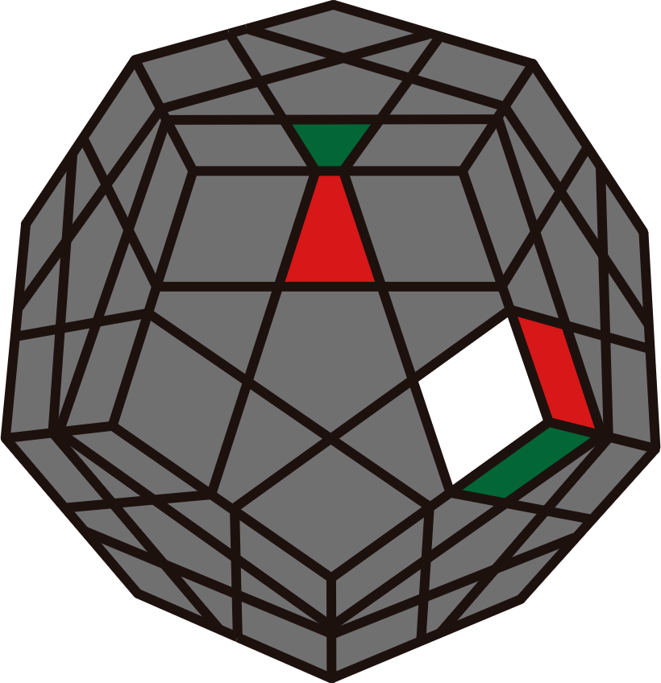 | 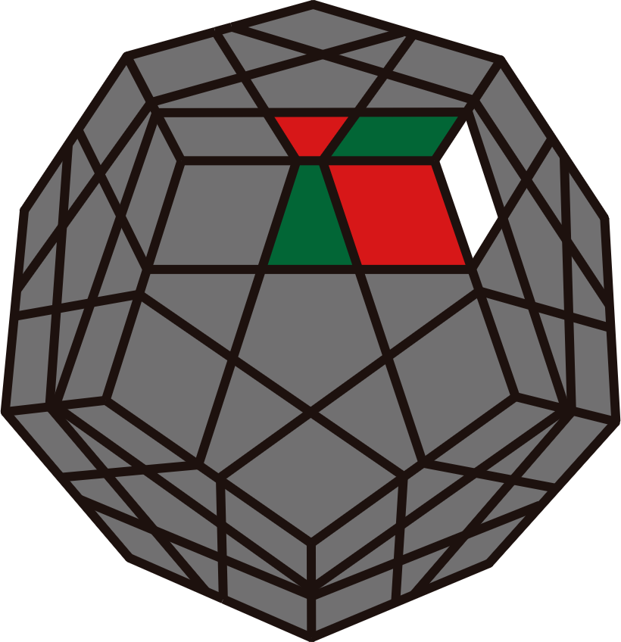 | 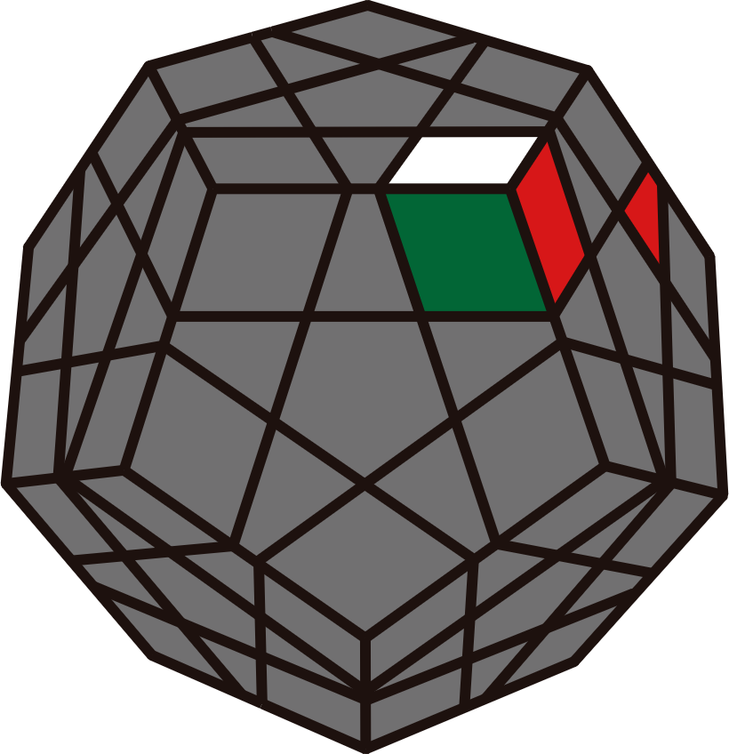
U' / U' F'  U' R U' R' | U F'  U2 R U' R' | R' U2' R2  R2 U2' R' | U R2' U'  BR2 U2'
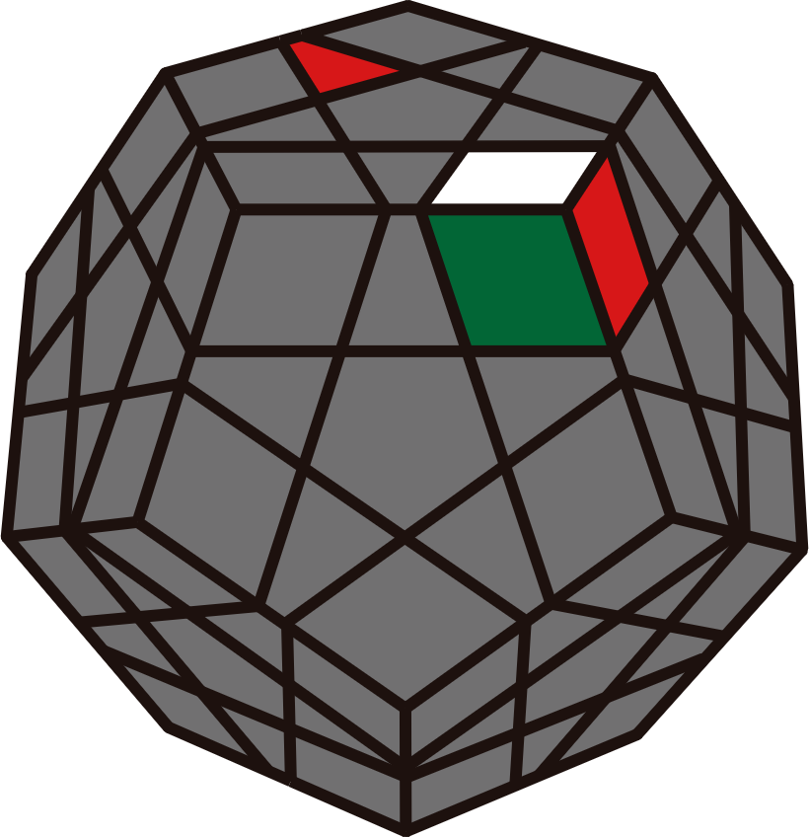 | 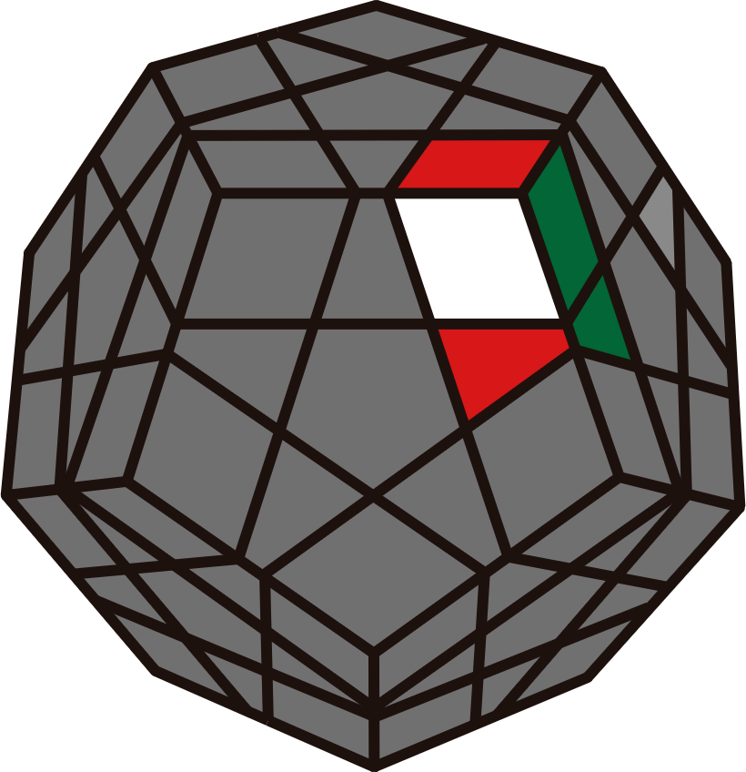 | 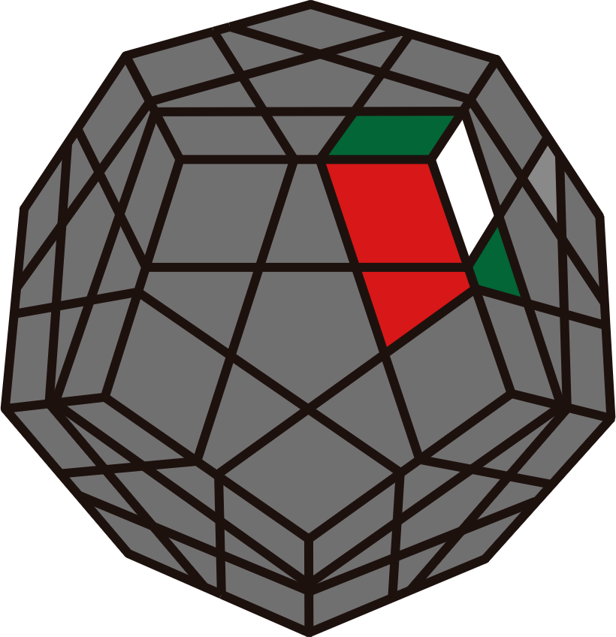 | 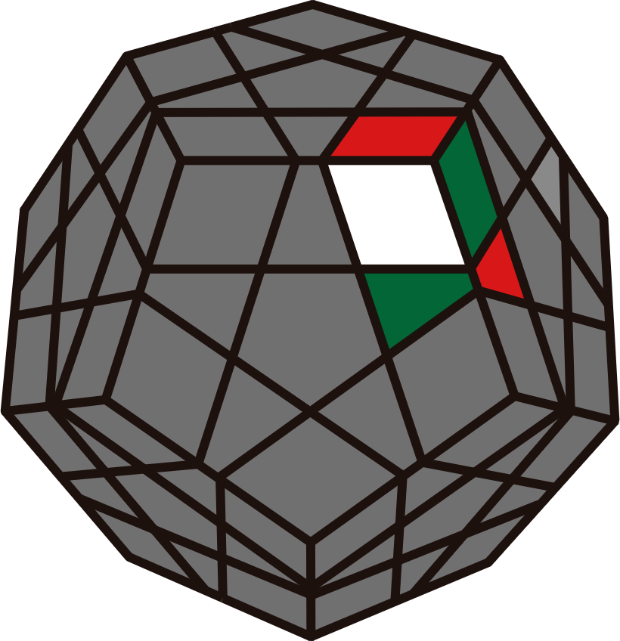
R | U' F'  U' R U' R' | U R | U2 R / U2 R U R'  U' R U R' / U F R'
F2L
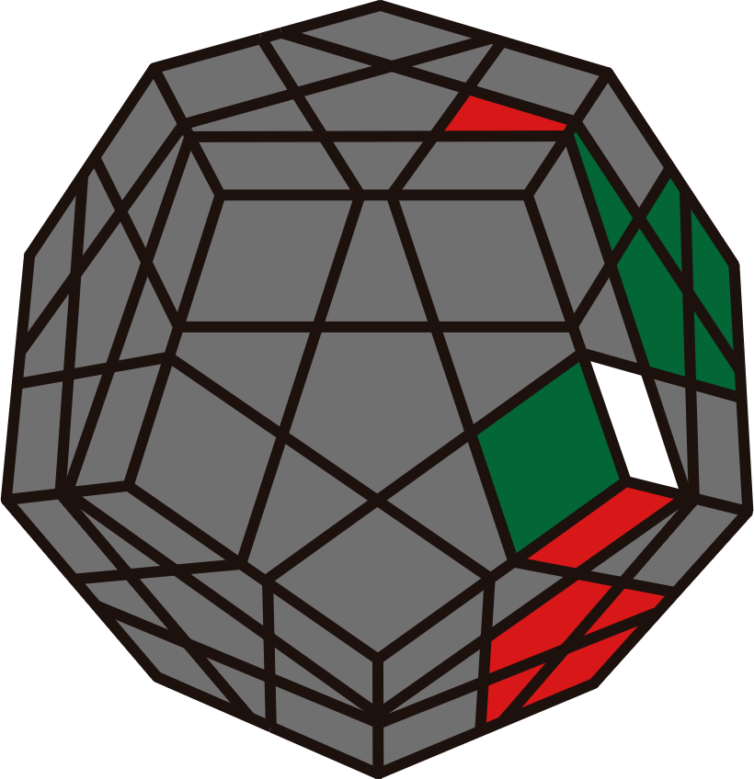 | 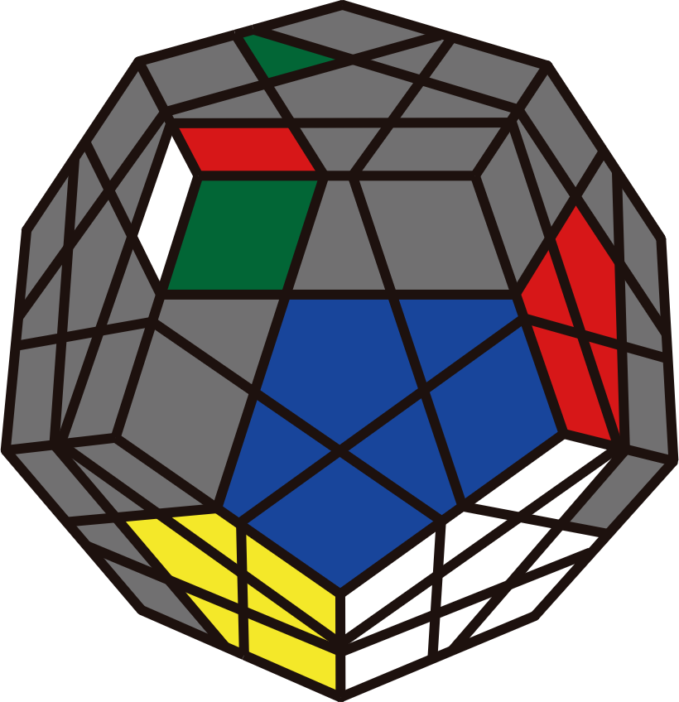 | 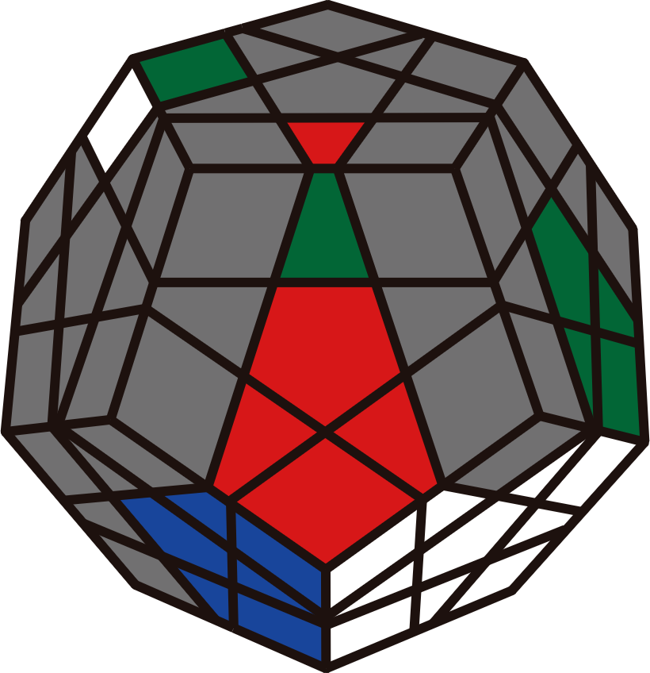 | 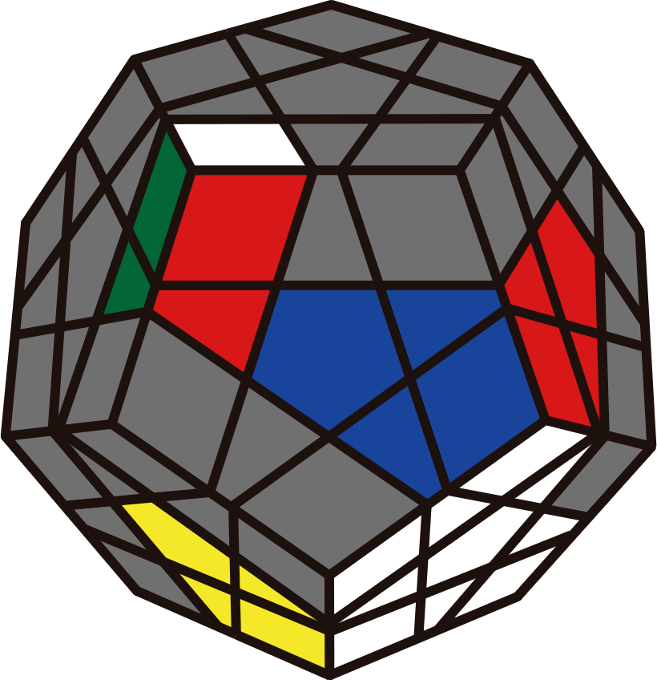
U' R2 U R2' | R' U2' R' U' R | L R U' R' | R2' F U' F' R2
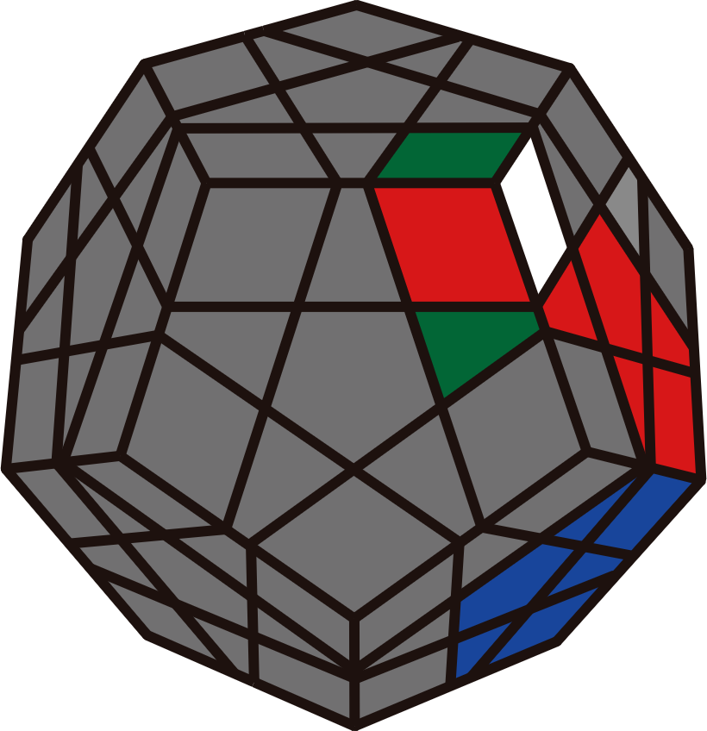 | 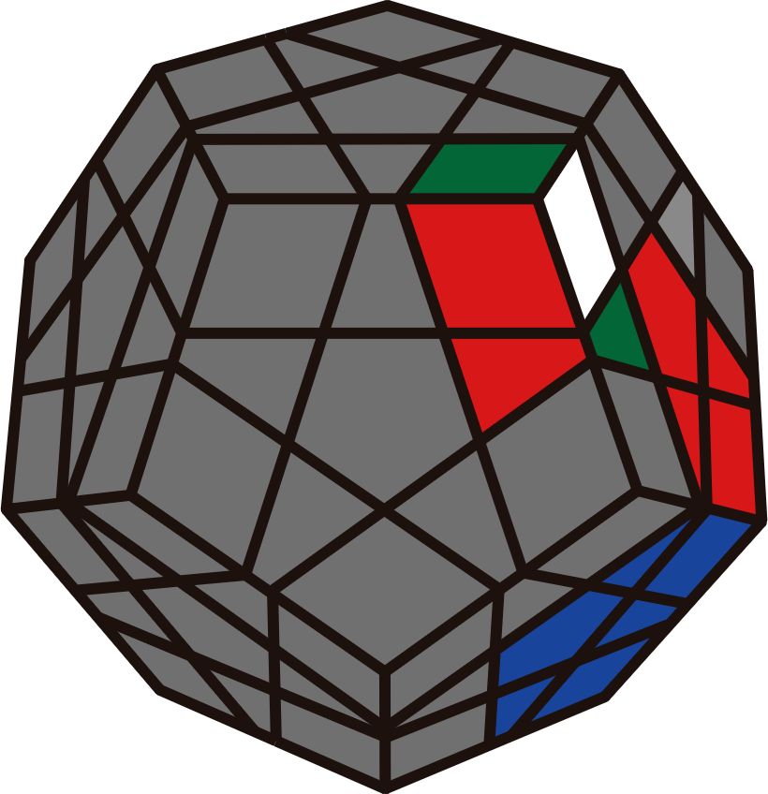 | 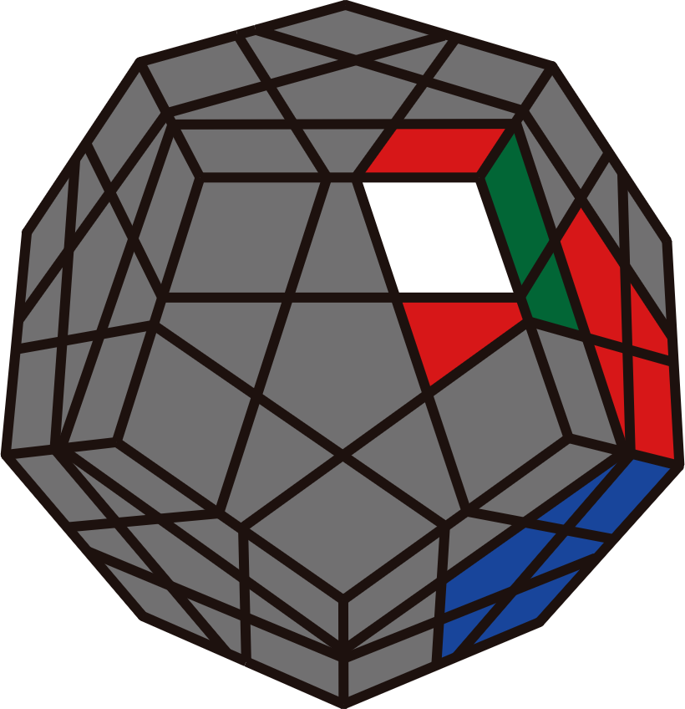 | 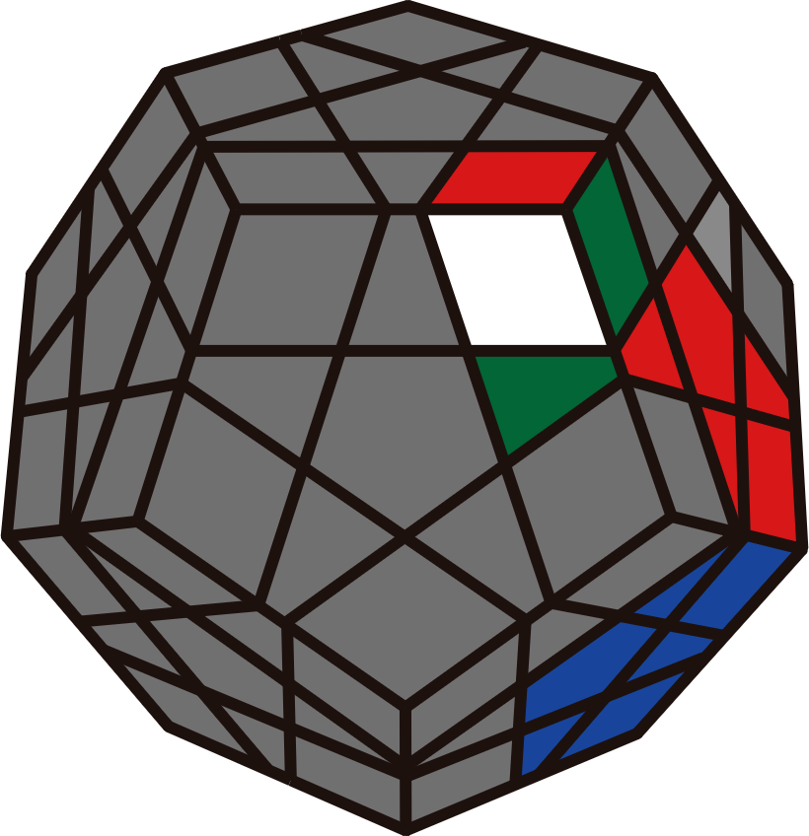
U R' U' R2 U R2' U' R  U' (R U' R' U)2 R' U' R | U (F' U F) (R' U2' R)  U' R U2' R' y R U R'  U R U R' U2 y R U R' | U' F' (R' U' R) | U' R U R2' U' R  U' F R2' F' R2
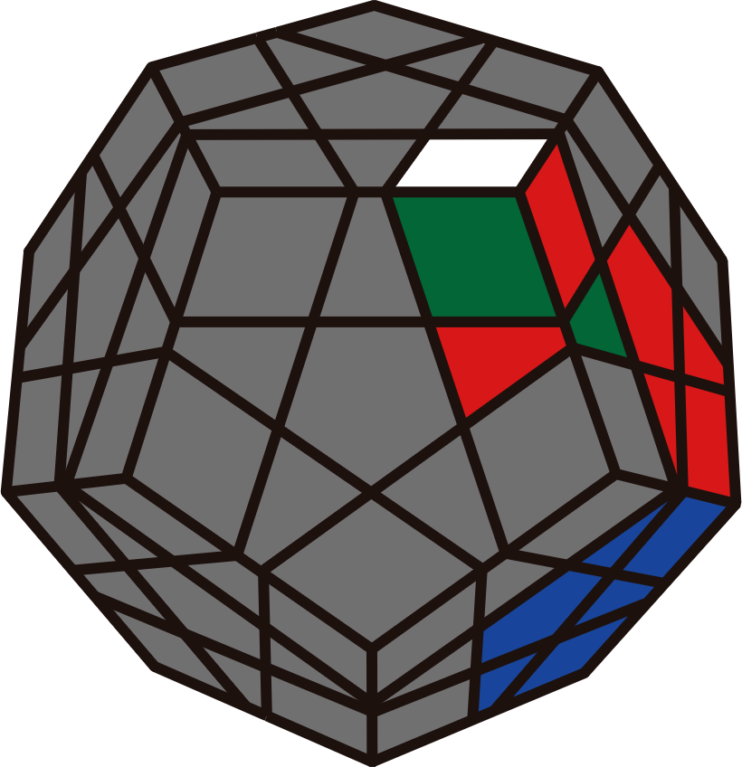 | 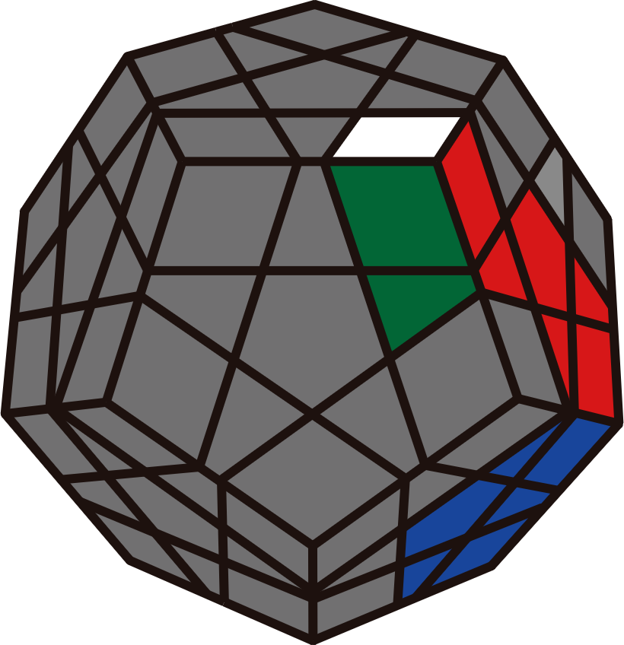 | 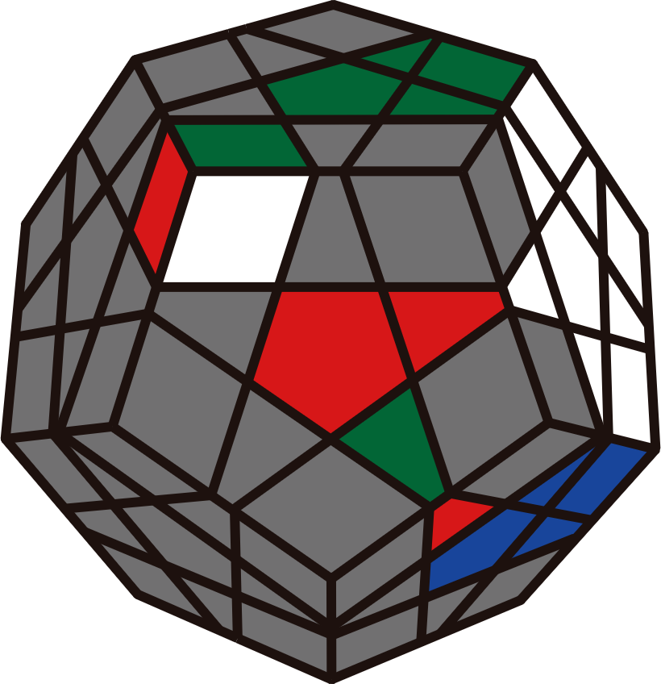 | 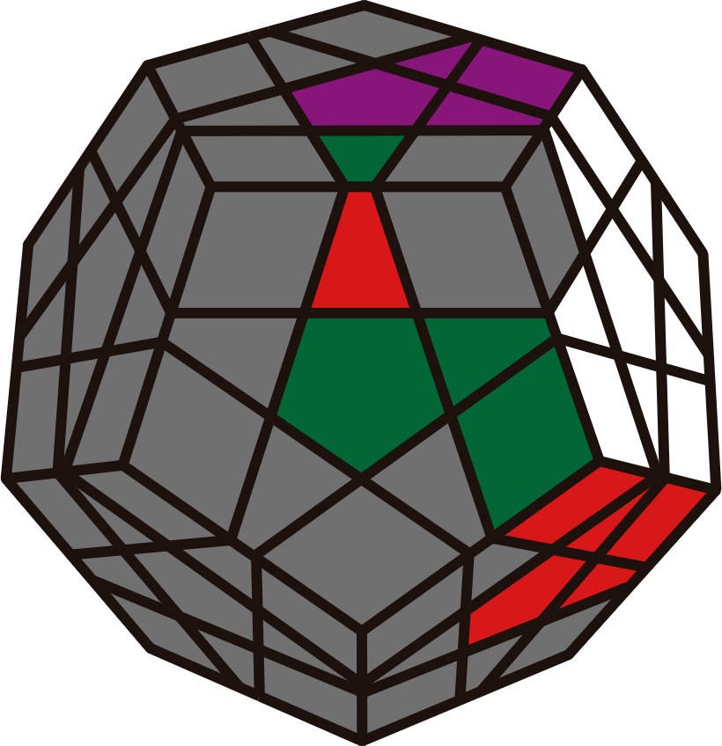
U (R' F R F') R' U' R | R U' R2' U R  y L' R U2' R | U' R' F' R U | U' R' F R U
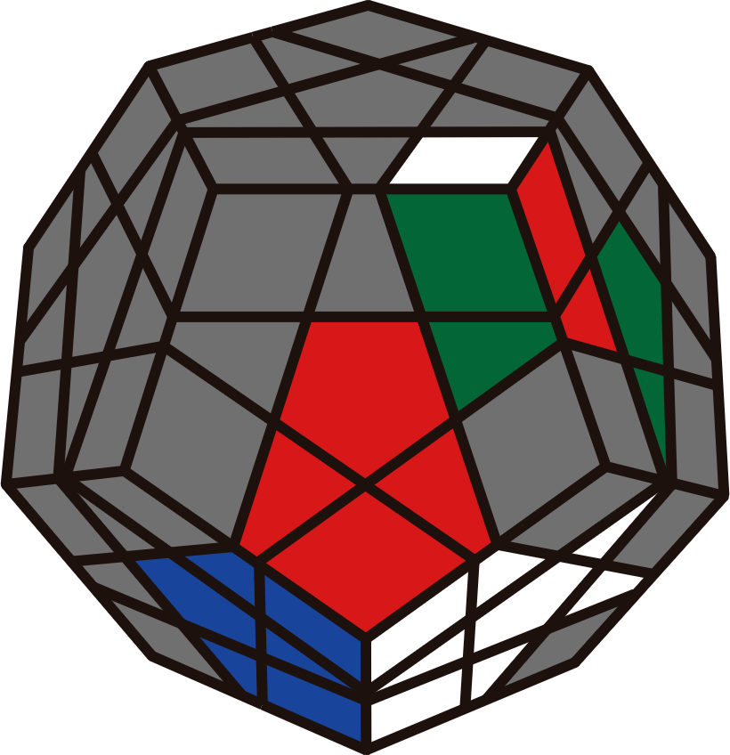 | 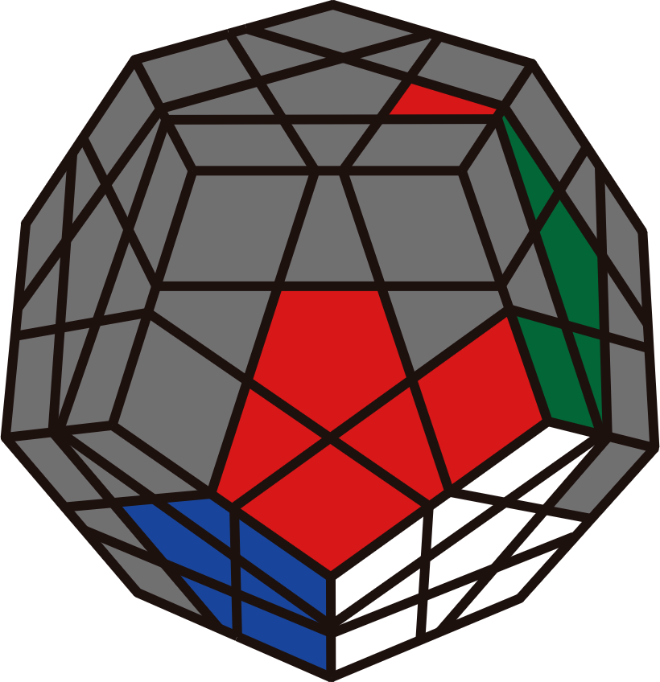 | 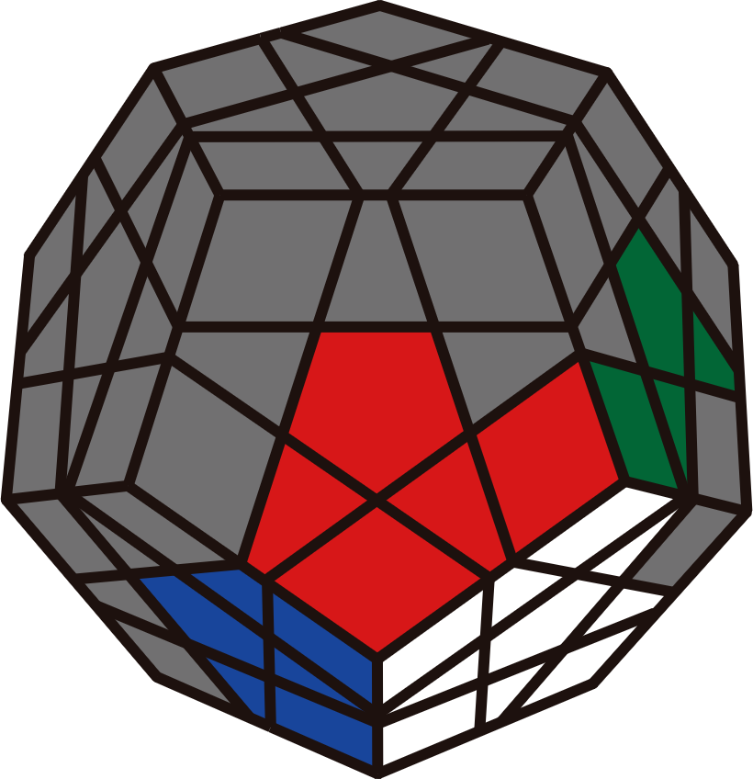 | 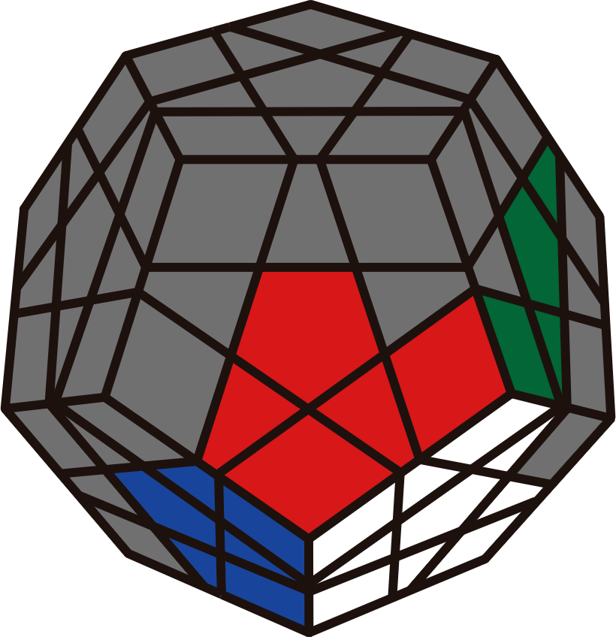
U' (R' F R F') (R U' R') | R2 U' R' U R2' | R2 U' R2 U R2' | R2 U' R2' U R2'
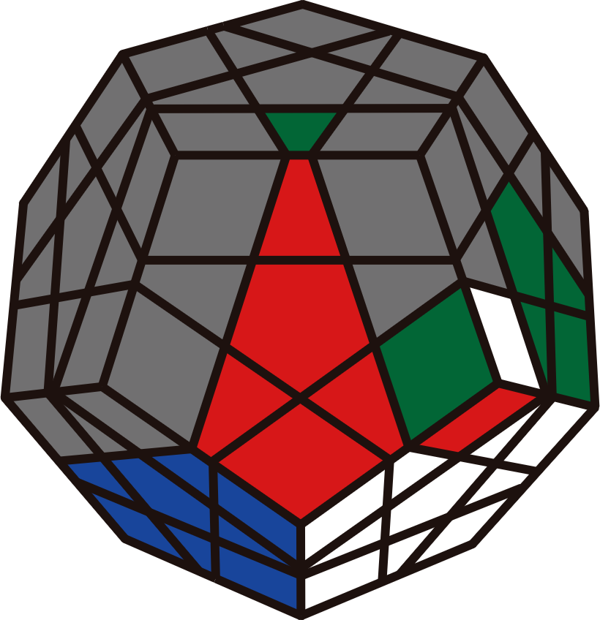 | 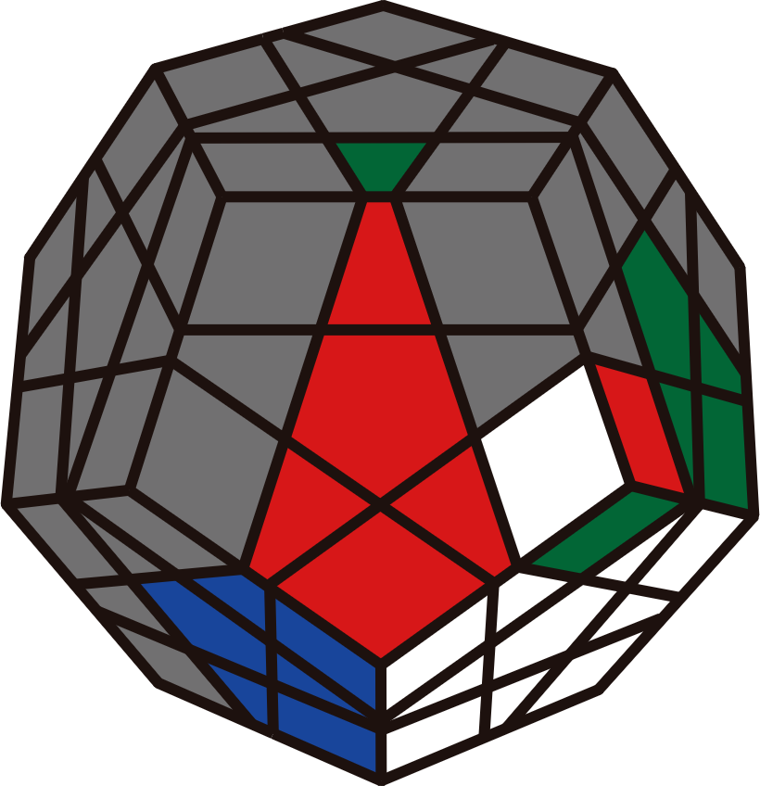 | 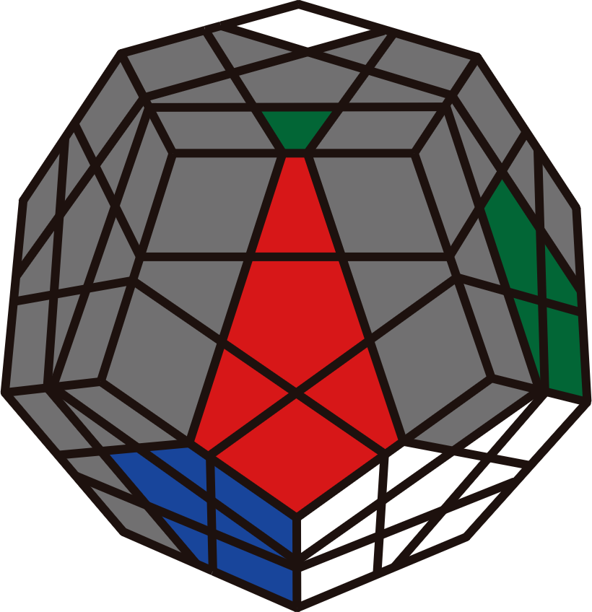 | 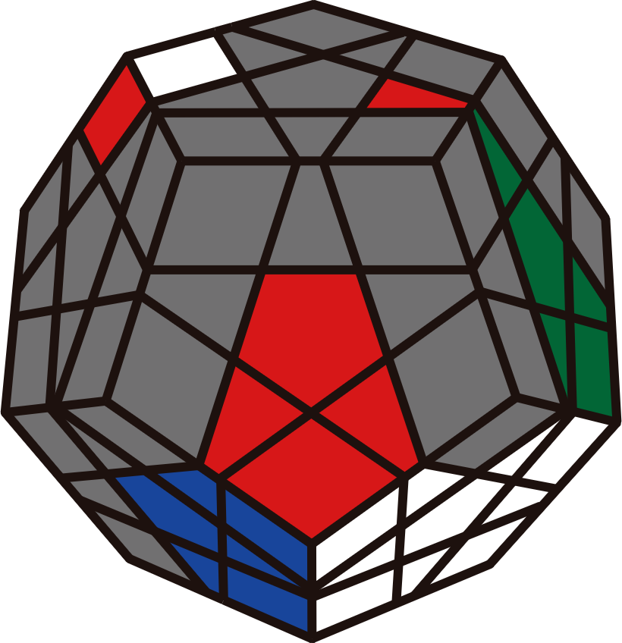
(R U R' U') (F R' F' R) | (R' F R F') (U R U' R') | (R U R') (F' U' F)  BR' U (F' U' F) | L U' (R U R')  (F' U' F) (R U R')
Stars in S2L
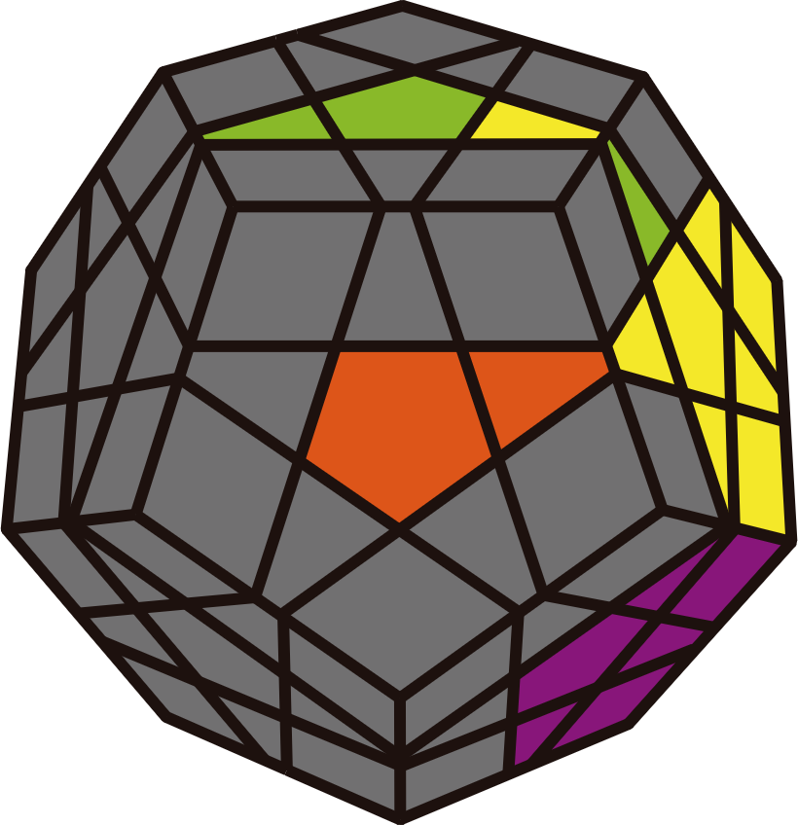 | 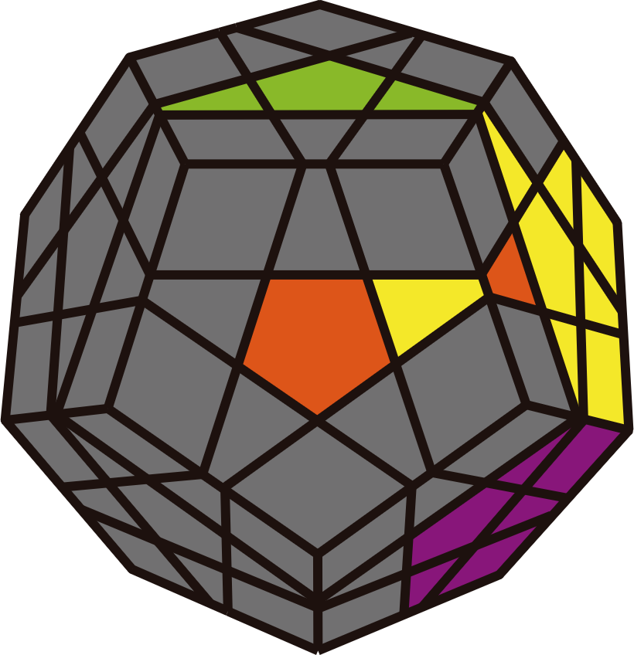 | 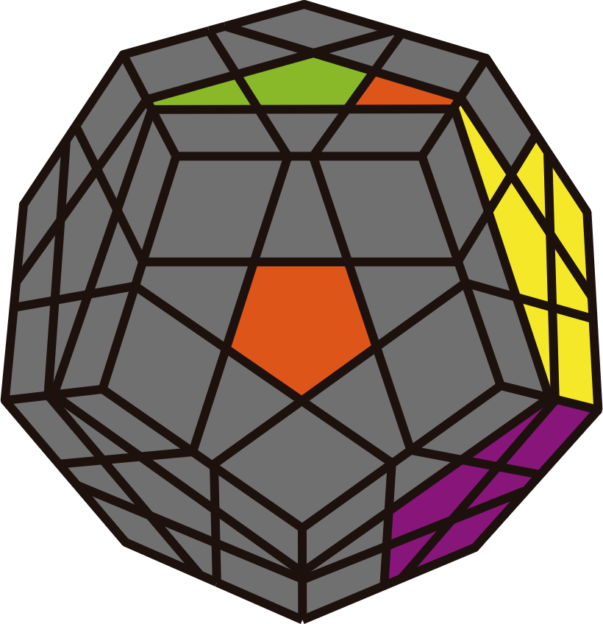 | 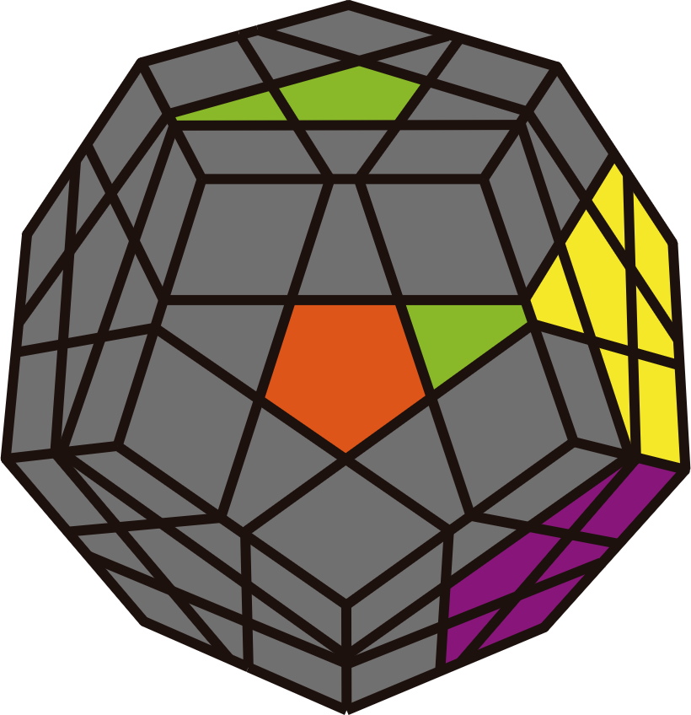
U R' F R | R U R' F | U R U' R' | F R' F' R
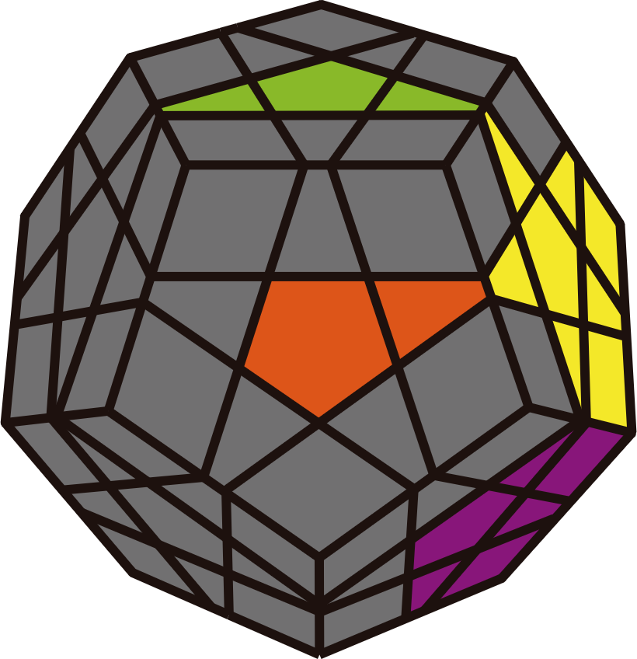 | 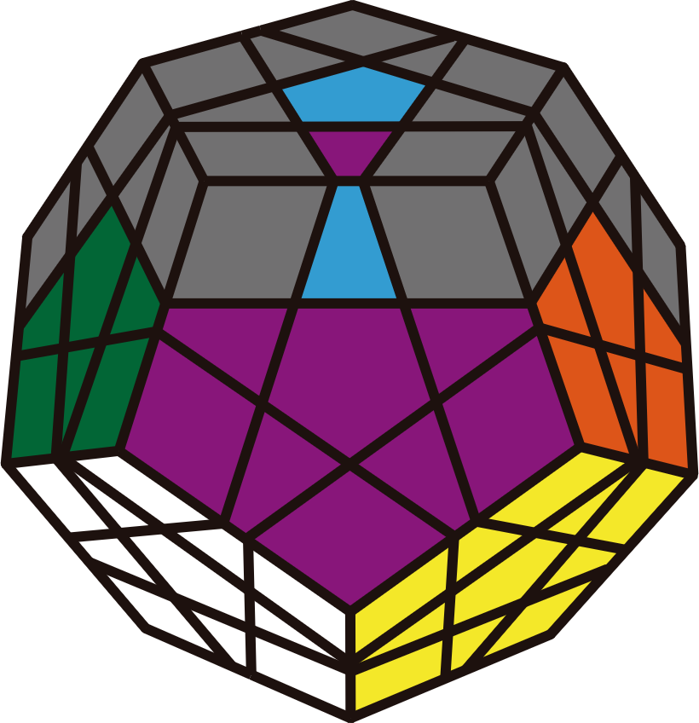 | 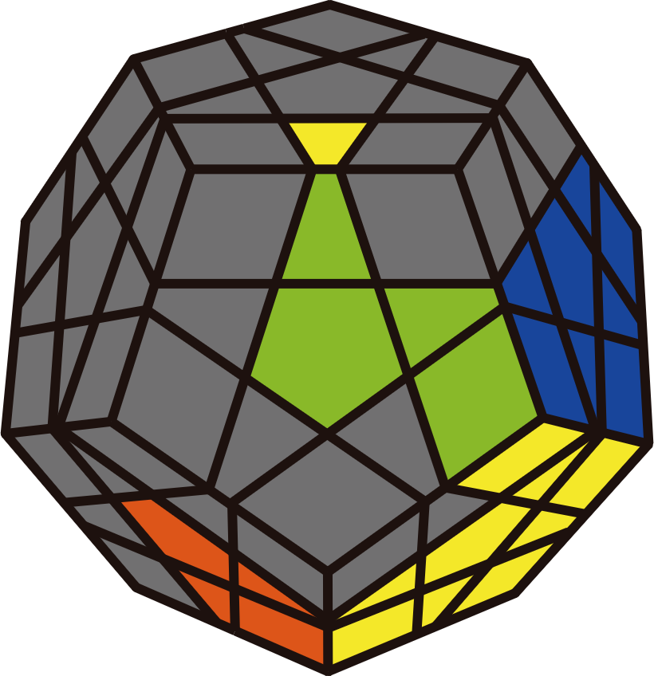 | 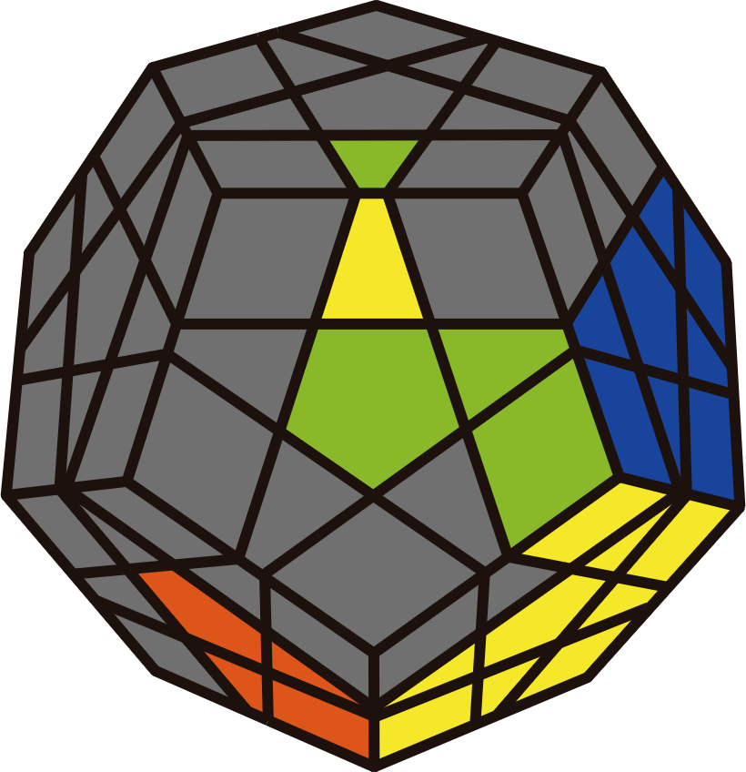
U R U' R' U | U' R RB R' U2 | R' F2 R | U' R' F R

