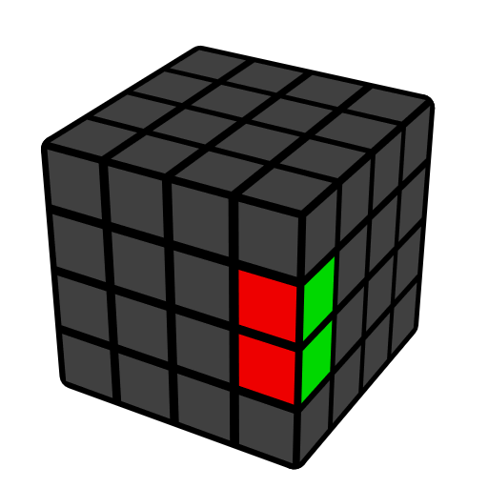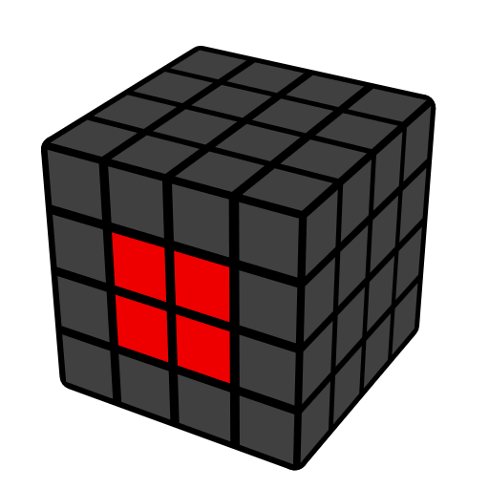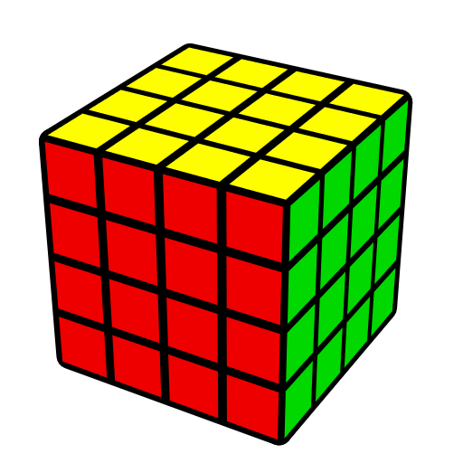**4x4 Redux Method**

**Notation**

|  |  |  |  |
| --- | --- | --- | --- |
| **R** Outer layer | **r** 2 layers | **2R** Inner Slice | **3r** 3 layers |
|  |  |  |  |

**F2C (Two Opposite Center)**

|  |
| --- |
|  |

**2nd Center**

|  |  |  |  |
| --- | --- | --- | --- |
|  |  |  |  |
|  | **r U' r'** | **r U2' r'** |  |

**L4C (Last Four Centers)**

Do z move to make L4C on M slice. Solve centers into correct relative positions. Solve F center (3rd center), do x', solve current F center (4th center), do x', solve current F center (5th center), then 6th center will be solved automatically. One can also solve U center, then do x. Below is general idea on F center.

**Relative Positions**

|  |  |  |
| --- | --- | --- |
|  |  |  |
| **Correct** | **Wrong** | **Wrong** |

**F Center**

|  |  |  |  |
| --- | --- | --- | --- |
|  |  |  |  |
| **r U2' r'** | **r U r'** | **r U' r'** | **Solved** |

**Edges**

Unsolved edge.

|  |  |  |  |
| --- | --- | --- | --- |
| **F10E (First Ten Edges)** | | **L2E (Last Two Edges)** | |
|  |  |  |  |
| **u' (R U' R') u** | **r' (U' R U) r** | **u' (R U R' F R' F' R) u** | **r' (U' R' U R' F R F') r** |

**3x3**

Solve the cube as if it were a 3x3.

**Redux**

|  |  |  |  |  |  |
| --- | --- | --- | --- | --- | --- |
|  |  |  |  |  |  |

**Parity Cases which** **are Impossible on 3x3**

|  |  |
| --- | --- |
| **OLL parity**  Odd flipped edges | **PLL parity**  Odd edge pair/corner swaps |
|  |  |
| **r U2 x r U2 (r U2' r' U2) l U2 (r' U2' r U2) r' U2' r'** | **r2 R2' U2 2R2 u2 2R2 u2 [U2]** |