**4x4 Half Centers Method**

**Introduction**

This method is pretty useful when at least two half centers (bars) exist.

**Make Three Half Centers**

After finishing three cross edges for Yau method, make three half centers (different colors),

then put them in the left side on the front, bottom and back faces.

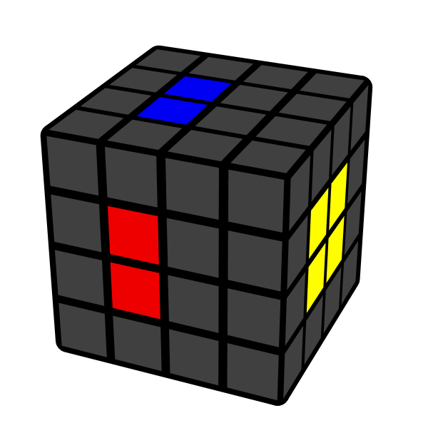 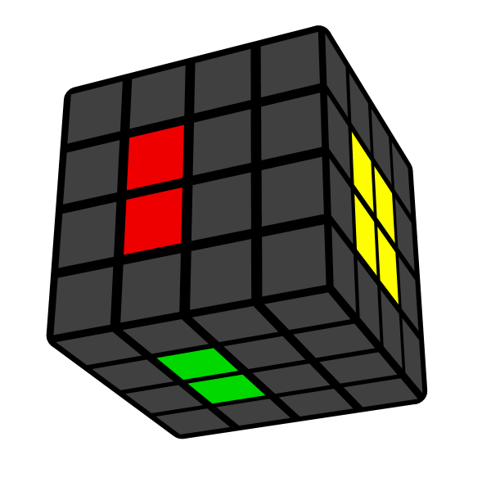

**Solve Bottom Center**

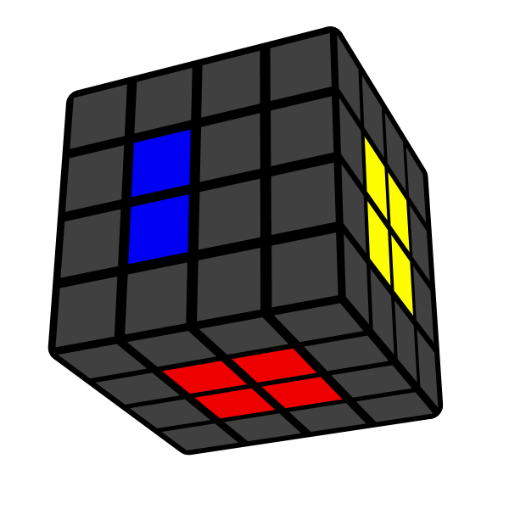

**Solve Front Center**

From now on, use only Rw and U moves to solve centers. You can also solve back centers first.

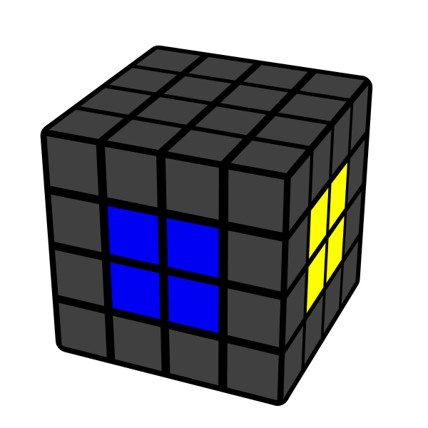

**Solve Back Center**

After this step, the last centers will be automatically solved.

