2x2 OLS Algorithms (Orientation of Last Slot)
https://bit.ly/2XGTXnn

These algorithms are used in SS method (Stern-Sun) (a supplement to Ortega method). Understanding these algorithms helps learn EG method further. TCLL- shapes are not included. It is not recommended to learn all of them. SS method:

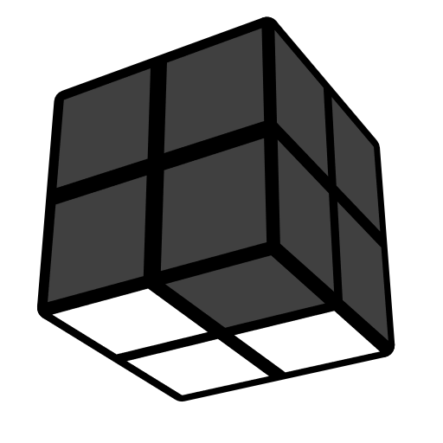 |  | 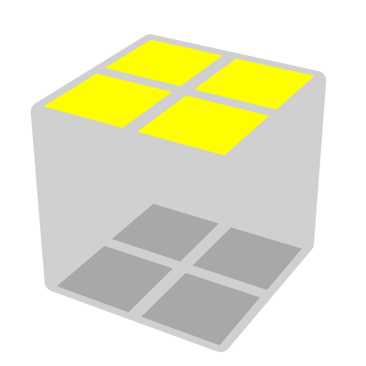 |  | 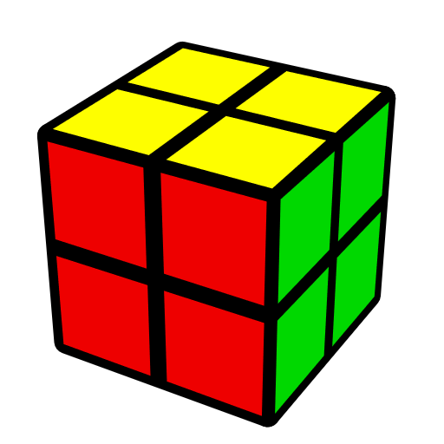
Solve 3/4 of a face, then place the unmatched corner in DRF position |  | 2x2 OLS  Skip OLL while solving last corner |  | PBL

CLL Shapes [26]
AS | 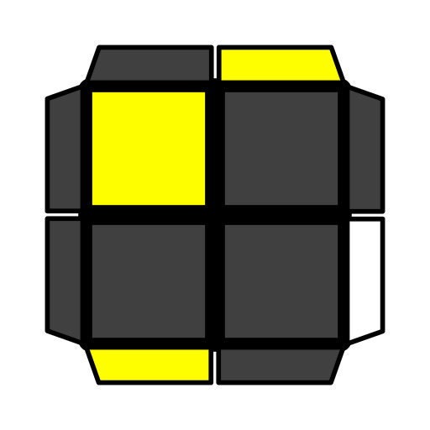 |  | 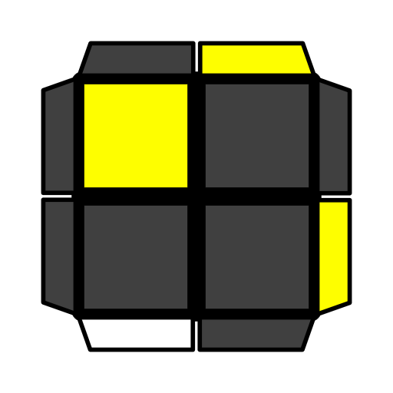 |  |  | 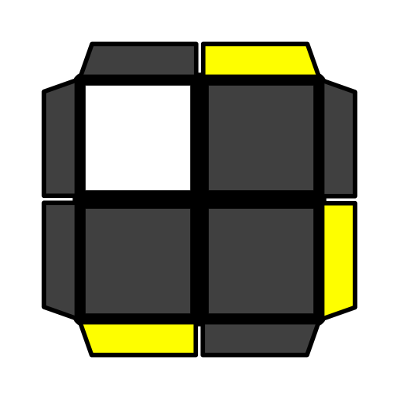 |  | 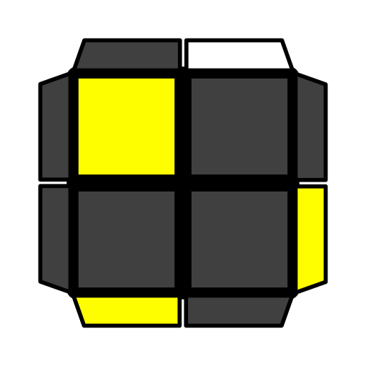
 | y' R2' U R2 y' R' U R |  | (R' U R U') R' U2 R |  |  | U R2 U R' U R' U R2 |  | U R2 U R' U R'
S | 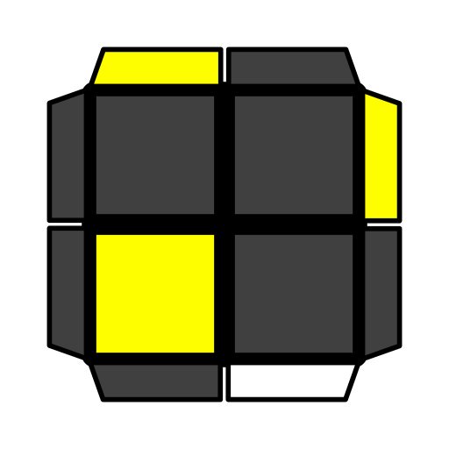 |  | 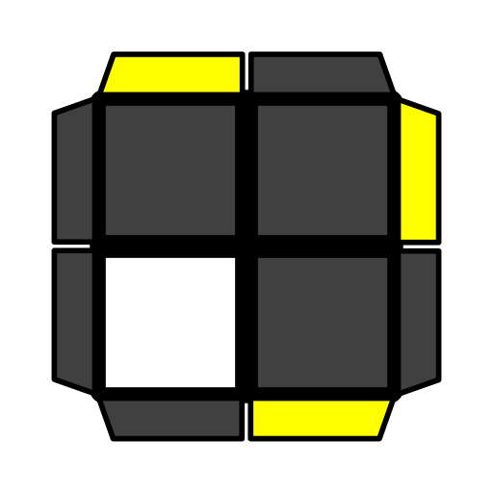 |  |  | 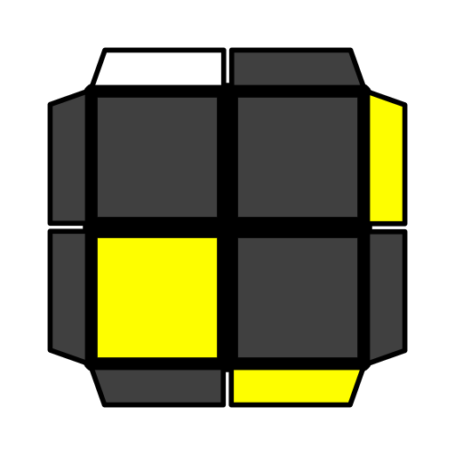 |  | 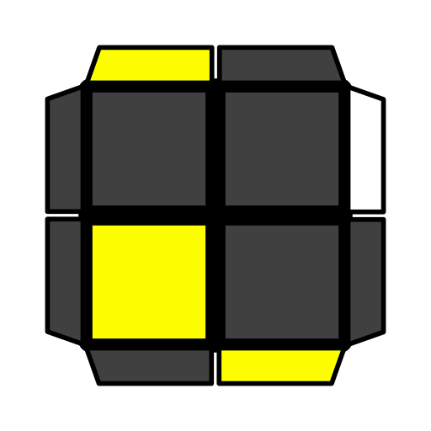
 | U' R2 U' R U' R |  | y' R2 U' R U' R U' R2 |  |  | (R U' R' U) R U2' R' |  | U R2 U' R2' y R U' R'
L | 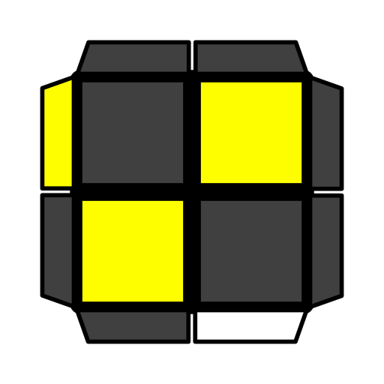 |  | 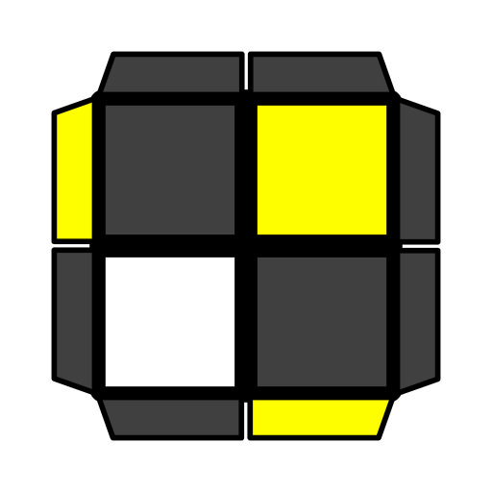 |  |  | 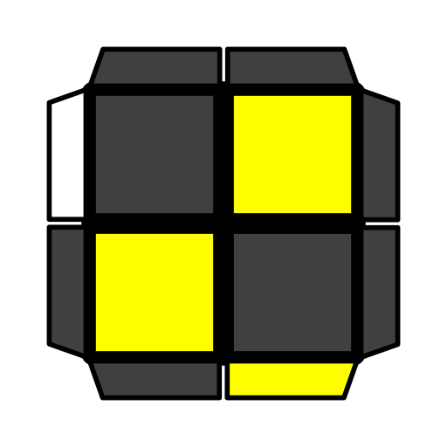 |  | 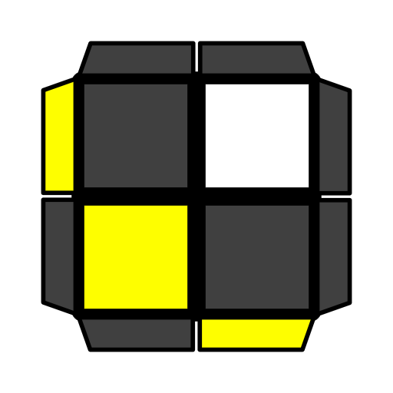
 | U2 F2 R U R' F |  | D' F R U2 R' F' |  |  | F R U2 R' F |  | R' U R' U' F U' R'
U | 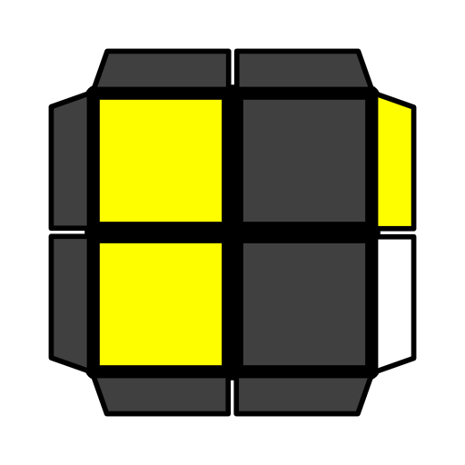 |  | 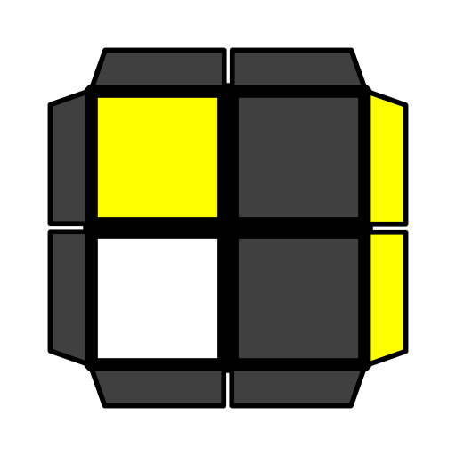 |  |  |  |  | 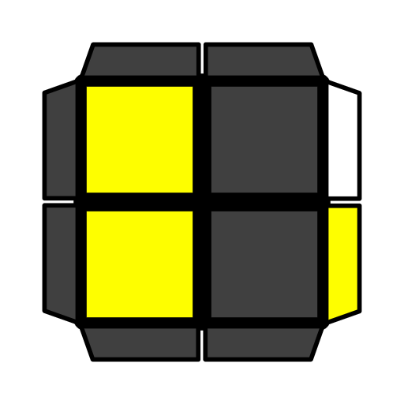
 | y' U' (R' U' R U) R' U R |  | y2 L2' B L2 B L2' B |  |  | D R2 B' R2' B' R2 B |  | U2 R U R' U' R U' R'
T | 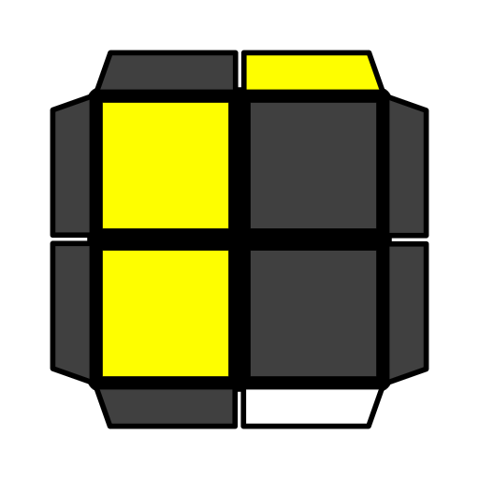 |  | 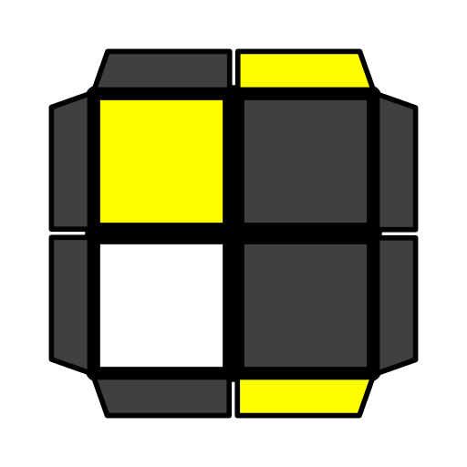 |  |  | 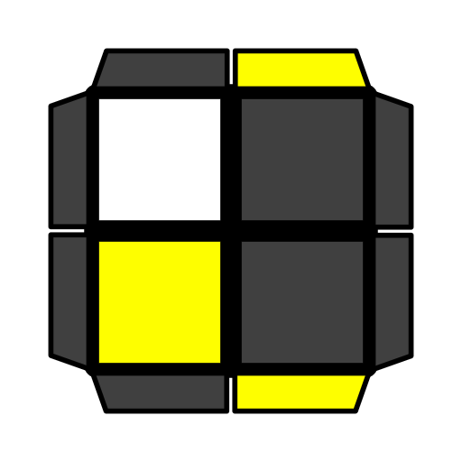 |  | 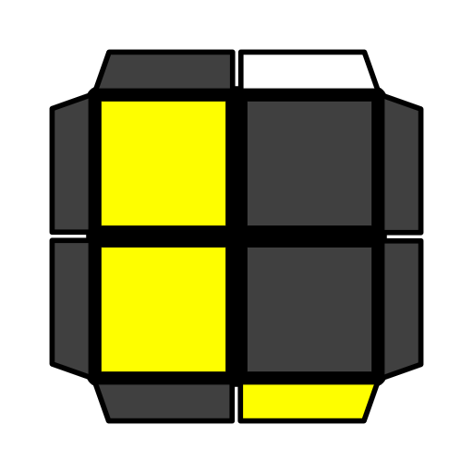
 | D (R' U R) B U' B' |  | (R U2' R' U2) R U2 R' |  |  | D (R' U2 R U2') R' U2 R |  | (R U' R') (F' U F)
Pi | 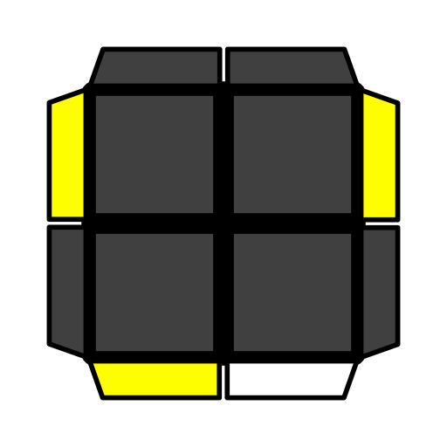 |  | 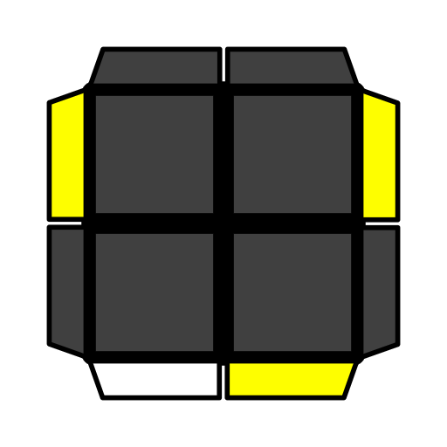 |  |  | 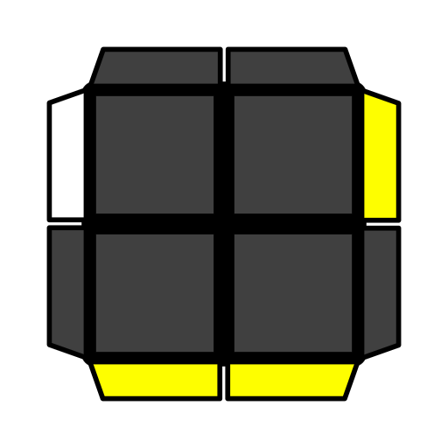 |  | 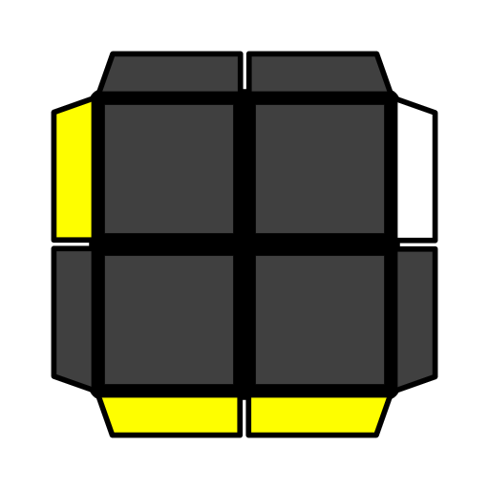
 | U' (R U2 R U') R U' R |  | y' (R' U2 R' U) R' U R' |  |  | y' U' (R' U' R U) R' U2 R |  | (R U R' U') R U2 R'
H | 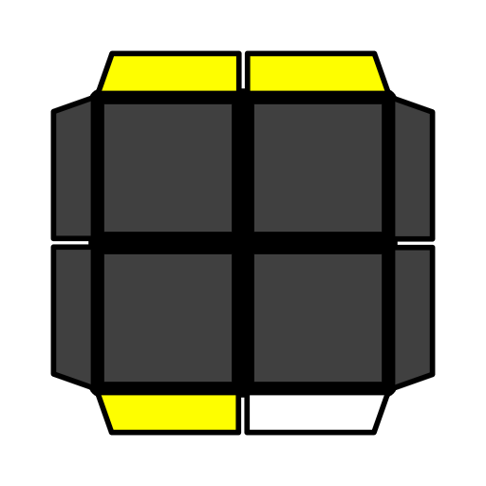 |  |  |  | 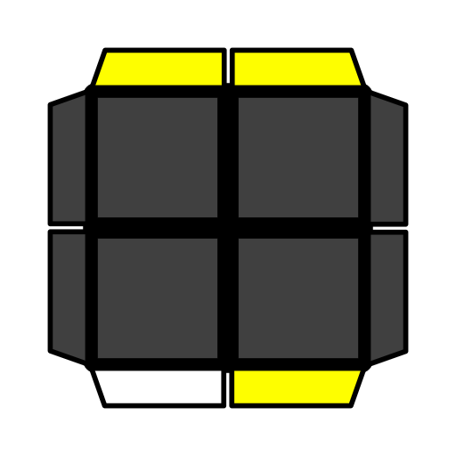
 | R2 U2' R' U R2 |  |  |  | y' U' R2' U2' R U' R2
TCLL+ Shapes [35]
Stollery | 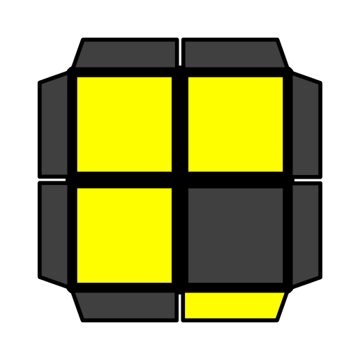 | 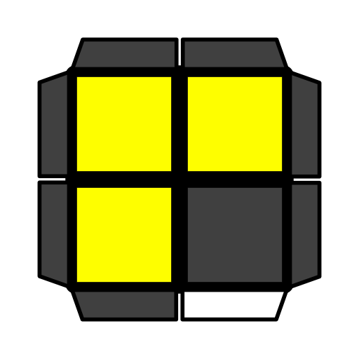 |  | 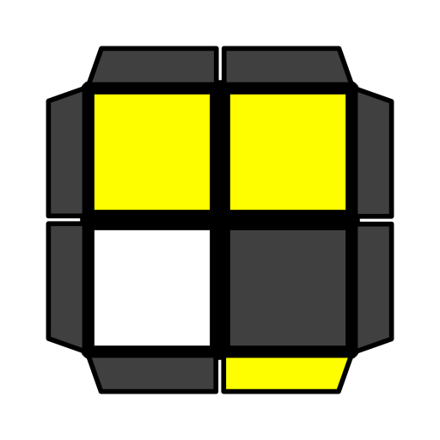 |  |  | 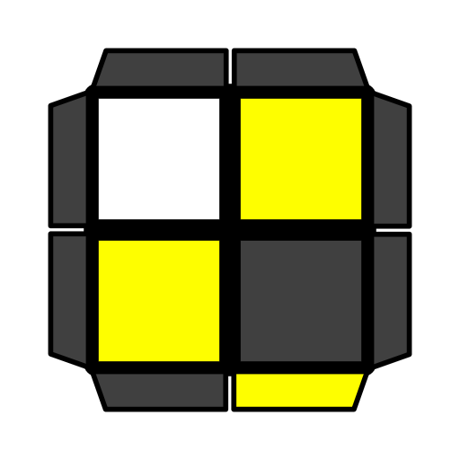 |  | 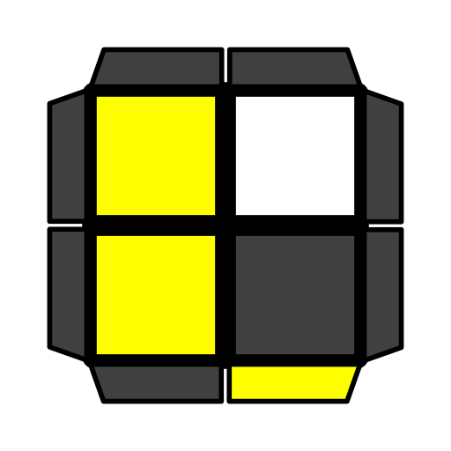
 | U F R F' R' | U (R U2 R' D') L' U L |  | U F' R U' R' F2 |  |  | U F' R U' R' D R2 |  | U2 R' U2' R U2 R
Gun | 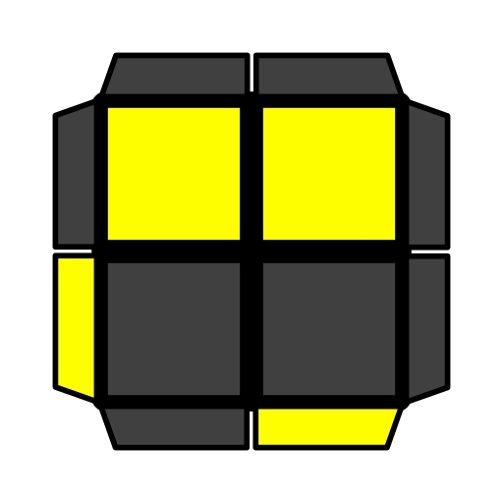 | 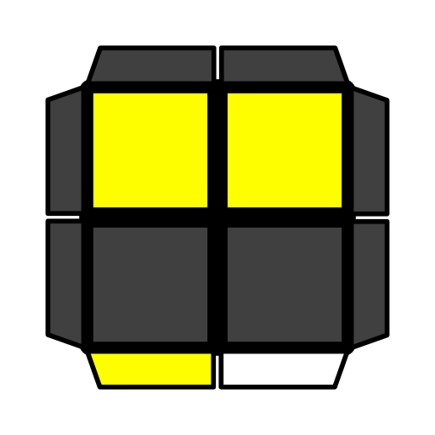 |  | 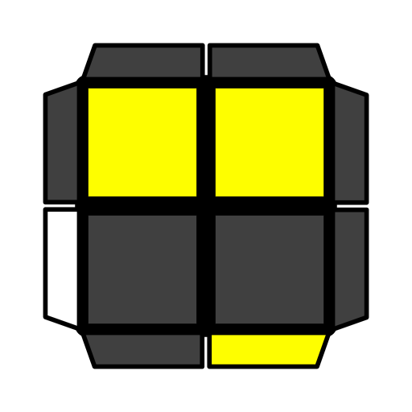 |  |  | 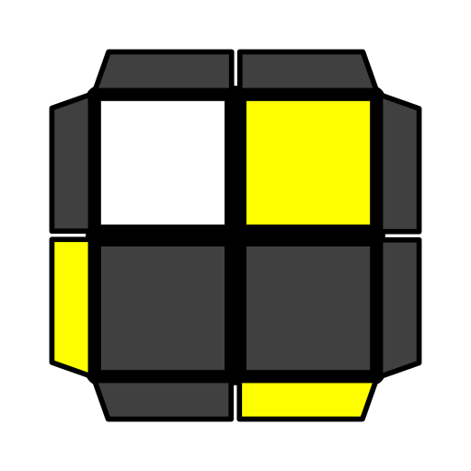 |  | 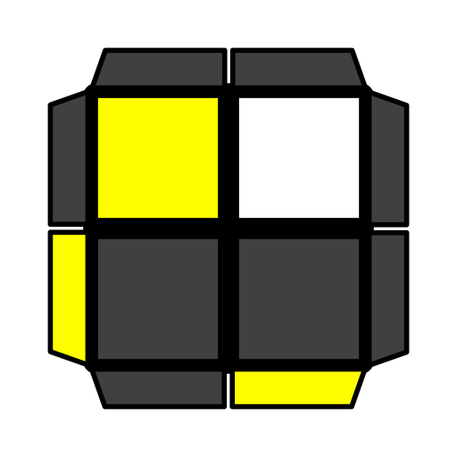
 | (R U' R' U) R2 U' R2' | U' (R2' F2 R2) U' R' |  | R U' R' |  |  | R U' R U' R2' |  | R U' R y R2 U' R2'
Two Face |  | 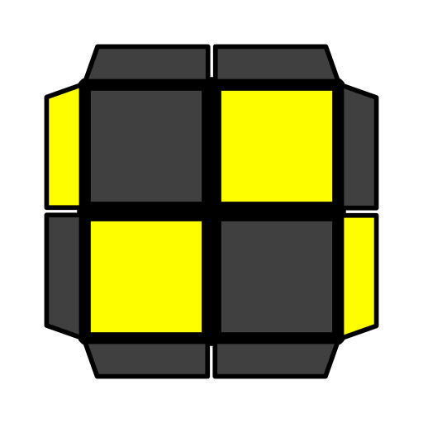 |  | 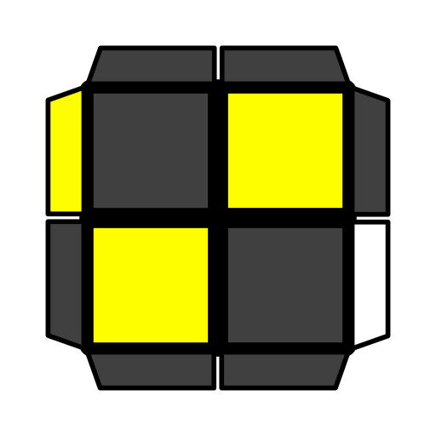 |  |  | 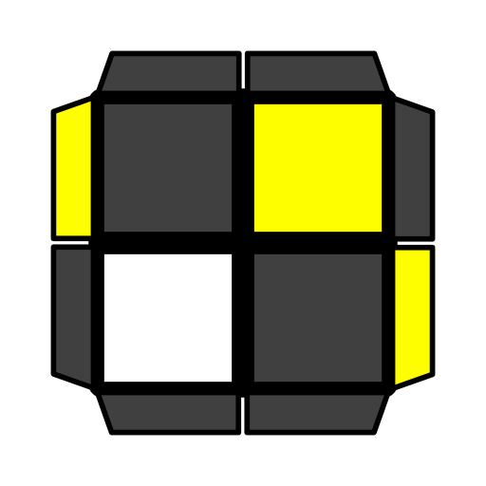
 |  | U R' U R U R' |  | R U R' |  |  | (R U R' U') R2 U' R2
Spaceship | 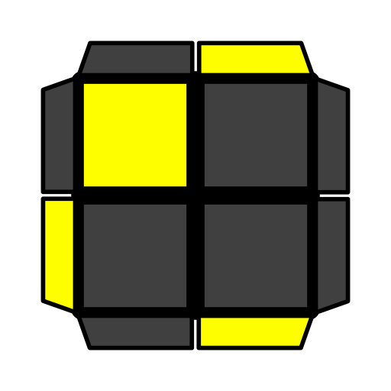 | 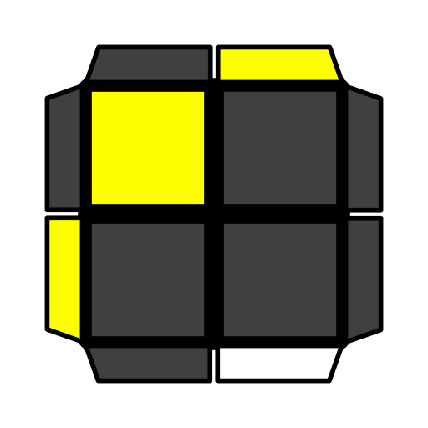 |  | 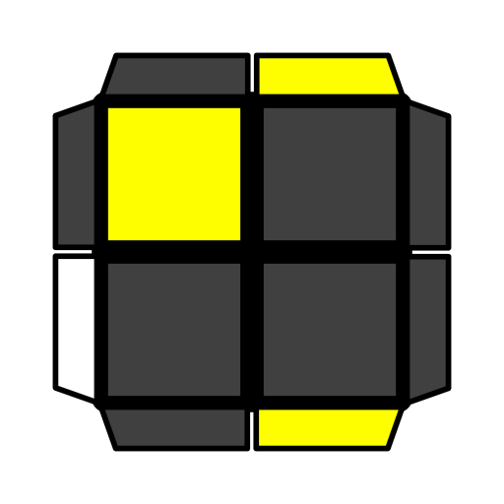 |  |  | 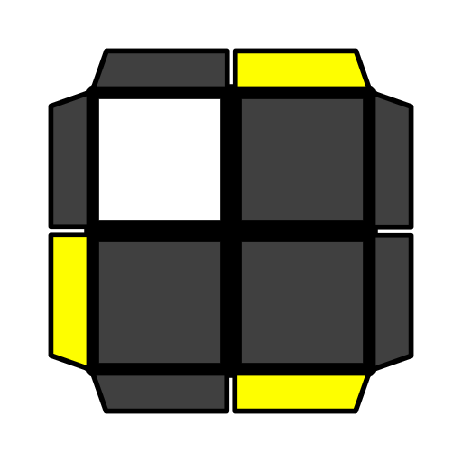 |  | 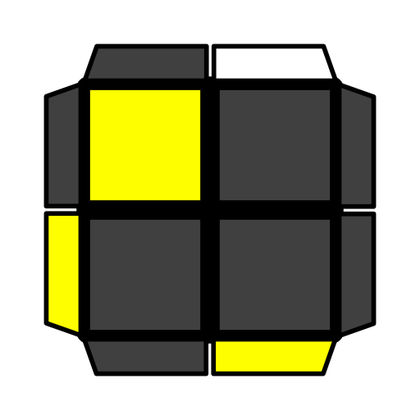
 | U y' (R' U' R U)  R' U' R | U y' R2 U' R' U R2 |  | U y' R2 U' R U R2 |  |  | U y' R2 U' R' U2 R2 |  | y F R U R' F'
Hammer | 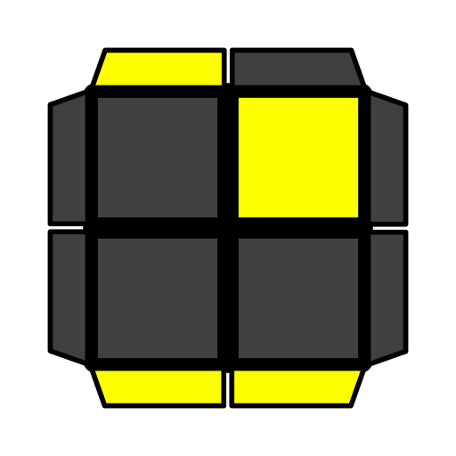 | 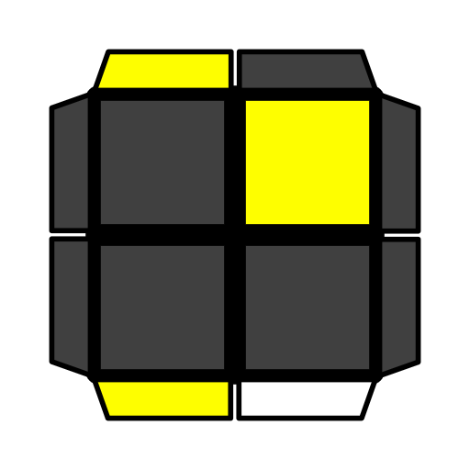 |  | 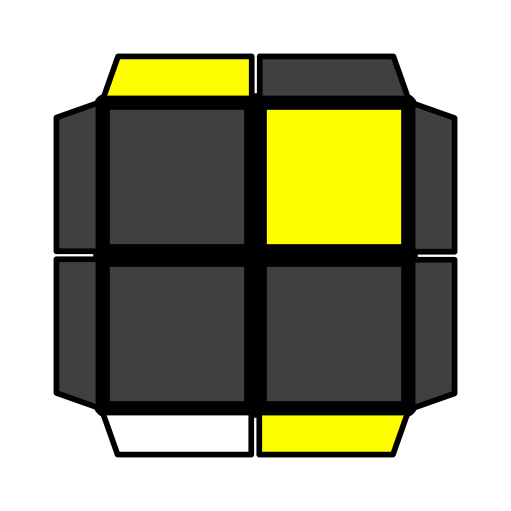 |  |  | 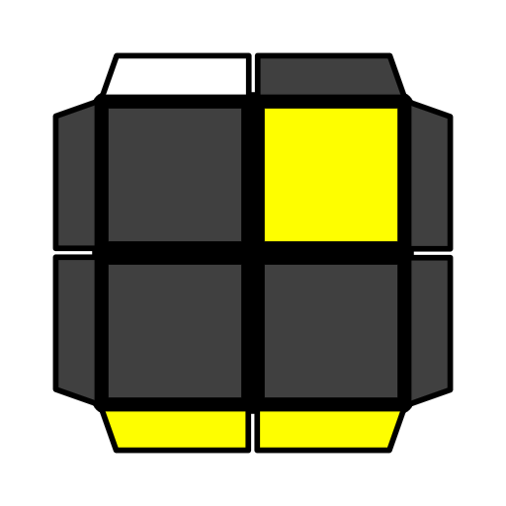 |  | 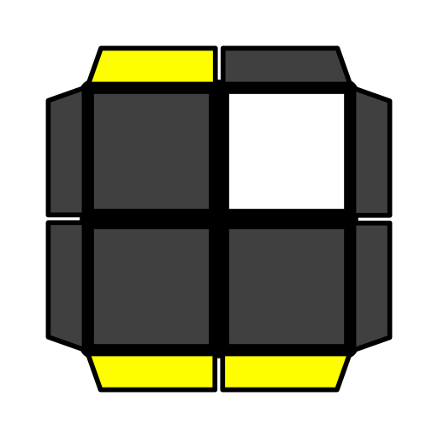
 | (R U2 R' U')  (R2 U' R2') | R U2 R U' R2' |  | U' F R' F' R |  |  | R U2 R' |  | y' U (R' U R' U)  (R' U2 R')
Turtle | 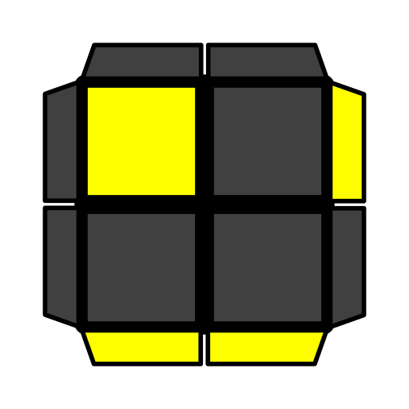 | 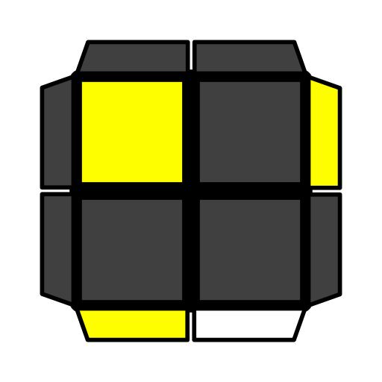 |  | 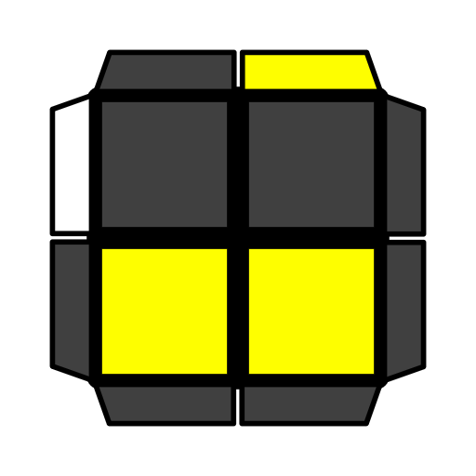 |  |  | 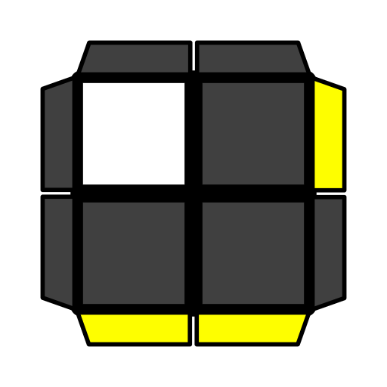 |  | 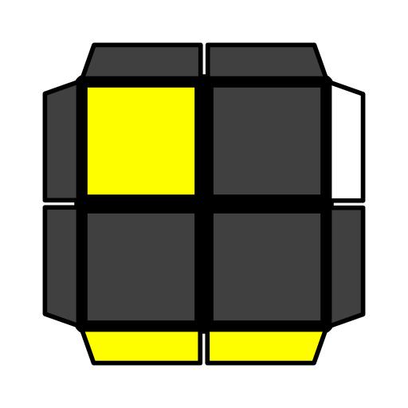
 | (R U' R' U) R U' R' | y R U' R2' F R |  | y R B R' B R2 B' |  |  | R U2' R2' F' U F |  | U F U' R2' F2 R
Poser | 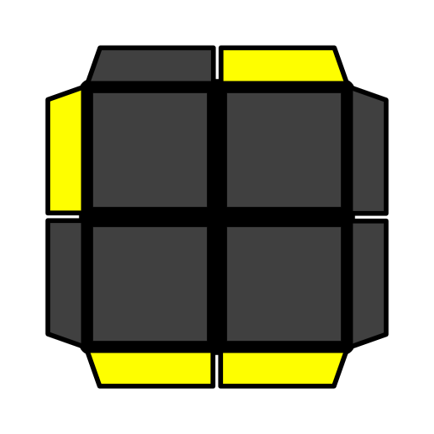 | 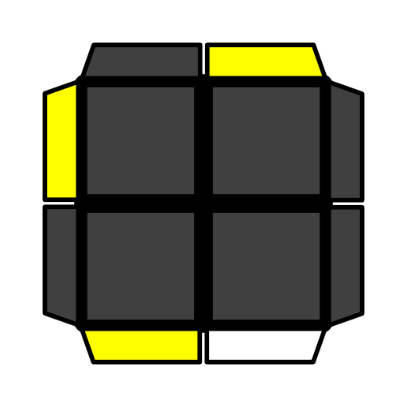 |  | 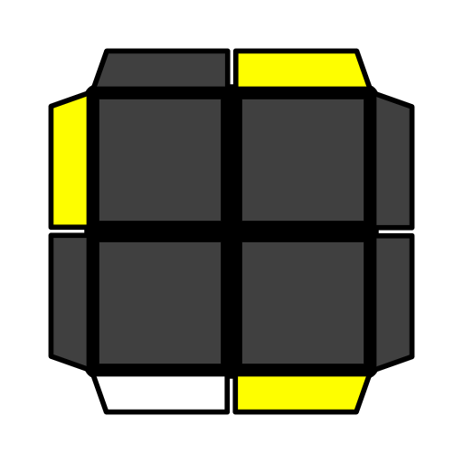 |  |  | 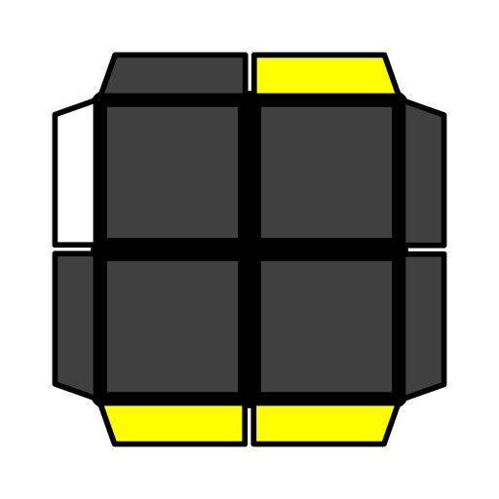 |  | 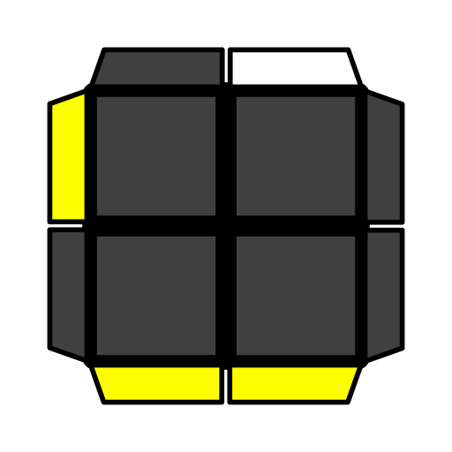
 | R U' R2' F R F' | U (R U' R U2')  R U2 R2 |  | (R U R' D) R' U R |  |  | R' F R2 U2' R' F |  | F R U' R2' F2 R
Pinwheel | 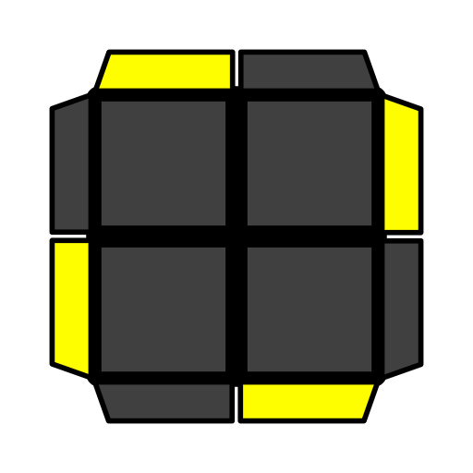 |  |  |  | 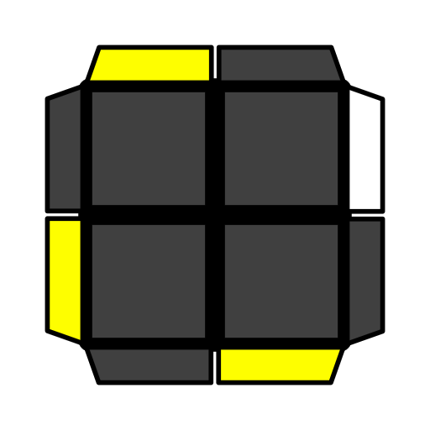
 | y' (R' U2 R' U) R' U2 R' |  |  |  | (R2 U2' R' U2) R' U R'

