2x2 LEG Algorithms

H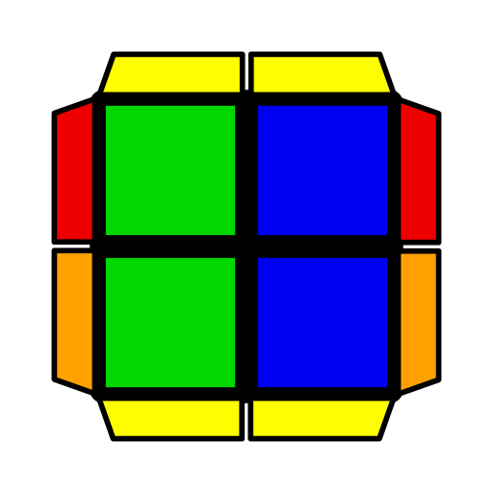 | 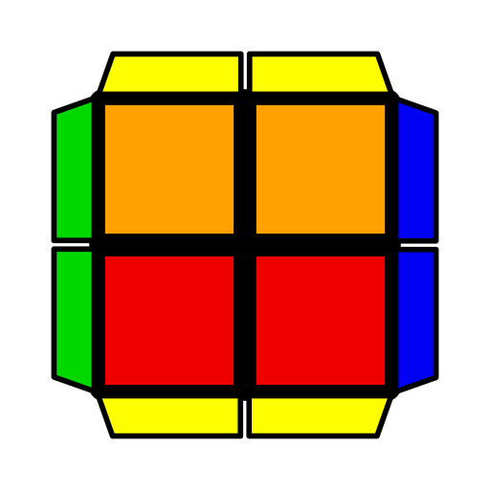 | 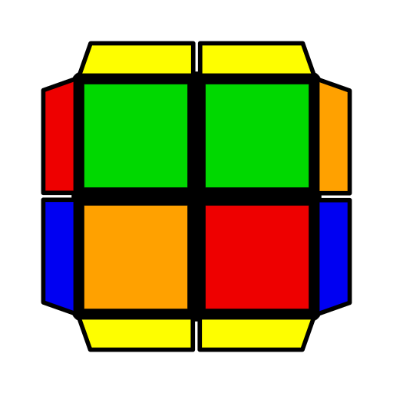 | 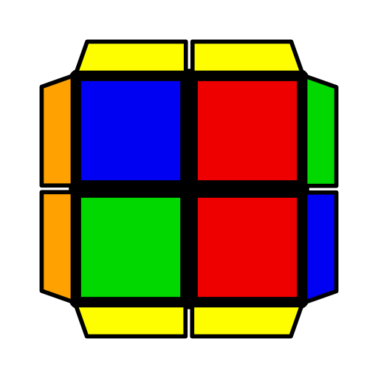 | 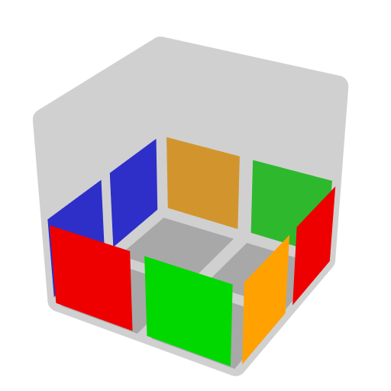
R (F2 R F' R' F U' F) | R2' U' (R U' R' U) (R' U' R U' R2) | F' R' U' F2 R U' F R' | R U' (F R' F' R)  U' R2  (R U2 R U')  (F R F' R) | Easy [12].
Pi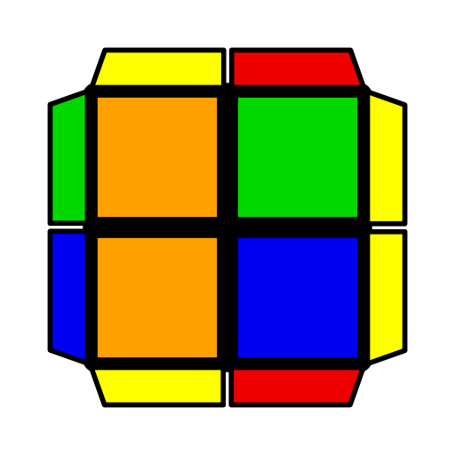 | 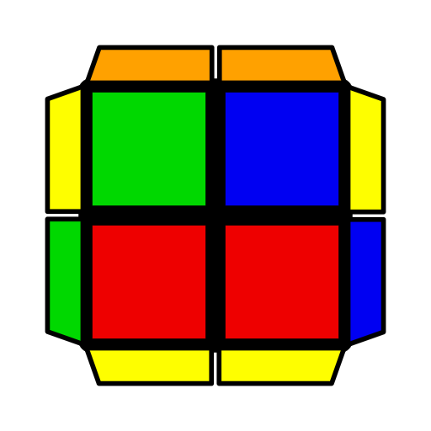 | 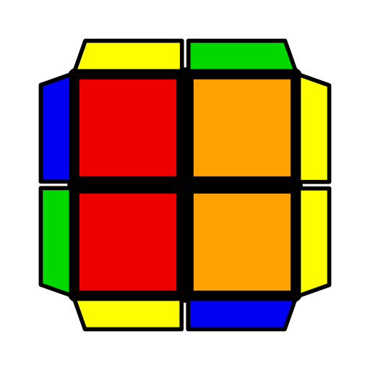 | 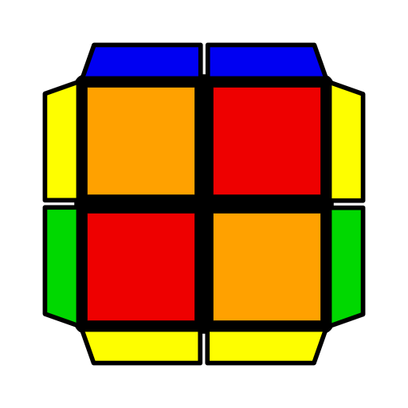 | 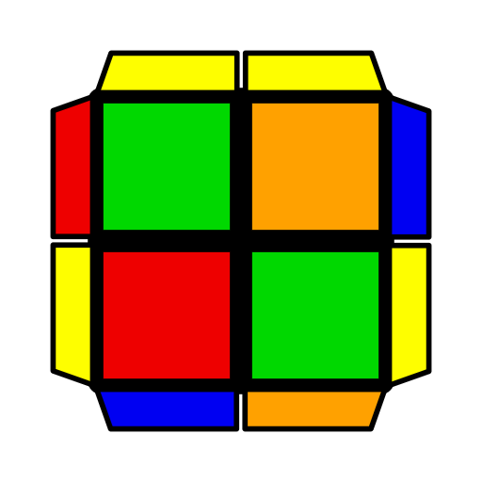 | 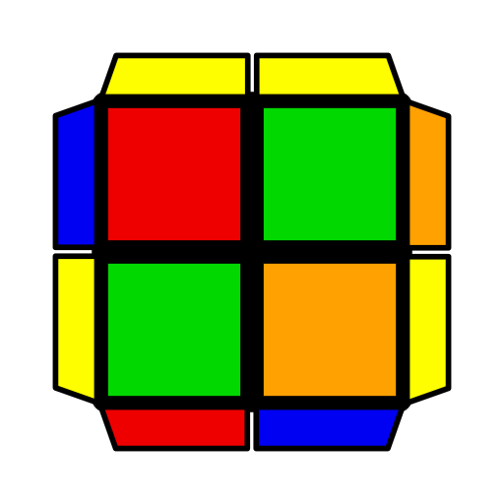
F R F' (R' F R2 F') R' U2 R  (R' F' R2 F')  (R2' U2' F R) | (R U R' U')  (R U2 R U' R2') | R F' U R' F2 U R F | R2 U (R' F R F')  U R' | (R U' R' F)  (R F' R2' U2' R) | (R U R' U)  (R2 U' R2' F R2 F')
U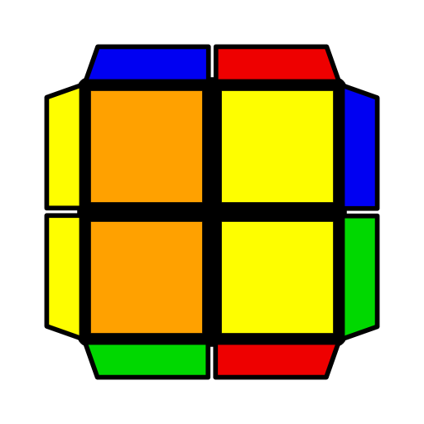 | 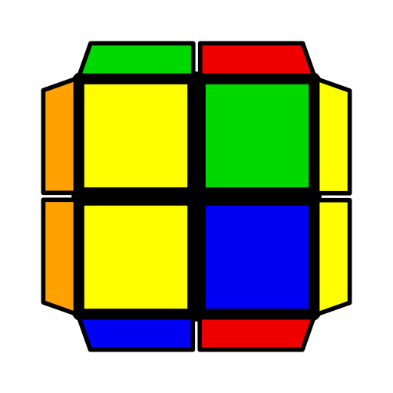 | 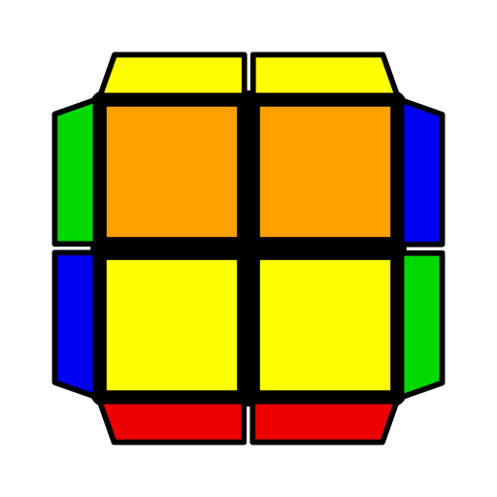 | 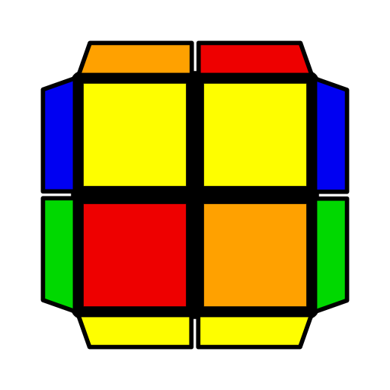 | 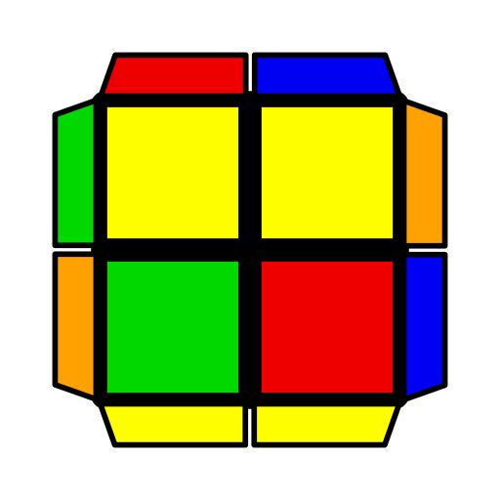 | 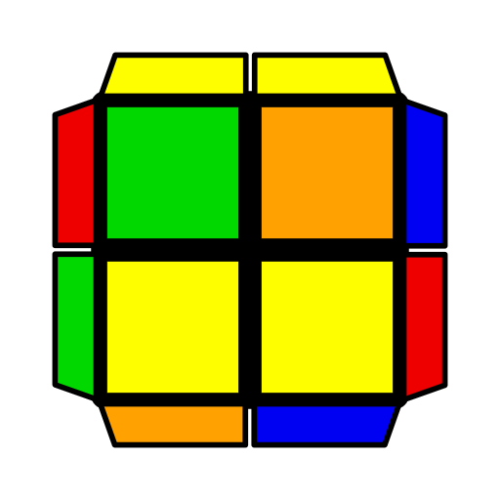
(R' U R' U')  (R U' R' U' R2)  U' (R2 U' R' U')  (R U' R' U R') | (R2 U R2' F')  (R2 F' R2' F R2) | (R U R' F)  R2 F' R U' R'  U' R2 F R U R' U' R2 U2 R2 F | (R2 U R' U) (R' F R F') R U R2' | (R2 U R' U2)  (R' F' U' F) | (R2' U' R U2 R)  F R F'
T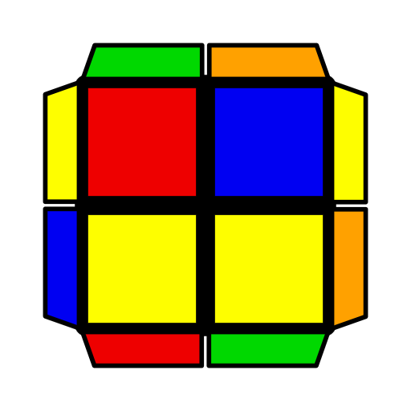 | 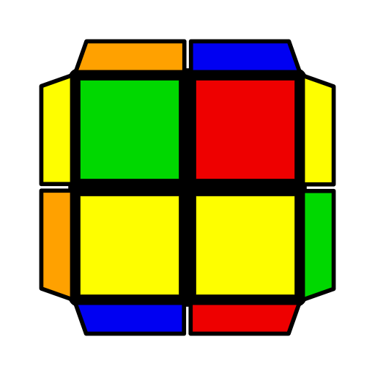 | 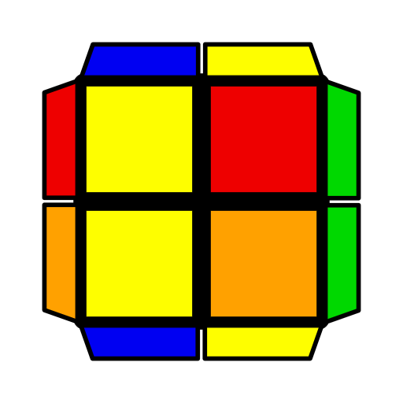 | 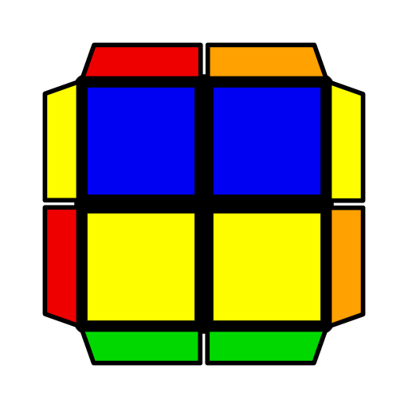 | 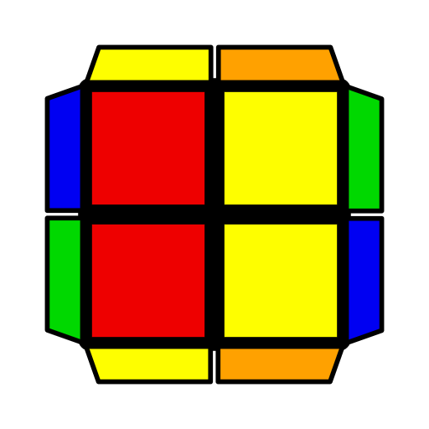 | 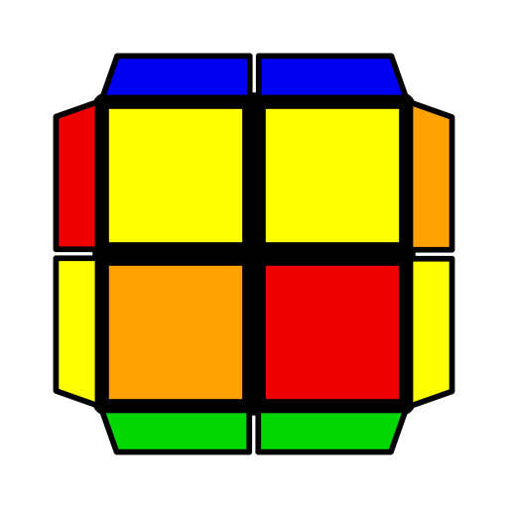
(R U R' U') F'  (R' U2 R U') F | R U' (F R2 F')  (U R U' R2')  U' (R2 U' R' U2)  (R' F R F') U2 R'  U' (R2' U' R2 U')  (R' F R' F') R2 | (R U2' R' U) (R' U' R U2) R U R' | F R F' (R' F R2 F') (U R' U R) | R2 U' R' (F R' F' R) (U' R U' R2') | (R' F R2 F')  (R' U2' F R F')
L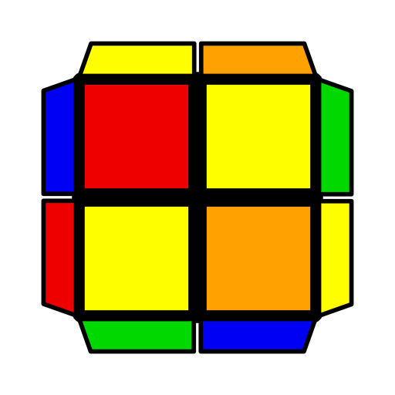 | 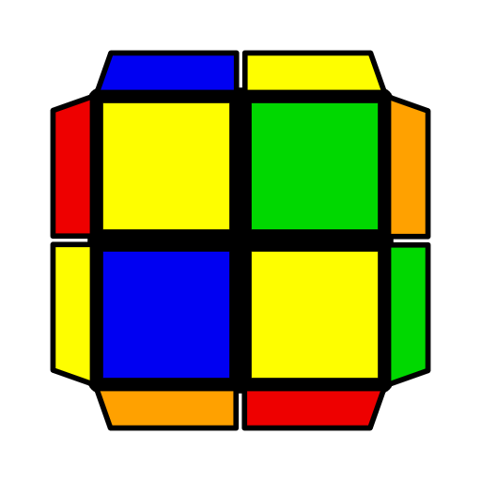 | 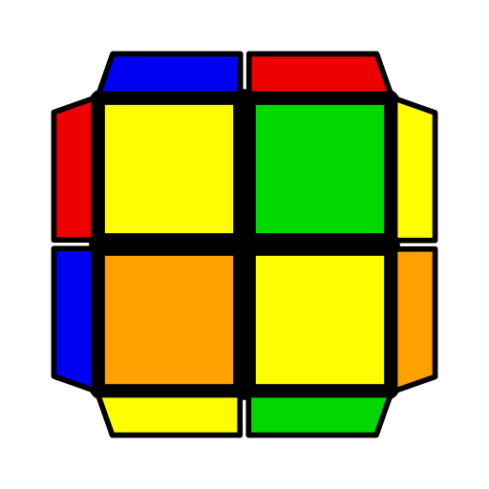 | 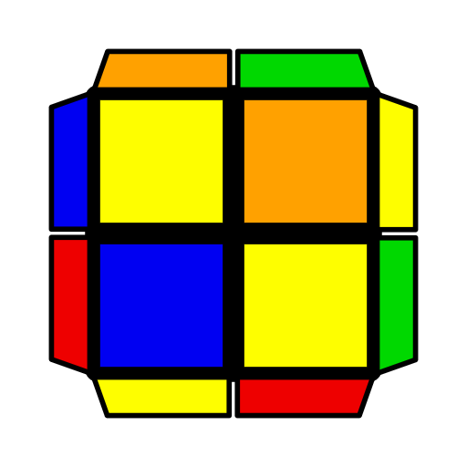 | 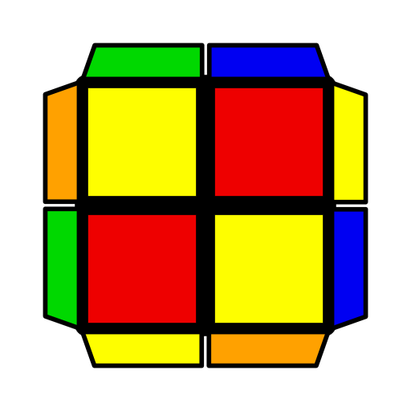 | 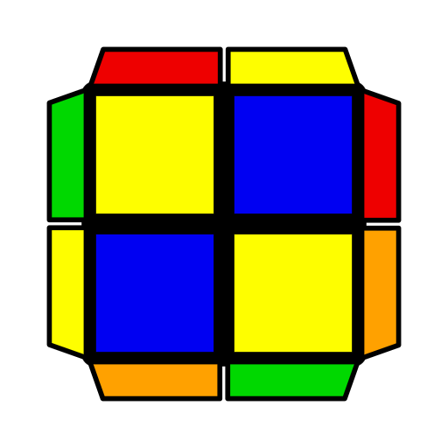
R U2' (F R' F' R) (U2 R U R2')  U' (R2' F R F')  (R U R2' U R2) | (R U' R' U')  (R2 U' R2' F R F') | (R' U R' U R2 U')  R U2' R'  (R U2 R' U) R2 U'  R U' R | R' F U2' (R2' F R U2) R U2' R2'  U' (R' U R' U') (R U R' F) R2 F' R | F' U (F R U2 R U' R2') | (R' U2 R' F)  (R2 F' U' R)
S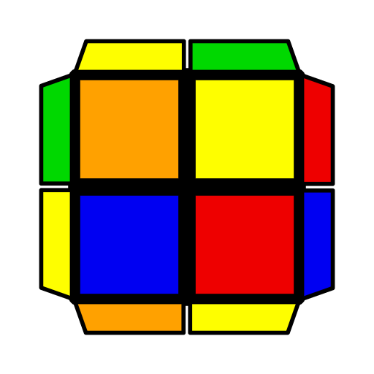 | 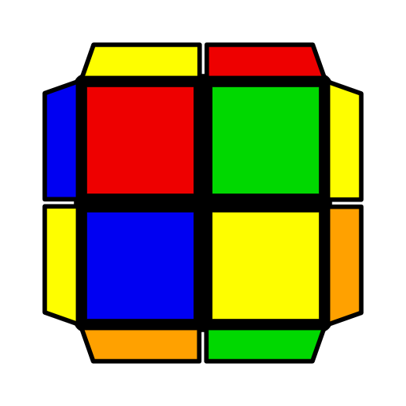 | 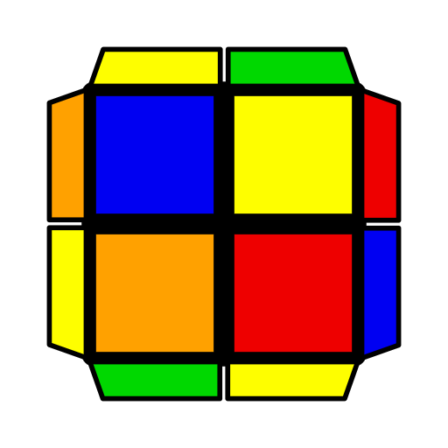 | 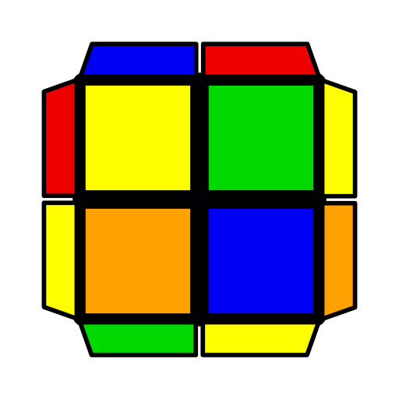 | 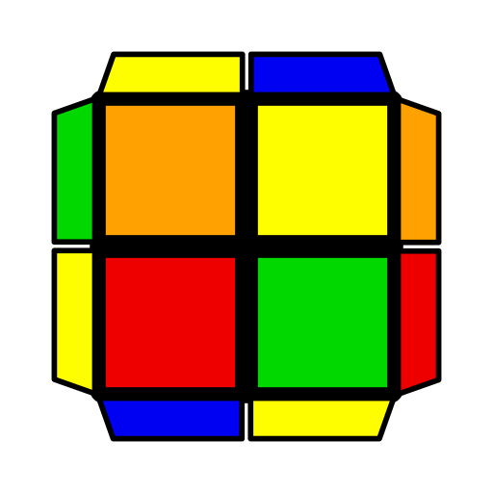 | 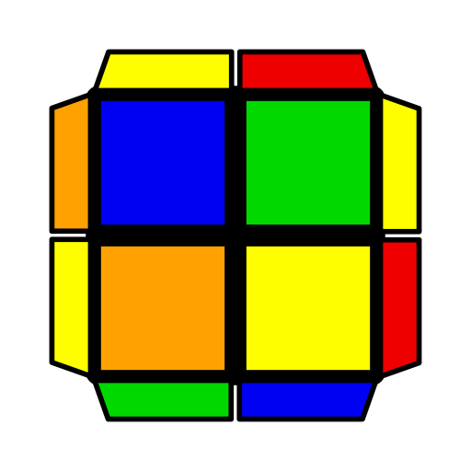
R' F R2 F' R2' U2' R | (R2 U' R2' U') (R2 U R' U') R U' R2' | (F R' F' R2 U2')  R U' R2' | R2 U' R2' F' R U2 (R' U2 R' F) | (F2 R F' U)  (R' F U' R2) | (R U2 R U')  (R2' F R2 F')
AS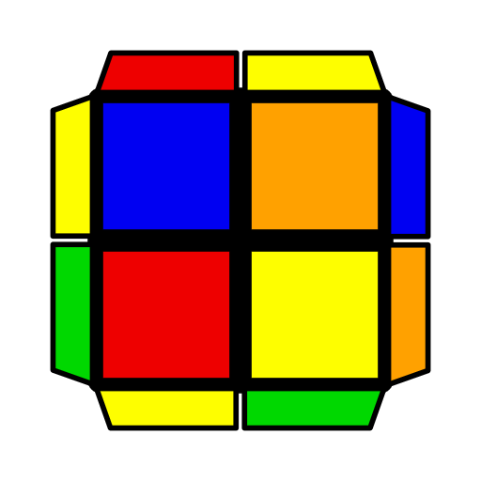 | 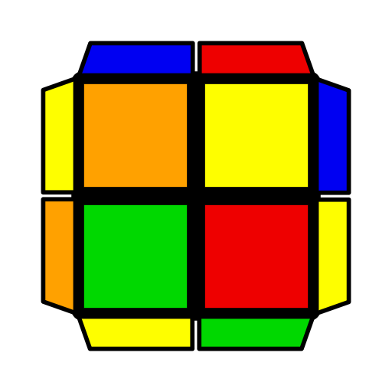 | 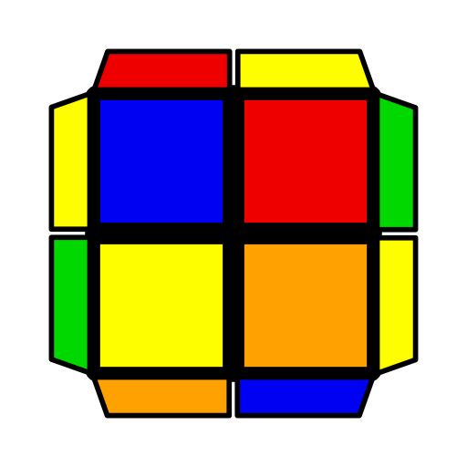 | 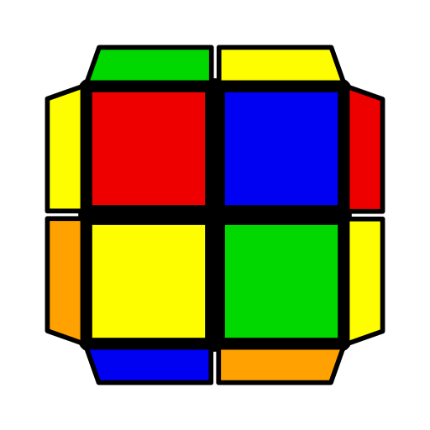 | 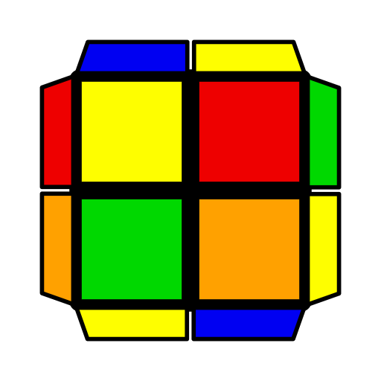 | 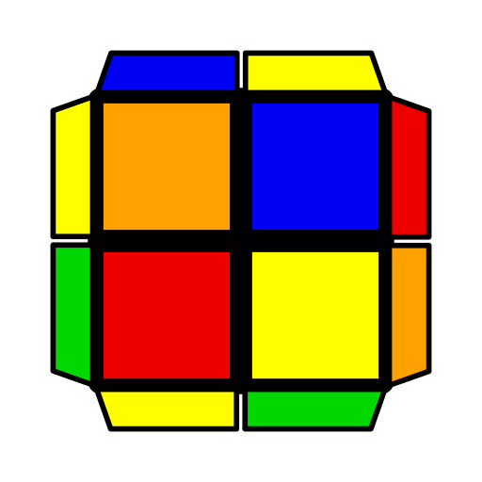
x' R U' R2' U R2 B2 R'  R F' R2' U2' F' R | (R2 U R2' U') (R U2 R' U') R U R' | (R2' F R F')  (U R' U R2) | F' (R U2 R U2')  R' F R2 U R2' | F' U2 (R U R' U')  (R' F2 R2 F' R') | (R2 U R' U2)  (R2' F R F')  U' (R U R' U') (R U R' F) R F' R'

2x2 TCLL+ Algorithms
Hammer
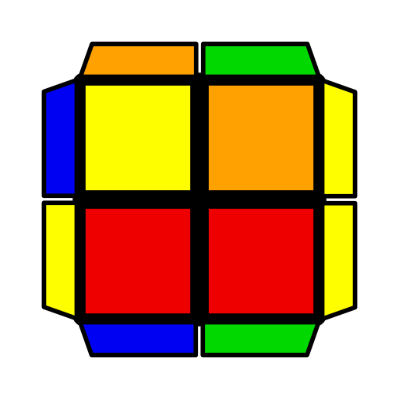 | 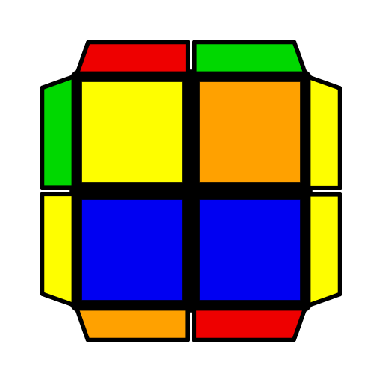 | 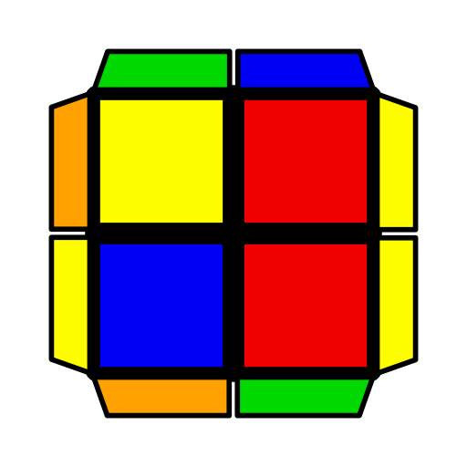 | 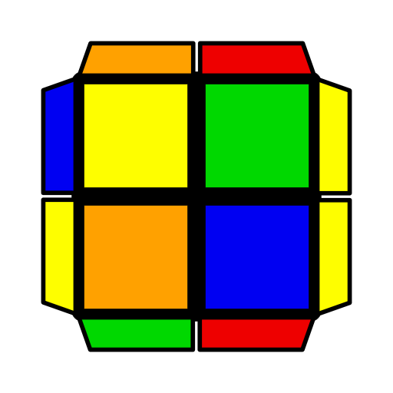 | 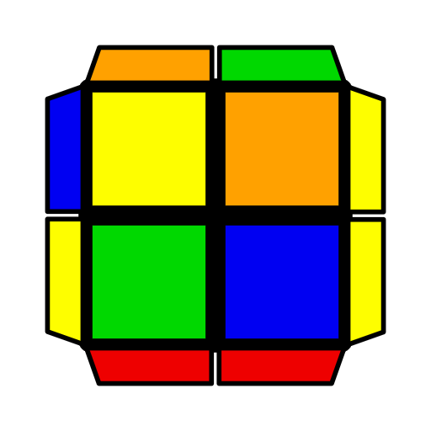 | 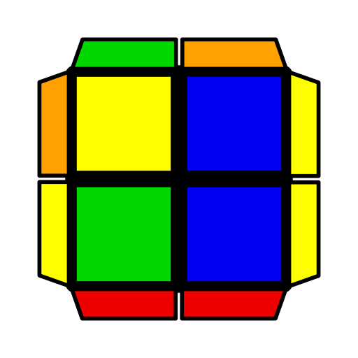
(R' F R F')2 | y' (R' U2 R D')  R U' R' | (F R' F' R2 U' R' U2) R U R' | U2 (R' F' R F')  (R' F R U2 F') | y F' (R' F' R U)  (R U R2' F' R) | U (R U R' F R F')  (R U R' U R')
Spaceship
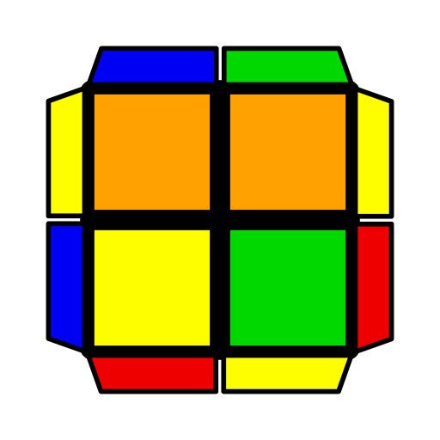 | 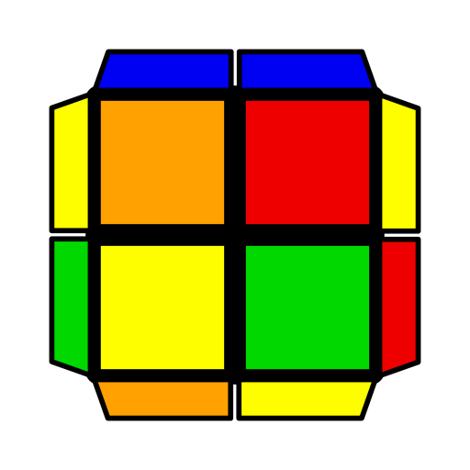 | 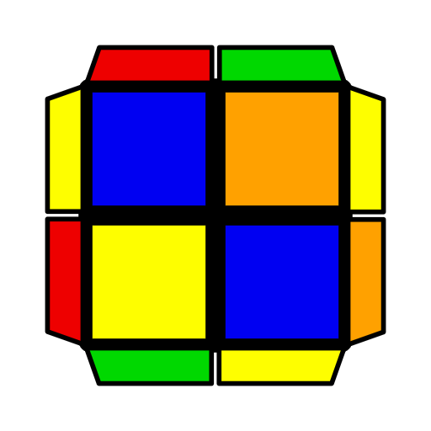 | 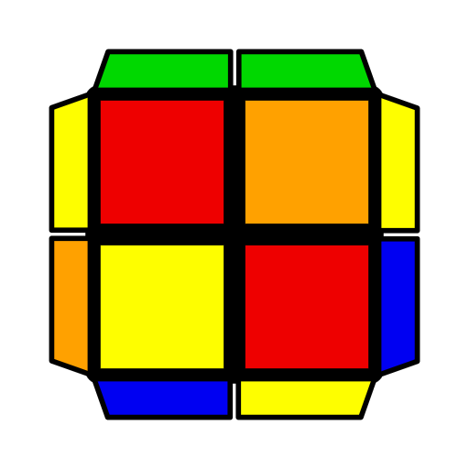 | 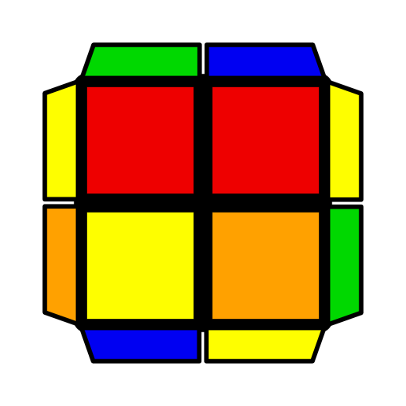 | 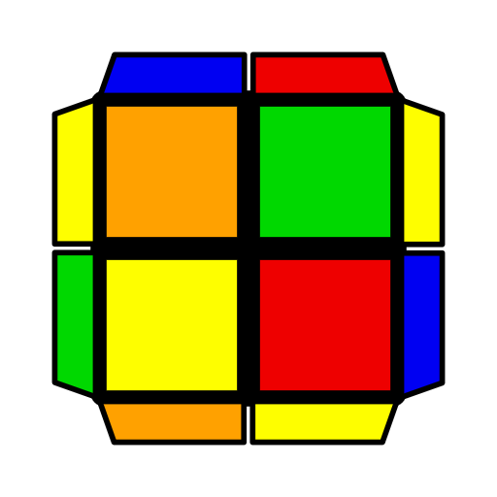
y' U2 R' U' R U R' U' R | U (R' F R F') (R' F R U) (R U' R' F') | U (R U' R' U) R2 U' (R' F R' F') | U (R U' R2' F R U) (R U' R' F') | U (R U2' R' U) (R' F R F') R U' R' | U (R' F' R U2)  (R' F' R2 U R') F2  U2 (R' F2 R U')  (R' F2 R2 U R') F2
Stollery
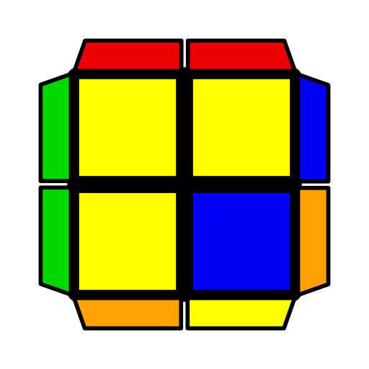 | 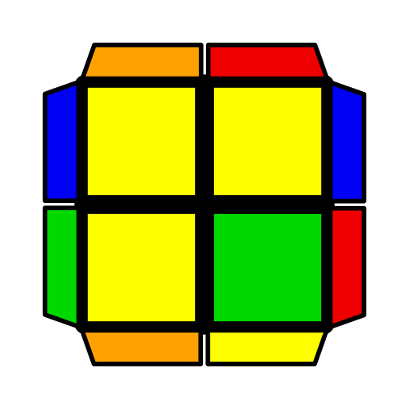 | 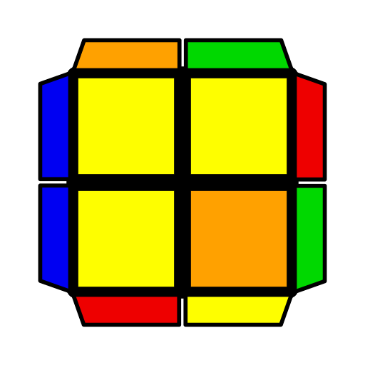 | 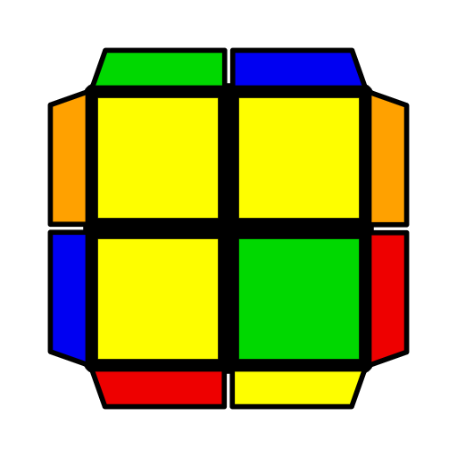 | 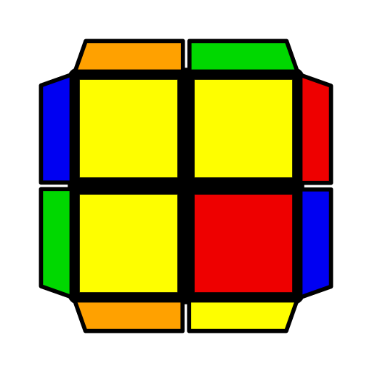 | 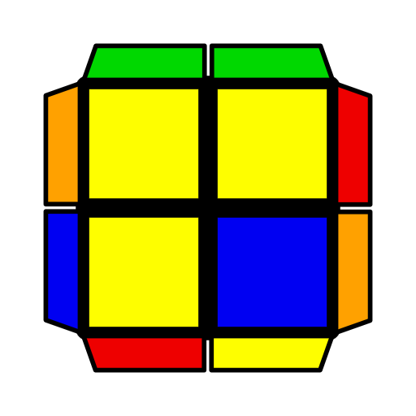
(R U R' U) (F' R U' R') F2 | U2 (R' F R U')  (F' R U2' R') F2 | U (R U' R' U') (R U' R' U) (R' F R F')  (R U R' U)  (F R F' R U R2') | (R U R' F) (R U R' U') R' F' R | y U (R' U' R U2 R' F2) R' F R2 | (R' U' F R F' U)  R2 U' R'
Pinwheel
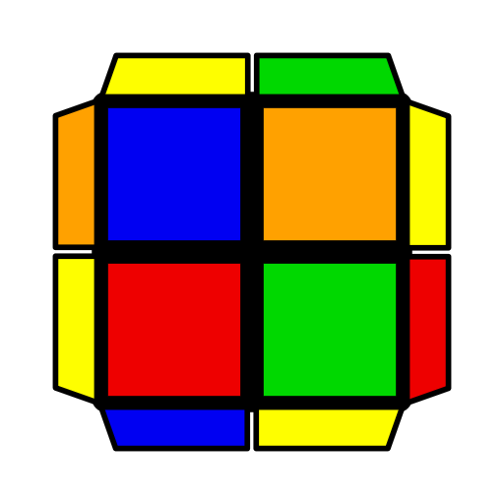 | 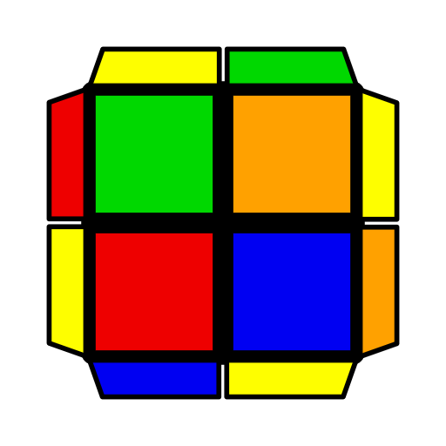 | 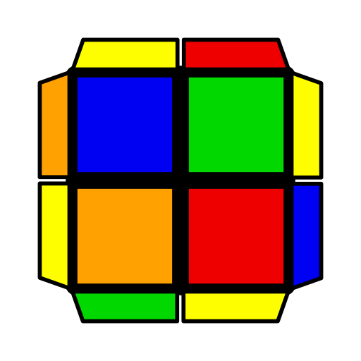 |  | 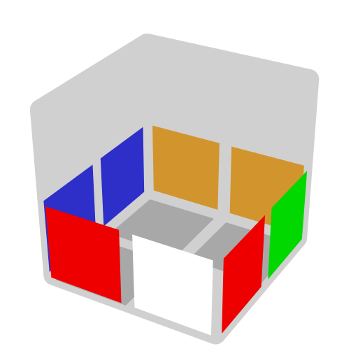
F' U (R U' R2' F2 R) F U F' | (R' F' U' F R2 U')  R U2 R | y F U' F2 (R U' R' U') R U' R'
Faces
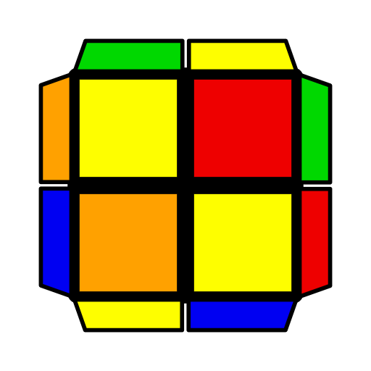 | 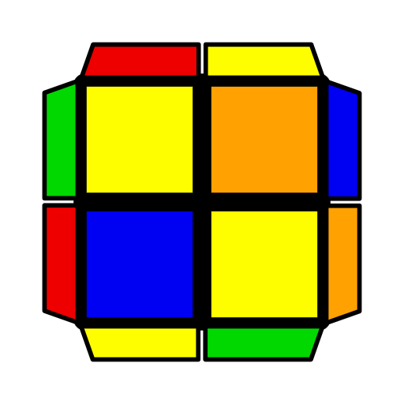 | 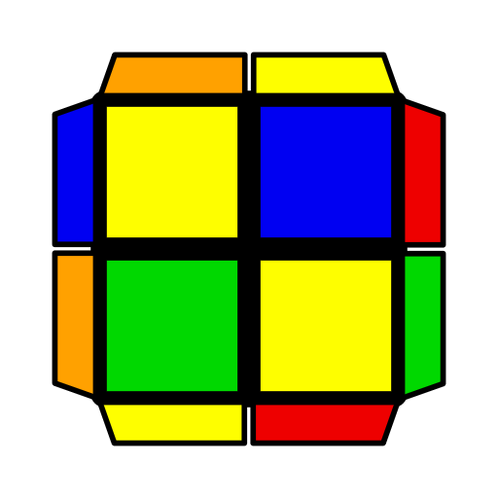 | 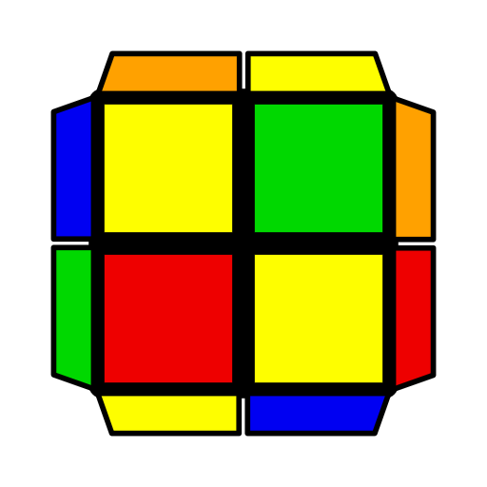
U (R U R' U') (R2 U R2' U' R2) | y' U R' U2 R'  F R F' R | (R U' R' U F')  (R' F' R F) | U R' U R (F R' F' R) U' R2
Turtle
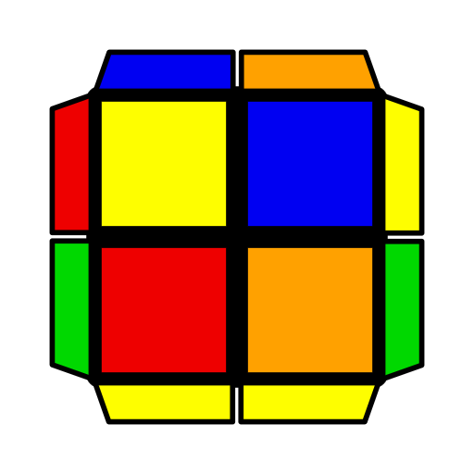 | 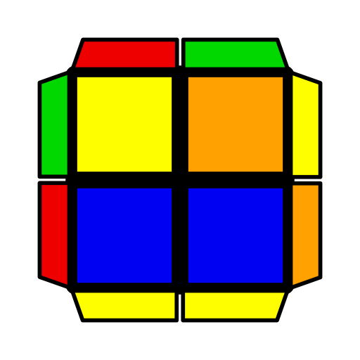 | 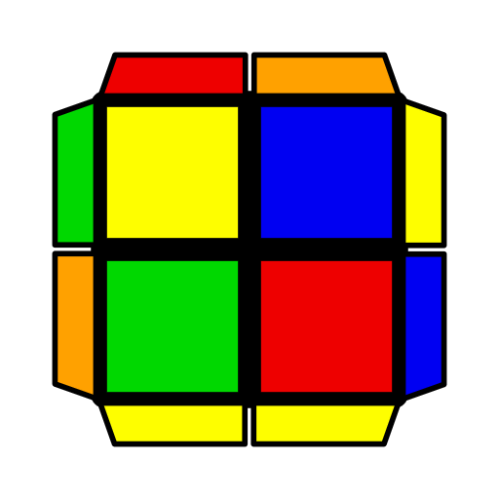 | 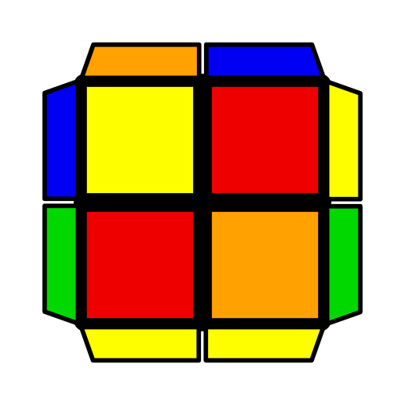 | 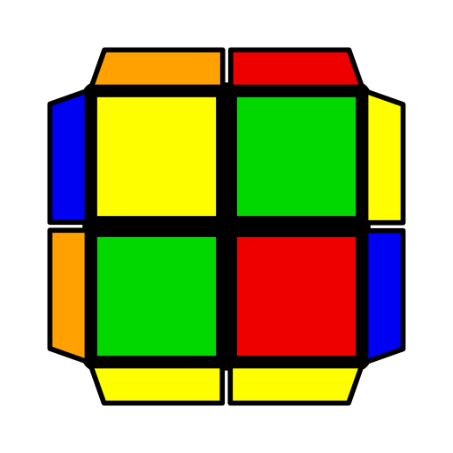 | 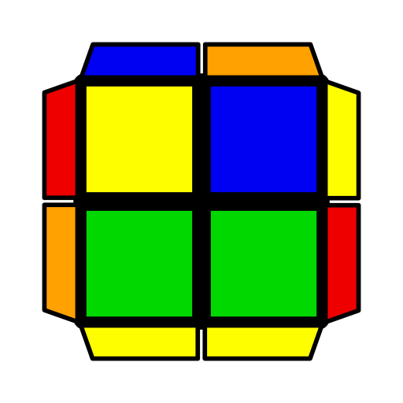
(R U' R' U) R U' R' | y (R' F' R U F') (R U R2' F R F') R U R' | (R' F R2 U R' F')  (R U' R' F') | U2 (F' U' F U')  R U2 R' | U2 (R' F R F')  (U2 R U2' R') | U2 (R U R2' F R F') (U2 R U' R')
Poser
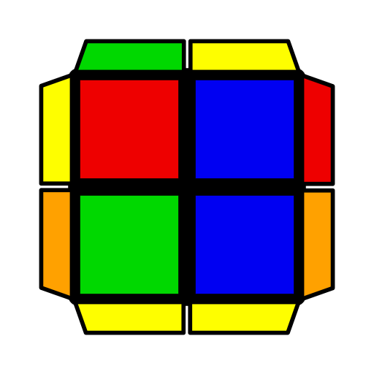 | 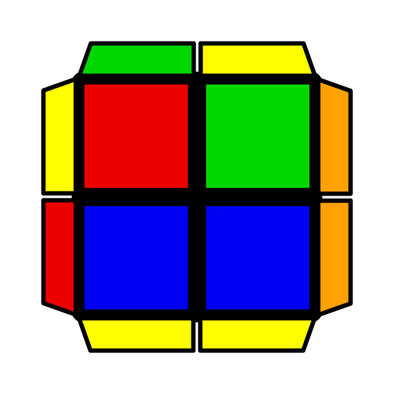 | 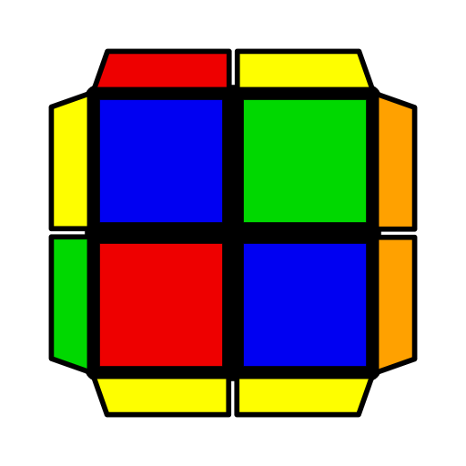 | 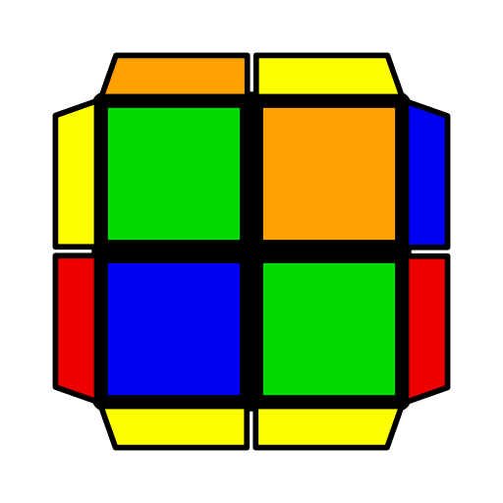 | 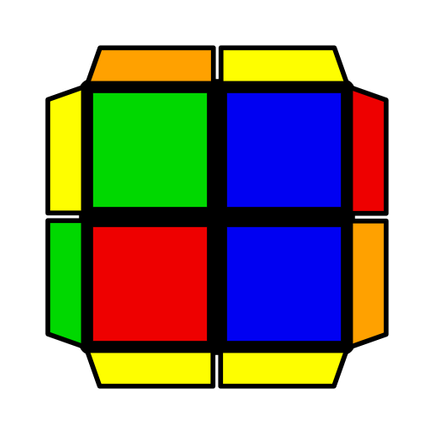 | 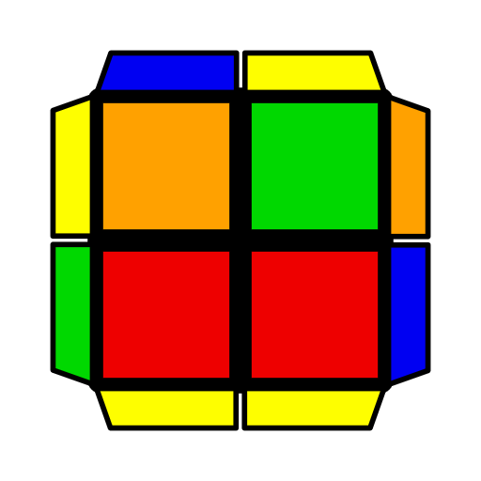
y (R U R' U') (R U2 R' F') (R U R' F') | U' (R' F R F') (R' F R2 U R' U' F') | (R U R' U2)  (R' F R F') R U' R' | U2 (R' F R) (F2 U' F) | R U' R2' F R F' | U2 F' U (R' F2 R F)
Gun
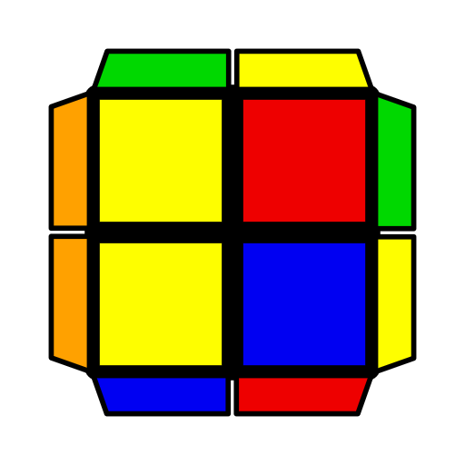 | 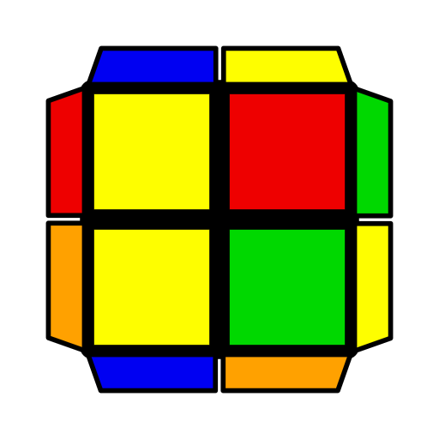 | 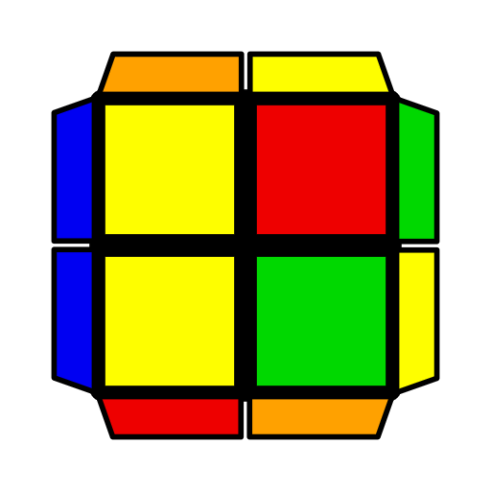 | 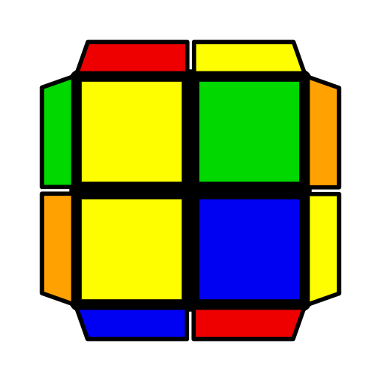 | 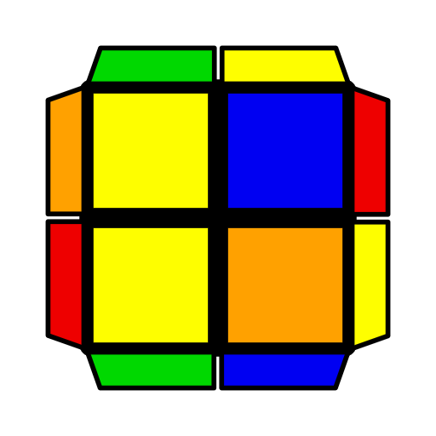 | 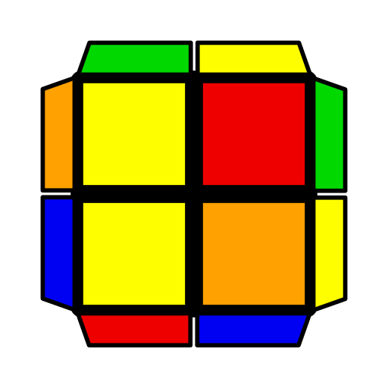
(R U' R' U2)  R U2' R'  U2 (R U' R' U') (R U' R' U2) R U' R' | y U' F' (R' F2 R F') (R' F R2 U' R') | U R U' R' F' U' F  (R' F R F')  (U R U' R') | (R U' R' U) (R U2' R') (F R' F' R) | U2 (R U R' U)  (R U R2' F R F')  y' (R2' F R F')  (R U R' U R) | U (R U2 R' F R F') R U R2'

2x2 TCLL- Algorithms
Hammer
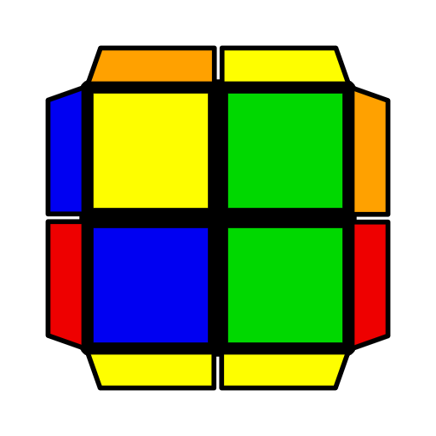 | 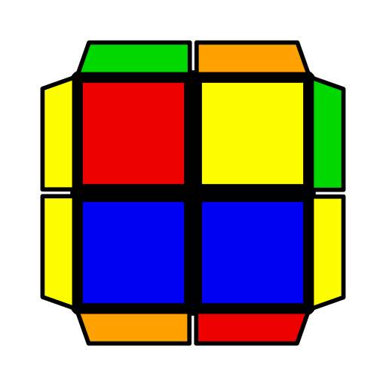 | 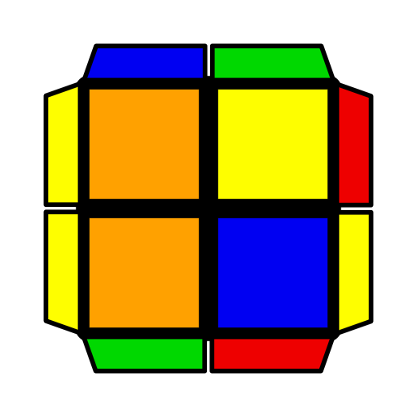 | 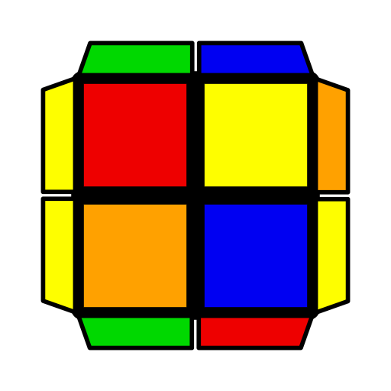 | 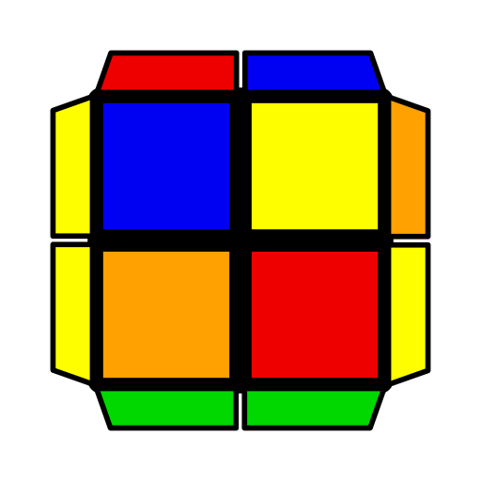 | 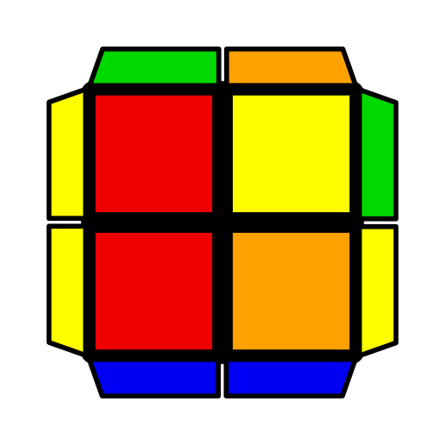
(F R' F' R)2 | U' (R U2' R' D)  R' U R | U' (R2' F R F')  (R U2' R' U' R) | U' R U R' (F R' F' R) (U' R U2' R') | U' F (R U R' U')  (R' F' R2 U R') | (R U' R U' R')  (F R' F' R) U' R'
Spaceship
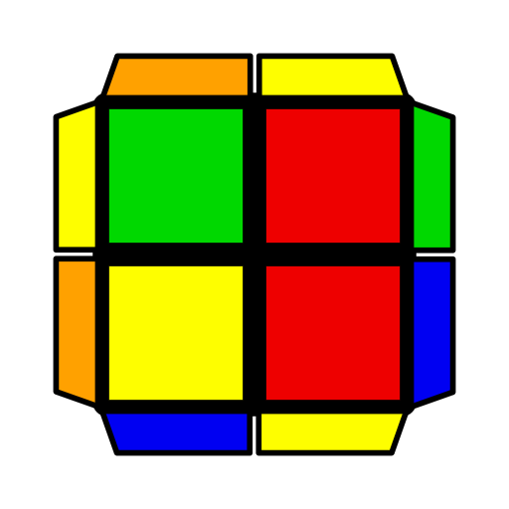 | 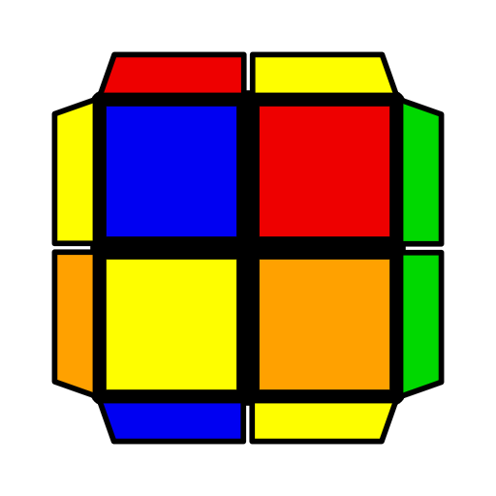 | 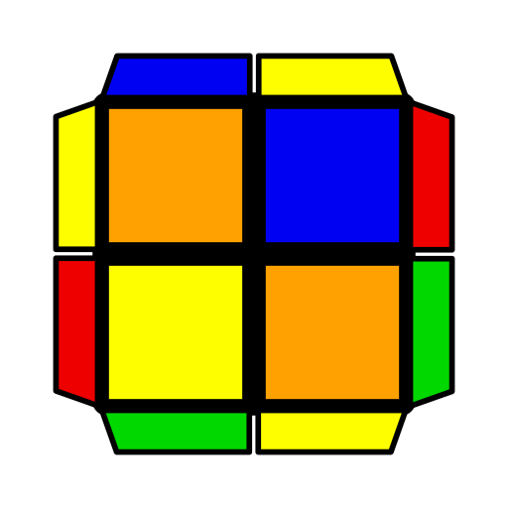 | 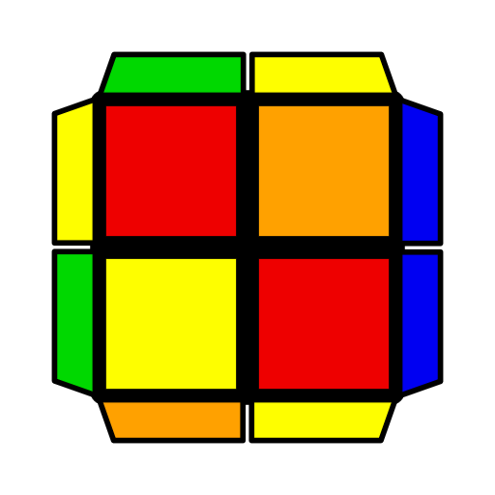 | 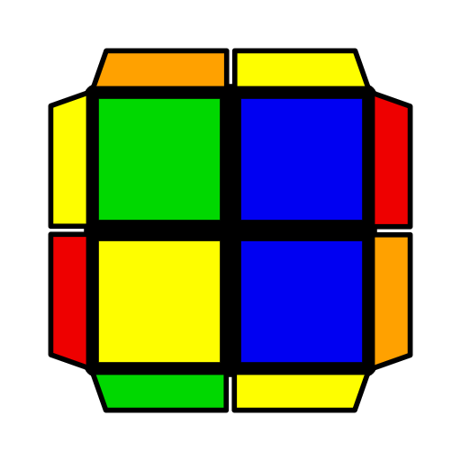 | 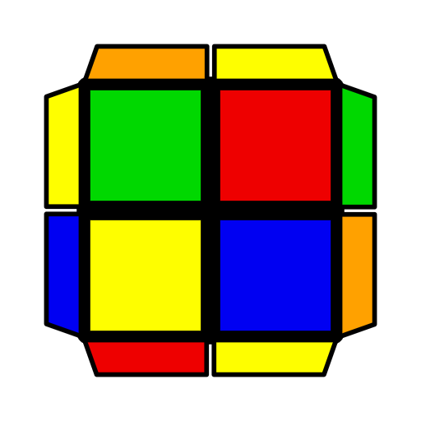
(R U R' U') R U R' | U2 F (R U R' U')  (R' F' R) (F R' F' R) | U2 (R U R' U' F)  (R' F R U) R' F R | y U (R' F R2 U' R' U') (R' F R F) | U F2 (R U' R' U2)  R' F R | (R U R' U' F) (R' F2 R U') R' F2 R
Stollery
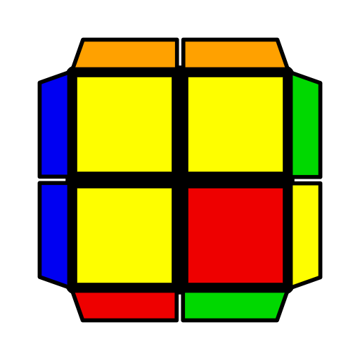 | 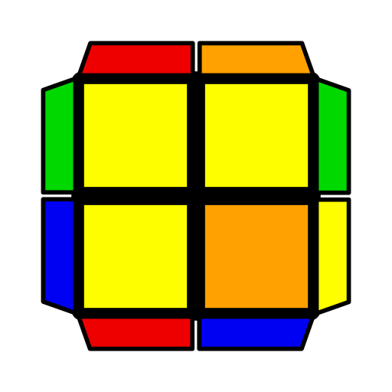 | 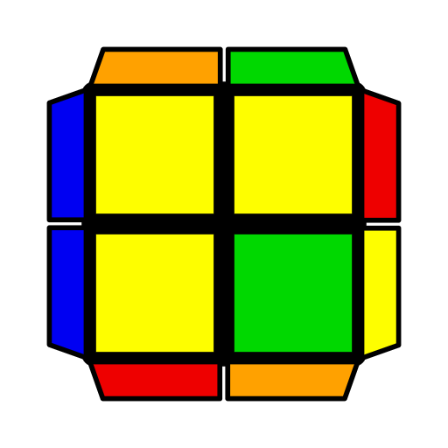 | 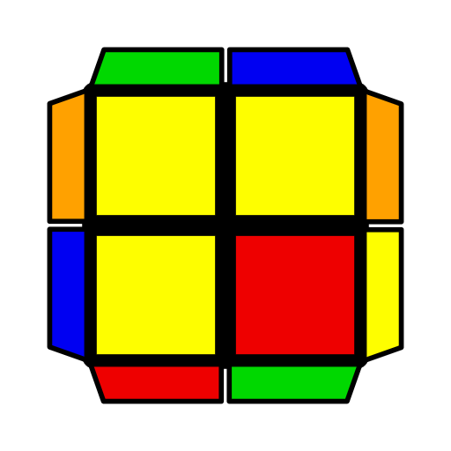 | 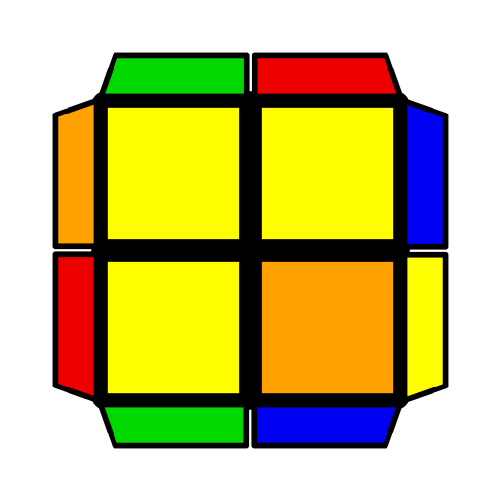 | 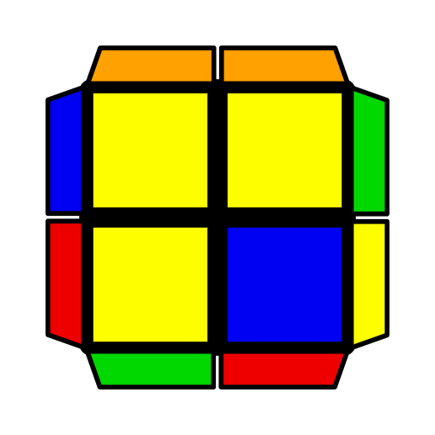
U2 (F2 R U R' F)  (U' R U' R') | (F2 R U2 R' F)  (U R' F' R) | (F R' F' U) (R2 U R2' U' R) | (R' F R U) (R U' R' F') R U' R' | (L U L' U2' L F2')  L F' L2 | U' (F R' F' R) U'  (R U R' U) R U R'
Pinwheel
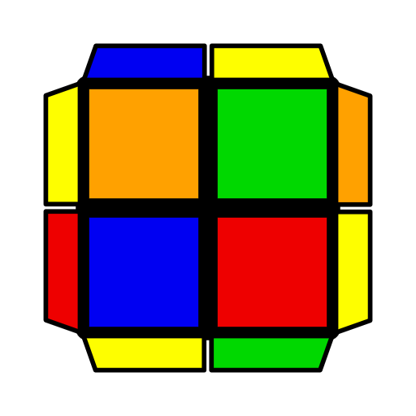 | 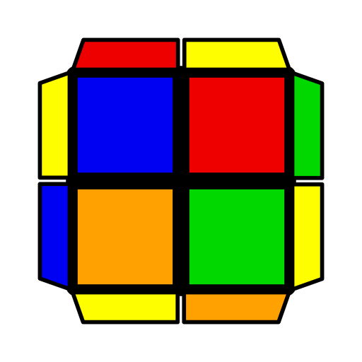 | 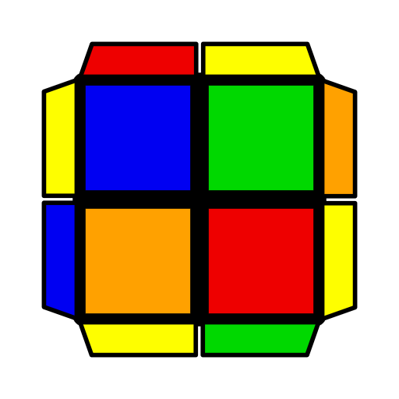 |  | 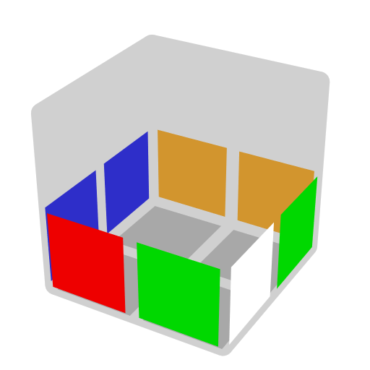
F U' F' (R U' R2' F2' R U' F) | (R' U2 R' U2')  (R2 F R' F' R') | y (R U R' U) (R U R') F2 U F'
Faces
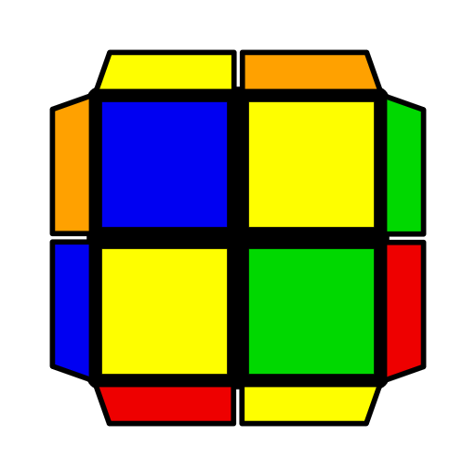 | 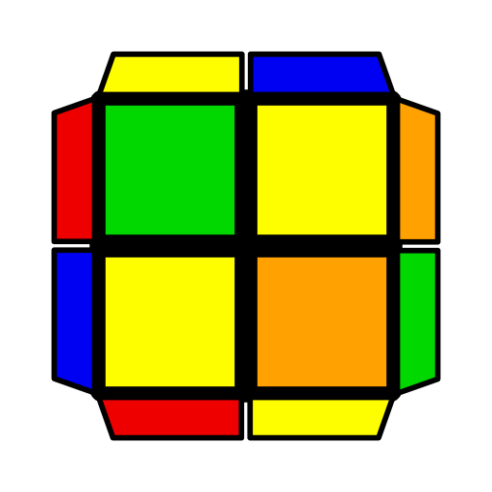 | 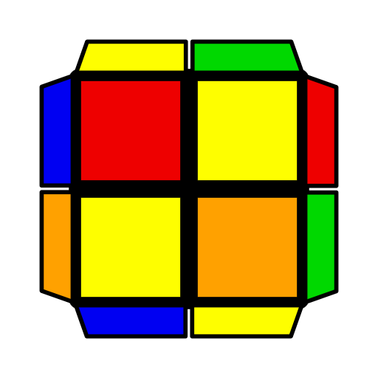 | 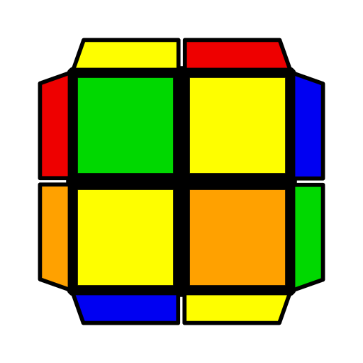
(R2 U R' U) (R U2' R' U2 R') | y2 L U2 L F' L' F L' | U F' (R' F R F)  (U' R U R') | U' (R' F R F')  (R U2' R' U') R U R'
Turtle
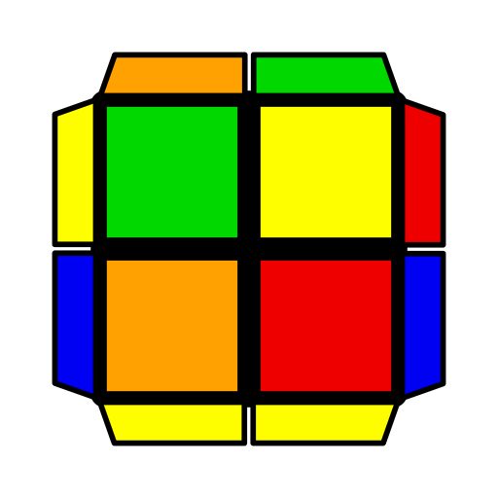 | 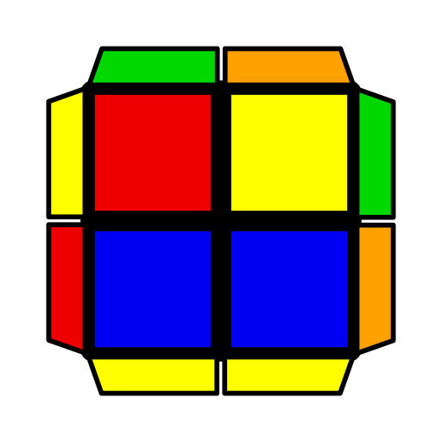 | 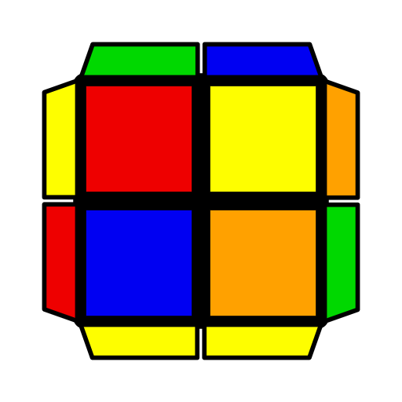 | 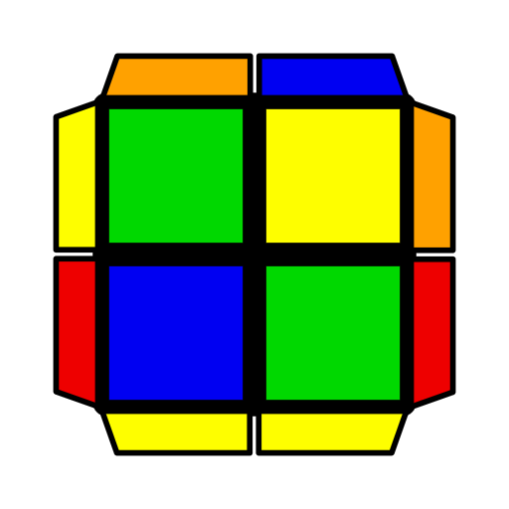 | 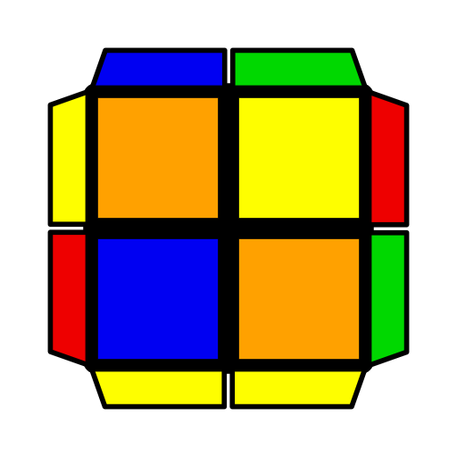 | 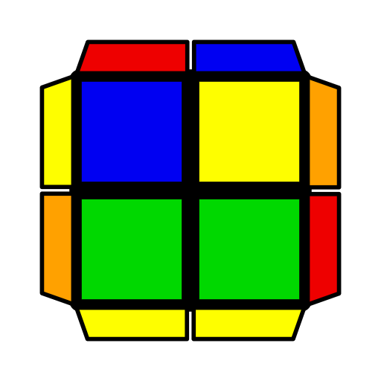
y U' (R' F R U')  R' F R | y' U (R' U R U') (R2' F R F')  (R U' R' U2 R) | U F R F' (R U R2' U') R U R' | U (R U R' U)  F' U2' F | U' (R U2' R' U2)  (F R' F' R) | (R U' R' U2)  (R U R2' F R F')
Poser
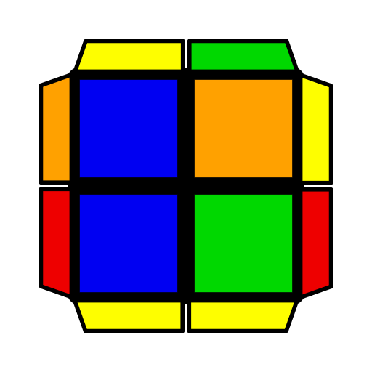 | 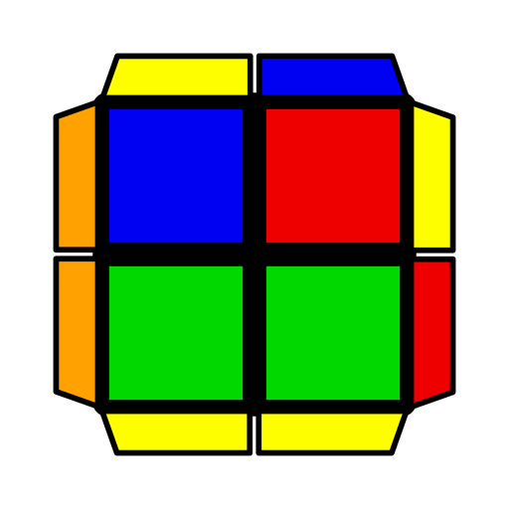 | 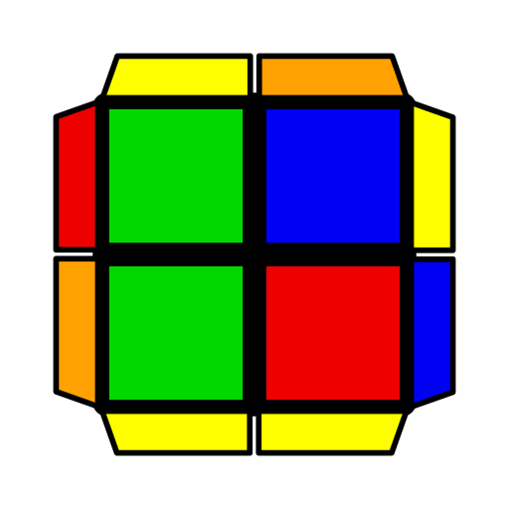 | 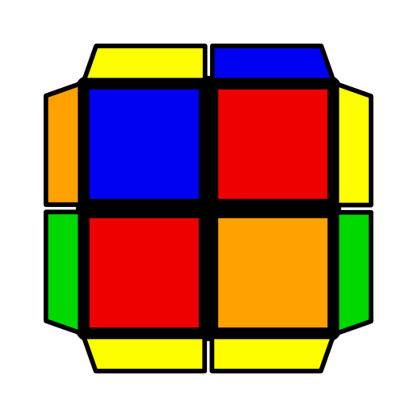 | 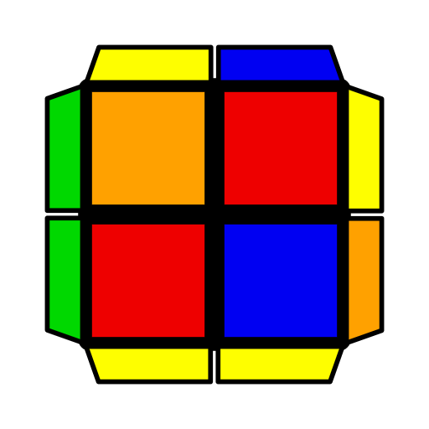 | 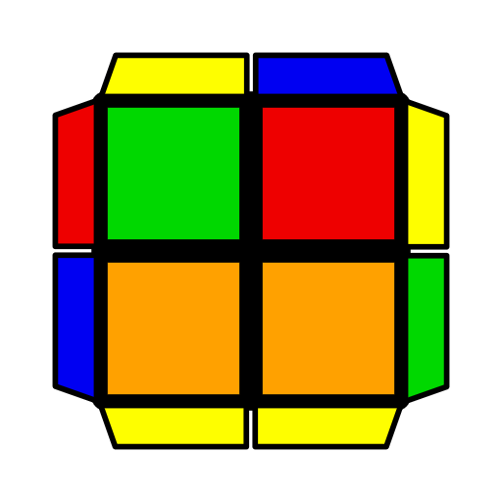
y F (R U' R' F) (R U2' R' U) R U' R' | U F U (R U' R2' F' R) (F R' F' R) | y U' R' F R2 U' R' F | U F R' F' R2 U R' | U (R U R') (F R' F' R) (U2 R U' R') | F' R' F2 R U' F
Gun
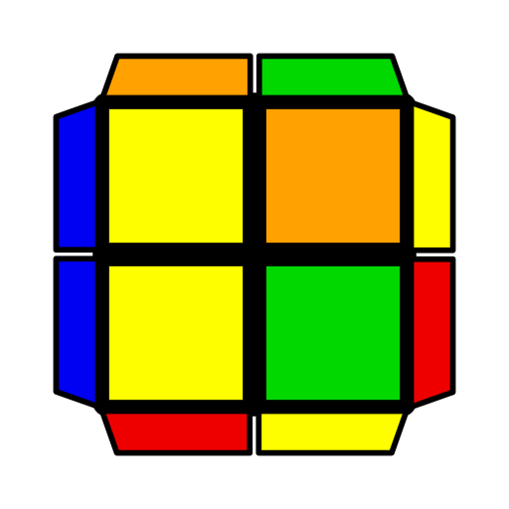 | 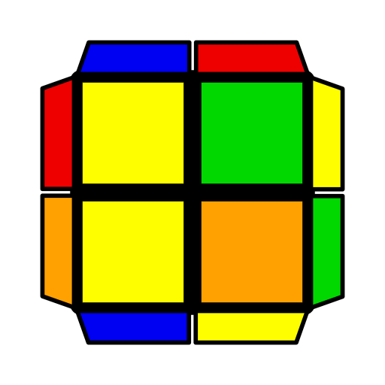 | 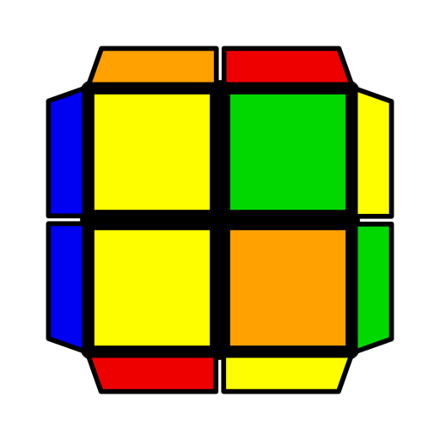 | 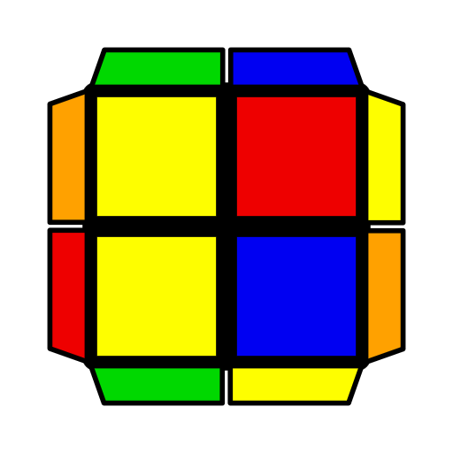 | 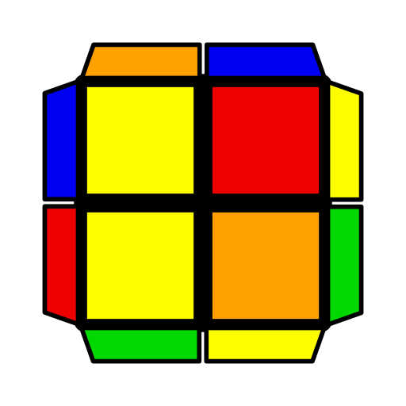 | 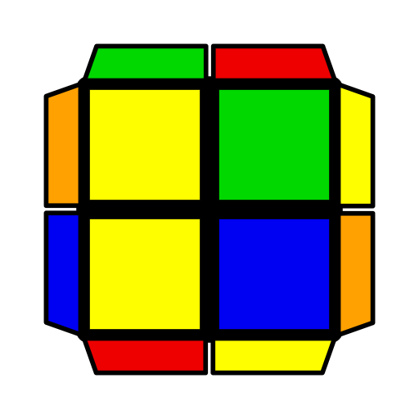
U (R U2' R' U2)  R U R' | y U' (R U R2' F' R F) (R' F2 R F) | U (R U R' U')  (F R' F' R) | U2 (F R' F' R2 U' R' U') R U' R' | y' U' R' (F R' F' R) U2 R | R2 U (R' F R F')  R' U' R

