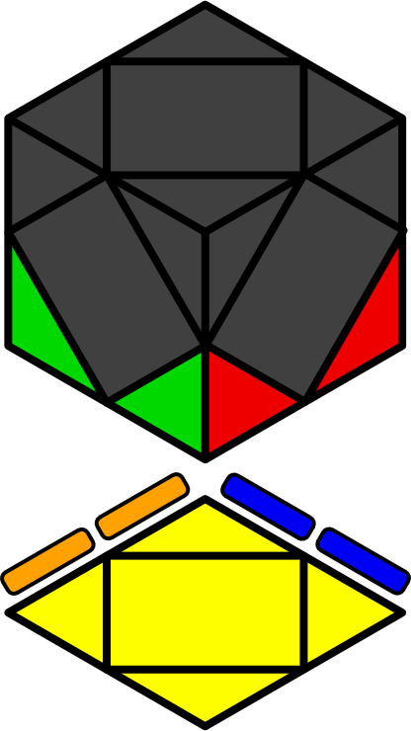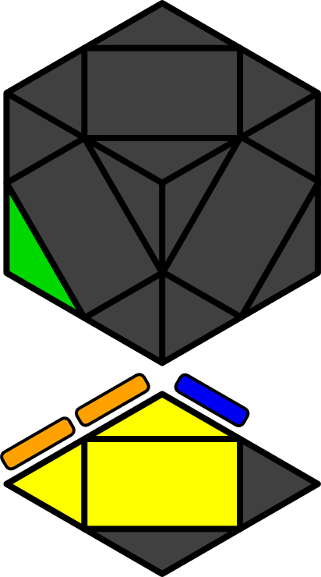**Skewb FL Algorithms (First Layer)**

FL that have least 2 solved corners on D [72] = 1-mover [2] + 2-mover [7] + 3-mover [13] + 4-mover [18] + 5-mover [23] + 6-mover [9]. Learn intuitively.

|  |  |  |  |  |  |  |  |
| --- | --- | --- | --- | --- | --- | --- | --- |
|  |  |  |  |  |  |  |  |
| **x r' R' r R** | **x R' r' R r** | **y' x R r' R'** | **x R r' R r** | **x R'** | **y' x r' R r' R'** | **x R** | **x r' R r** |
|  |  |  |  |  |  |  |  |
| **x R' r R r'** | **x r R' r R r** | **x r' R' r R r'** | **x R' r R r** | **x r R' r R** | **x R' r R** | **x r R' r R r'** | **x r' R' r R r** |
|  |  |  |  |  |  |  |  |
| **x r' R' r' R r'** | **x r R' r' R** | **x r R' r' R' r'** | **x R' r' R** | **x r' R' r' R r** | **x R' r' R r'** | **x r R' r' R r** | **x r' R' r' R** |
|  |  |  |  |  |  |  |  |
| **x R r R r' R'** | **x R' r R' r'** | **x R r'** | **x R' r' R'** | **y x B R**  **r' R r** | **x r R' r**  **R r' R** | **y x B r' R r** | **x R r** |
|  |  |  |  |  |  |  |  |
| **x R' r R r' R** | **y x R' B**  **r' R r** | **x r' R r**  **R r' R'** | **x R' r' R**  **r' R r** | **x r' R** | **x r' R r'** | **x R' r R**  **r' R r** | **x r' R' r' R'** |
|  |  |  |  |  |  |  |  |
| **x r R r'** | **x r R' r' R'** | **x r' R' r**  **R r' R** | **x r' R r**  **R' r' R** | **x r2' R r** | **x r R** | **x R r R'**  **r R r'** | **x R r' R'**  **r R r** |
|  |  |  |  |  |  |  |  |
| **x r R r' R** | **x R' r R' r' R** | **x R r' R** | **x R' r' R'**  **r' R r** | **x r' R r' R r** | **x r R r' R r** | **x r' R r' R** | **x R' r'**  **R' r' R** |
|  |  |  |  |  |  |  |  |
| **x r R r R r** | **x R r R' r' R'** | **x R r R r** | **x R' r R' r R** | **y' x b'**  **R r' R'** | **x R r R** | **x r' R r R r** | **y x r' R r B'** |
|  |  |  |  |  |  |  |  |
| **x R' r R r' R'** | **x r R' r'** | **y x B' R**  **r' R r** | **x R' r'** | **x r' R'** | **x R' r**  x r R' | **x R' r'**  **R r' R'** | **x r' R' r'** |