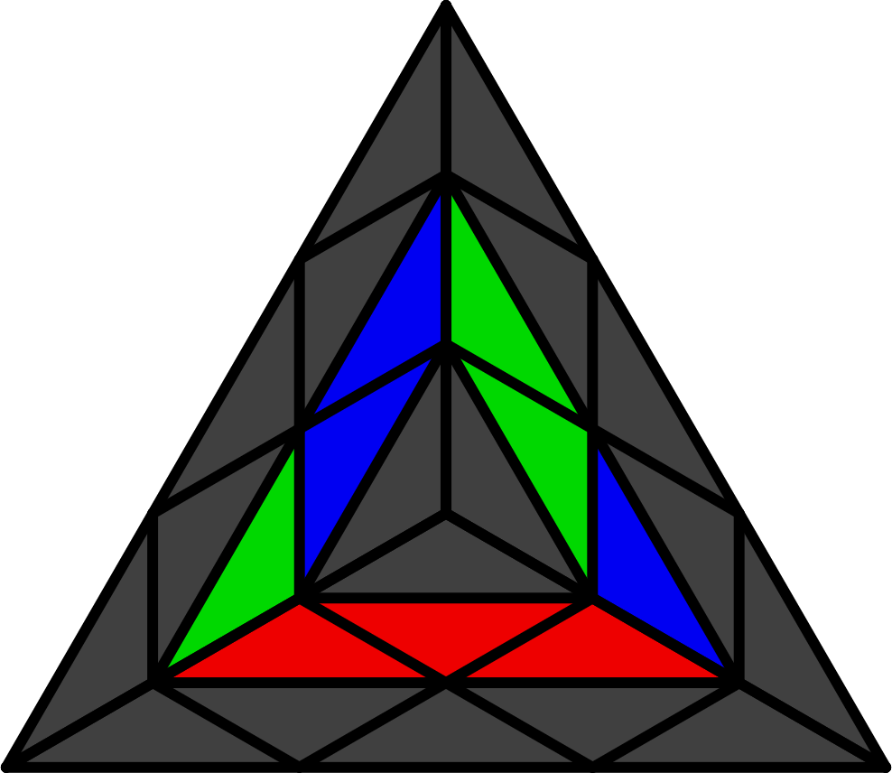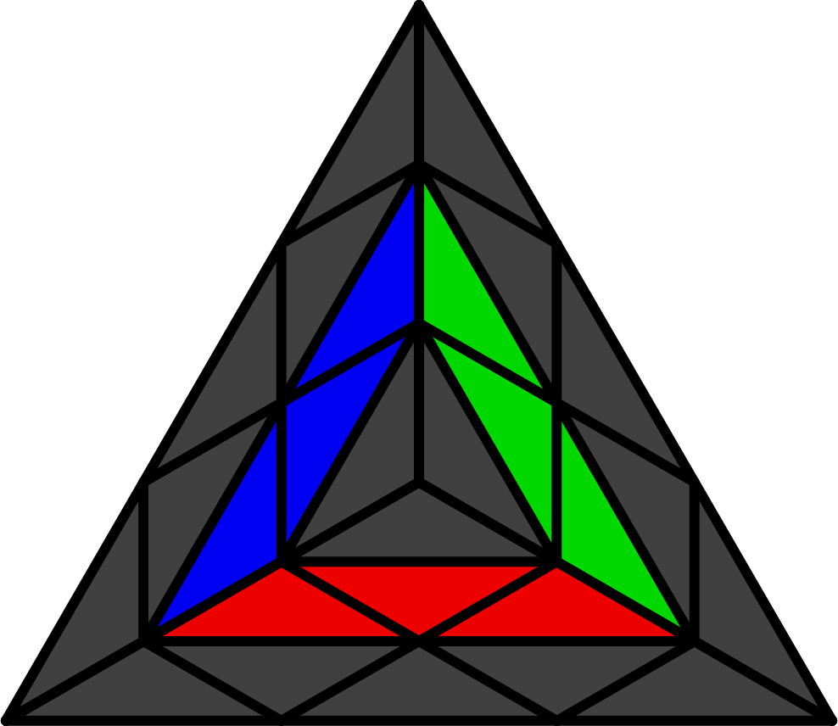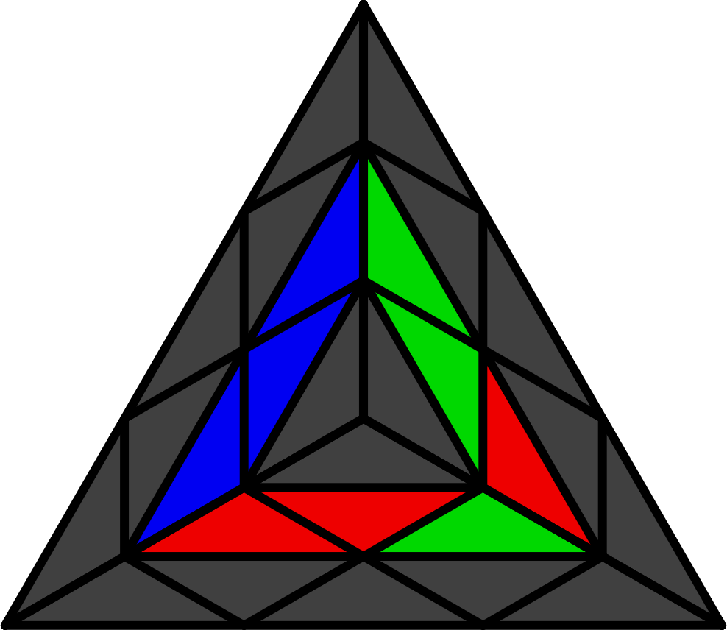**Pyraminx 1-Flip, WO, Nutella Methods**

Learn intuitively. Learn multi-angle algs.

**Centers**

S = R' L R L', H = L R' L' R.

|  |  |  |  |  |  |
| --- | --- | --- | --- | --- | --- |
| **1-Flip** | | | | | |
|  |  |  |  |  |  |
| **Start** | **H (L' U L)** | **R' U (R L R' L')** | **L U' (L' R' L R)** | **R' Dw R**  **(L' R' L R)** | **L R (L R' U' R)** |
|  |  |  |  |  |  |
| **R' U L'** | **L U' R** | **R' U' B U' L'** | **L U B' U R** | **R' U' B' U' L'** | **L U B U R** |
|  | | | | | |
| **WO (Wedel-Odder)** | | | | | |
|  |  |  |  |  |  |
| **Start** | **Solved** | **R' L' R' L R** | **L R L R' L'** | **R L (R L R' L' R)** | **S R' L2 R'** |
|  |  |  |  |  |  |
| **R' L R' L' R L'** | **L R' L R L' R** | **R' Dw R Dw R'** | **L Dw' L' Dw' L** | L R' L2' Dw  (L U L) | R' L R2 Dw'  (R' U' R') |
|  |  |  |  |  |  |
| **Nutella** | | | | | |
|  |  |  |  |  |  |
| **Start** | **S (R L R' L')** | **R' L R L2'** | **L R' L' R2** | L' R' L R' L R | L R L' R L' R' |
|  |  |  |  |  |  |
| **R' U' y' L R' L'** | **L U y R' L R** | **R' L' R2 Dw' R'** | **L R L2' Dw L** | **L' Dw' R' L'** | **R Dw L R** |

**ELL**

See ELL in keyhole method.