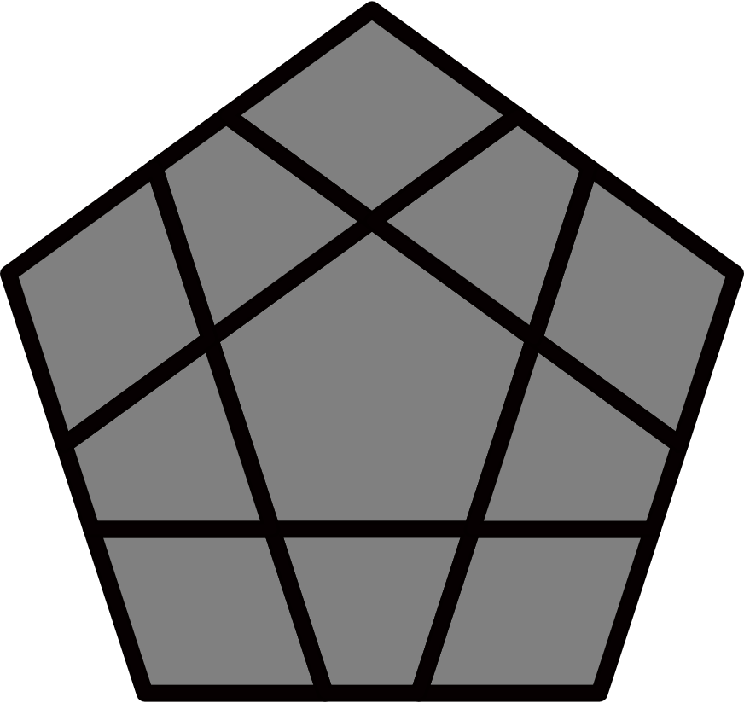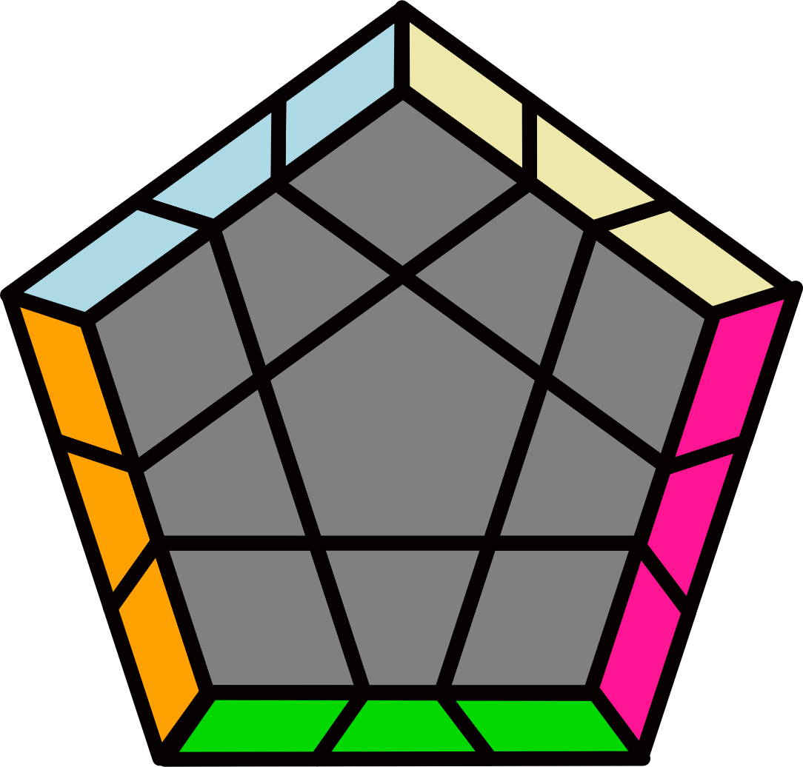**Megaminx PLL Algorithms**

Algorithms from James Macdiarmid [http://bit.ly/2BfW2w6](http://docs.google.com/spreadsheets/d/1lVODoMORbDdVXwTG4RUZPWCSrx8uPx2bvwvXg5tuQYE)

CPLL are not included. B=BR, D=DR. 3x3 PLL or PLL inverse.

|  |  |  |  |  |  |  |  |  |  |  |  |  |  |  |
| --- | --- | --- | --- | --- | --- | --- | --- | --- | --- | --- | --- | --- | --- | --- |
| **Mushroom** | | | **Horseface** | | | | | **Bunny** | | | **Sunny** | | | **Checker** |
| **M+** | **M-** | | | **H+** | | **H-** | | | **B** | | **S** | | **X** | |
| **3/4/5EP [11]** | | | | | | | | | | | | | | |
| **M+** | | **M-** | | | | | **H+** | | | | | **H-** | | |
| **(R' U' R U') (R U R2' U)**  **R U' R U' R'** | | **(R U R' U R' U' R2 U' R' U R' U R)** | | | | | **(R' U2' R U') (R U R2' U)**  **(R U' R U') R' U2 R' U R** | | | | | **(R U2 R' U) (R' U' R2 U') (R' U R' U) R U2' R U' R'** | | |
| **B** | | | | | **S** | | | | | **X** | | | | |
| **L U2' L' y' R' L' U2 L U R**  **y R L U2' R' U L'** | | | | | **(R U2 R2' F R F' R U2')**  **y (R U' R' U' R U R' F')** | | | | | **(R U R' U R' U' R2 U' R' U R' U R) U' (R U R' U R' U' R2 U' R' U R' U R)** | | | | |
| **M+** | | **M-** | | | | | **H+** | | | | | **H-** | | |
| **(R2 U2 R2' U R2 U2 R2') U' (R2 U2 R2' U R2 U2 R2')** | | **(R2' U2' R2 U' R2' U2' R2) U (R2' U2' R2 U' R2' U2' R2)** | | | | | **(R' U2' R U' R' U2' R2)**  **(U2' R' U' R U2' R')** | | | | | **(R U2' R' U' R U2' R') U2' (R' U2' R U' R' U2' R)** | | |
| **2 Lines, 2 Blocks, Line + Block [4]** | | | | | | | | | | | | | | |
|  | |  | | | | |  | | | | |  | | |
| **(R U R' U2') R' U2' (R U R' U) (R2 U' R' U2) (R U' R' U) R U' R'** | | **(R' U' R U2') (R2' U2' R2 U) (R' U2' R' U2') R U2 R** | | | | | **(R U2 R' U') (R U R' U)**  **(R U2' R' U2) R U2 R'** | | | | | **R' U2' (R U R' U') (R U' R' U2) (R U2' R' U2' R)** | | |
|  | | | | | | |  | | | | |  | | |
| **J Perm [6]** | | | | | | | **(R U R' F' R U R' U' R' F R2 U' R')** | | | | | **(R' U L' U2' R U' R' U2 R L)** | | |
|  | |  | | | | |  | | | | |  | | |
| **(R' U' R U' R U R2' U R U') F' (R U R' U' R' F R2 U' R')** | | **(R U2 R' U2') (R U' R' U') R' U2' (R U R' U) R2 U R'** | | | | | **(R U R2' F' R U R U' R' F) (U R' U' R2 U' R' U R' U R)** | | | | | **(R U' R2' U') (R U' R' U2) (R U R U) (R' U2 R U2' R')** | | |
|  | | | | | | |  | | | | |  | | |
| **Line + T/R Perm or Bar [10]** | | | | | | | **R2 U2 R2' U R2 U2 R2'** | | | | | **R2' U2' R2 U' R2' U2' R2** | | |
|  | |  | | | | |  | | | | |  | | |
| **(R U R' U2) (R' U2' R2 U') R' U R' U2 R** | | **(R' U' R U2') (R U2 R2' U) R U' R U2' R'** | | | | | **(R' U2' R U') (R U R2' U2) R U2' R U' R'** | | | | | **(R U2 R' U) (R' U' R2 U2') R' U2 R' U R** | | |
|  | |  | | | | |  | | | | |  | | |
| **(R U R' U) (R2 U2' R2' U2') (R U2 R U2) R' U2' R'** | | **(R' U' R U') (R2' U2 R2 U2) (R' U2' R' U2') R U2 R** | | | | | **(R U2 R U2') (R' U2' R' U2) (R2 U2 R2' U') R U' R'** | | | | | **(R' U2' R' U2) (R U2 R U2') (R2' U2' R2 U) R' U R** | | |
|  | | | | | | |  | | | | |  | | |
| **Block + 2/1 Bars [10]** | | | | | | | **(F R U' R' U' R U R' F' R U R' U' R' F R F')** | | | | | **(F R' F' R) (U R U' R') F (R U' R' U) (R U R' F')** | | |
|  | |  | | | | |  | | | | |  | | |
| **(R' U2 R' D') (R U' R' D)**  **R U R U' R' U' R** | | **R U (R2 U' R' U') (R U R' U') R' U (R2' U R U' R)** | | | | | **R U2 (R2' F R F') (R U' R' F') U F R U' R'** | | | | | **R' U' (R2' U R U) (R' U' R U) R U' (R2 U' R' U R')** | | |
|  | |  | | | | |  | | | | |  | | |
| **(R U' R U) (R2' U R' U')**  **(R' U R U') (R' U' R2 U R)** | | **(R' U R' U') (R2 U' R U)**  **(R U' R' U) (R U R2' U' R')** | | | | | **R' U (R U R' U') R' D'**  **(R U R' D) R U2' R** | | | | | **(R U' R' F) U (R U' R' F')**  **(R U R') (F' U' F) (R U R')** | | |
| **5 Bars [4]** | | | | | | | | | | | | | | |
| **H+** | | **B** | | | | | **H-** | | | | | **B** | | |
| **(R U2 R' F') (R U R' U') (R' F R2 U2' R')** [H-: U' alg] | | **(R L U2 L' U R' L U' R U2 L' U2 R')** | | | | | **(R' U2 R' U2') (R U' R' U2') R U2 R** [H+: U alg] | | | | | **(R' L' U2' R U' L R' U L' U2' R U2' L)** | | |
|  | | | | | | |  | | | | | | | |
| **4/3 Bars [5]** | | | | | | | **(R U R' U' R' F R2 U' R' U' R U R' F')** | | | | | | | |
|  | |  | | | | |  | | | | |  | | |
| **(R U R' F' R U R' U' R' F R U' R' F R2 U' R' U' R U R' F')** | | **(R' U' R U2') (R2' U2' R2 U') (R2' U2' R2 U) R' U R** | | | | | **R2 U B2' U (R2' U R2 U') B2 U2' R2'** | | | | | **R2' U' F2 U' (R2 U' R2' U) F2' U2 R2** | | |
| **R Perms [4]** | | | | | | | | | | | | | | |
|  | | **B** | | | | |  | | | | | **B** | | |
| **R' U2' (R2 U R' U')**  **(R' U2 R U R U' R')** | | **R2 U R2' U2 R U2' (R U R' U') (R U' R2' U2) R U R'** | | | | | **R U2 (R2' U' R U)**  **(R U2' R' U' R' U R)** | | | | | **R2' U' R2 U2' R' U2 (R' U' R U) (R' U R2 U2') R' U' R** | | |
| **R Perm + Bar [8]** | | | | | | | | | | | | | | |
|  | |  | | | | |  | | | | |  | | |
| **(R' U2 R U') (R2' U2 R2 U) (R' U' R' U2') R U' R** | | **y2 (R2 U2 R2' U R2 U2 R2') U2' (R2 U2' R2' U' R2 U2' R2')** | | | | | **y' (R' U' R U) (R' U R2 U) (R' U R U) (R' U' R' U') R2 U' R'** | | | | | **(R' U R' U2) (R U R U')**  **(R2' U2' R2 U) R' U2' R** | | |
|  | |  | | | | |  | | | | |  | | |
| **y2' (R U2' R' U) (R2 U2' R2' U') (R U R U2) R' U R'** | | **(R2 U2' R2' U' R2 U2' R2') U2 (R2 U2 R2' U R2 U2 R2')** | | | | | **y2' (R U R' U') (R U' R2' U') (R U' R' U') (R U R U) R2' U R** | | | | | **y2 (R U' R U2') (R' U' R' U) (R2 U2 R2' U') R U2 R'** | | |
|  | | | | | | |  | | | | |  | | |
| **Y/T Perm [6]** | | | | | | | **R2' U2' R2 U2 R2' U' R2 U2 R2' U2' R2** | | | | | **R2 U2 R2' U2' R2 U R2' U2' R2 U2 R2'** | | |
|  | |  | | | | |  | | | | |  | | |
| **(R' U2' R U2 R' F R U R' U' R' F' R2)** | | **(R2' F R U) (R U' R' F')**  **(R U2' R' U2 R)** | | | | | **(R2 U2 R2' U) (R2 U' R2' U) R2 U2 R2'** | | | | | **(R2 U2' R2' U') (R2 U R2' U') R2 U2' R2'** | | |
| **Adj Bars [12]** | | | | | | | | | | | | | | |
| **H+** | | **H-** | | | | | **H** | | | | | **S** | | |
| **y2' B (R U R' U) (R U R' U') (R U' R' U') B' (U2' R U2 R')** | | **y (R2' U2' R2 U' R2' U2' R2) U' (R2 U2 R2' U R2 U2 R2')** | | | | | **y' (R U2 R' U2) (R' U2' R2 U') (R' U R' U2) (R U2 R U' R')** | | | | | **y' (R U' R' U2) (R2 U R' U2) (R U' R' U') (R U' R' U' R')** | | |
| **B** | | **M** | | | | | **H+** | | | | | **H-** | | |
| **y (R2' U2 R2 U) (R2' U' R2 U2') (R2' U' R2 U2) R2' U2' R2** | | **(R U2 R' U2) (R U2 R U2) (R' U R' U') (R2 U2' R' U' R')** | | | | | **(R' U2' R U2') (R U2 R2' U) (R U' R U2') (R' U2' R' U R)** | | | | | **(R' U R U2') (R2' U' R U2') (R' U R U) (R' U R U R)** | | |
| **H** | | **S** | | | | | **B** | | | | | **X** | | |
| **(R U R' U) (R' U2' R2 U) (R2' U R2 U2) (R' U' R U2' R')** | | **y2' (R2 U2 R2' U R2 U2 R2') U (R2' U2' R2 U' R2' U2' R2)** | | | | | **y2' (R2 U2' R2' U') (R2 U R2' U2) (R2 U R2' U2') R2 U2 R2'** | | | | | **y' (R' U2' R U2') (R' U2' R' U2') (R U' R U) (R2' U2 R U R)** | | |
| **Opp Bars [12]** | | | | | | | | | | | | | | |
|  | |  | | | | |  | | | | |  | | |
| **(R' U' R2 U') (R2' U2 R U) (R U2' R U) (R2' U2 R2 U2 R2')** | | **(R2 U2' R2' U2') (R2 U' R' U2) (R' U' R' U2') (R2 U R2' U R)** | | | | | **y' (R2' U2' R2 U' R2' U2' R2) U (R2 U2 R2' U R2 U2 R2')** | | | | | **y2' (R U R' U2 R U2 R') U'**  **(R' U' R U' R' U2 R)** | | |
| **S** | | **X** | | | | |  | | | | |  | | |
| **y (R U R U) (R' U R U) (R' U2' R U') (R2' U2' R U R')** | | **y2 (R U R U2) (R2' U R U') (R U2' R' U2') (R' U2' R U2' R')** | | | | | **(R U R2' U) (R2 U2' R' U') (R' U2 R' U') (R2 U2' R2' U2' R2)** | | | | | **(R2' U2 R2 U2) (R2' U R U2') (R U R U2) (R2' U' R2 U' R')** | | |
| **M-** | | **M+** | | | | |  | | | | |  | | |
| **y2 (R' U' R U2' R' U2' R) U**  **(R U R' U R U2' R')** | | **y' (R U2 R' U) B' (U R U' R' U') B (R U2' R')** | | | | | **y' (R' U' R' U') (R U' R' U') (R U2 R' U) (R2 U2 R' U' R)** | | | | | **y (R2 U2 R2' U R2 U2 R2') U' (R2 U2' R2' U' R2 U2' R2')** | | |
| **R Perm [8]** | | | | | | | | | | | | | | |
|  | |  | | | | |  | | | | |  | | |
| **(L F R' F' L' F) (R2 U R' U R U2' R') F'** | | **F (R U2 R' U' R U' R2')**  **F' L F R F' L'** | | | | | **y' (F R U R' U' F')**  **(L F R U' R' U F' L')** | | | | | **y2' (L F U' R U R' F' L')**  **(F U R U' R' F')** | | |
|  | |  | | | | |  | | | | |  | | |
| **(R' U' R' F) (R U R U') R' y' (R2' U' R U') R' U2 R B** | | **(R' F' U' F U R) U**  **(R' U' F R' F' R U R)** | | | | | **(R' U' R2 U') (R2' U2 R U) (R U2' R U) (R2' U R2 U2' R2')** | | | | | **y2 (R' U' R' F R F' U R) U' (R' U' F' U F R)** | | |
| **Bar + Lights [4]** | | | | | | | | | | | | | | |
|  | |  | | | | |  | | | | |  | | |
| **(R U2' R' U') (R U2' R2' U2) L U' R U L' R' U2' R** | | **(R' U2 R2 U2') (R' U2 R' U) (R U2 R' U) (R2 U2 R2' U2' R)** | | | | | **F U2' (R' U' R F') (R' U' R F) U' (R' U2' R U2) F'** | | | | | **(R U2' R2' U2) (R U2' R U') (R' U2' R U') (R2' U2' R2 U2 R')** | | |
| **Bar [12]** | | | | | | | | | | | | | | |
| **H+** | | **H-** | | | | | **M+** | | | | | **M-** | | |
| **(R2' U2 R2 U) R2' F2 U' (R2 U R2' U) F2' U R2** | | **R2' U' F2 U' (R2 U' R2' U) F2' (R2 U' R2' U2' R2)** | | | | | **(R U2 R' U') (R2 U R' U) (R U2' R' U) (R' U R U2 R')** | | | | | **(R U2' R' U') (R U' R U2) (R' U' R U') (R2' U R U2' R')** | | |
| **X** | | **X** | | | | | **H+** | | | | | **H-** | | |
| **(R2 B2' R2' U') (R2 B2 R2' U2) (R2 B2' R2' U') R2 B2 R2'** | | **R2 U R2' U R2 U2' R2' U2 y' R2' U' R2 U2' R2' U2' R2** | | | | | **R2 U B2' U (R2' U R2 U') B2 (R2' U R2 U2 R2')** | | | | | **(R2 U2' R2' U') R2 B2' U (R2' U' R2 U') B2 U' R2'** | | |
| **M+** | | **M-** | | | | | **X** | | | | | **X** | | |
| **(R' U2 R U) (R' U R' U2') (R U R' U) (R2 U' R' U2 R)** | | **(R' U2' R U) (R2' U' R U') (R' U2 R U') (R U' R' U2' R)** | | | | | **(R2' F2 R2 U') (R2' F2' R2 U2) (R2' F2 R2 U') R2' F2' R2** | | | | | **R2' U' R2 U' R2' U2 R2 U2' y R2 U R2' U2 R2 U2 R2'** | | |
|  | | | | | | |  | | | | | **H** | | |
| **Lights [10]** | | | | | | | **y (R U R' U' R' F R2 U' R' U' R U R' F') U2' (R U R' U' R' F R2 U' R' U' R U R' F')** | | | | | **y' (R' U2 R U) (R' U R U') (R' U2 R U') (R U R' U) R U2' R'** | | |
|  | |  | | | | |  | | | | |  | | |
| **(R U R U) (R' U R' U) (R U' R U2') (R' U2' R' U') R U2 R'** | | **y2' (R U2' R' U) (R U2 R U2) (R' U R' U') (R U' R U')**  **R' U' R'** | | | | | **F U2' F' U2' R F R' U' R F' U2' R' U' R U2' R'** | | | | | **y2' (R U R' U') (R' U2 R U) (R U R2' U) (R U' R U) (R' U' R U2' R')** | | |
|  | |  | | | | |  | | | | |  | | |
| **y2' (R' U2' R U) (R' U R2 U2') (R' U' R U) (R' U2' R U' R')** | | **y2 (R U2 R' U') (R U' R2' U2) (R U R' U') (R U2 R' U R)** | | | | | **y2 (R U R' U2) (R U' R' U)**  **(R U2 R2' U') (R U' R' U2 R)** | | | | | **y2' (R' U' R U2') (R' U R U') (R' U2' R2 U) (R' U R U2' R')** | | |
|  | | | | | | |  | | | | |  | | |
| **Others [10]** | | | | | | | **F U2 (R U2' R' U) (R U R' U2') F' (R' U' R U2') R' U2' R** | | | | | **F (R U R' F) U R' U' F' U (R2 U2' R' F')** | | |
|  | |  | | | | |  | | | | |  | | |
| **(R' U2 R' U') (R2 U' R' U') (R U R' U) (R' U R2 U')**  **R' U2' R** | | **(R U2' R U) (R2' U R U)**  **(R' U' R U') (R U' R2' U)**  **R U2 R'** | | | | | **(R' U R U2) (R' U2 R U) (R2' U' R U') (R' U' R U2)**  **R' U R2** | | | | | **(R2' U' R U2') (R' U R U) (R' U R2 U') (R' U2' R U2') R' U' R** | | |
|  | |  | | | | |  | | | | |  | | |
| **(R' U' R2 U') (R' U R U') (R2' U' R2 U) (R' U' R U) R2' U2 R** | | **(R2 U R2' U) (R U2' R' U) (R' U2' R U) (R' U R2 U)**  **R U' R2'** | | | | | **R U R' y (R2' U2' R2 U') (R2' U2 R2 F) (R2' U R2 U2') F'** | | | | | **R' U' R y' (R2 U2 R2' U) (R2 U2' R2' B') U B U' R2 U' R2'** | | |