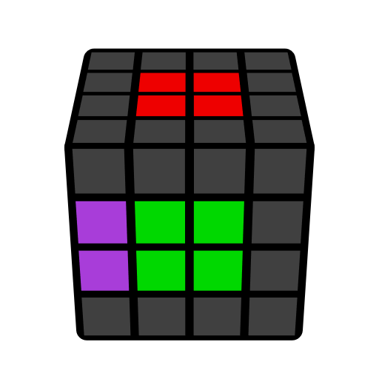**4x4 L2C Algorithms (Last Two Centers)**

r, 3r, 2L-gen. Learn intuitively. Immovable, basic.

|  |  |  |  |
| --- | --- | --- | --- |
|  |  |  |  |
| **r U' r'** | **r U r'** | **2L' U r** | **2L' U' r** |
|  |  |  |  |
| **r U2' r'** | **(r U' r' U) r U2' r'** | **3r r' U2 r** | **(r U' r' U) 2L' U2 r** |
|  |  |  |  |
| **r U' r2' 3r U r** | **(r U' r' U) 2L' U r** | **r U r2' 3r U' r** | **(r U r' U') 2L' U' r** |
|  |  |  |  |
| **(r U' r' U') 2L' U' r** | **r U' r2') 3r U' r** | **r U r2' 3r U r** | **(r U r' U) 2L' U r** |
|  |  |  |  |
| **r U2' r2' 3r U r** | **r U' r2' 3r U2 r** | **r U2' r2' 3r U2 r** | **Solved** |