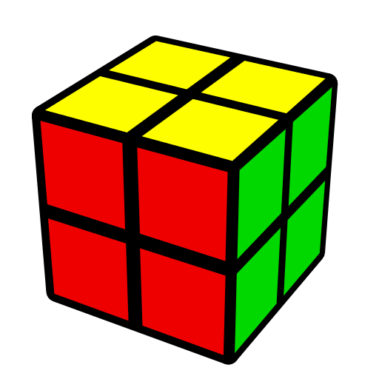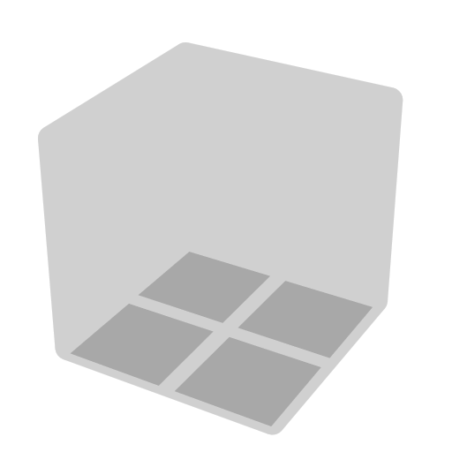**2x2 EG Methods (Erik-Gunnar)**

Algs from Chris Olson http://cyotheking.com, Will Callan <http://bit.ly/2lQXlxe>, Jack Pan http://bit.ly/2nCwwyc

|  |  |  |
| --- | --- | --- |
| **Face** | **EG** | **AUF** |

|  |  |  |  |  |  |  |
| --- | --- | --- | --- | --- | --- | --- |
| **Intermediate** | | | | | | |
| **CLL** | | **EG1** | | | **EG2** | |
|  | | | | | | |
| **Advanced** | | | | | | |
| **LEG** | | **TCLL+** | | | **TCLL-** | |
|  | | | | | | |
| **Supplement** | | | | | | |
| **LS1** | **LS2** | | **LS3** | **TEG2+** | | **TEG2-** |

Special finger trick: In F' U', use right index to execute F'.

**Predict D Layer**

|  |  |
| --- | --- |
|  |  |
| **Matched Color Side** | **Opposite Color Side** |

2 matched color side => CLL; 2 opposite color side => EG2; Other cases => EG1, and the opposite side of opposite color side is matched color side.

**Predict AUF (Adjust U Face)**

After doing alg, U layer will follow the image below (exceptions exist), then AUF can be recognized by comparing U layer to D layer.

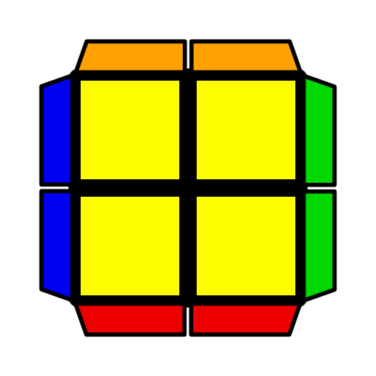

**Examples**

|  |  |  |
| --- | --- | --- |
|  |  |  |
| **R' U' R2 U R' U2 R U2' R' U R'**  Pick FUR sticker as AUF sticker. After doing alg, it will be front. | **R U2 R U' R' F R' F2 U' F**  Pick UFL sticker as AUF sticker. After doing alg, it will be front. | **R U R' U R U2' R'**  Pick FUL sticker as AUF sticker. After doing alg, it will be back. |

**2x2 CLL Algorithms**

|  |  |  |  |  |  |
| --- | --- | --- | --- | --- | --- |
| **1** | **2** | **3** | **4** | **5** | **6** |
| **H** |  |  |  |  | |
| **R2 U2 R U2' R2'**  R2 U2' R' U2 R2 | **R U' R' (F R' F' R2 U' R') (F R' F' R)**  (R' F R F') (R U R2' F R F') R U R' | **(R U R' U R U R')**  **(F R' F' R)**  U2 (L' U' L U' L' U' L) (F' R U R') | **F (R2 U' R2' U')**  **(R2 U R2') F'**  U2 (F R' F' R) U' (R U' R' U) (R' F R F') | Mirror. Start thumb from back, right (left) thumb and midfinger always pinch the initial DR (DL) piece *. | |
| **Pi** |  |  |  |  |  |
| **R U' R2' U R2 U R2' U' R**  R' U R2 U' R2' U' R2 U R'  F (R U R' U')2 F' | **R' U' (R' F R F')**  **(R U' R' U2 R)** | **(R' F R F') (R U' R' U') R U' R'**  U2 (R U' R' F) (L' U L U) L' U L | **(R U' R U') (R' U R' F) R2 F'**  (F R' F' R) U' (R U R' U) (R' F R F')  U2 F (R2 U' R2' U)  (R2 U R2' F') | **(R U2' R' U') (R U R' U2') (R' F R F')**  U F' (R U R' U2') (R' F R F') R' F2 R | **(L' U2 L U) (L' U' L U2) (R U' R' F)**  U' (F R' F' R) U2 (R U' R' U) R U2' R' |
| **U** |  |  |  |  |  |
| **F (R U R' U') F'**  R' U' (F R' F' R) U R  U2 F (U R U' R') F'  U2 R' U' (R' F R F')  U R | **(R' U' R2 U) (R' U2 R U2') R' U R'**  U' (R' F R F')2 (R U R' U') R U R'  U2 R2' F2 (R U R' F)  (U' R U R2) | **(R U2 R U' R' F)**  **R' F2 U' F**  U' (F R U R' U2 F')  (R U' R' F)  z' U2 R' U' (R2 U' R' U') R U' R' | **(F R' F' R) U' (R U' R' U2) R U' R'**  U2 (F' R U R') U (L' U L U2) L' U L  U2 (R U R' U) (R U' R U') (R' F R' F') | **(R U' R2' F R F')**  **(R U R' U') R U R'** | **(R' F R2 U' R' F)**  **(R' F' R U) R' F' R** |
| **T** |  |  |  |  |  |
| **(R U R' U') (R' F R F')**  U2 (F' L' F L')  (U' L U L) | **(L' U' L U) (R U' R' F)**  U2 (F R F' R)  (U R' U' R')  U2 F R F' (U' R' U' R) | **(R U2' R2' F R F')**  **(R U' R' U) R U2' R'**  U2 (L' U2 L2 F' L' F) (L' U L U') L' U2 L  U' F U' (R U2 R' U')  (F2 R U R') | **(R U' R' U) (R U' R')**  **(F R' F' R)2**  U2 (R' U R' U2') (R U2 R' U) R2 U' R'  (R' U R U2') (R2' F' R U') R' F2 R2 | **(R U R' U2') (R U R' U) (R' F R F')**  U2 (L' U' L U2) (L' U' L U') (R U' R' F)  U F (R U R' U') (R U' R' U') (R U R' F')  U' (R U2' R' U)2  (R' F R F') | **(R' U R U2')**  **(R2' F R F' R)**  (L U' L' U2)  (L2 F' L' F L')  U' (R U2 R' U') R2 U' R' F R' F' |
| **L** |  |  |  |  |  |
| **F' (R U R' U') R' F R**  U' F (R U' R' U')  (R U R' F')  U2 (R U R U')  (R' F R' F') | **(F R' F' R) (U R U' R')**  U2 (L' U' L' U)  (L F' L F) | **(R U2' R2' F R F')**  **R U2' R'**  U2 (L' U2 L2 F' L' F)  L' U2 L  U' R U2' R' (F R' F' R2 U2' R') | **R2' U' (R U2' R' U2)**  **R U' R2'**  (R' U R' U2') (R U' R' U) R U' R2  U (R2 U R' U2)  (R U2' R' U R2) | **(R U' R' U) (R U' R')**  **(F R' F' R2 U R')**  U (R U R' U') (R' F R2 F') (U' R' U' R)  U' L F (L' U' L U) (L F' L2 U L U2 L') | **R' F' (R U R' U') (R' F R2 U' R' U2 R)**  U (R U R2' F') (R U R U') (R2 F' R F)  U' (L' U L U') (L' U L) (F' L F L2' U' L) |
| **S** |  |  |  |  |  |
| **R U R' U R U2' R'**  U' R' U2' R U R' U R | **R' F R2 F' U' R' U'**  **R2 U R' \*** | **(F R' F' R)**  **(U2 R U2' R')** | **R U' R' (F R' F' R)** | **(R' F' R2 U R' F')**  **(R' F R2 U' R')** | **(L' U2 L U2)**  **(R U' R' F)** |
| **AS** |  |  |  |  |  |
| **R' U' R U' R' U2 R**  U R U2' R' U' R U' R' | **L F' L2 F U L U**  **L2 U' L \*** | **(F' R U R')**  **(U2' L' U2 L)** | **(R' F R F') R U R'** | **(R U R2' F' R F)**  **(R U' R2' F R)** | **(R U2' R' U2)**  **(R' F R F')** |

**2x2 EG1 Algorithms**

|  |  |  |  |  |  |
| --- | --- | --- | --- | --- | --- |
| **1** | **2** | **3** | **4** | **5** | **6** |
| **H** |  |  |  |  | |
| **R' F (R2 U' R2' U')**  **F U R** | **F' U (R U' R2' F2)**  **R U' F** | **(R' U' R' F2) U F' R F'**  U2 (L U L F2)  U' F L' F  U (R' F R F') U2  (F R U2' R' F) | **(R U R' F') (R U R' U') R U R'** | [R] denotes putting D-bar in DR. Mirror. | |
| **Pi** |  |  |  |  |  |
| **R2 B2 (R' U R' U')**  **(R U2 R U' R2')**  F2 (R U R' U2')  (R U R' U' F) | **R' F R2 U' R2' F R**  R U R2' F' R2 U R' | **F R' F U' (F2 R U R)** | **(R U' R' U) (R U' R' F)**  **R U' R'**  (R' F R U') (R' F R F') R' F R  F' (R U R' U') (R U R' F') R U R' | **(R U R' U) (R U' R2' F' R) (F R' F' R)**  U2 F U' (R U2 R' F')  (R U R' F')  U (R U' R2' F R U) (R U' R' U') (R' F R F') | **(R' F R F') (R' F R2 U R' U') R U' R'**  U F (R U' R' F)  (R U2' R' U) F' |
| **U** |  |  |  |  |  |
| **(R U' R2' F) (R2 U R' U') R U' R'**  (L' U L2 F') (L2' U' L U) L' U L  (R U R' U) (R U R2' F R2 U' R') | **(R U' R' U) (R U' R' F) (R U2' R') (F R' F' R)**  U2 (R' F R U') (R' F R F') (R' F2 R F') R U R'  [R] U2 (R' U R' U')  (R U' R' U') F2 R2 | **(R U' R2' F2 R F')**  **(U R U R')**  U2 F' U2 (R U2' R' U2) F | **(R' F R F') (R' F R2 U' R')**  U2 (R U' R' F)  (R U' R2 F R) | **(R U' R' U) (R U' R' U') (F R U' R')**  (L F' L2 U L)  (D' L' U' L) | **(R' F R2 U' R')**  **(D R U R')**  (L' U L U') (L' U L U) (F' L' U L) |
| **T** |  |  |  |  |  |
| **F (R U' R2' F' R U) R' F' R**  U' (R U' R2' F) (R2 U R' U2) (R' F R F') | **F' (R' F R2 U R' U')**  **R U R'**  U (R U' R' U2) (R U2' R' F) R U' R' | **(R U' R2' F) (R U R U2' R')**  U2 (R' F R2 U' R' U') R' F2 R | **(R U R2' F' R F R' F') (R2 U' R' F R' F' R)**  U R2 B2 U' (R' U' R U') R' U R' | **(R U R2' F' R)**  **(F R' F' R)**  U2 (R' F' R2 U R')  (F' R U R') | **(R U' R' U2)**  **(F R U2' R' F)**  U (R U R' F)2  (U' R U' R') |
| **L** |  |  |  |  |  |
| **(R U' R' U) (R U' R2' F' R F)**  U (R U R' F') (R U2' R' U2) R U R' | **(R' F R U') (R' F R2 U R' F')**  U (R' F R F') (R' F R U) R U2' R' | **R' U (R2 U' R2' U')**  **(F R2 U' R')** | **(R' F R2 U R')**  **(F' R U2' R')**  U (R' F2 R F')  (R' F R2 U R') | **(R U R' F') (R U R' U') (F R' F' R)**  U F' (R' F R U') (R U R' U' R U R') | **(R' F' R F) (R' F' R U) (F' R U R')**  U R' U2' F (R U2 R U' R2' F) |
| **S** |  |  |  |  |  |
| **B' U L2 F2' U F'**  U' (R U R' U) F R U' R2' F' R | **(R U R') (F2 U F)**  **(R U R')**  U2 F (R2 U' R2' F)  U' F2 U' R | **(F R' F' R) U**  **(R' F' R2 U R')**  U (R' F R U2 R U') (R2' F2 R F') | **F' (R' F R2 U R' U')**  **(F R' F' R)**  U' F' U (R U' R' U)  (F R U R') | **(R U' R' U) (R U' R' U') (R' F' R F)** | **(R' F R2 U' R' U)**  **(R U' R' F)** |
| **AS** |  |  |  |  |  |
| **B U' R2' F2 U' F**  U2 R' F (R2 U R' F')  (U' R U' R') | **(R U' R' F' U')**  **(F2 R U' R')**  U' R U' (F2 R U2 R U' B) | **F' (R U R' U')**  **(R U R2' F' R)** | **F (R U' R2' F' R U)**  **(F' R U R')**  U' (R U' R' F' U')  (R U R' U' F) | **F' (R' F R U) (R U R' U') R U R'**  U2 (R U R' F' U') (R U R' U') R U R' | **(R U' R2' F R U')**  **(R' F R F')** |

**2x2 EG2 Algorithms**

|  |  |  |  |  |  |
| --- | --- | --- | --- | --- | --- |
| **1** | **2** | **3** | **4** | **5** | **6** |
| **H** |  |  |  |  | |
| **(R2' F U2' F2)**  **R2 F' R2'** | **R2 U2 R U2' B2 R2'** | **(R' U' R U2' R2' F' R) U' F R** | **R U2' B2 (R' U R U') B R'** | Anti-CLL [12] (cancelling into R2 B2 R2', etc.), R2 B2 R2', etc. [6] (cancelling into CLL). Start thumb from back. | |
| **Pi** |  |  |  |  |  |
| **F U' (R U2 R U')**  **(R' U R' F')** | **(R' U2' R2 U' R')**  **F2 R2 F'** | **R' F' U (R' F R2 U2' R' U R)** | **(R' F U' R U R')**  **F2 U2' R** | **(L U2' L' U)**  **(L2 F2' L' F' L')**  (R' U' R' F2 R2 U) R') F2 R | **(R' U2 R U')**  **(R2' F2 R F R)** |
| **U** |  |  |  |  |  |
| **(R' U R' F U')**  **(R U' R' U2' R2)** | **(F R U R' U' F)**  **R2 B2** | **(R U R' U' R) B2**  **(R' U R U' R')** | **(R2' F2 R U R U2')**  **(R2' F R F' R)** | **(R U' R' U2) (L U L' U2') R U' R'** | **(L' U L U2') (R' U' R U2) L' U L** |
| **T** |  |  |  |  |  |
| **(F R F' R U R' U')**  **R B2 R2'** | **(R U R' U' R' F R F') R2 B2 R2'** | **(R' U R' F)**  **(U' R U R2)**  U' (R' U R' F) (R2 U2' R' U' R) | **R2' F2 (R U' F R' F' R U R)**  U2 R2 B2 R2' (F R U R' U' F') | **(R' U R U2' R2' F R F') R' F2 R2**  U (R' F2 R U') (R' U  R' F R U' R) | **(R' U2 R' F2 R)**  **F2 R** |
| **L** |  |  |  |  |  |
| **R2 B2 R2' F (R' F'**  **R U R U' R')** | **R2 B2 R2' (F' R U R' U' R' F R)** | **R' U' F2 (R U2 R' U2') F R** | **R' U' (R U R' F') (R U R' U') R' F' R2** | **(F R' F' R U R U')**  **R B2 R2'** | **(F' R U R' U' R' F)**  **R' F2 R2** |
| **S** |  |  |  |  |  |
| **F U' (R2 U' R' U2)**  **(R U' R2' F')** | **R U R' U R U2 R B2 R2'**  U' R' U2 R U R' U R' F2 R2 | **(R U' R' F R' F')**  **R' F2 R2** | **F (R2 F' R2' F')**  **R U' R** | **(L U L' U L U)**  **(L F2' L' F L')**  (R' F R' F2) (R U R U R' U R) | **R2 B2 (R' U' R' F) R' F' R** |
| **AS** |  |  |  |  |  |
| **(R' U R U') (R2' F R F') (R U R' U')**  **R' F2 R2** | **R' U' R U' R' U2 R' F2 R2**  U' R U2 R' U' R U' R B2 R2 | **(R' F R F') (R U R B2 R2')** | **(R' U R' F) (R2 F R2' F')** | **(R' U' R U' R' U') (R' F2 R F' R)** | **R2' F2 R (F R F'**  **R U R')** |