2x2 1-Look

Assume first face is yellow. Most L/R mirror cases are not included. Left image shows the case, right shows prediction by the suggested algorithm. First predict OLL: track any 3 white stickers; Then predict EG: track any 3 non-white stickers on any 3 white pieces. For the cases where all the yellow pieces are in first layer, one can do U move first to make better EG.

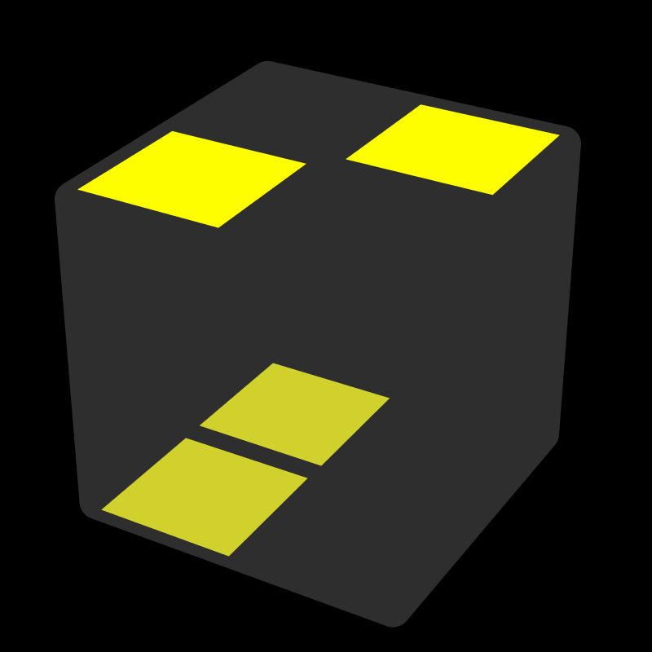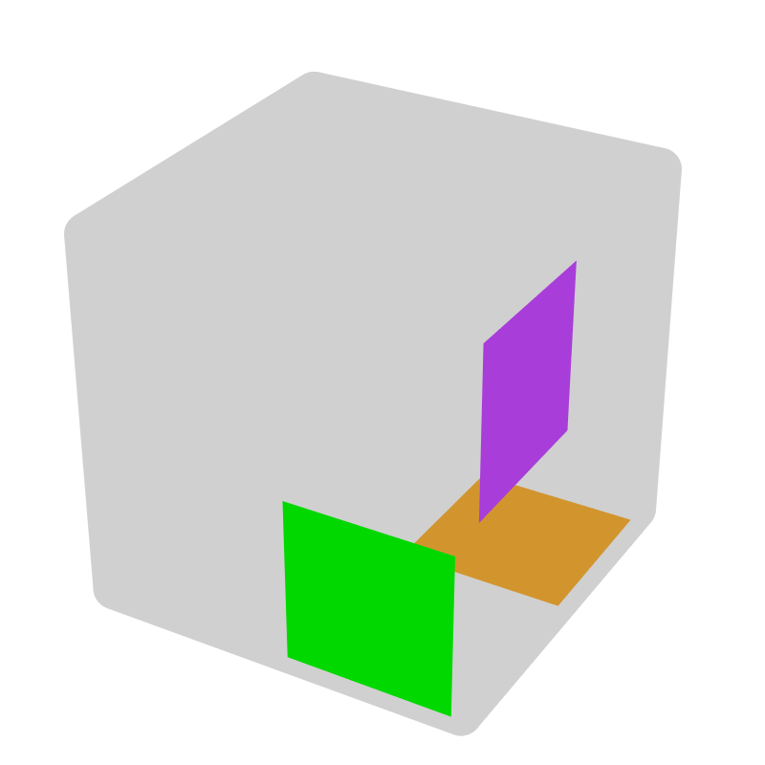* |  | Alg of left image R U R' U R2 moves purple, green, orange pieces in right image by y2 z, y2 z +, y2 z F. Notation: fixed piece, piece by pure rotating, twist piece, piece by 1 or 2 moves, piece by 2 moves. case with 3 relatively fixed piece [8], same case*. + = CW, - = CCW.
R U R' U R2 | y2 z (+, F)
Alternative algorithms

Bar [36]
LS (Last Slot) [5]
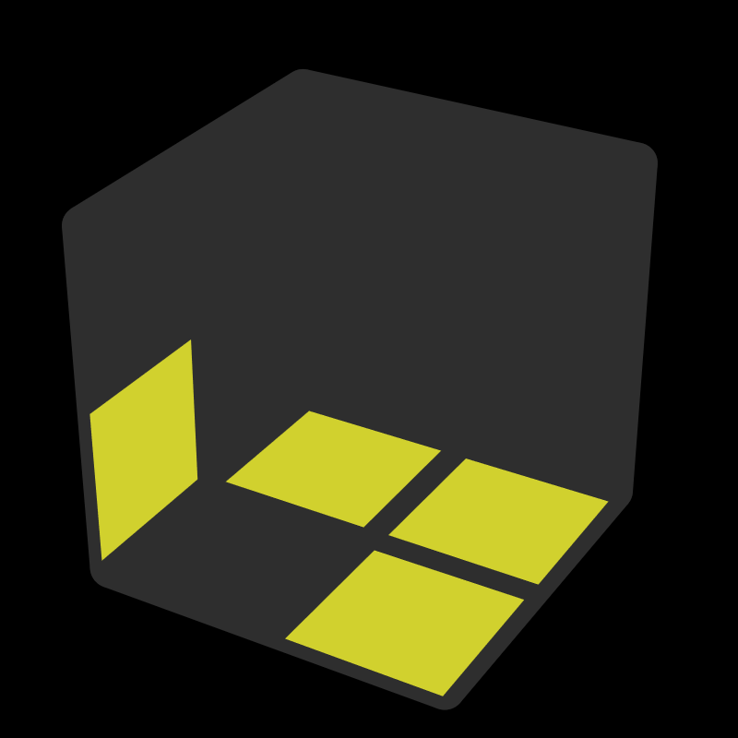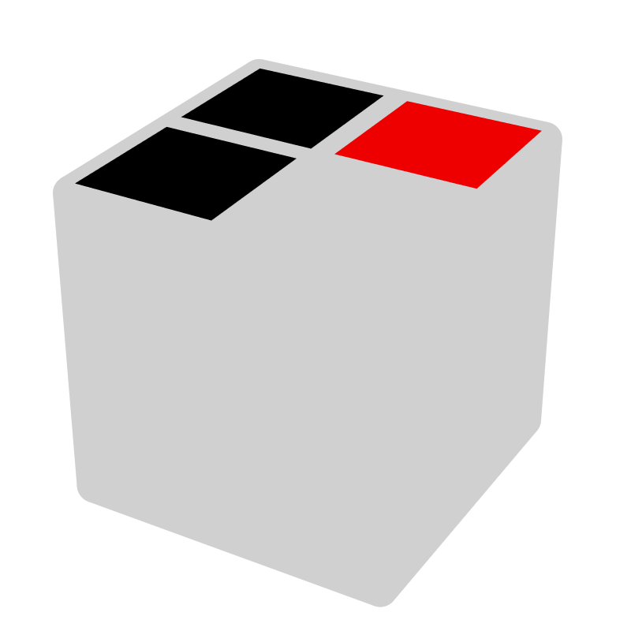 |  |  |  | 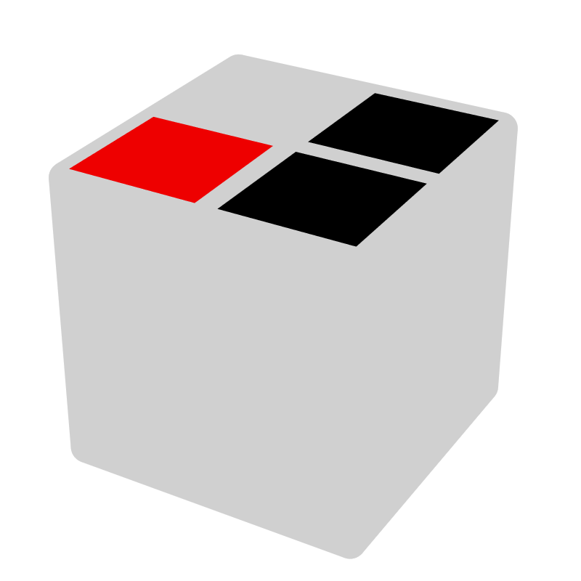* |  |  |  | 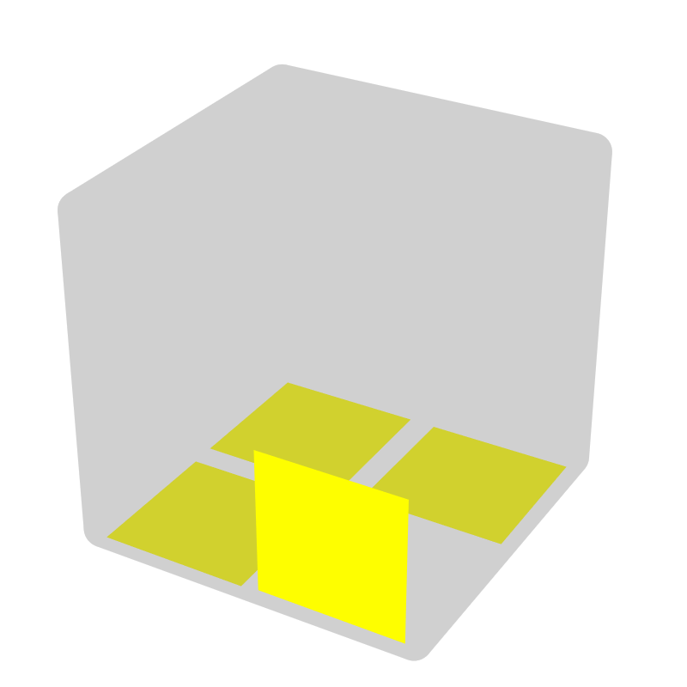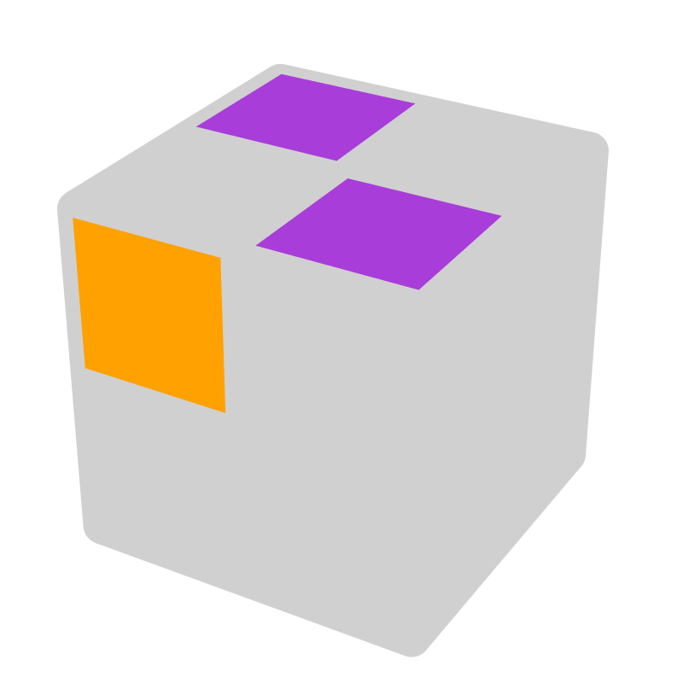*
F' R' F R |  | U |  | R U R' F' |  | U |  | R' U R U R' |  | y F R
= y L' F' L F = y2 z F' R' U R |  |  |  | = y' F R F' R' = y2 z U R U' F'
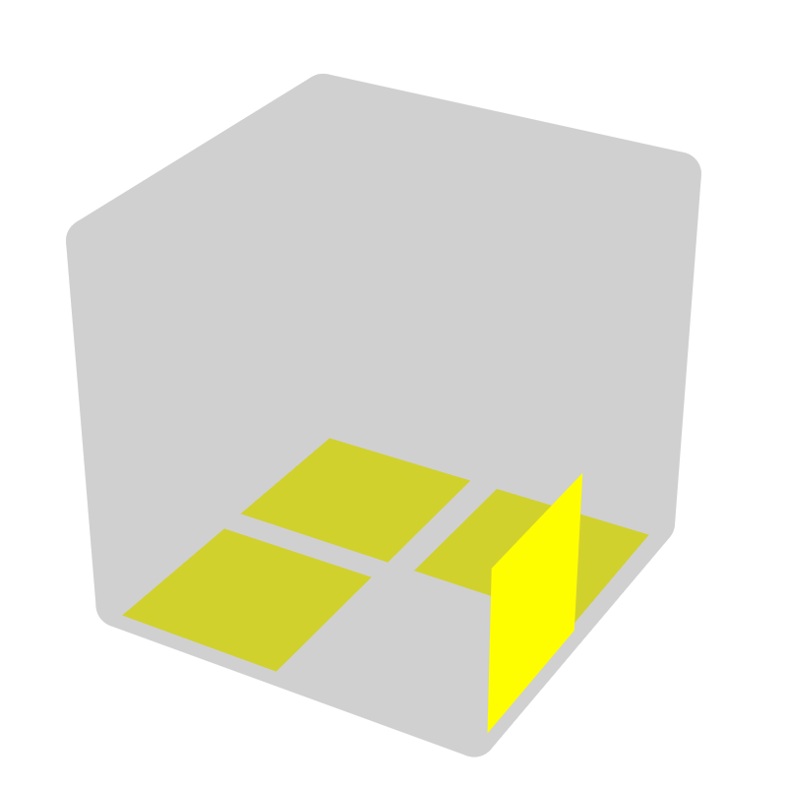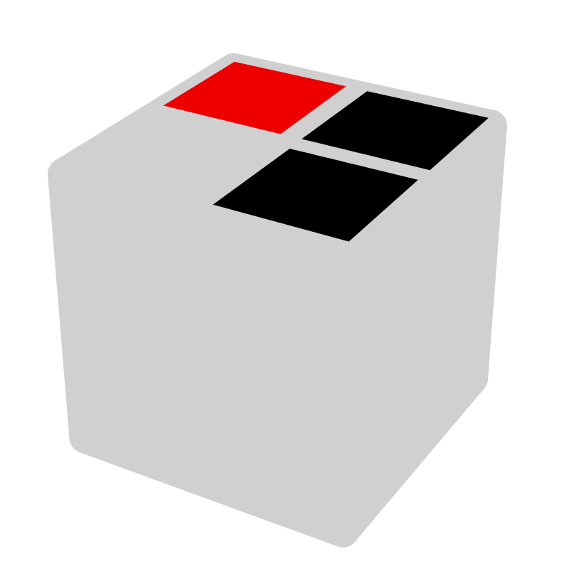 |  |  |  | 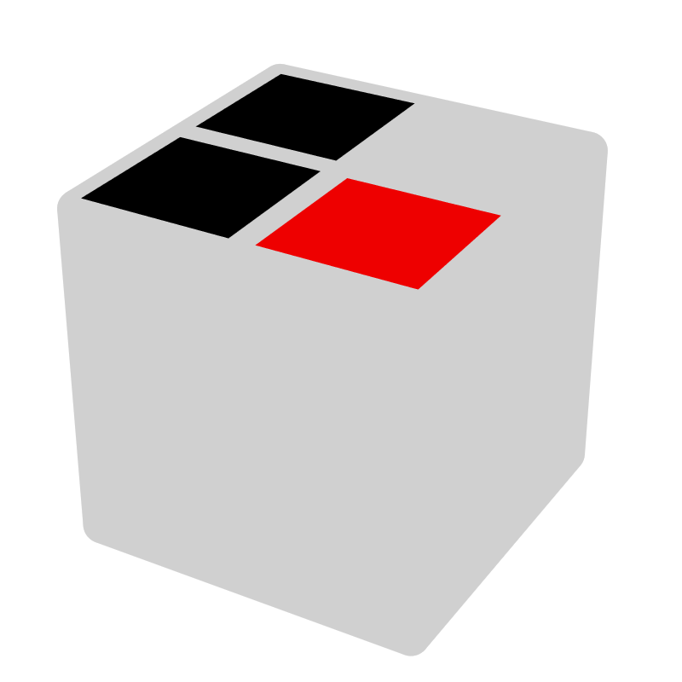* |  |  |  | 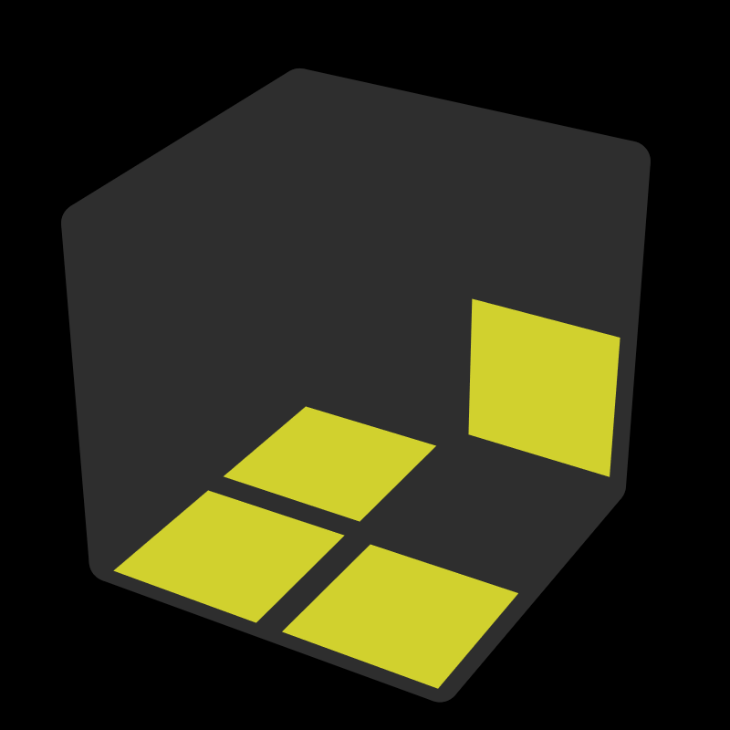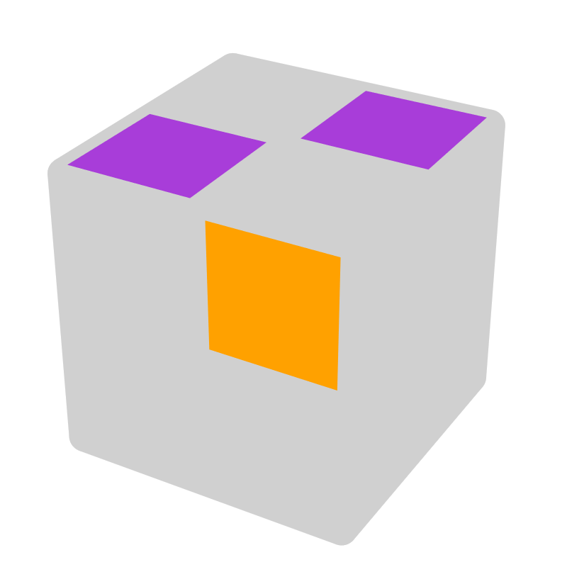*
F R U' R' |  | U' |  | R' F' R F |  | U' |  | R U' R' U' R |  | y' R' F'
= y' R F R' F' = y2 z' F L U' L' |  |  |  | = y F' L' F L = y2 z' U' L' U F
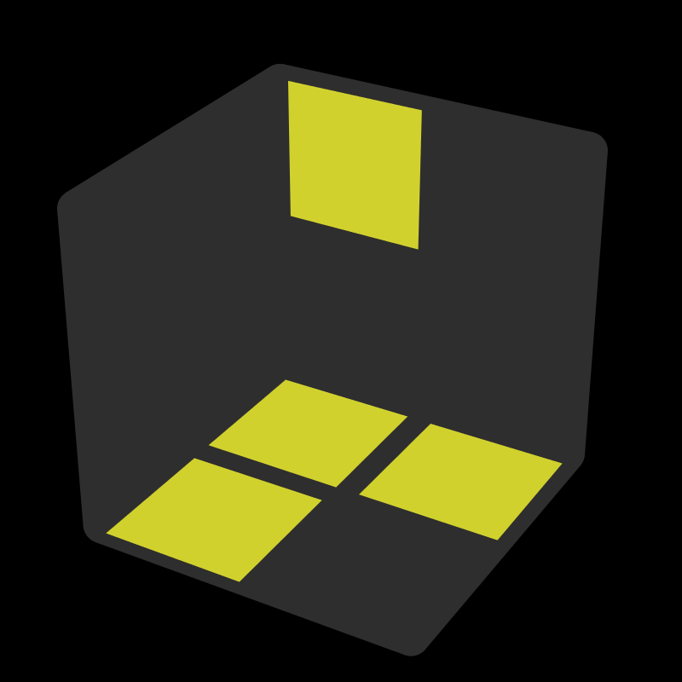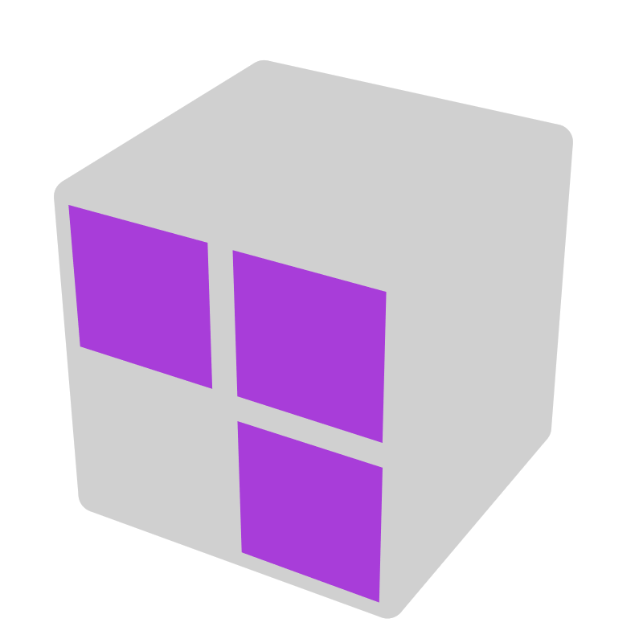 |  |  | 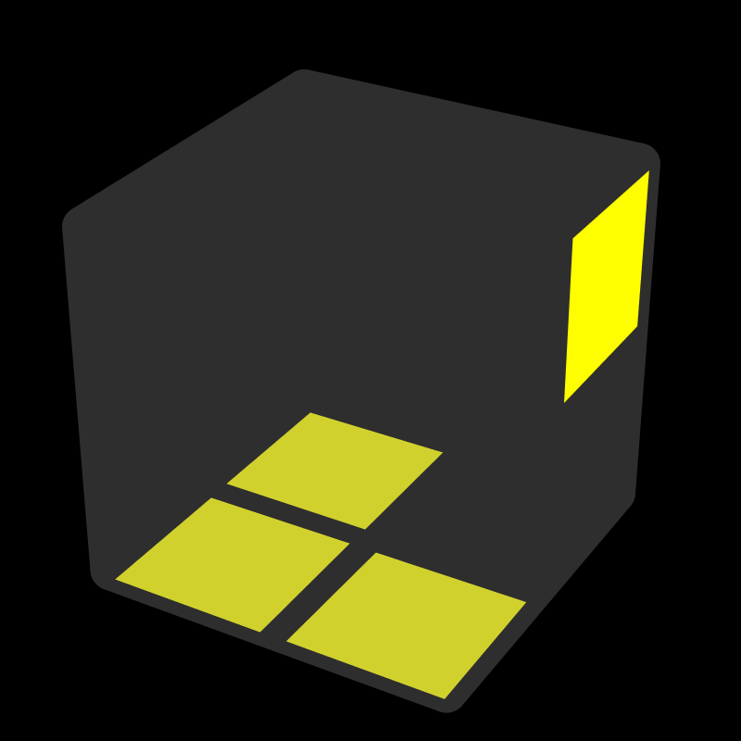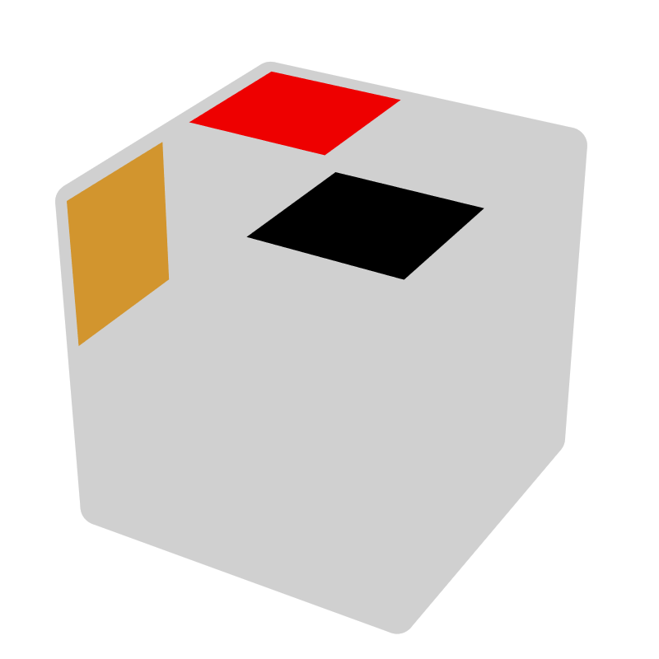* |  |  | 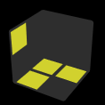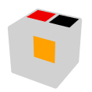* |  |  | 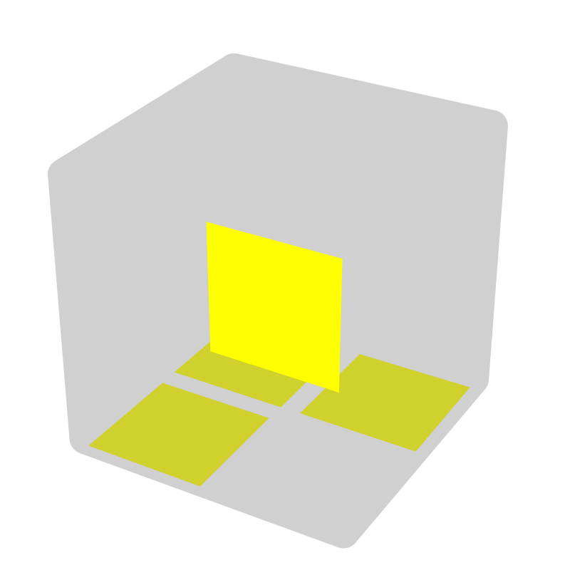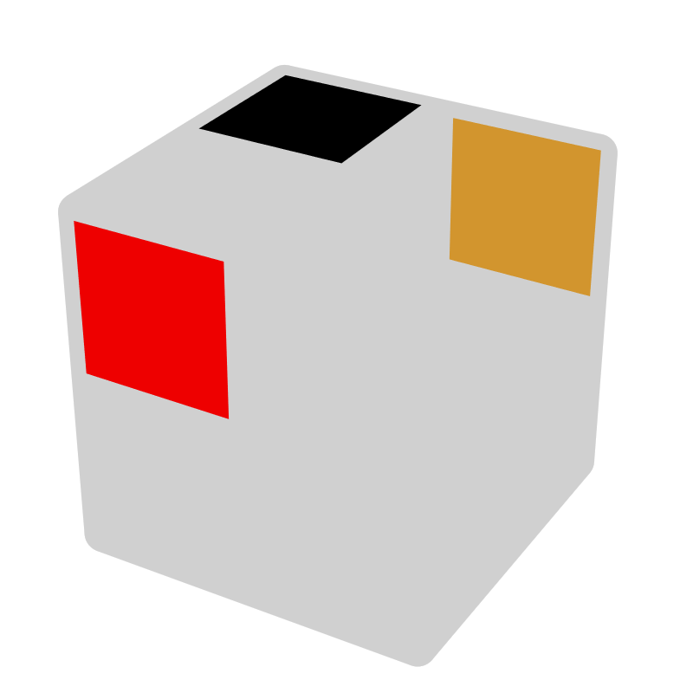*
R U2' R' | z2 x |  | R' U' R |  | U', U' R | R U' R' | U', R U' |  | R' F R F' |  | F R, R' U
 |  |  | = y' F' L' F = y2 R' F' R |  |  | = y' F R' F' |  |  | = y F' R U R'
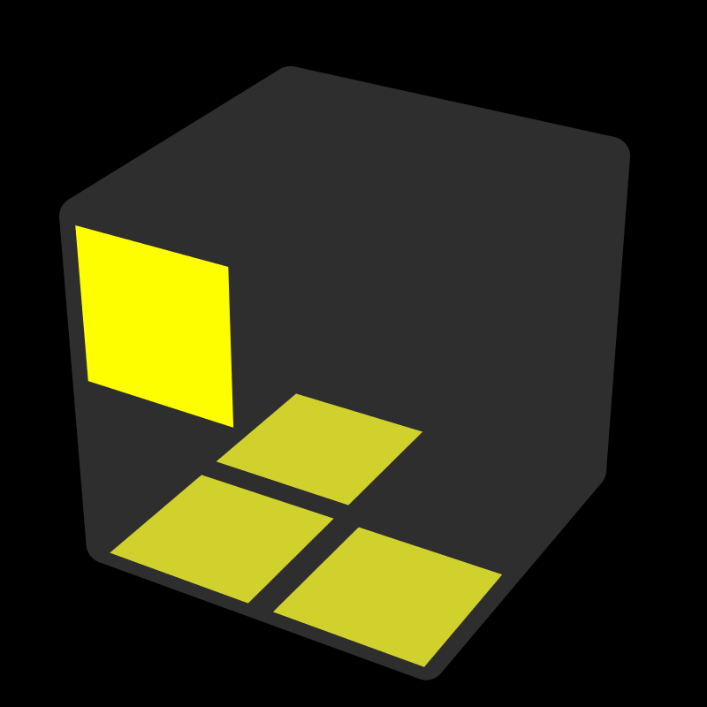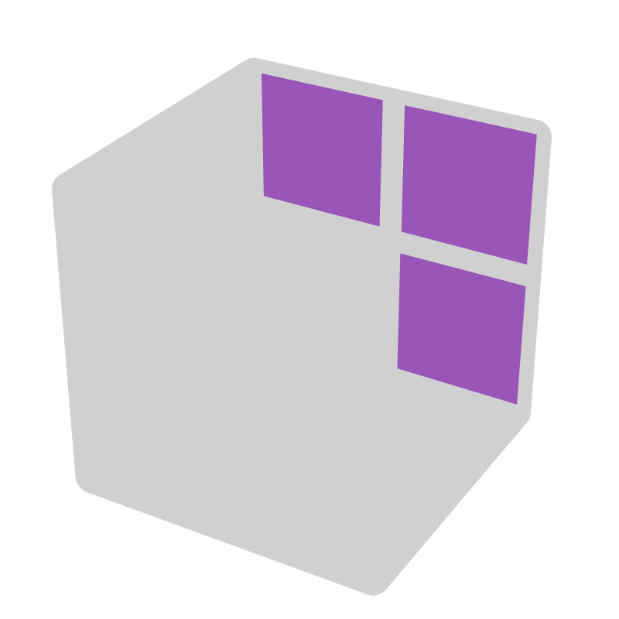 |  |  | 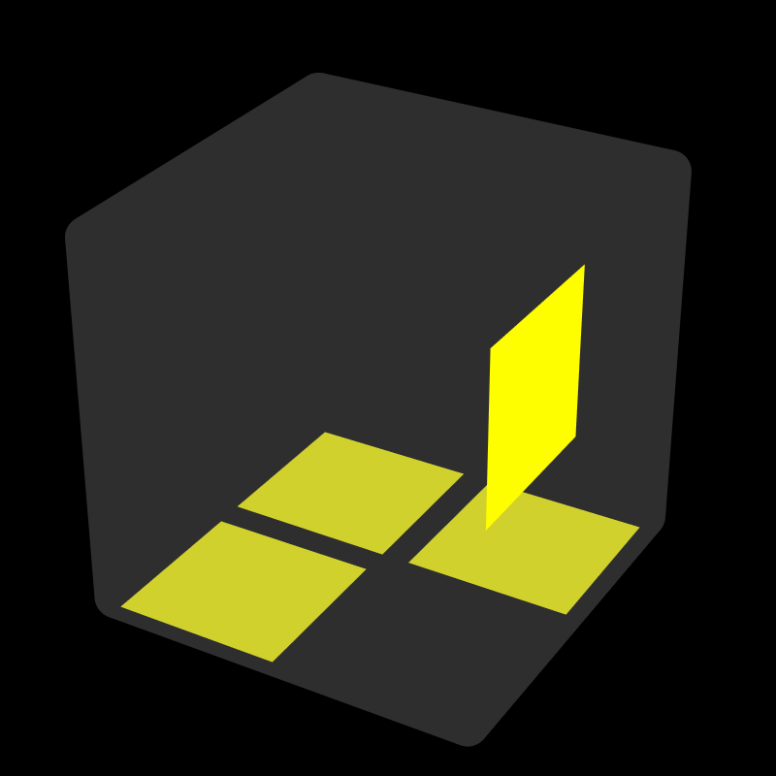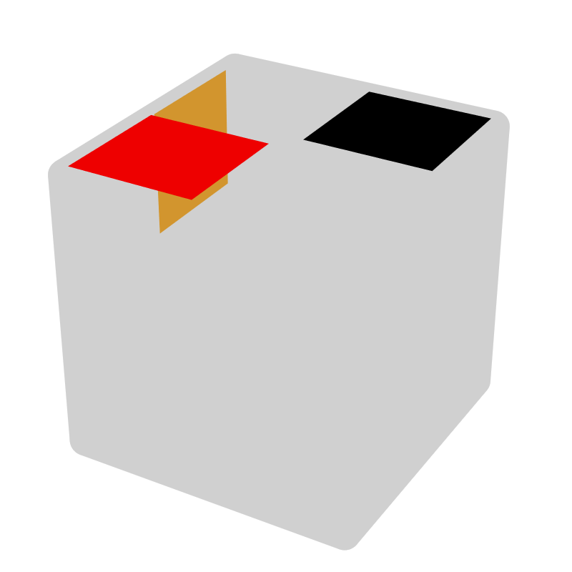* |  |  | 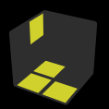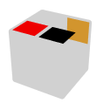* |  |  | 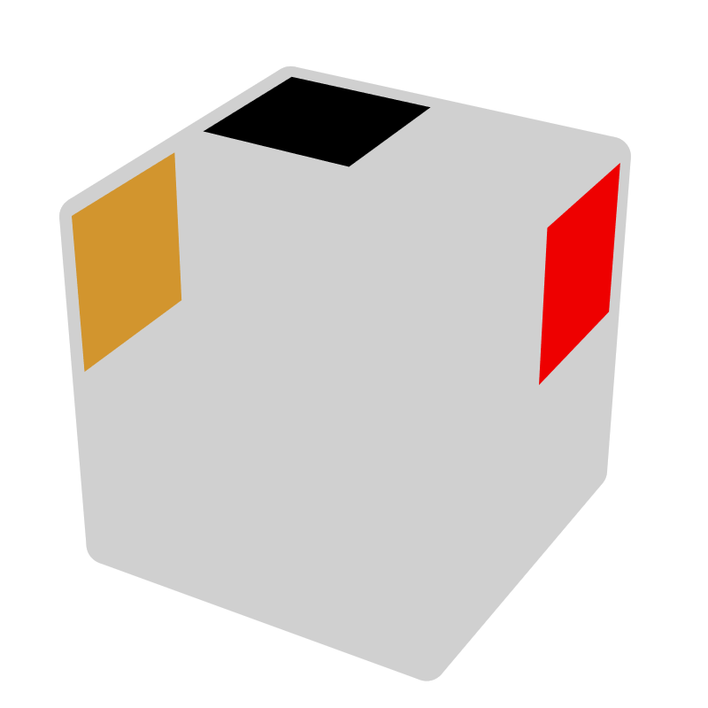*
R' U2 R | z2 x' |  | R U R' |  | U, U R' | R' U R | U, R' U |  | F R' F' R |  | R' F', F U'
 |  |  | = y' F R F' |  |  | = y' F' L F = y2 R' F R |  |  | = y R U' R' F
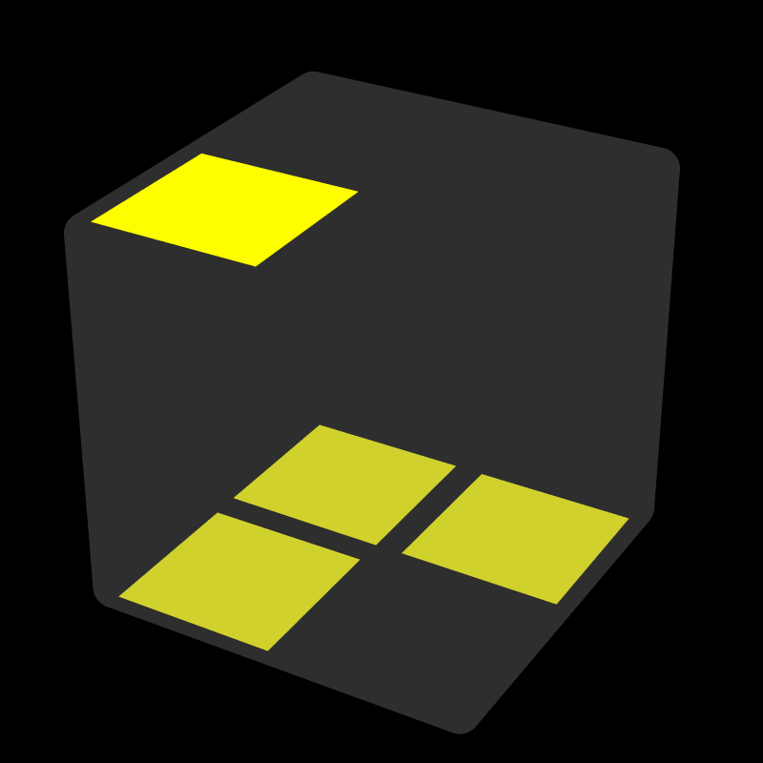 |  |  | 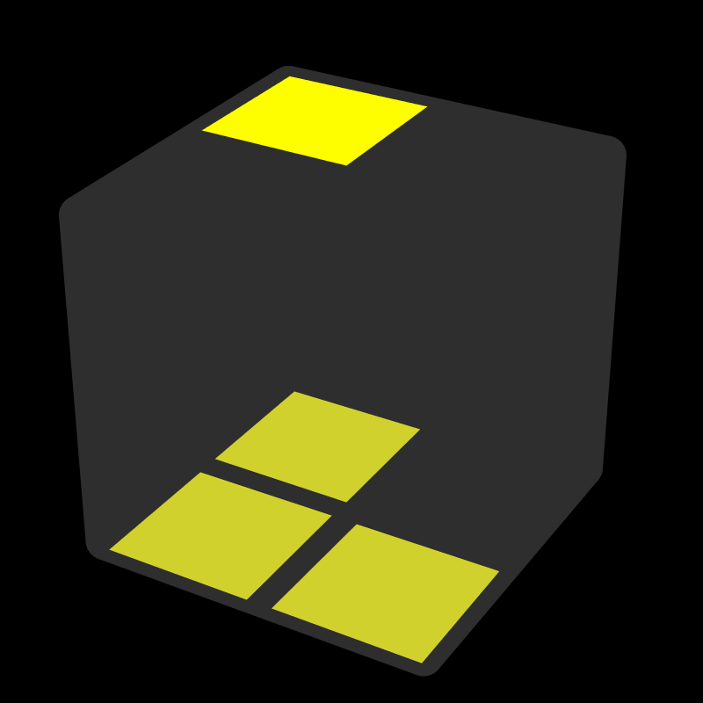* |  |  | 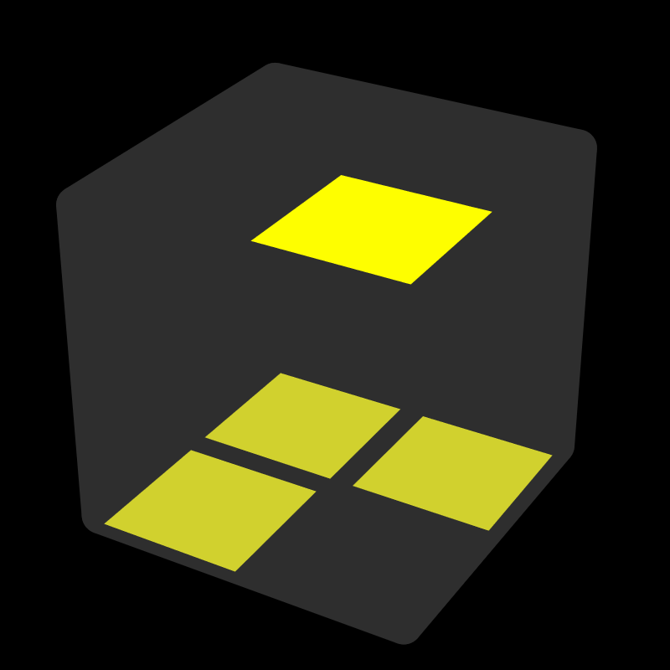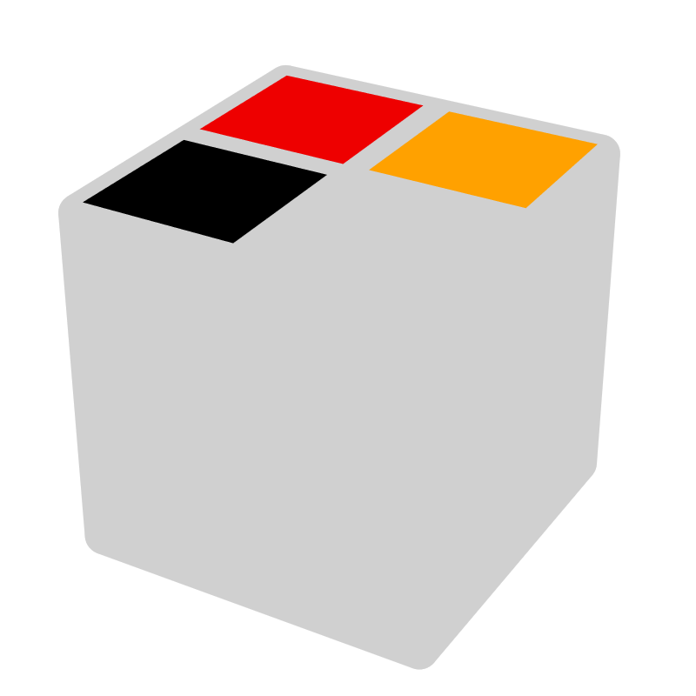* |  |  | 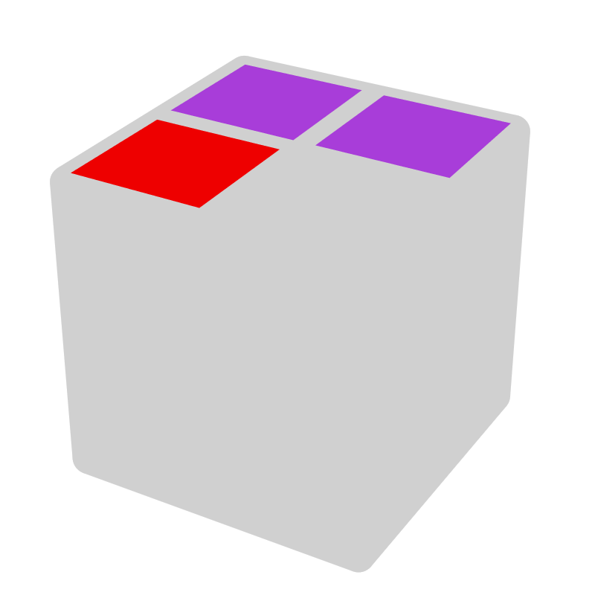*
R2 U' R2' | U' |  | R2 U R2' |  | U | R2 U R2' U' R2 | U, U' |  | R2 U R2' U' F2 R2 |  | y' U'
DD [4]
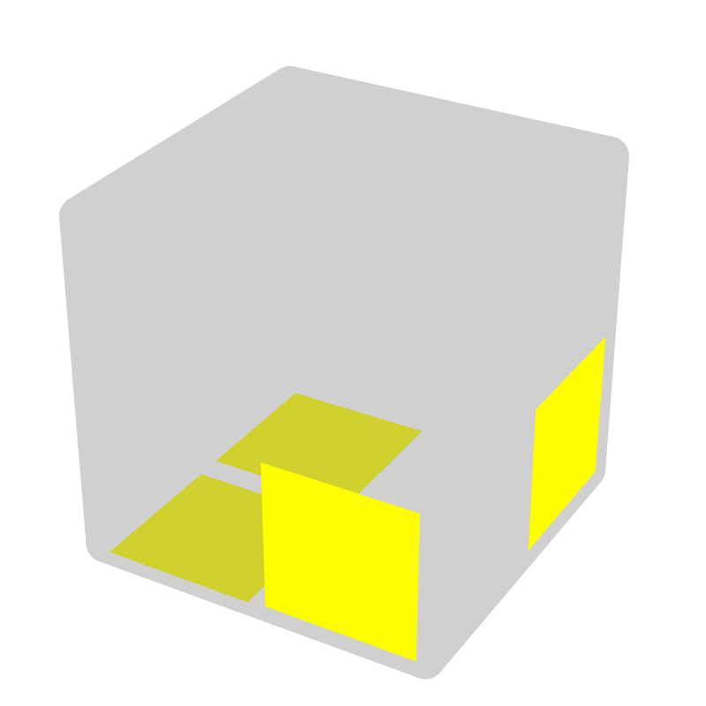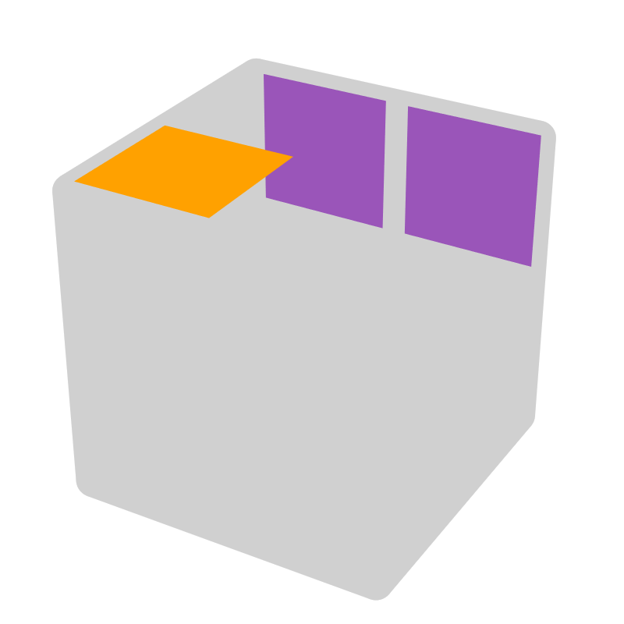 |  |  | 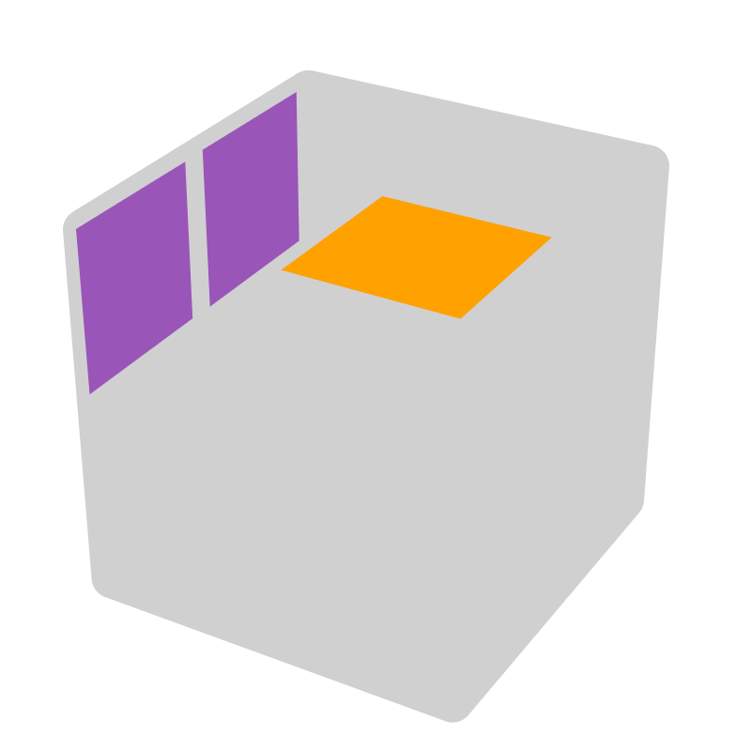* |  |  | 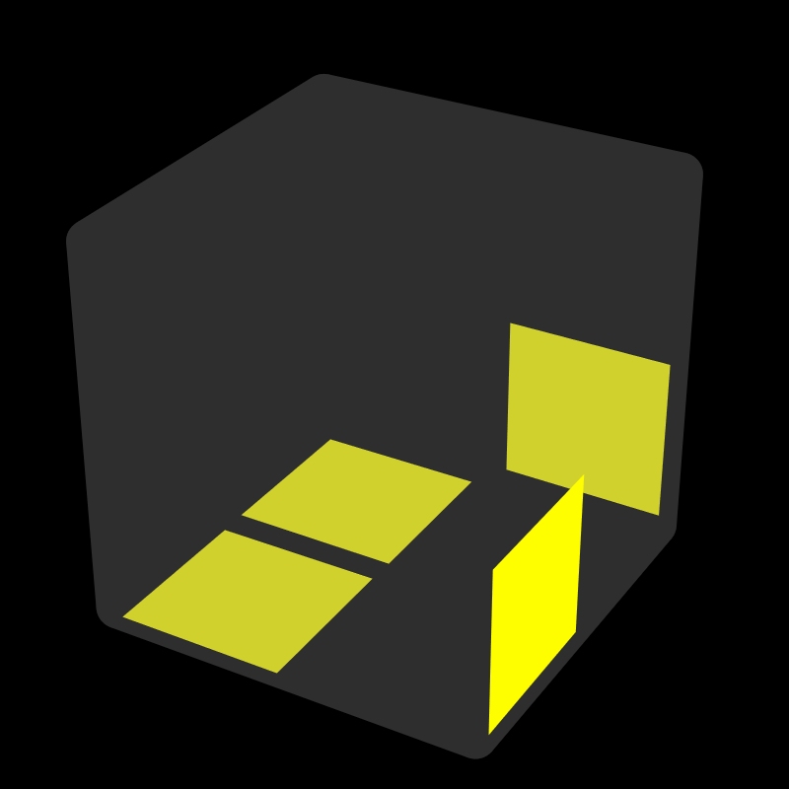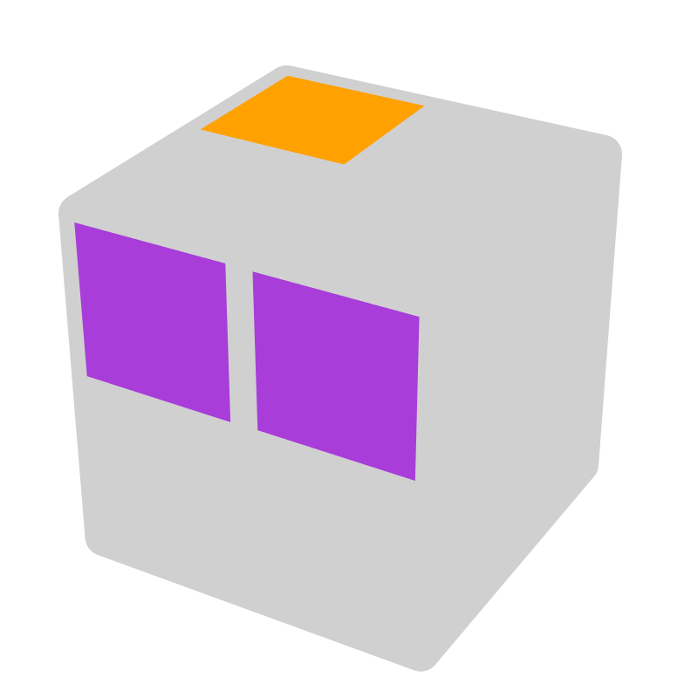 |  |  | 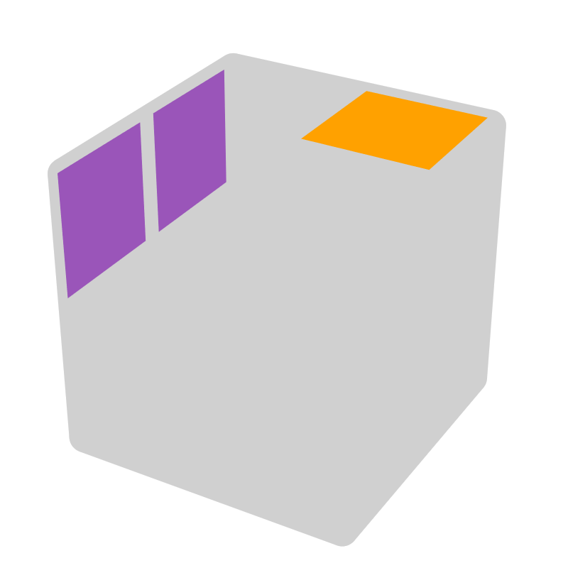*
R' U2 R U' R' | z' x' D' R' |  | R' U' R U2' R' |  | z y D' B' | R U2' R' U R | z' x D R |  | R U R' U2' R |  | z y' D F
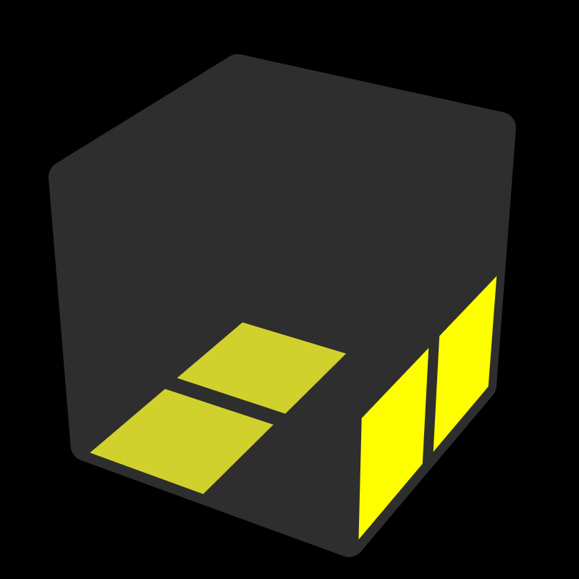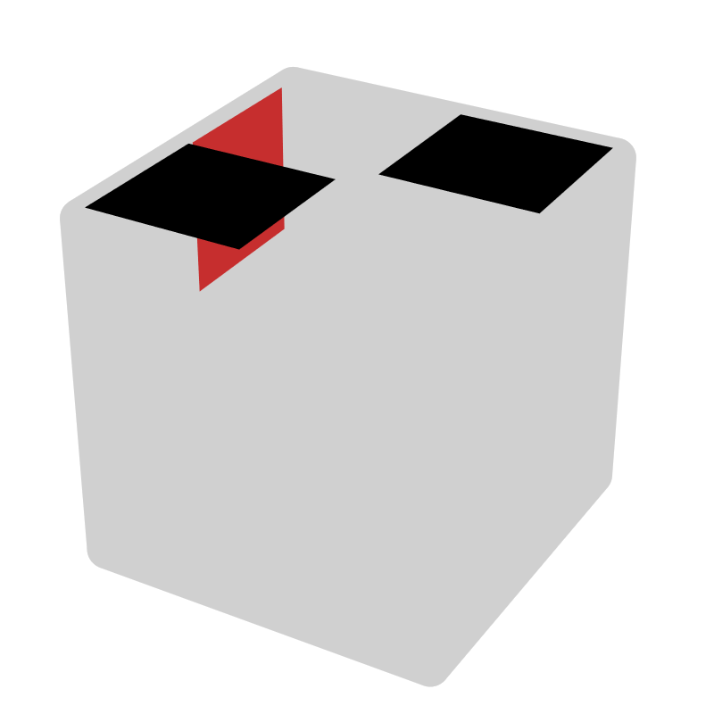 |  |  | 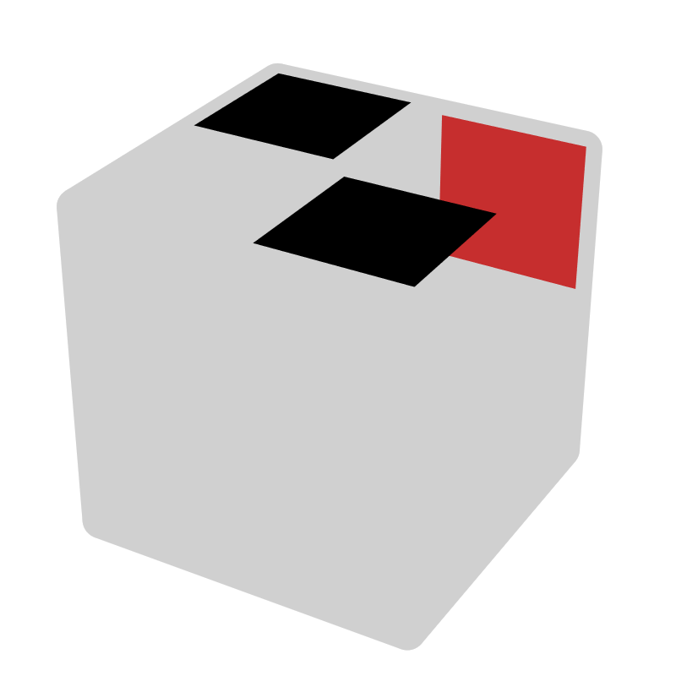* |  |  | 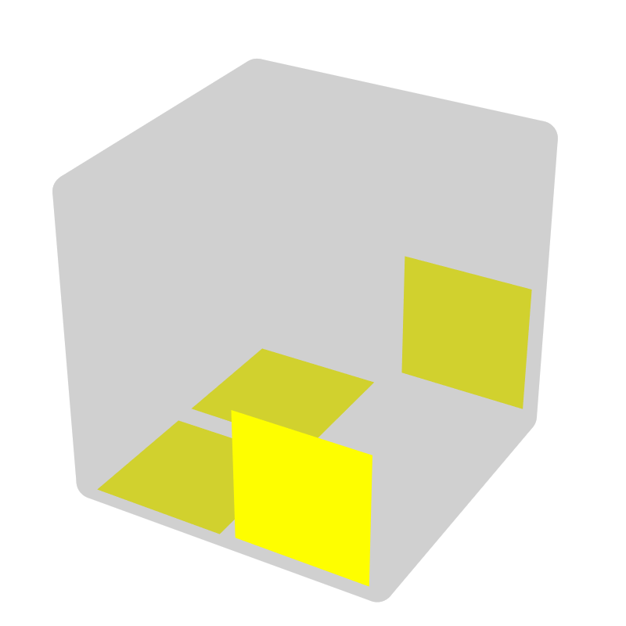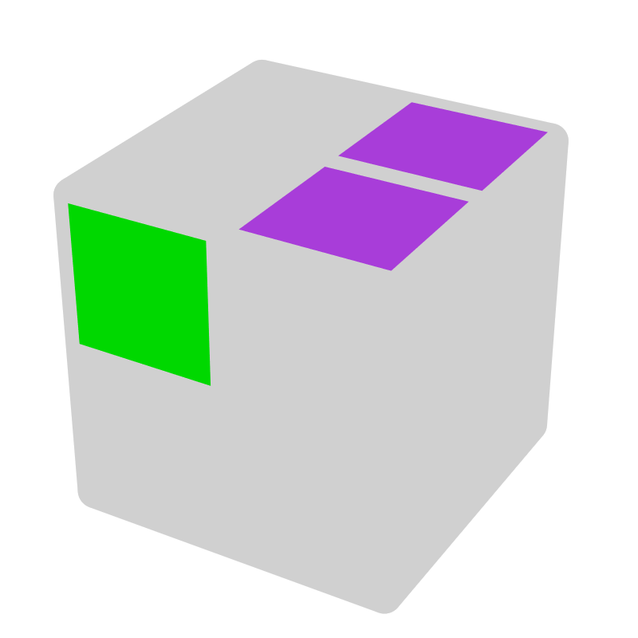 |  |  | 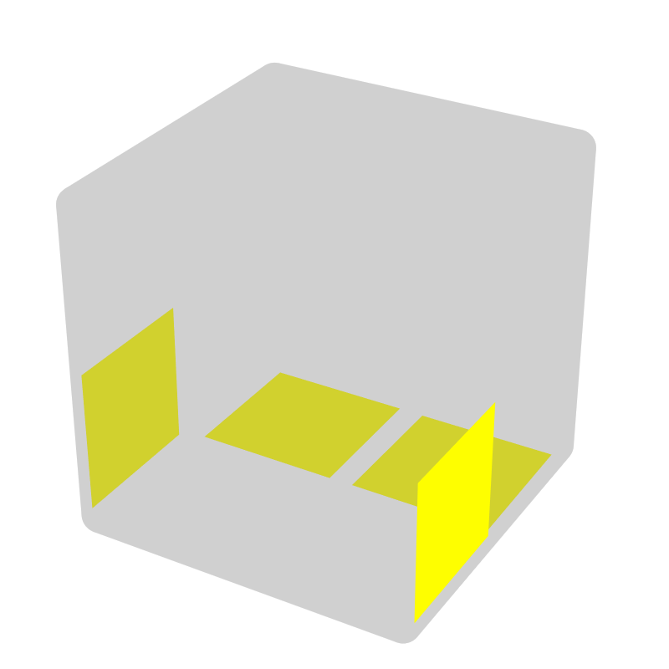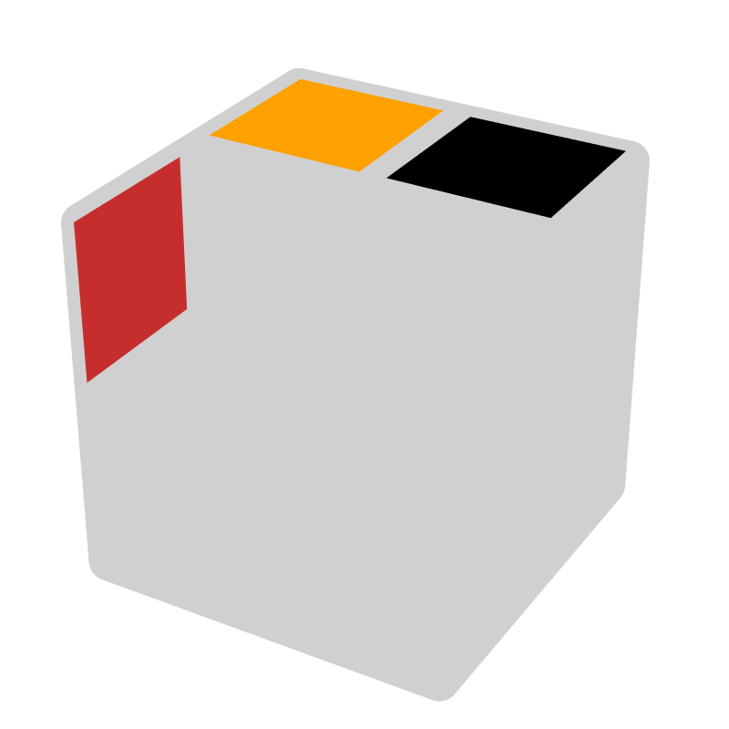*
R' U R2 U' R | U R' |  | R U' R2' U R' |  | R' U | R U2' R2' U R2 | y2 - |  | F R2 U' R2' |  | F, U'
 |  |  | z ->other case
UD - 1 move D [6]
 |  |  | 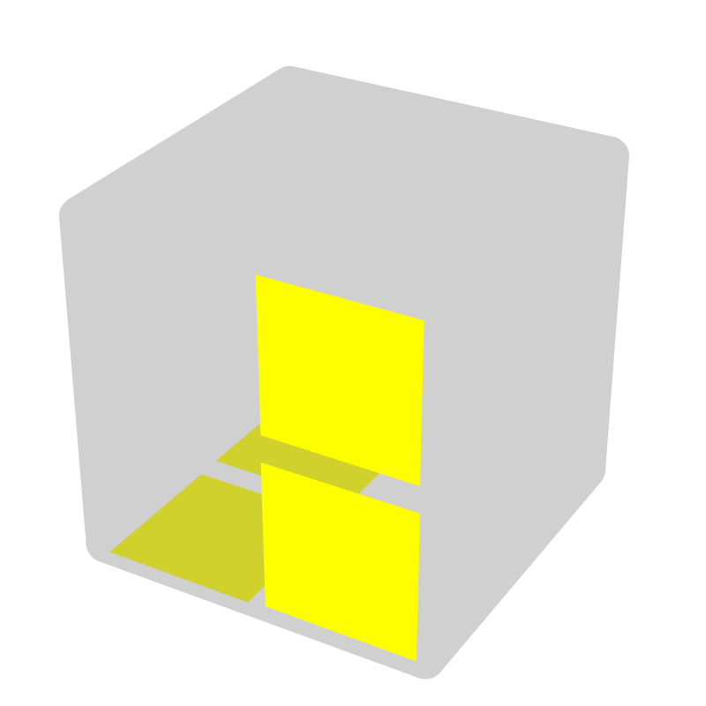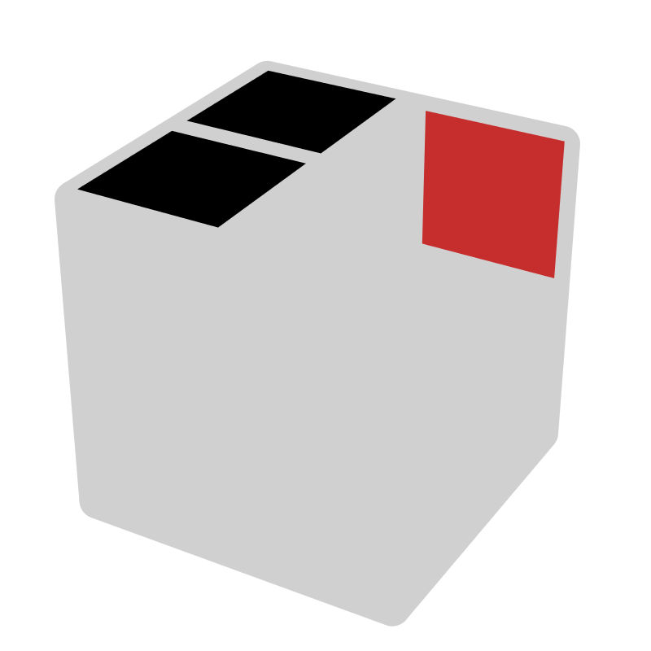 |  |  | 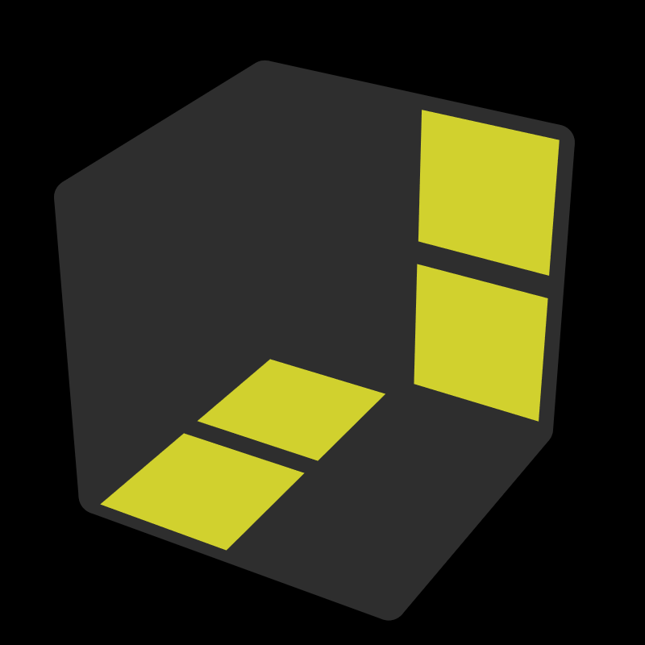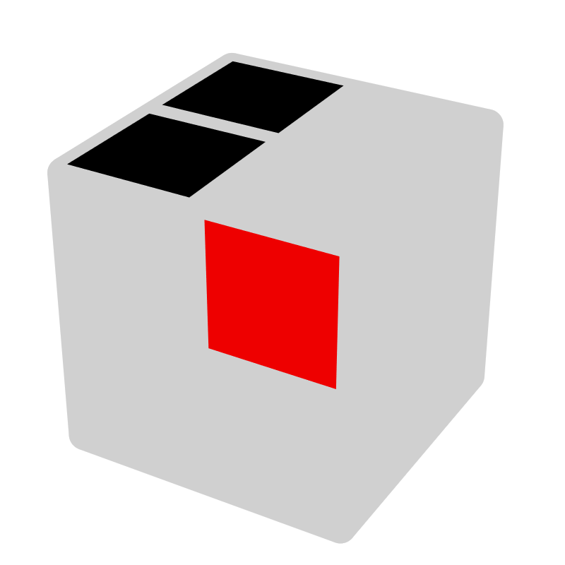
 |  |  | R' |  | R' | R | R
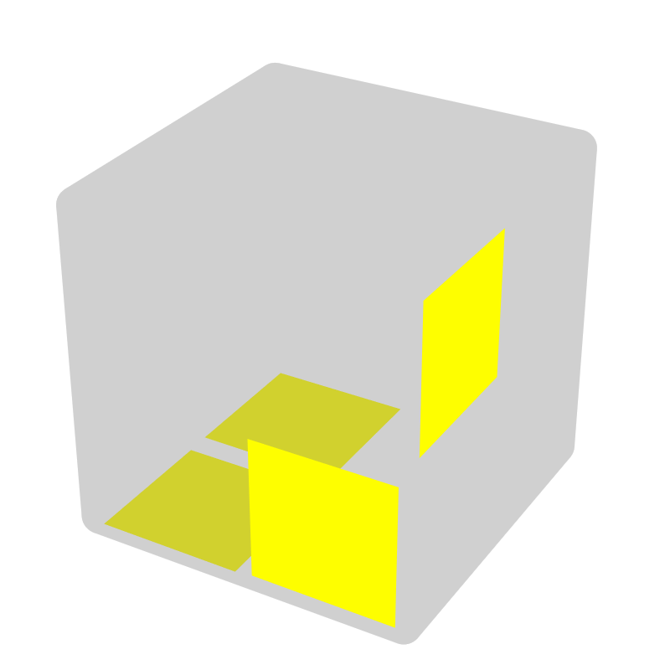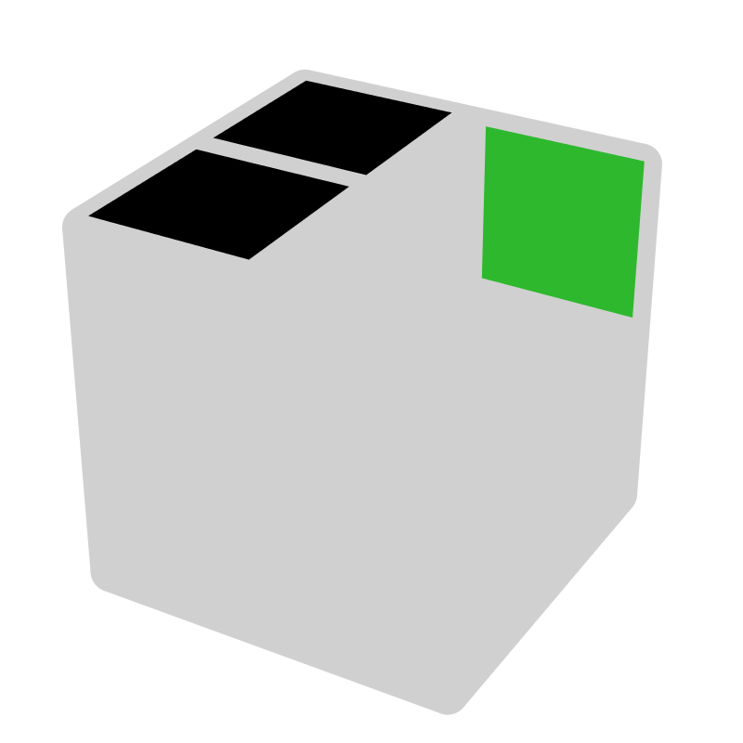 |  |  | 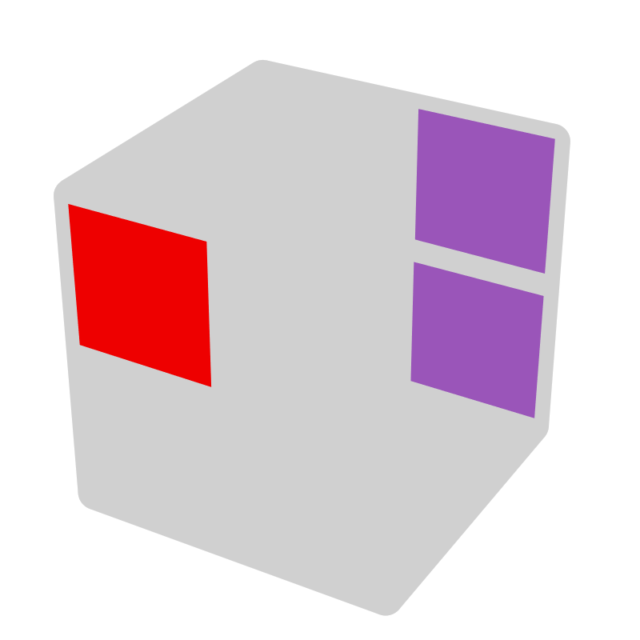* |  |  | 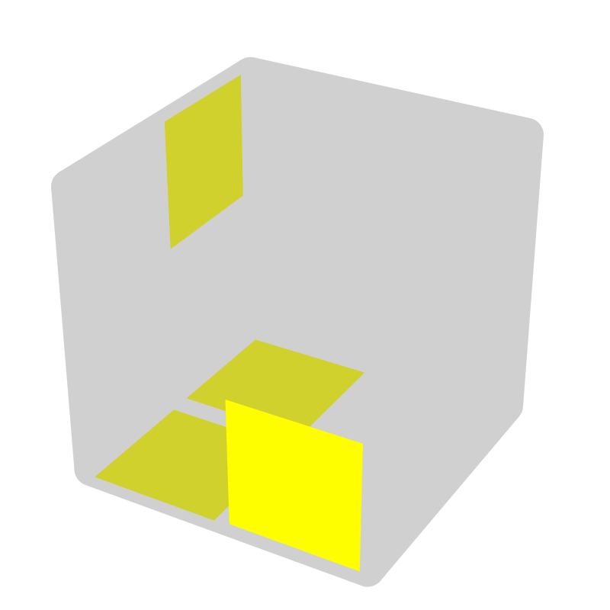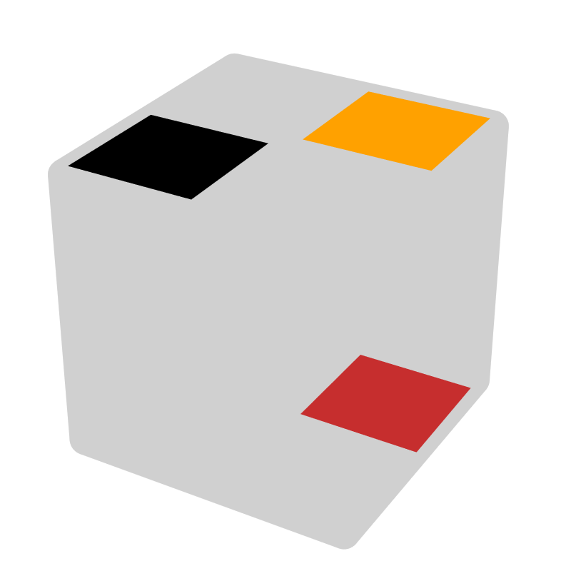* |  |  | 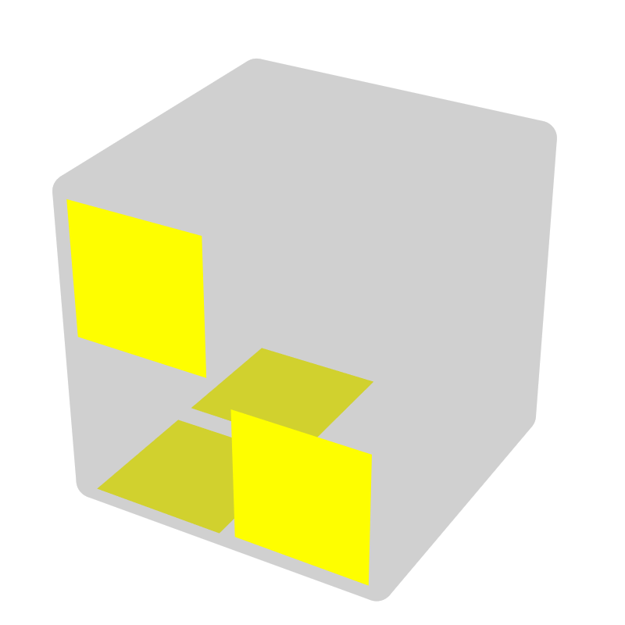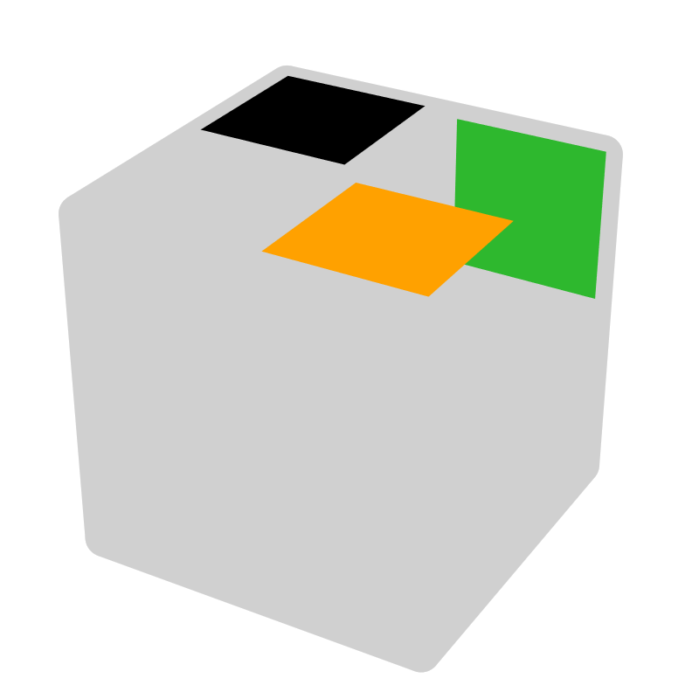*
R2' F' R F | - |  | R' F R U' R' |  | x' L2 | R U R' U' R2 | R2, U' |  | R' U' R U R' |  | -, U
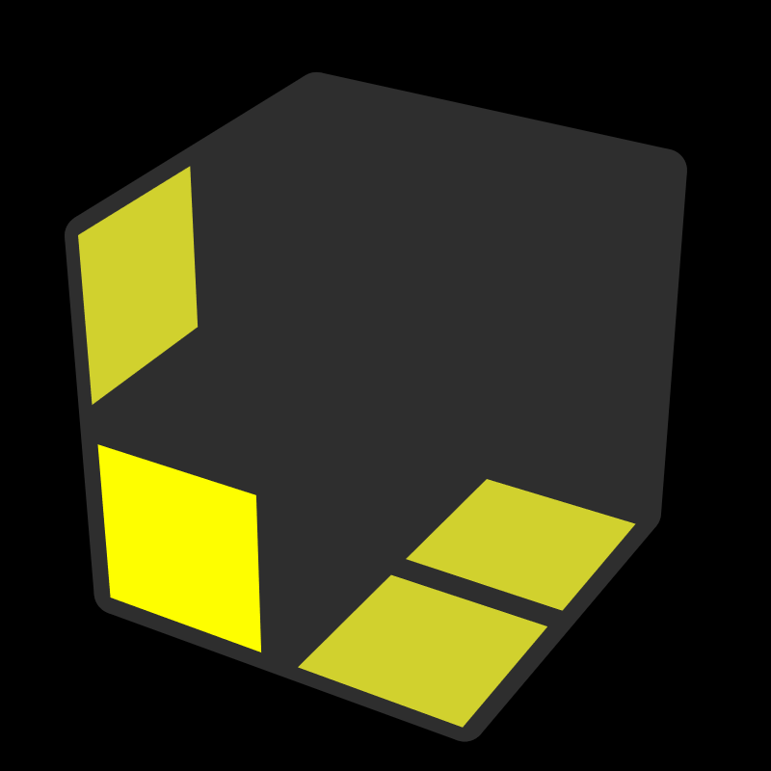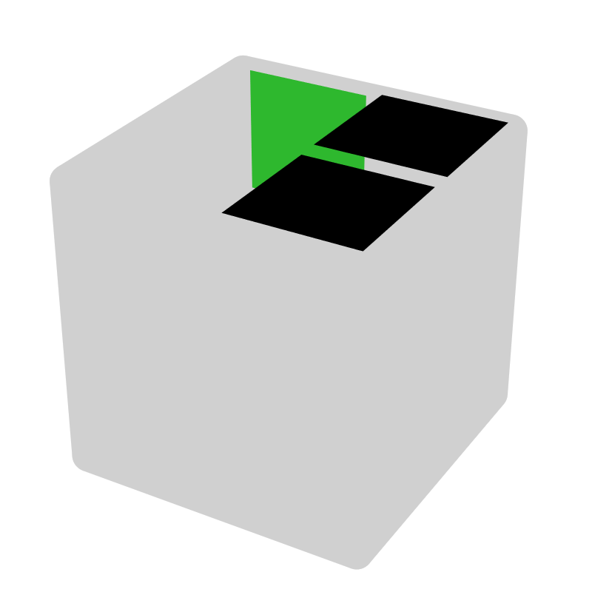 |  |  | 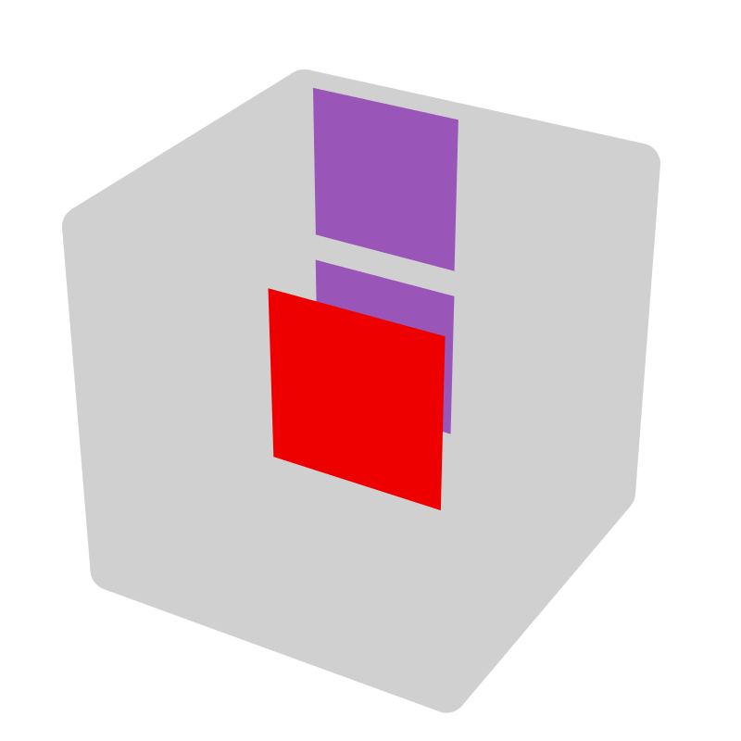* |  |  | 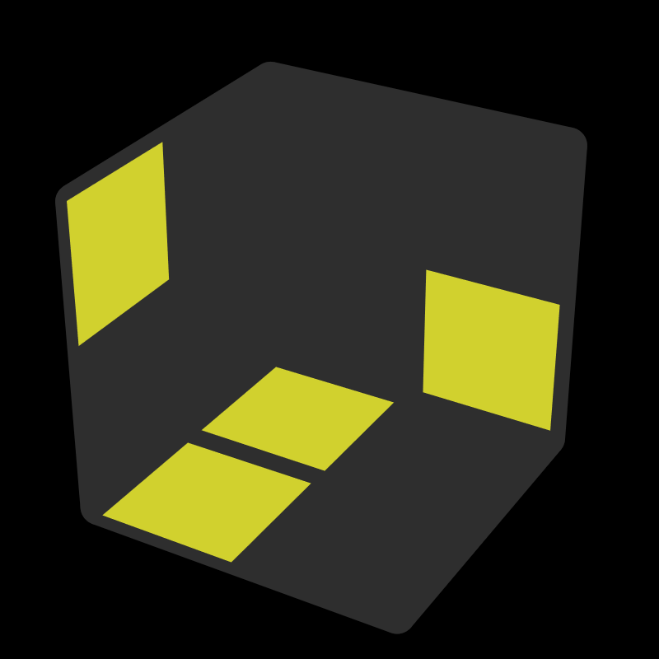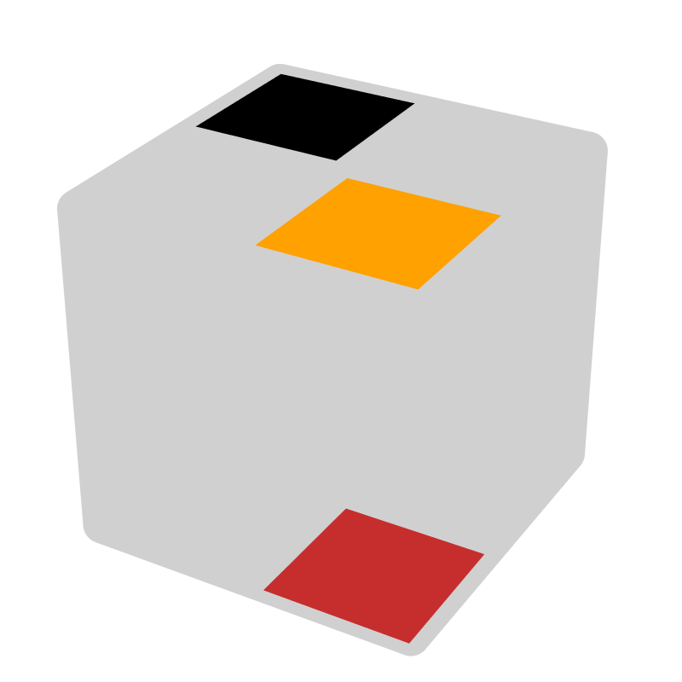* |  |  | 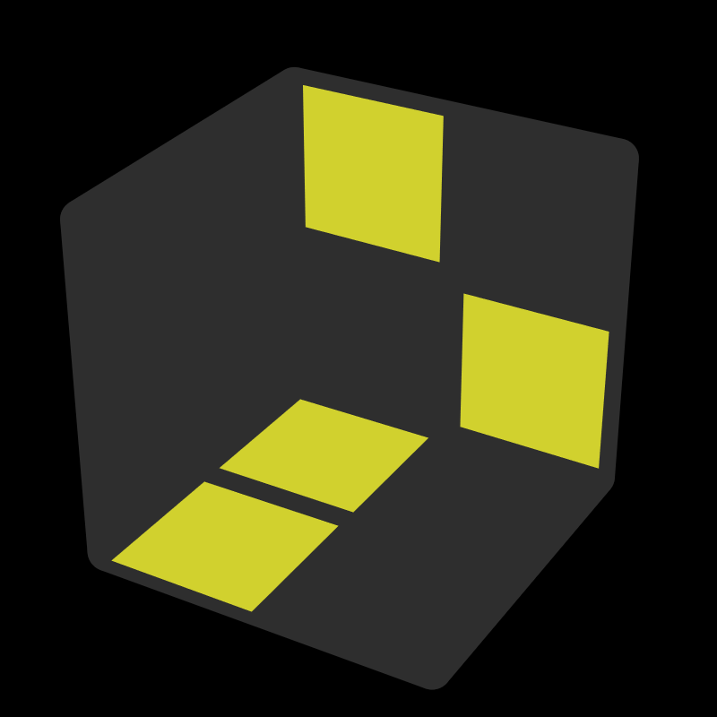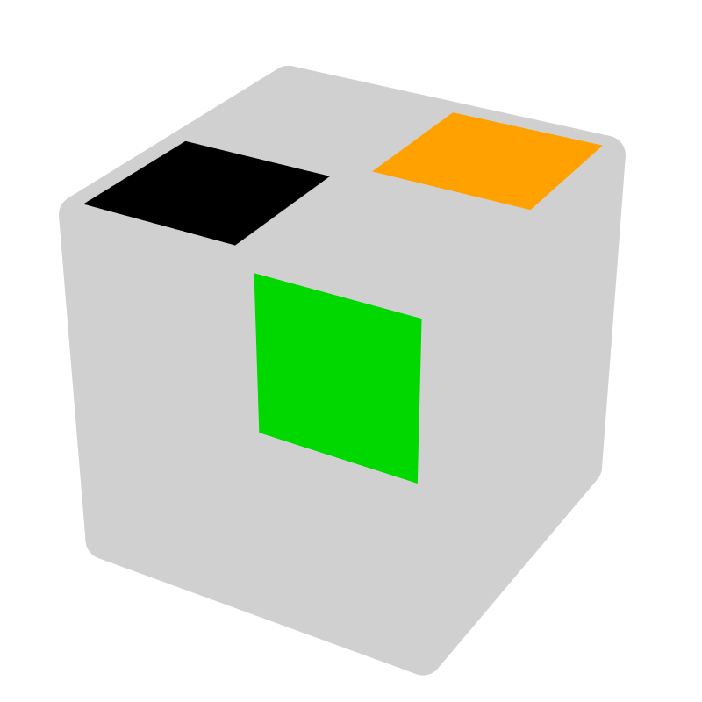*
L2 F L' F' | + |  | L F' L' U L |  | x' R2 | R' U' R U R2' | R2, U |  | R U R' U' R |  | +, U'
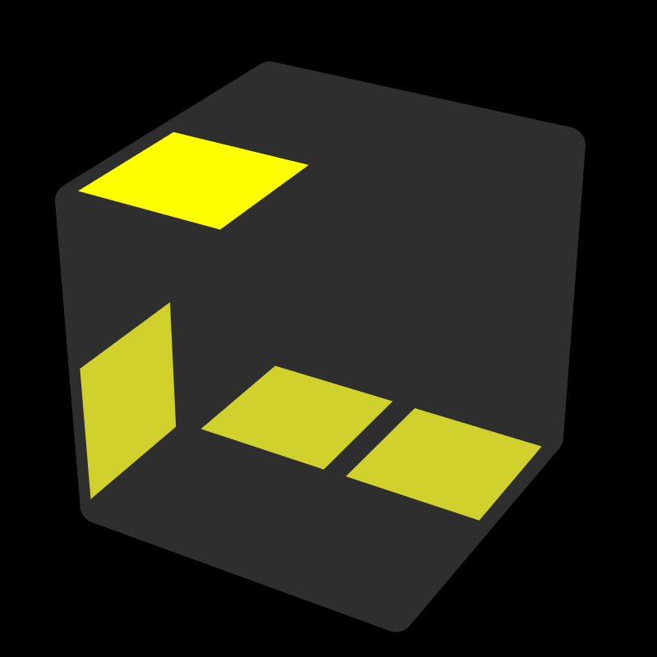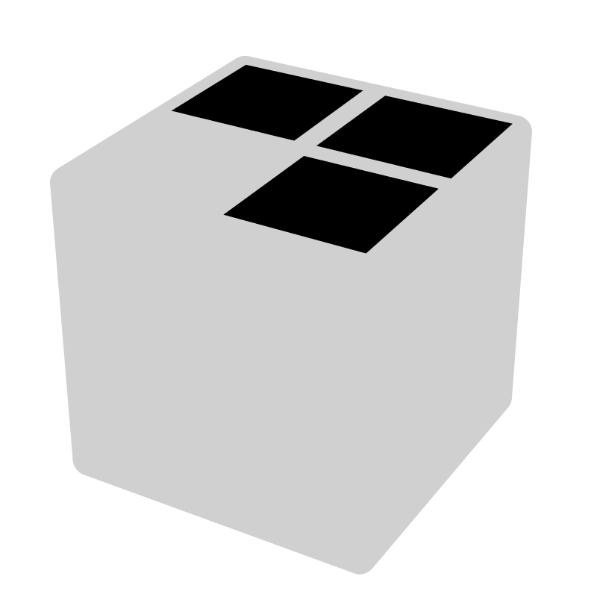 |  |  | 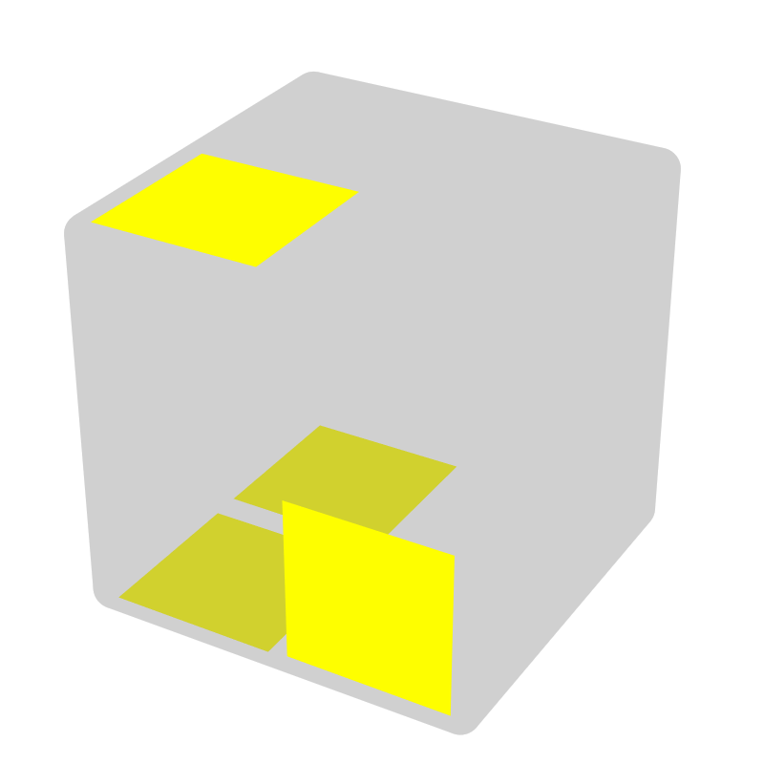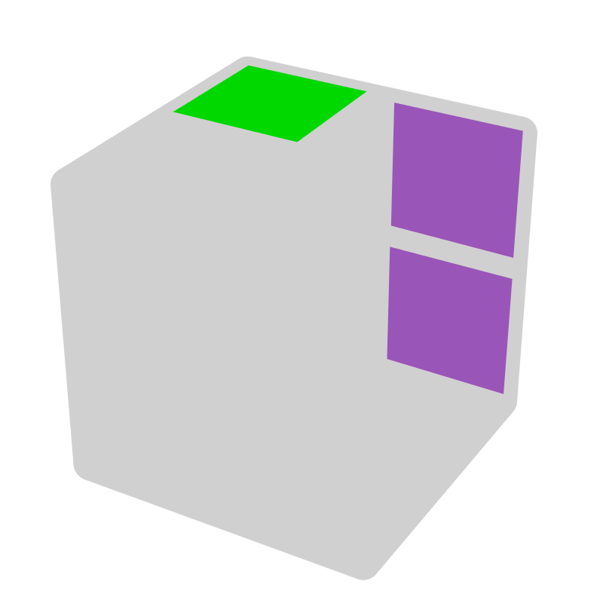* |  |  | 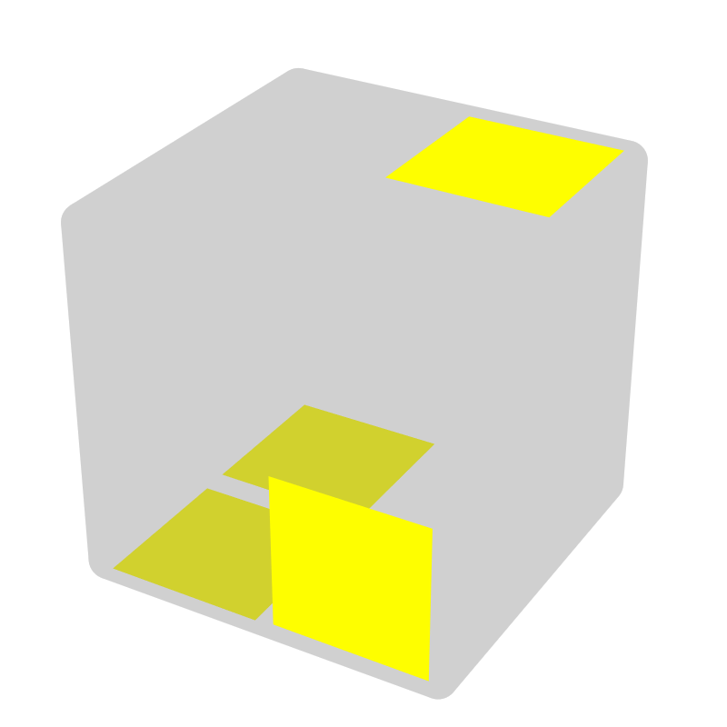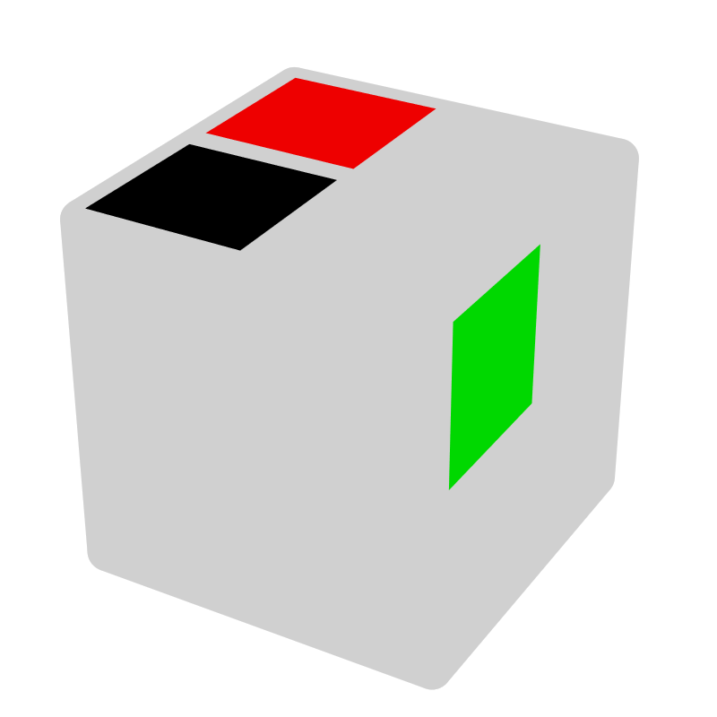* |  |  | 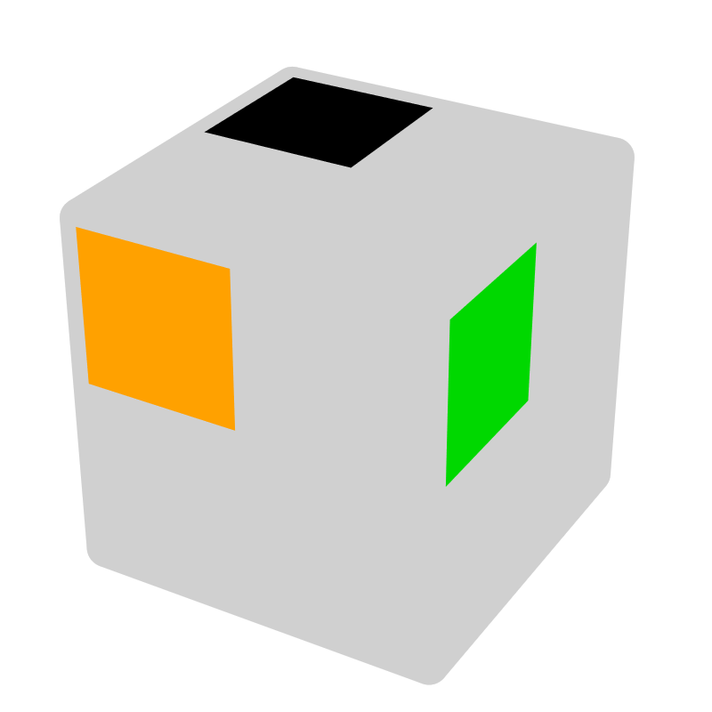*
R2 U' R' U R' F' |  |  | R U' R2' |  | x' - | R' U R U' R' | -, U |  | R2' F R F' |  | -, F R
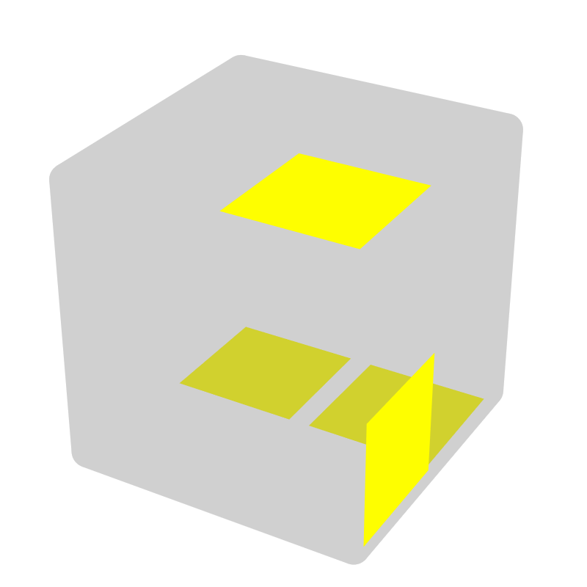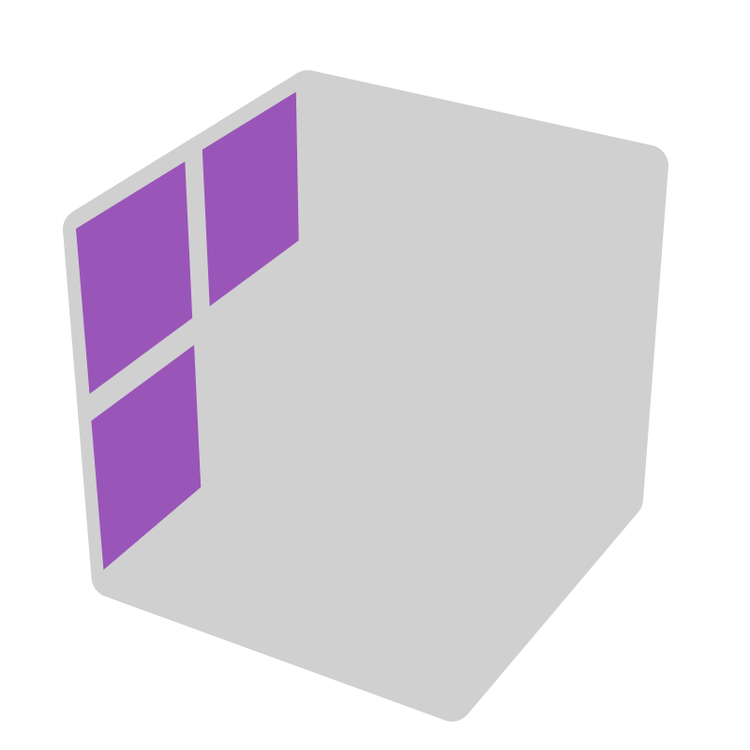 |  |  | 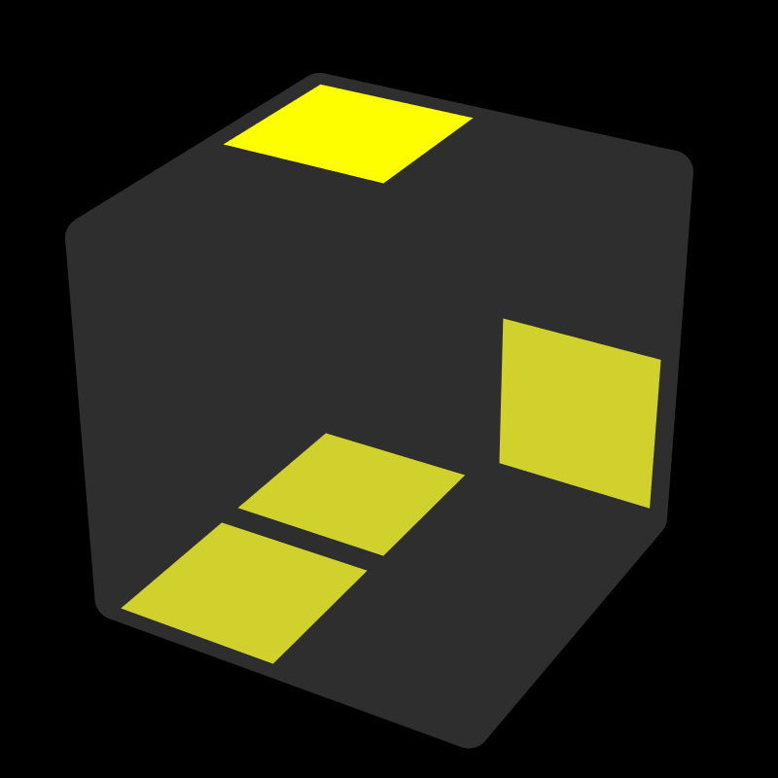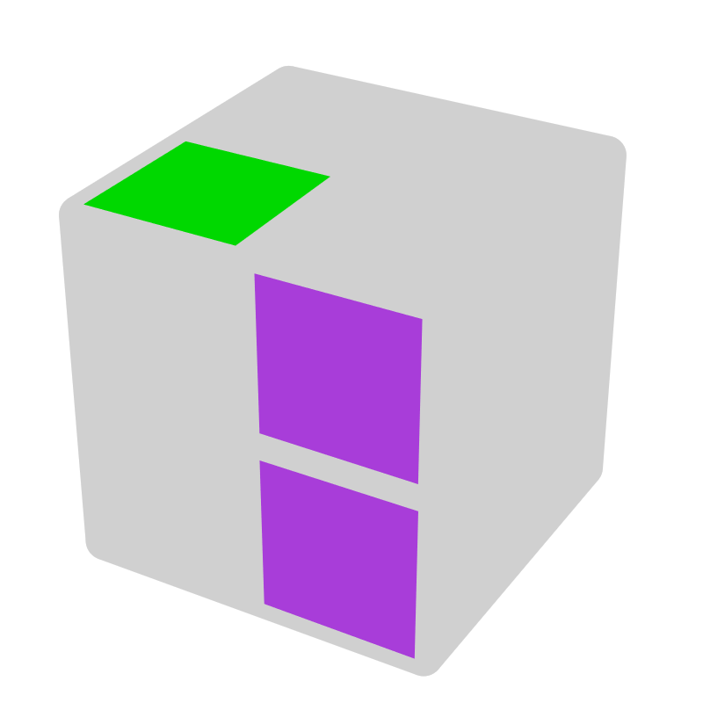* |  |  | 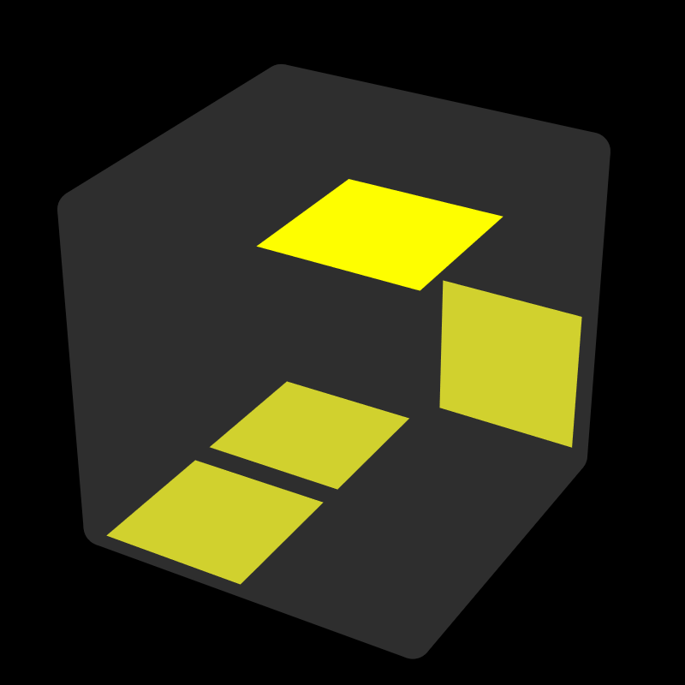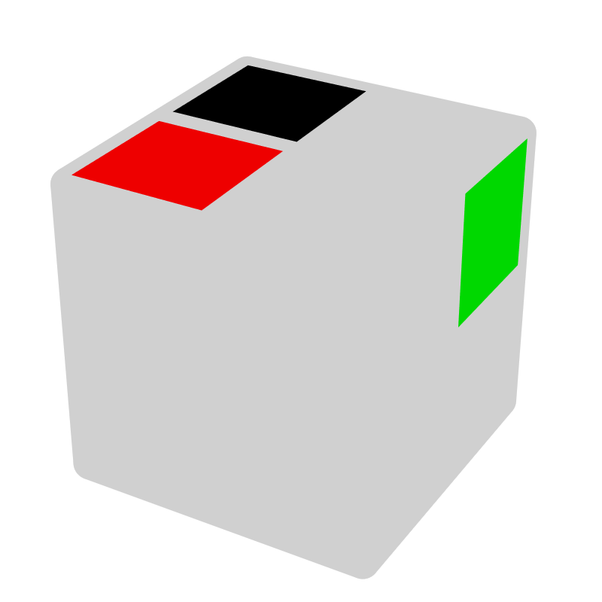* |  |  | 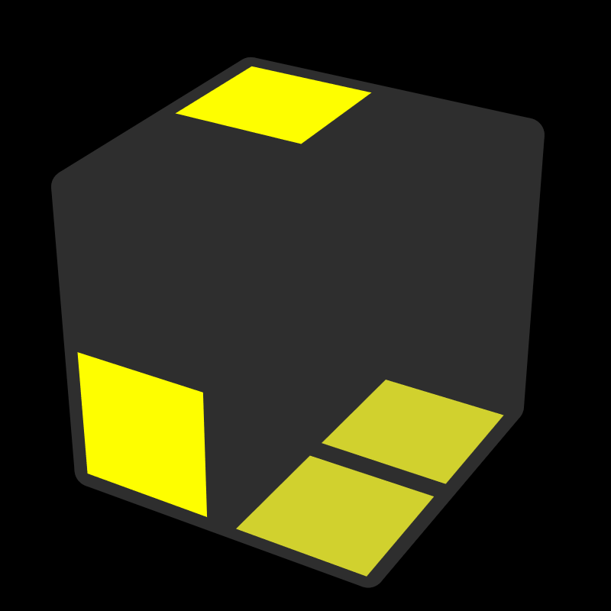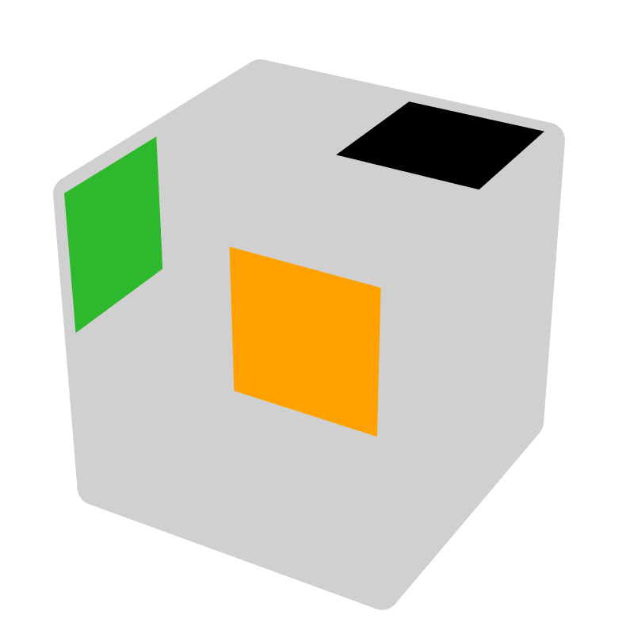*
R U R' U' F | z |  | R' U R2 |  | x + | R U' R' U R | +, U' |  | L2 F' L' F |  | +, F' L'
UD - 3 move D [6]
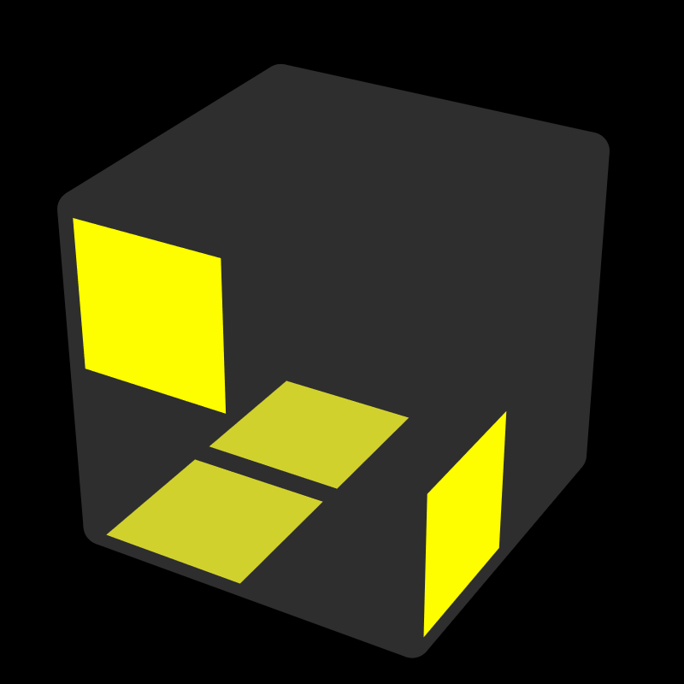 |  |  | 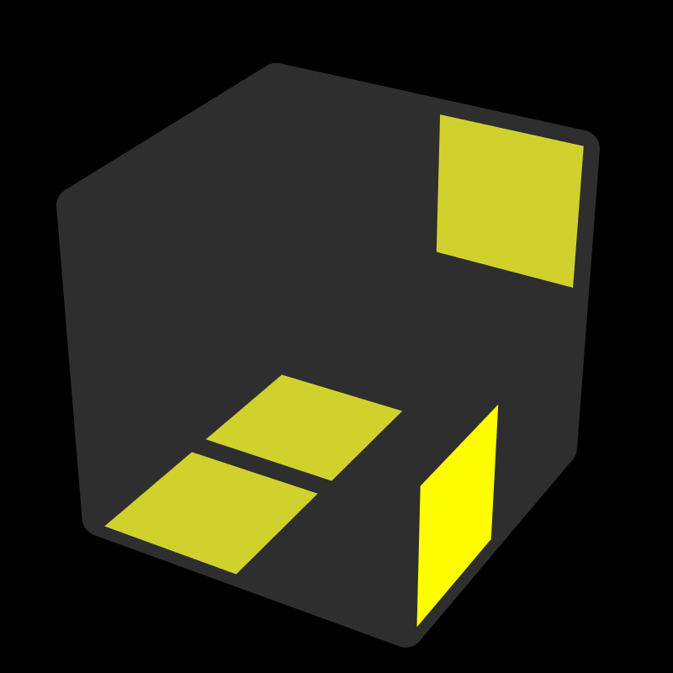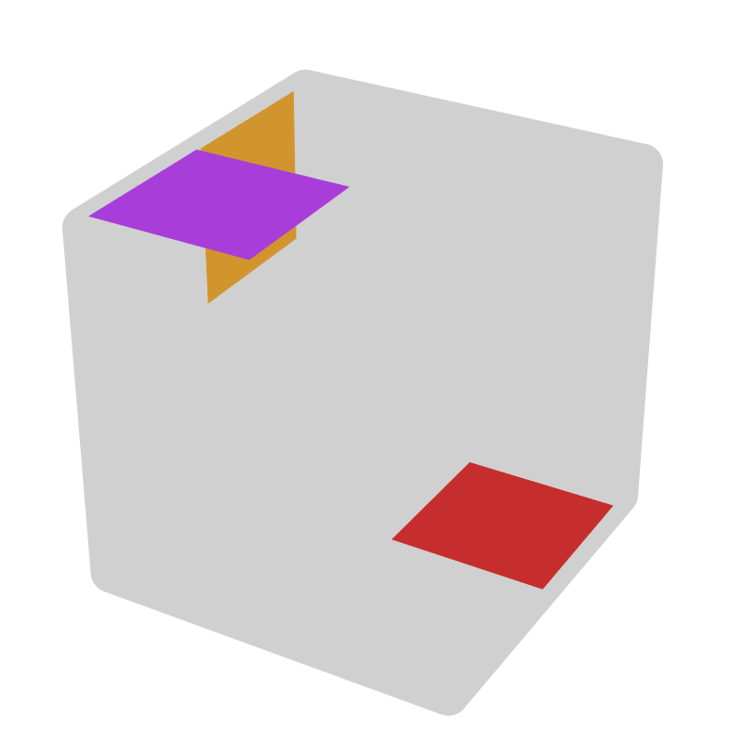* |  |  | 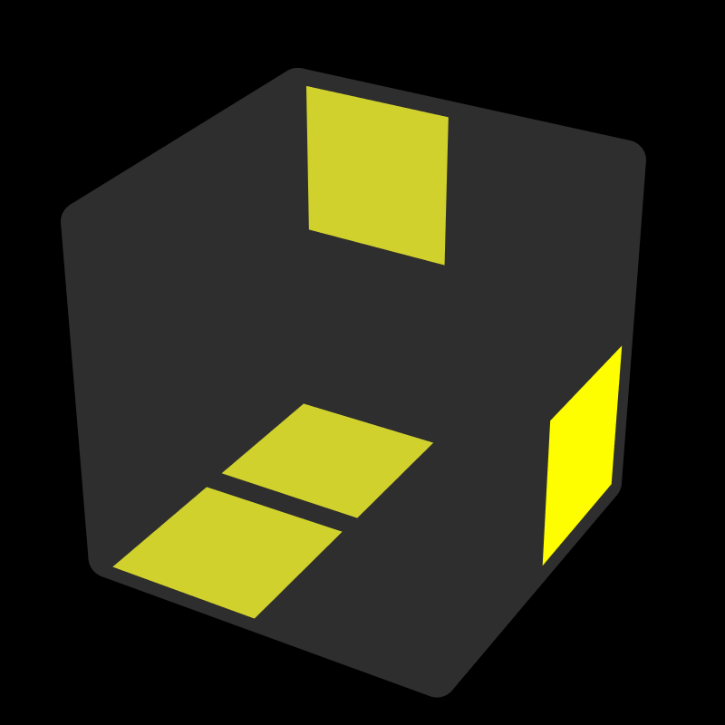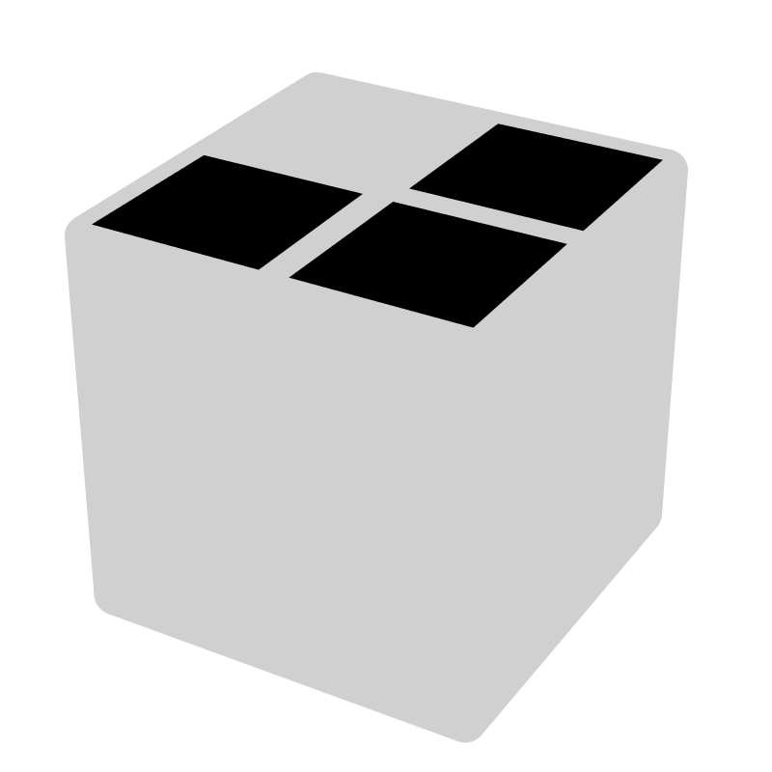 |  |  | 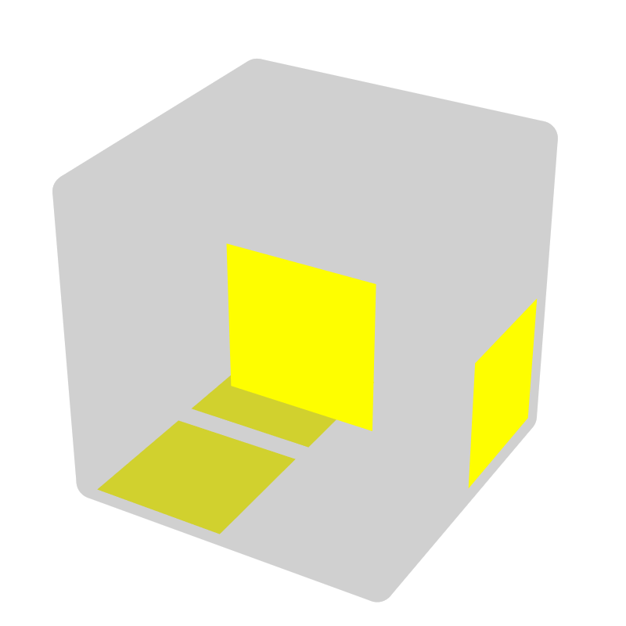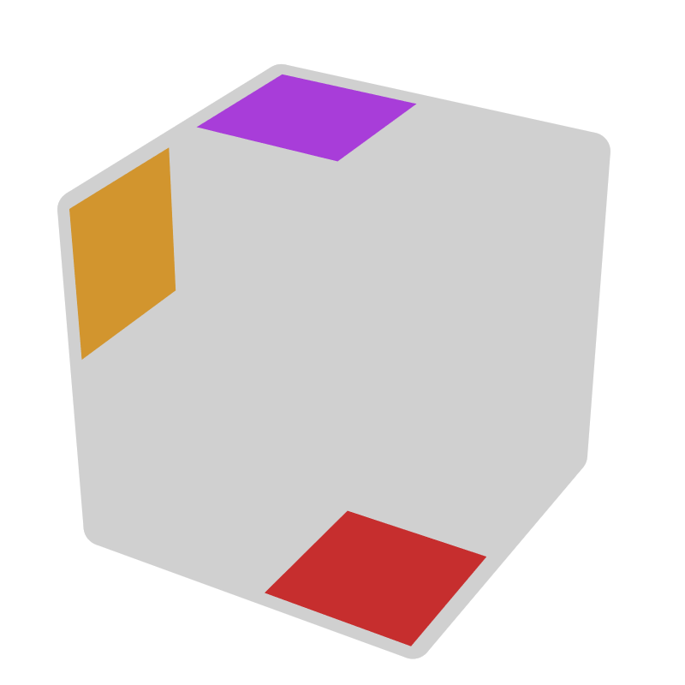*
F R U' R U R2' |  |  | R2 U R' |  | y (F2, R') | B' R' U R' U' R2 |  |  | R2' U' R |  | y' (B2, R)
 |  |  | U z y ->other case |  |  |  |  |  | U' z y' ->other case
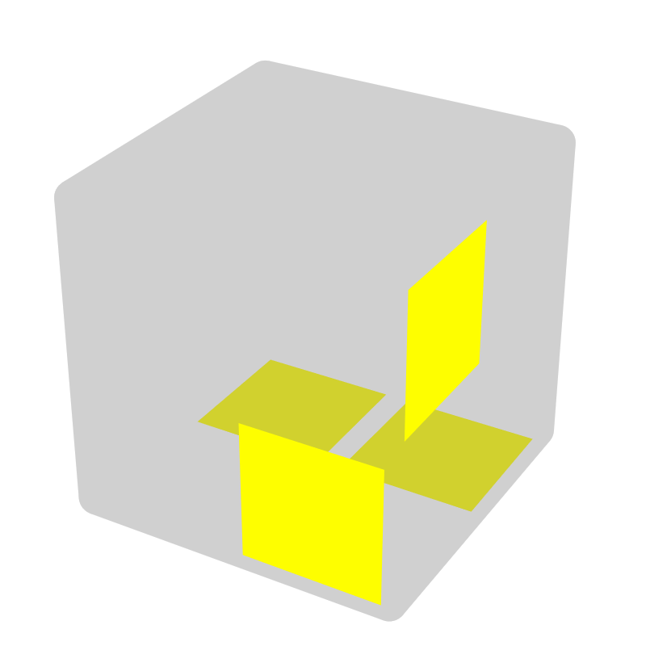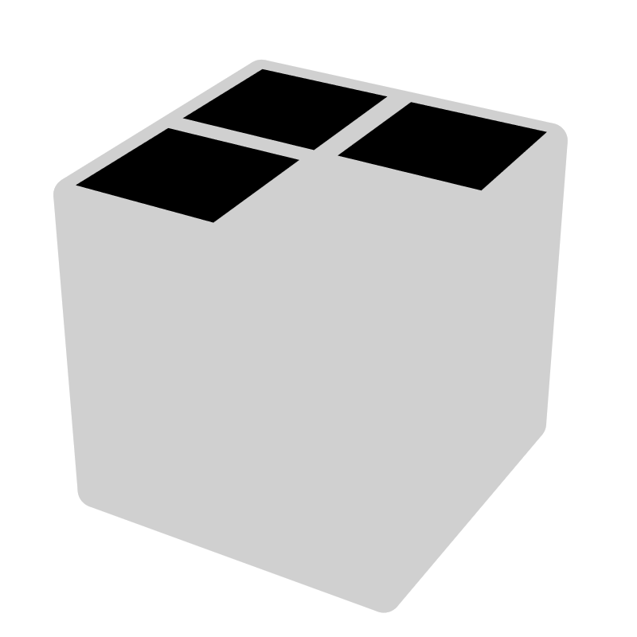 |  |  | 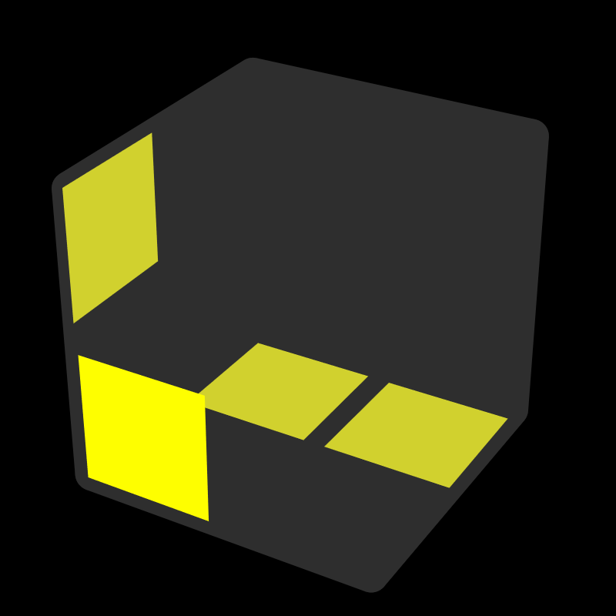 |  |  | 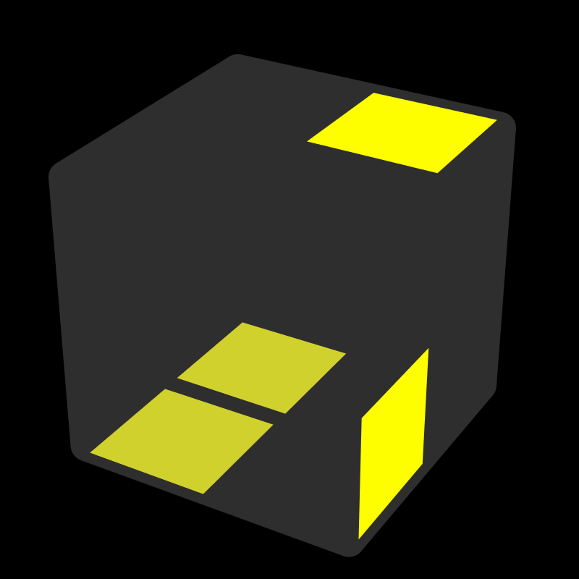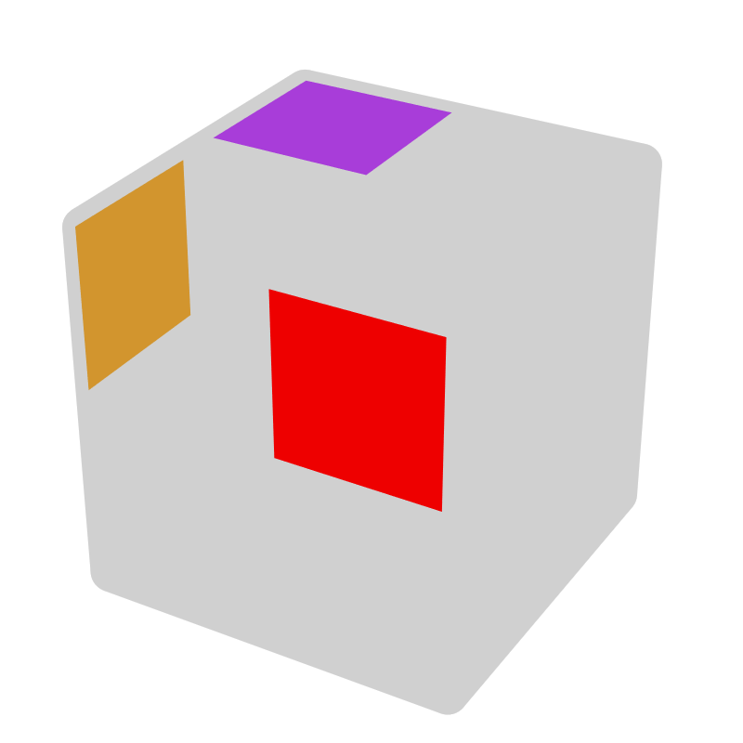 |  |  | 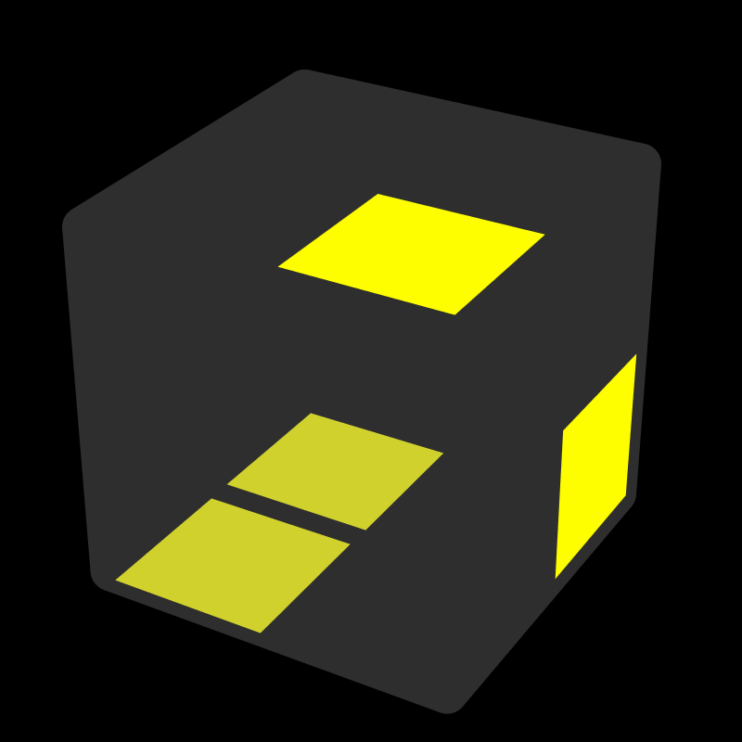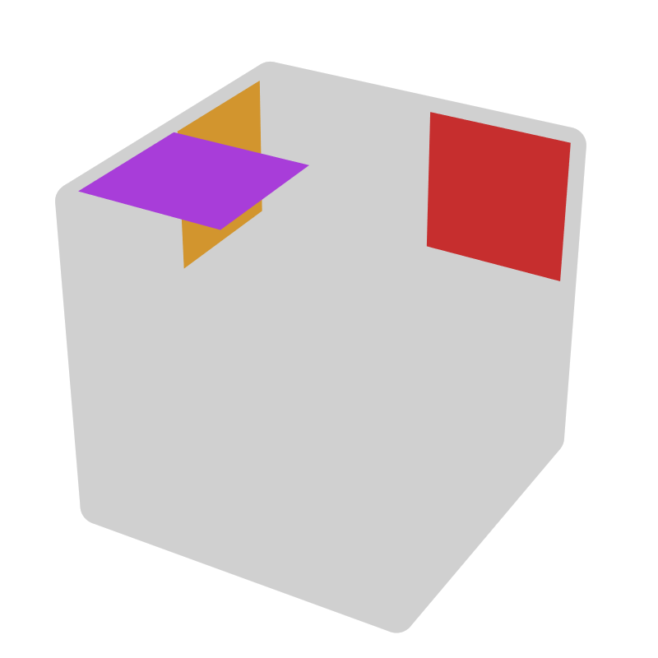
R' D R |  |  | L D' L' |  |  | R U' R | y' (B, R) |  | R' U R' |  | y (F', R')
= y F' R F |  |  | = y' F U' R'
UU - 2 Up [2]
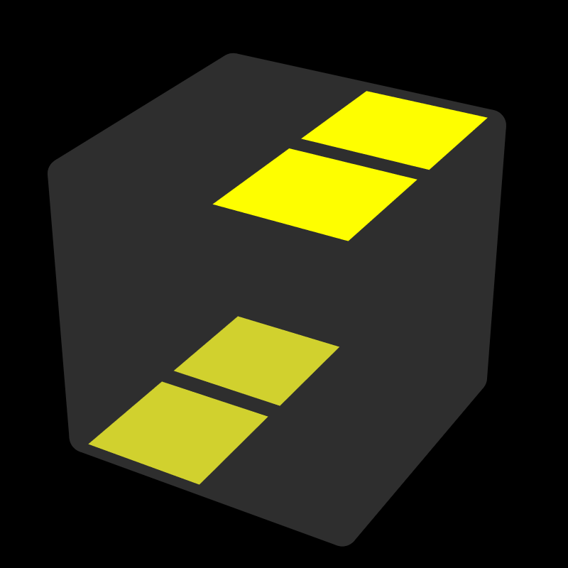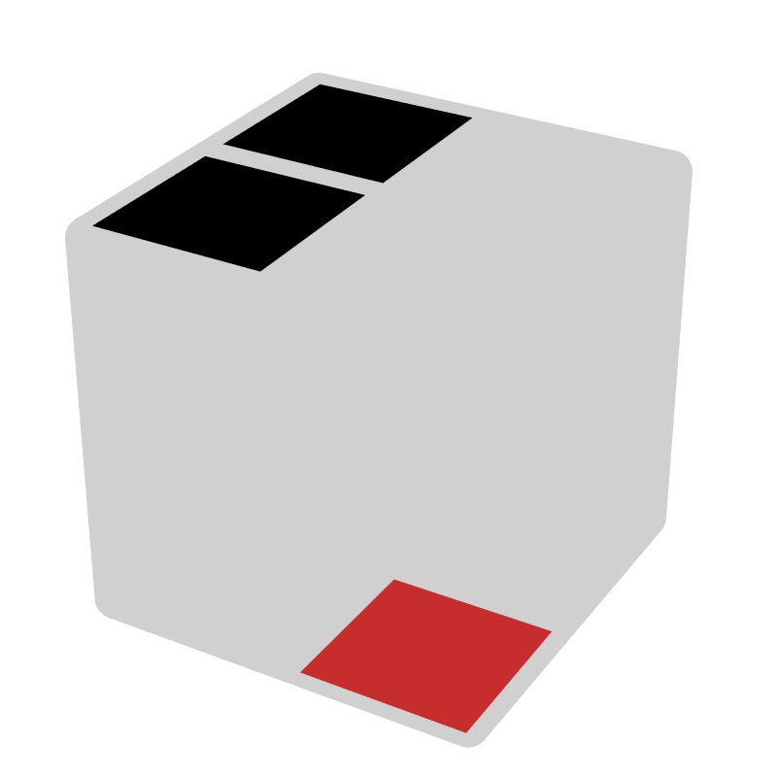 |  |  | 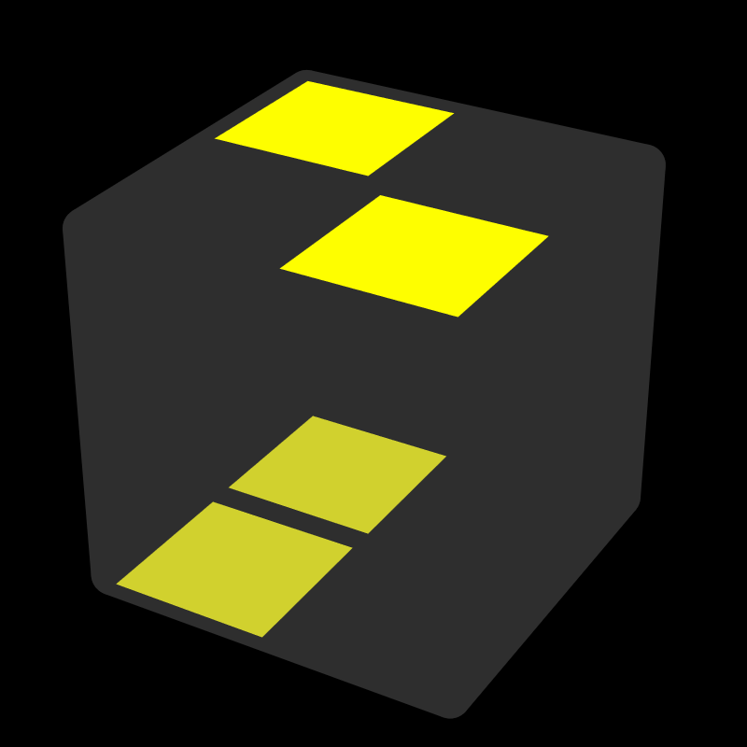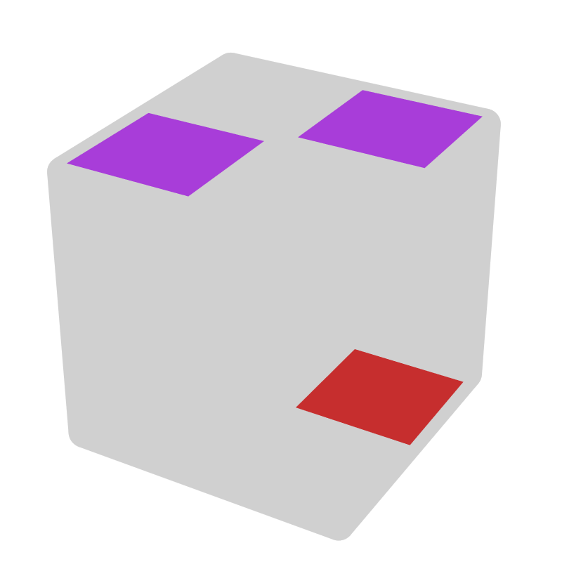 |  |  | 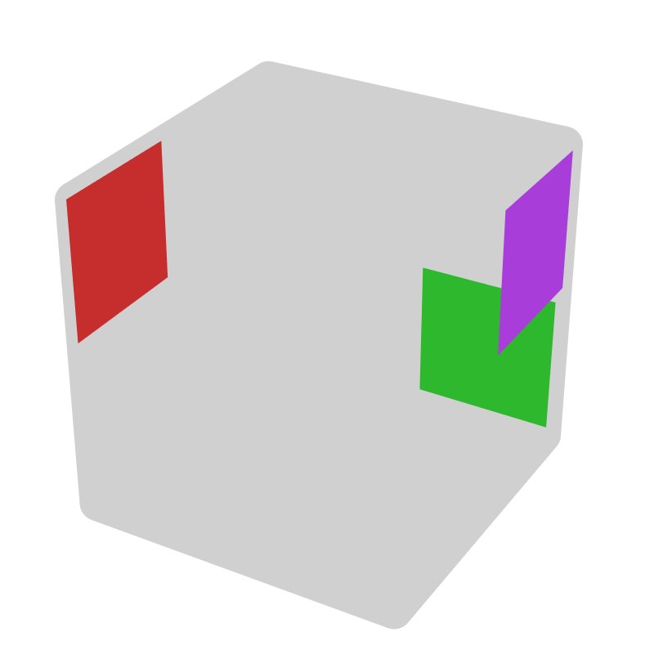* |  |  | *
R2 | R2 |  | R2 U' R2' U' R2 |  | y' B2 | R' U' R U' R2' | y2 z (-, B2) |  | R U R' U R2 |  | y2 z (+, F)
 |  |  | U' R2 U R2' U R2
UU - 1 Up [6]
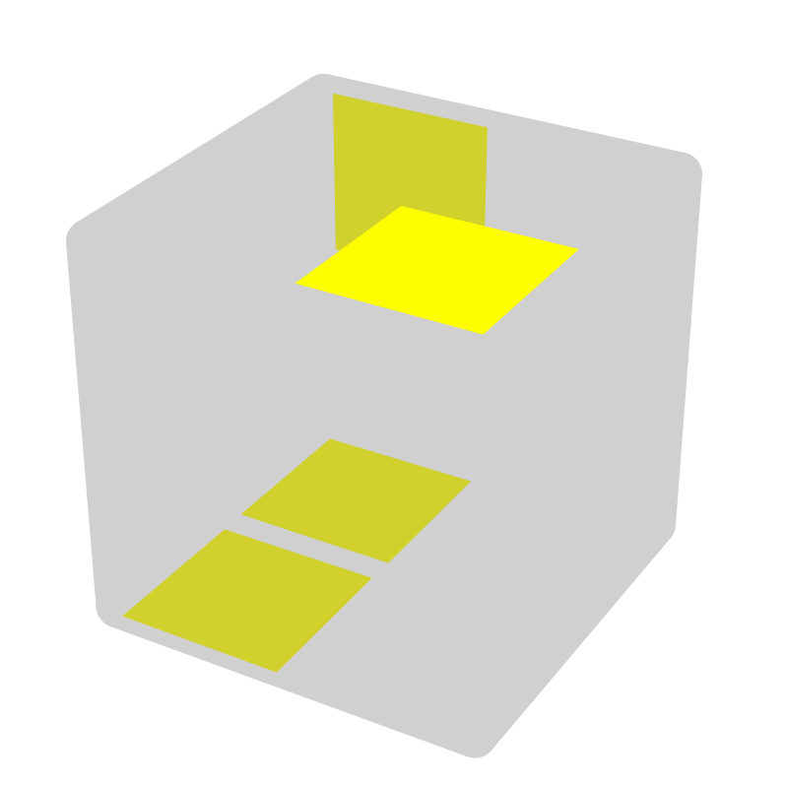 |  |  |  | 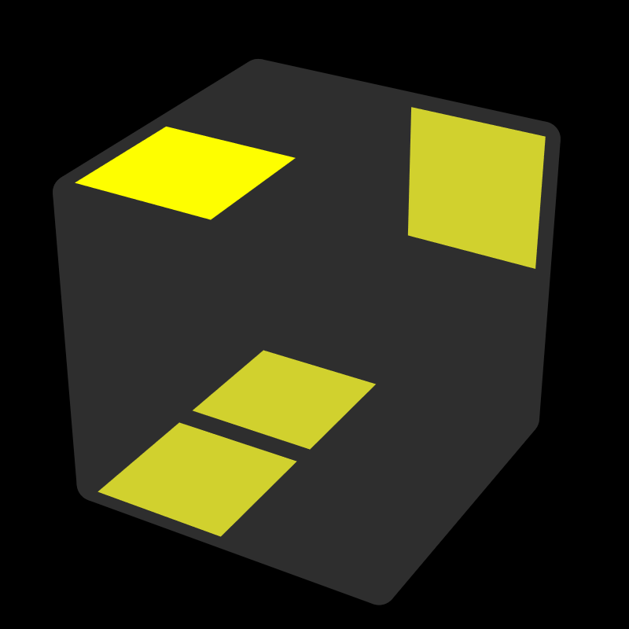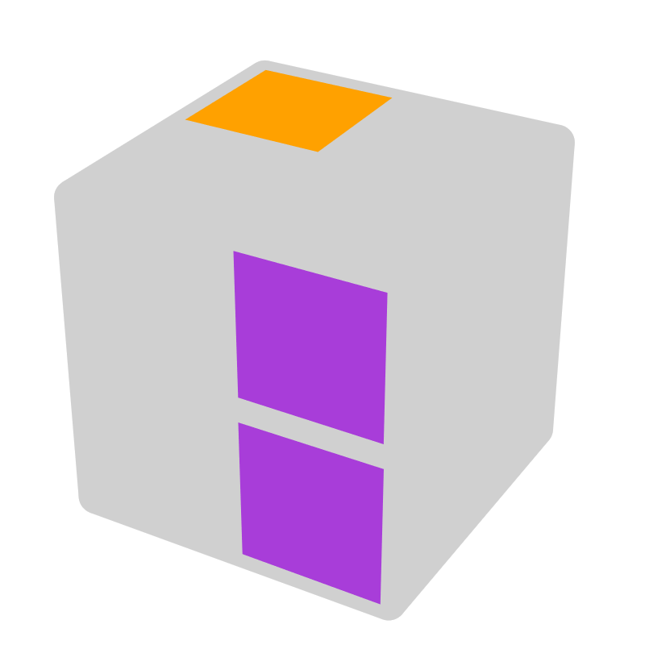* |  |  |  | 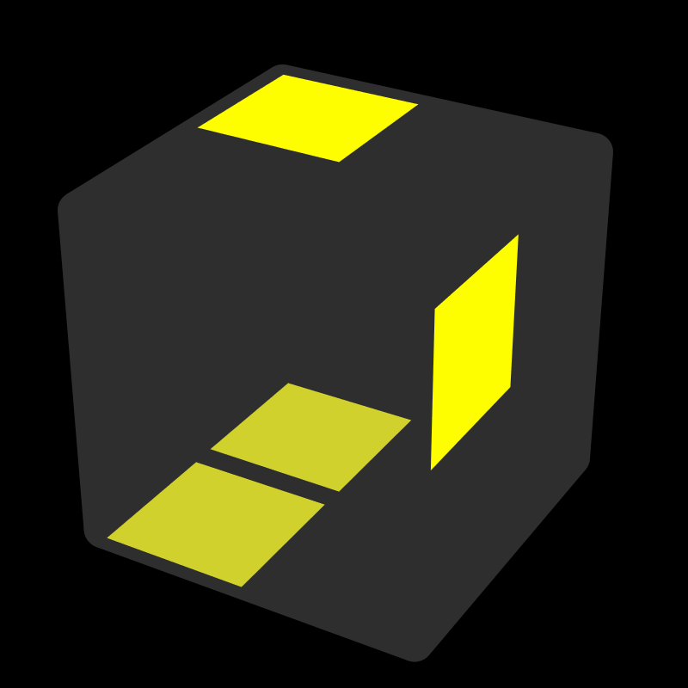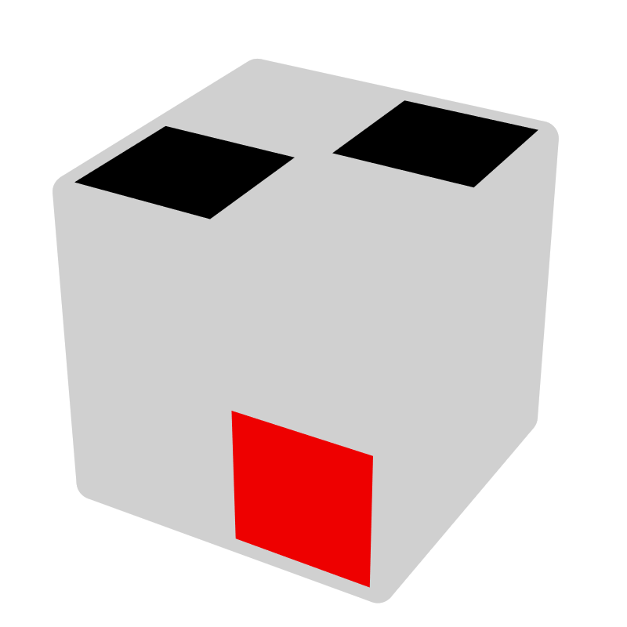*
R' U2 R' |  | z2 x' R2 |  | R' U' R2 |  | x L U' |  | R' U R U' R |  | R
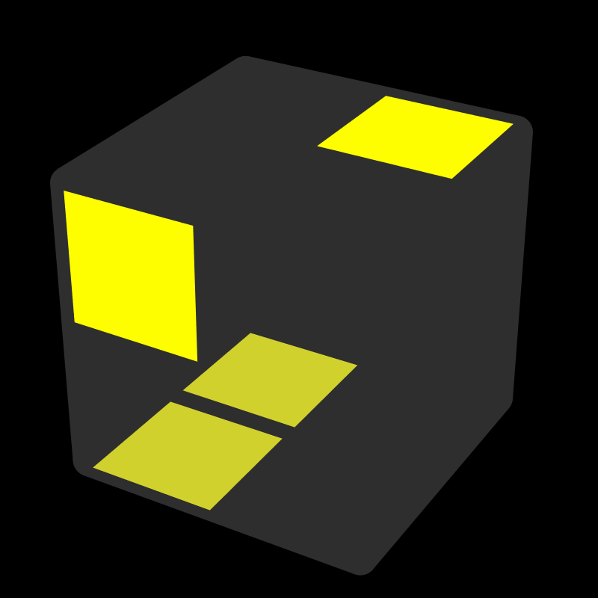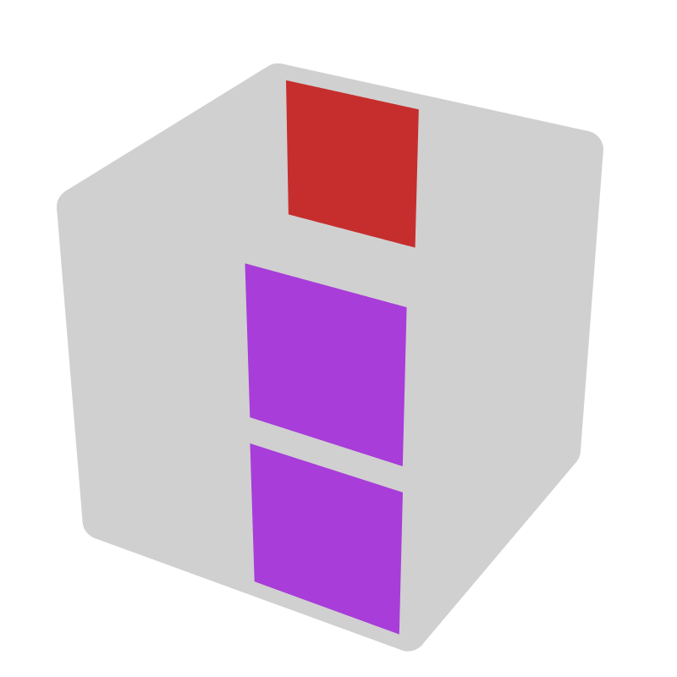 |  |  |  | 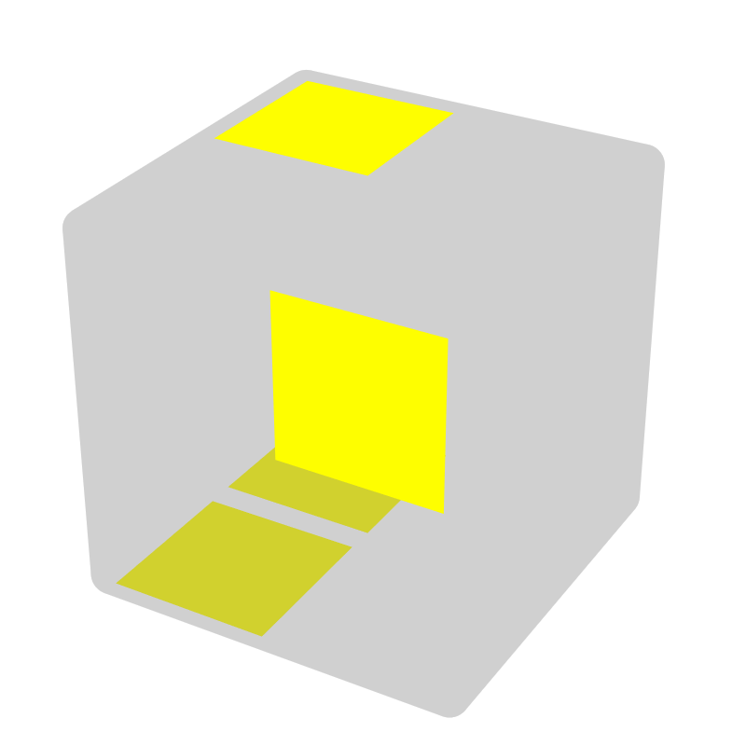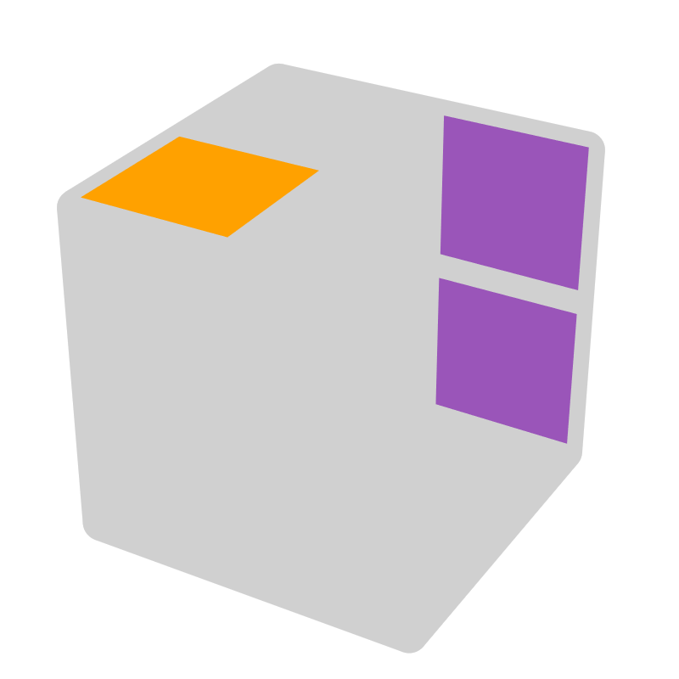* |  |  |  | 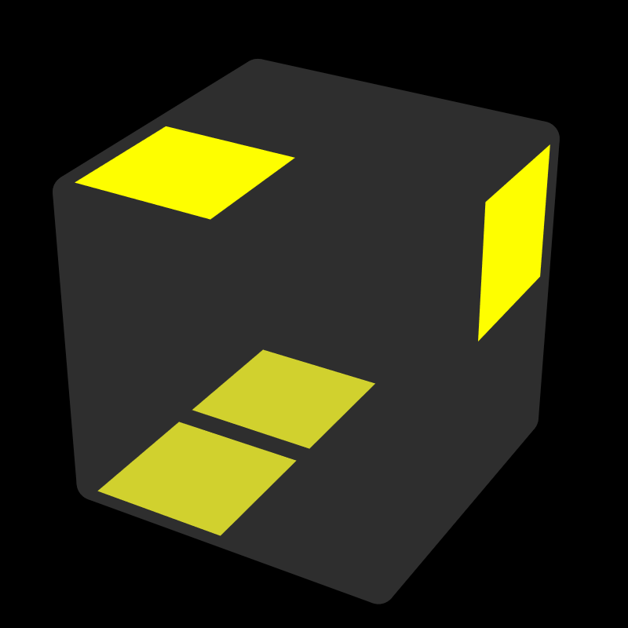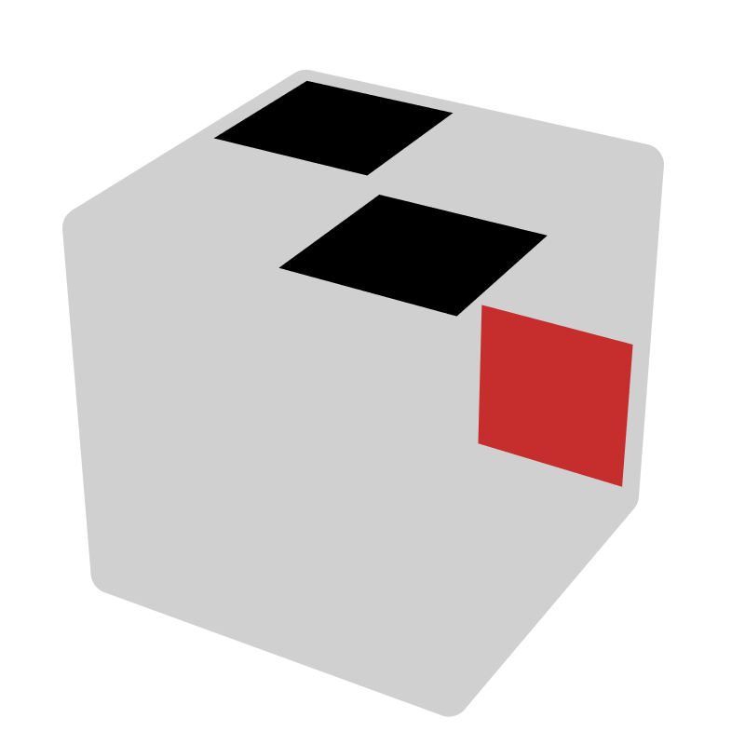*
R U2 R |  | z2 x R2 |  | R U R2' |  | x' L' U |  | R U' R' U R' |  | R'
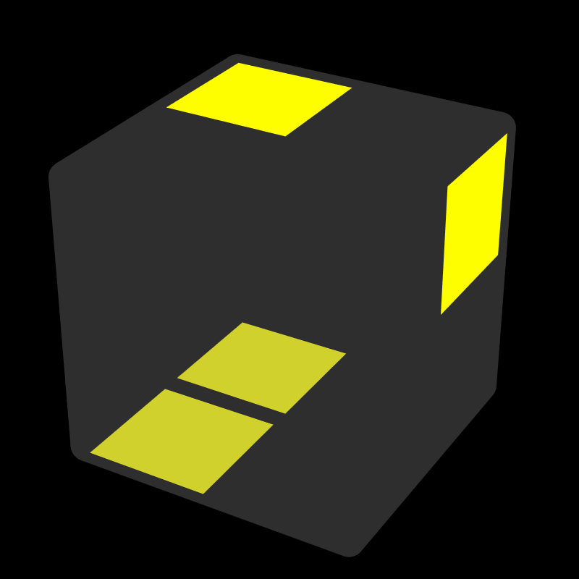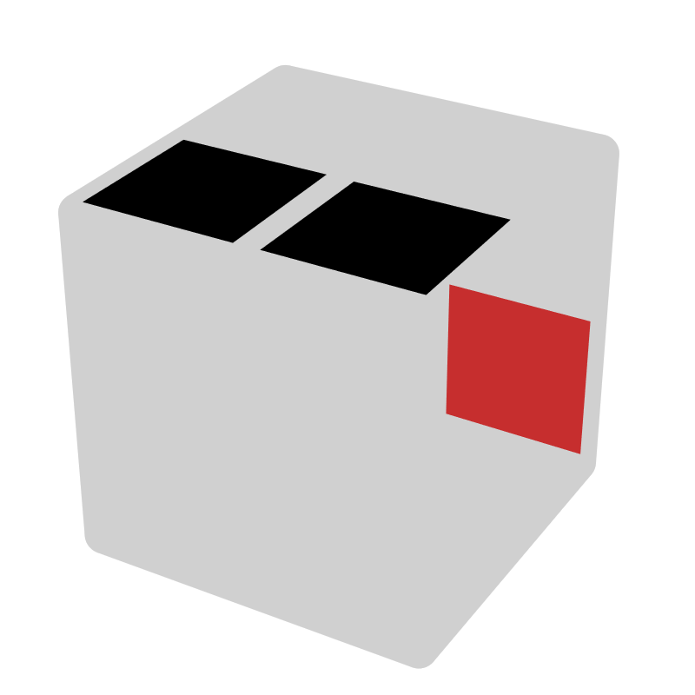 |  |  |  | 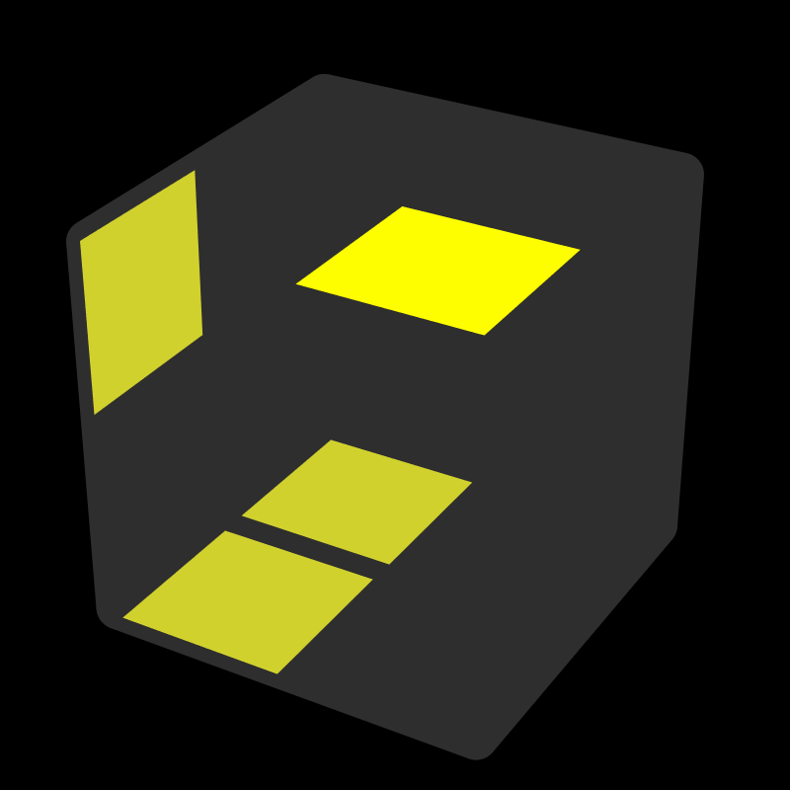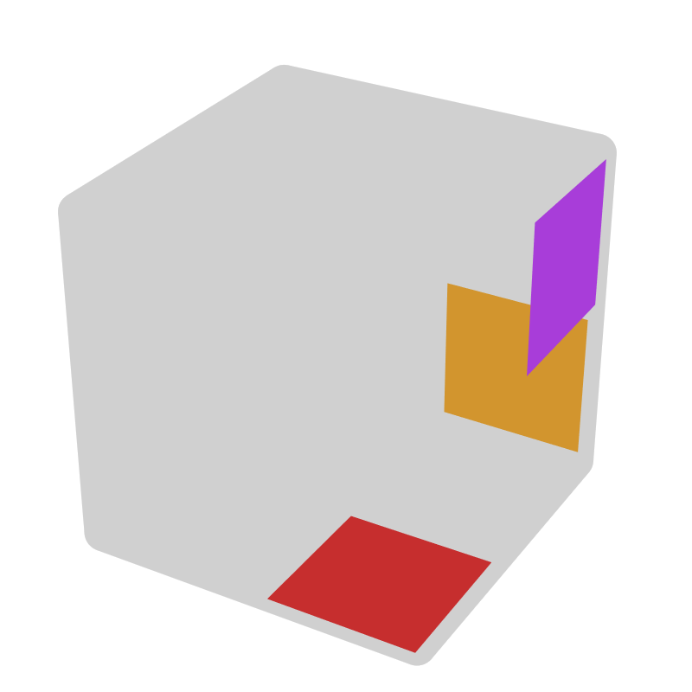* |  |  |  | 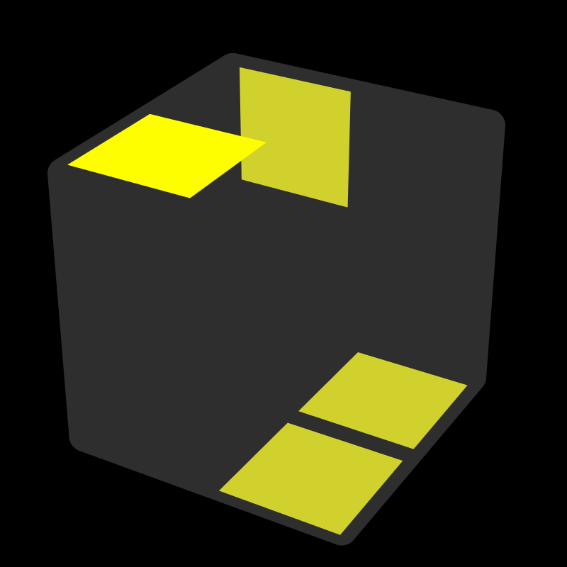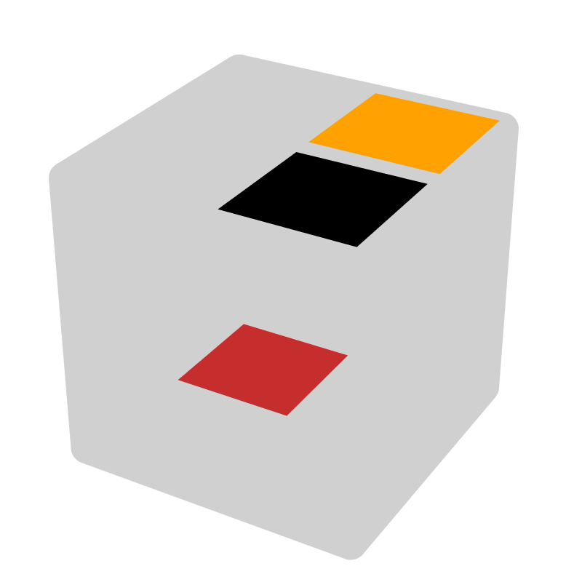*
R2' U R U' R |  | R' |  | R' U' R' |  | y2 z (B', L') |  | L' F U' F' |  | R2, U'
 |  |  |  |  |  |  |  | = y' F' R U' R' = y2 R' F R' F'
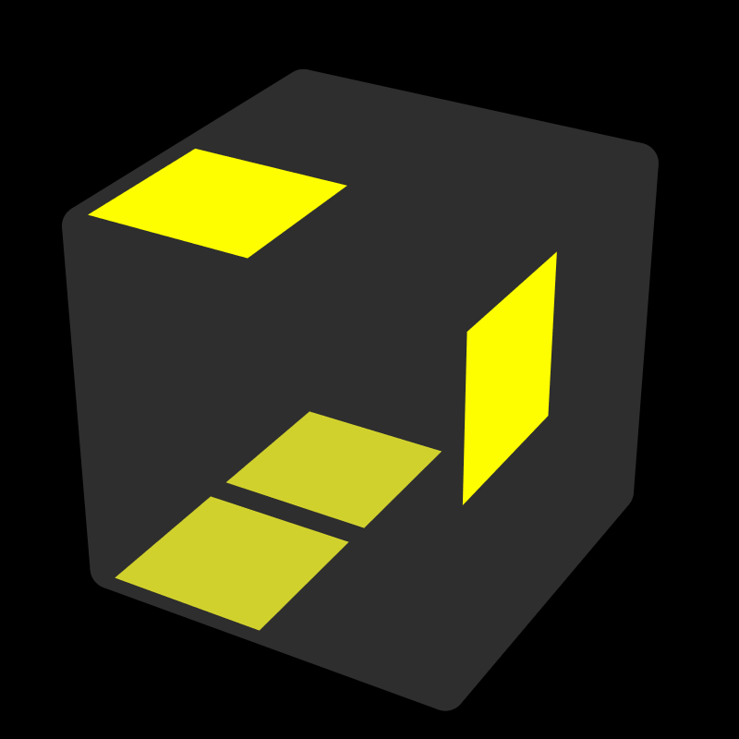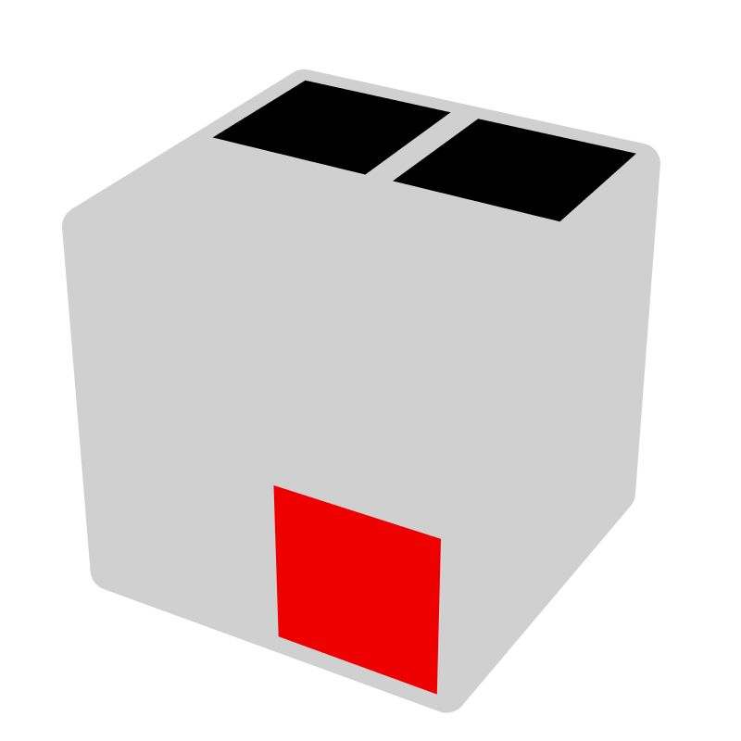 |  |  |  | 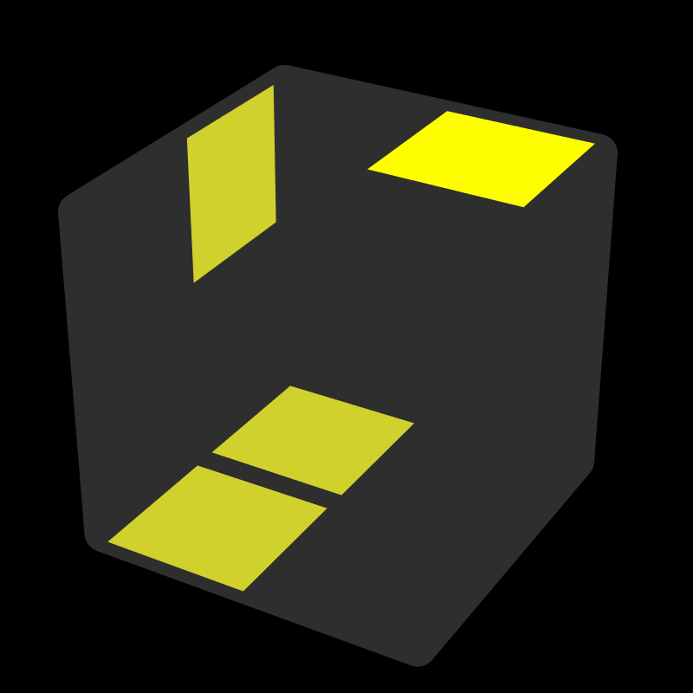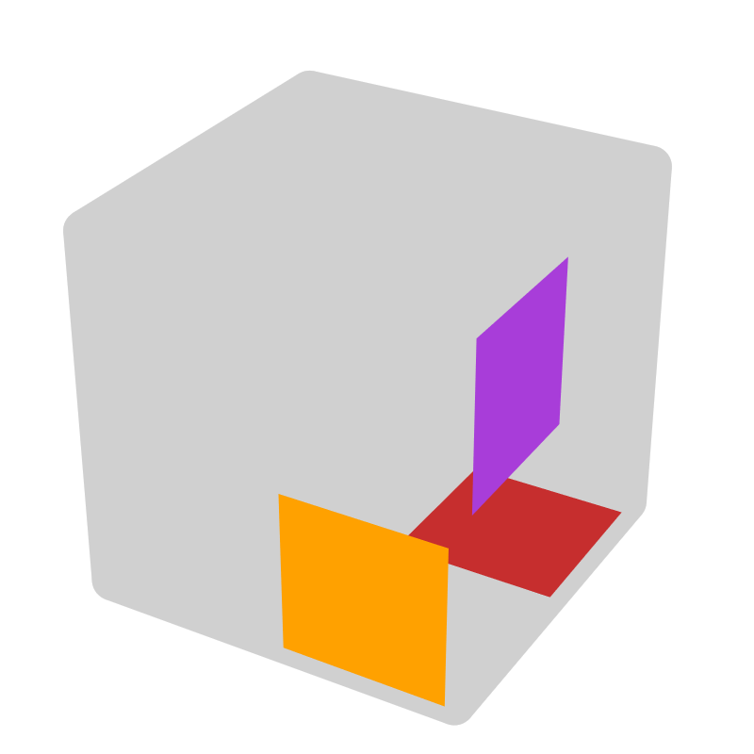* |  |  |  | 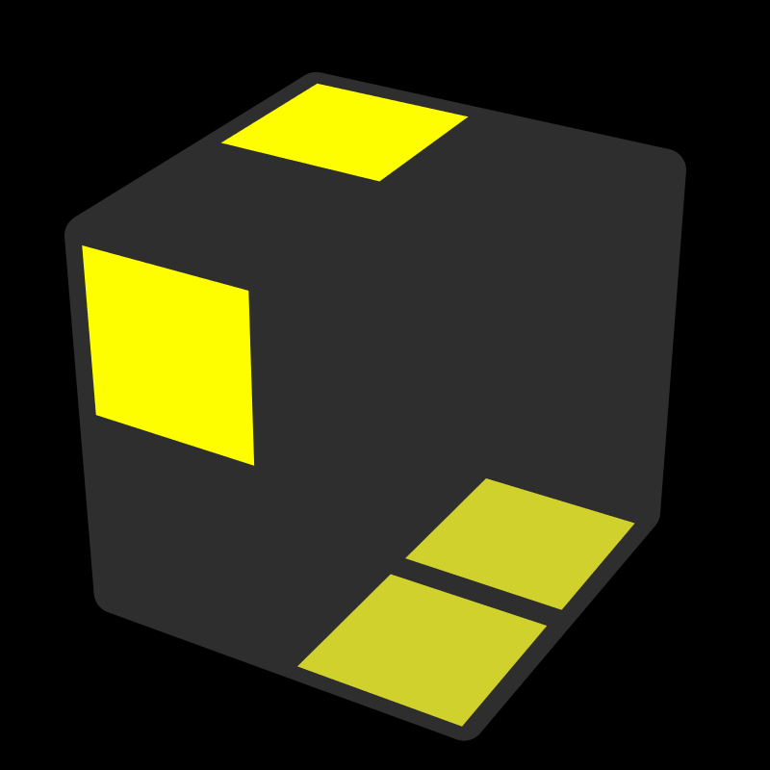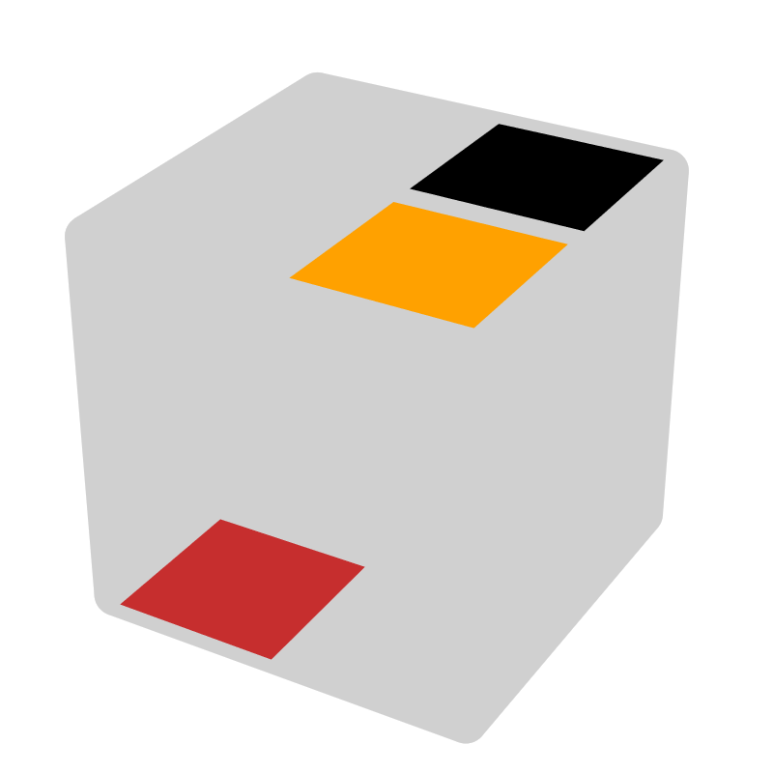*
R2 U' R' U R' |  | R |  | R U R |  | y2 z (F, L) |  | L F' L F |  | L2, U
 |  |  |  |  |  |  |  | = y' F R' F R = y2 R F' U F
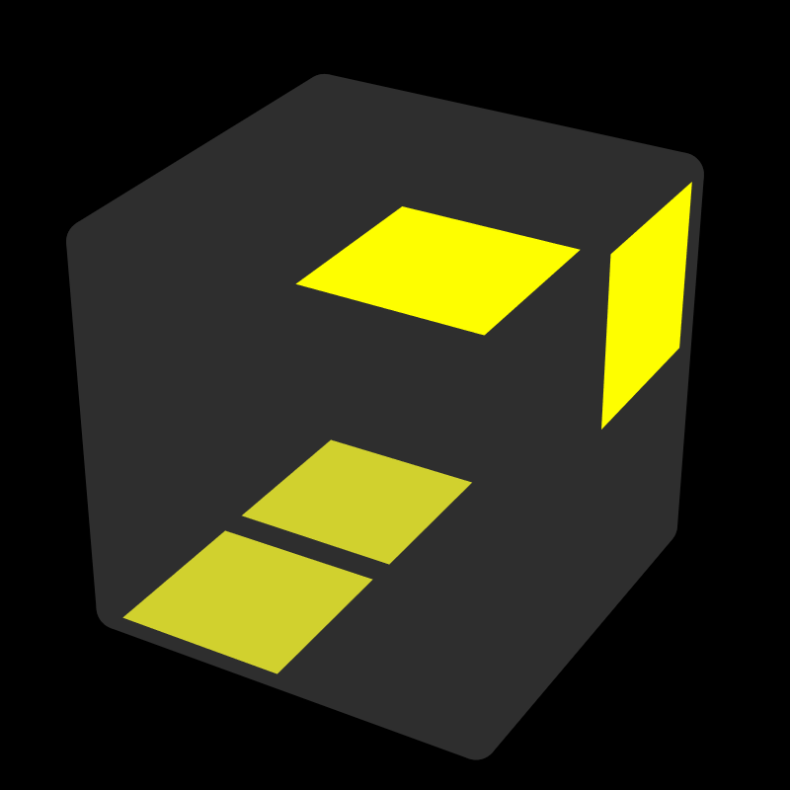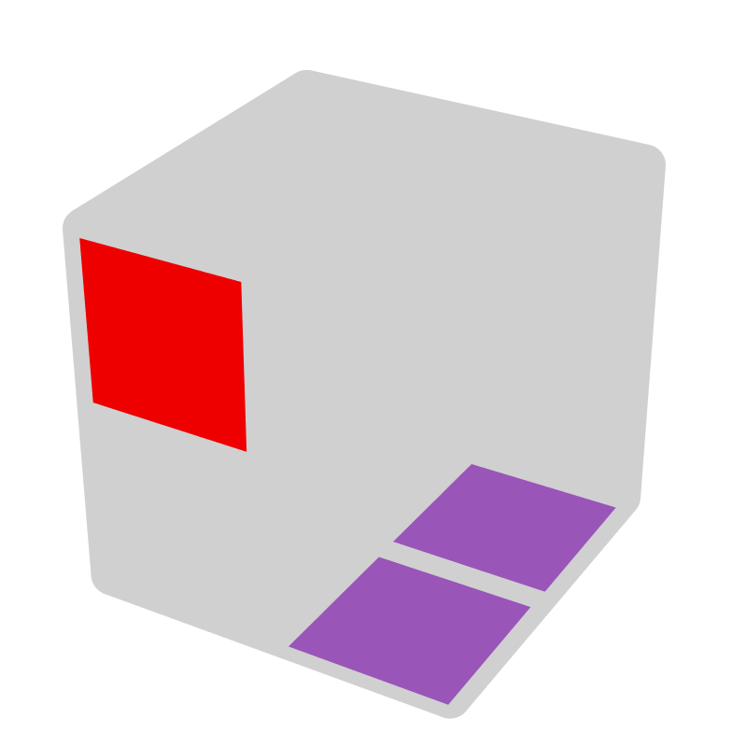 |  |  | 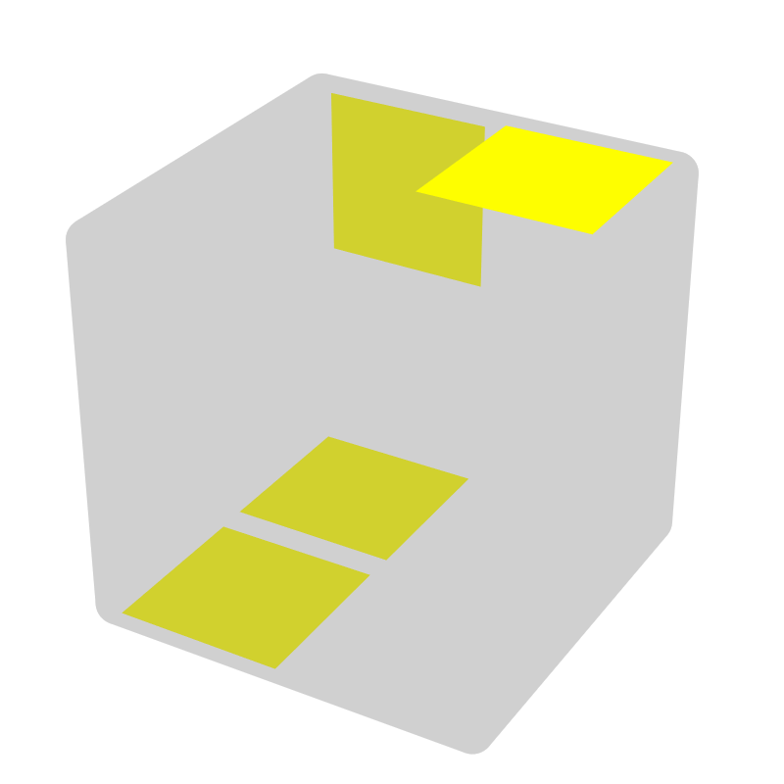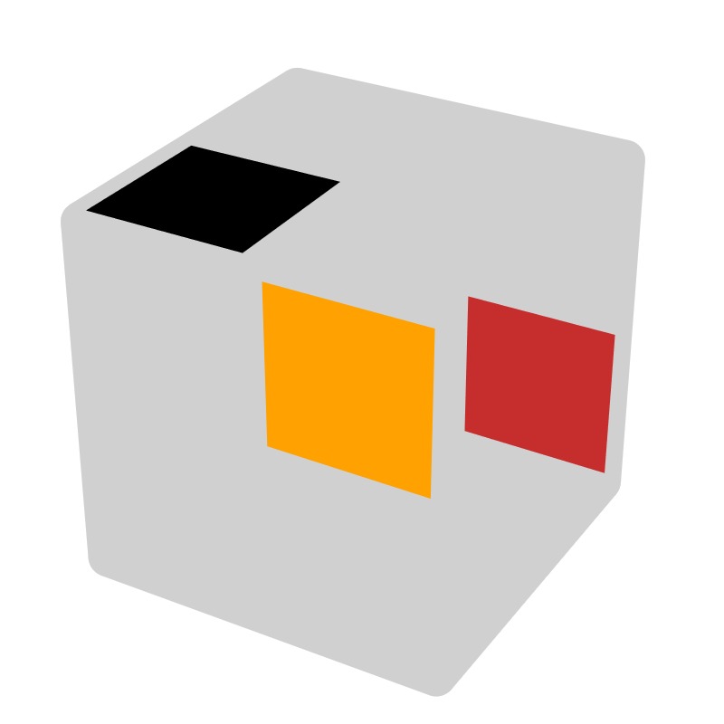* |  |  | 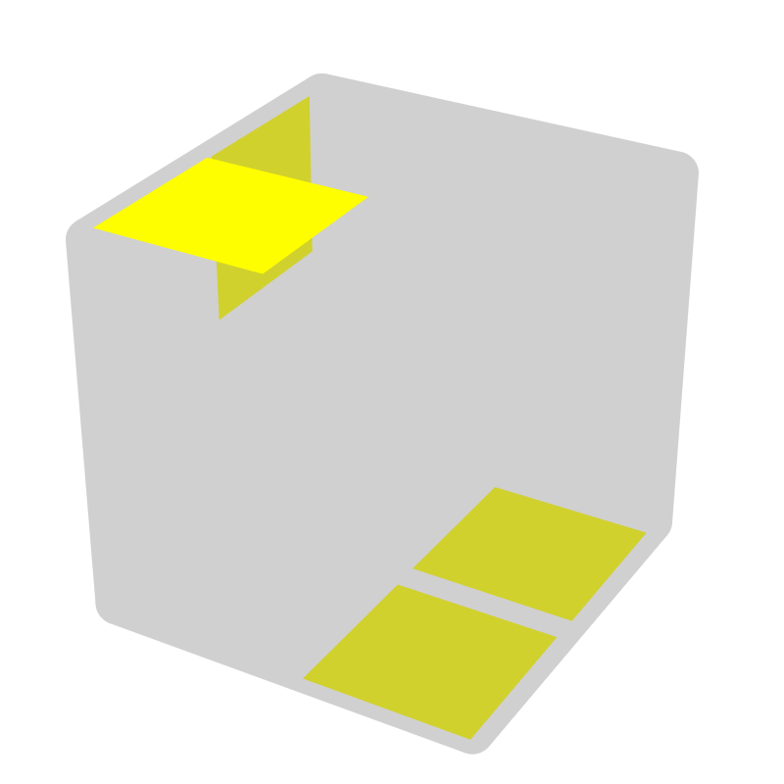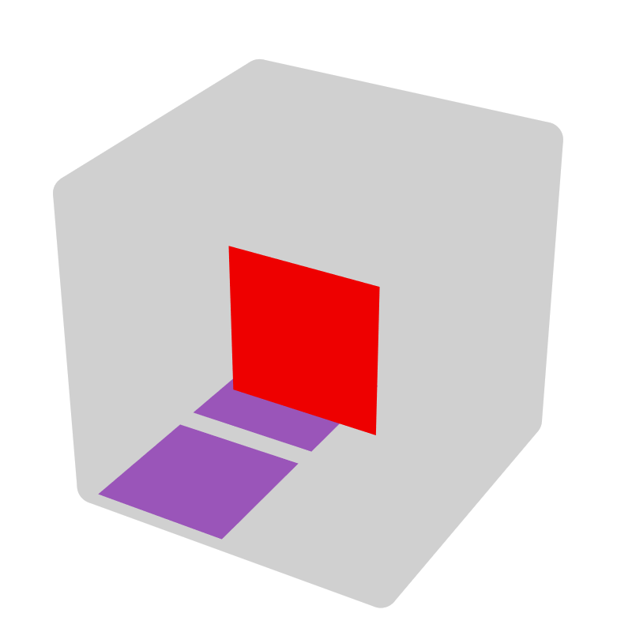 |  |  | 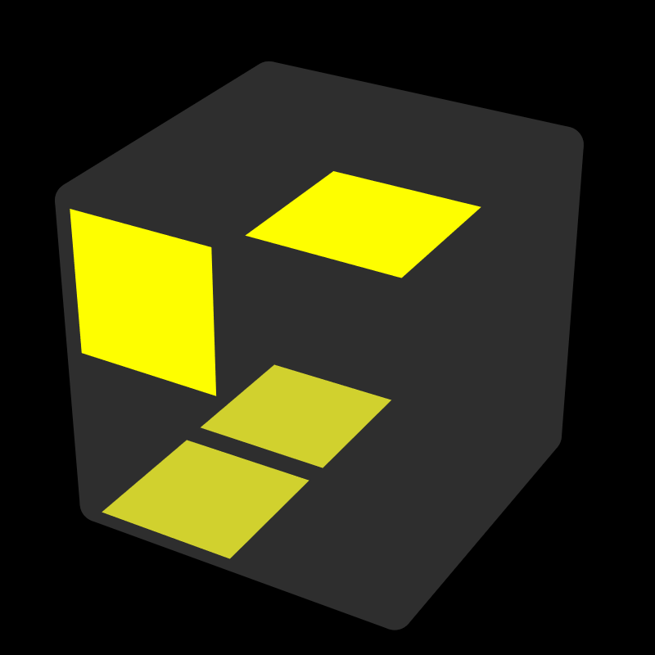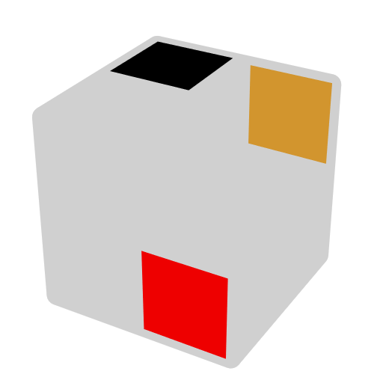*
R2' F R U' R' | x2 L |  | R2 U R' U' R |  | R', R U' | L2 F' L' U L | x2 R' |  | R2' U' R U R' |  | R, R' U
UU - 0 Up [7]
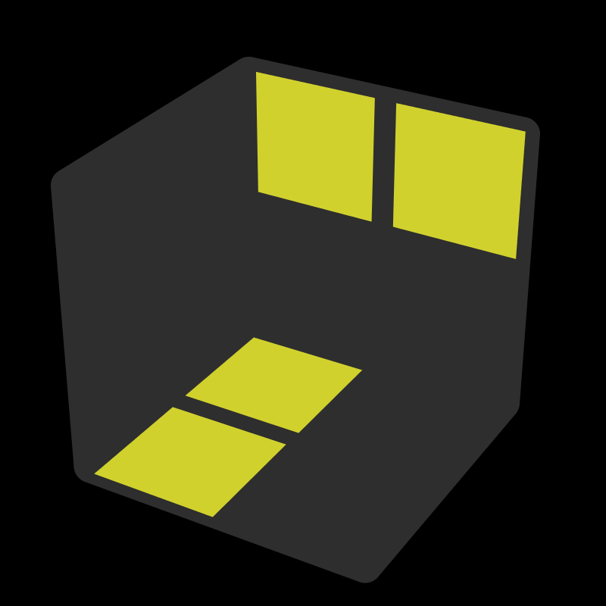 |  |  | 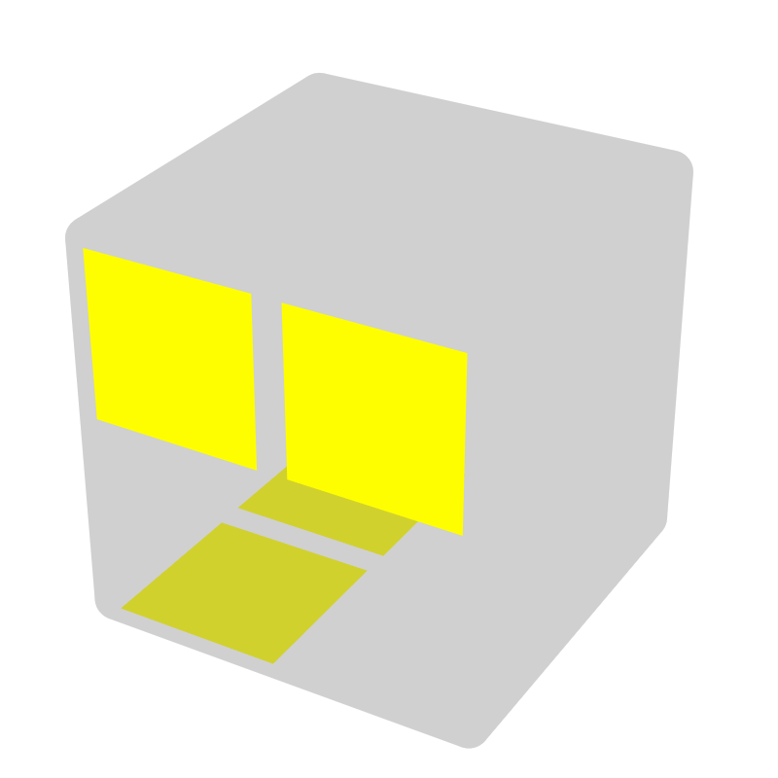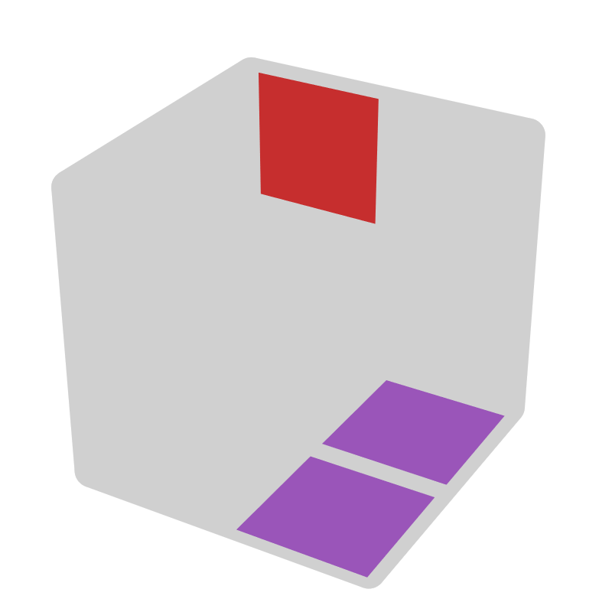* |  |  | 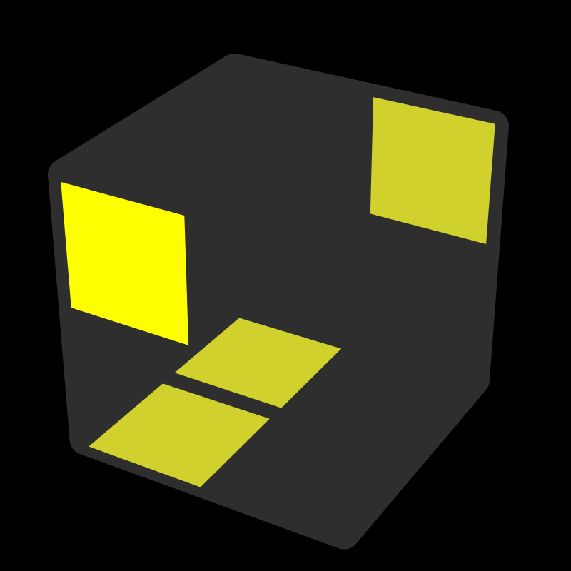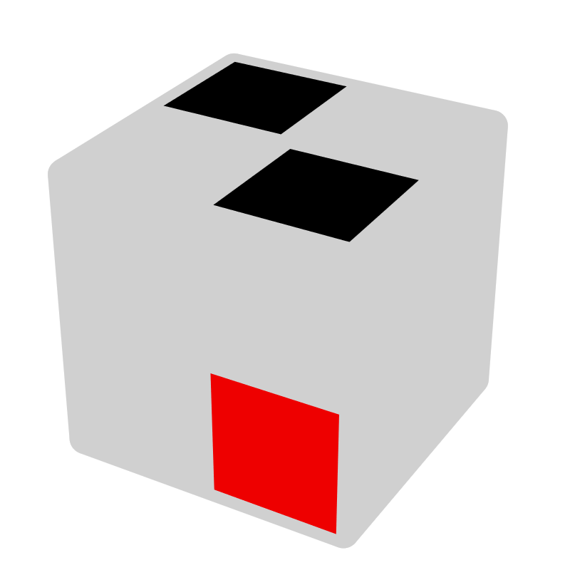 |  |  | 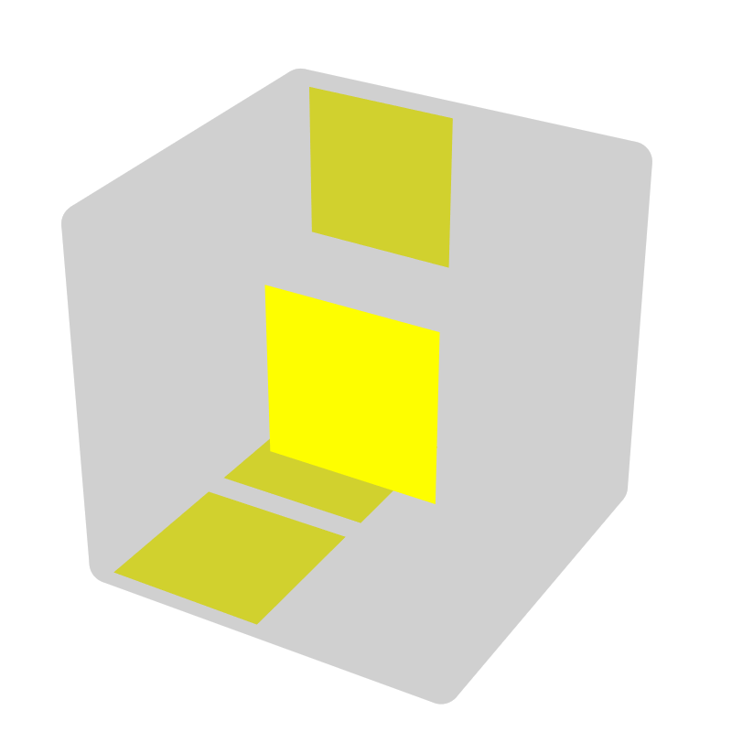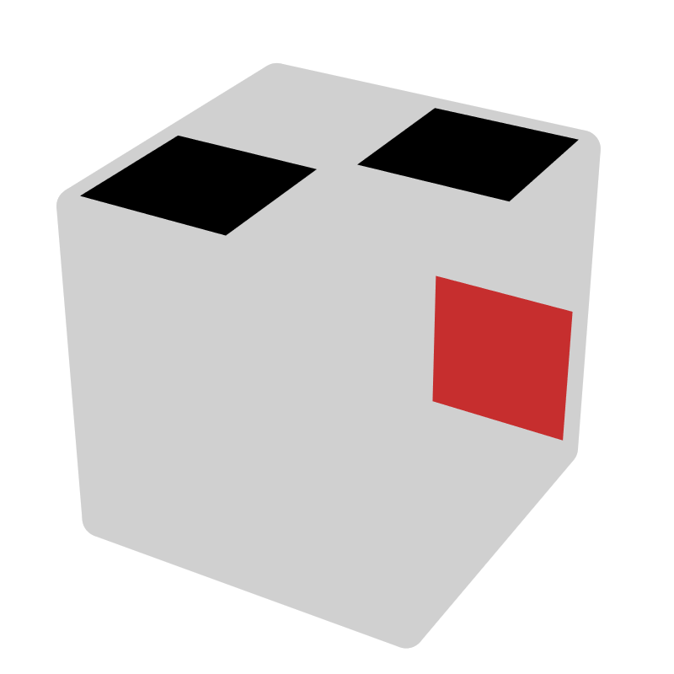
R2 U2' R' | z2 R |  | R2' U2' R |  | z2 R' | R U' R U R' | R U' |  | R' U R' U' R |  | R' U
U' R' U' R2 U R'
U' R U R2' U' R
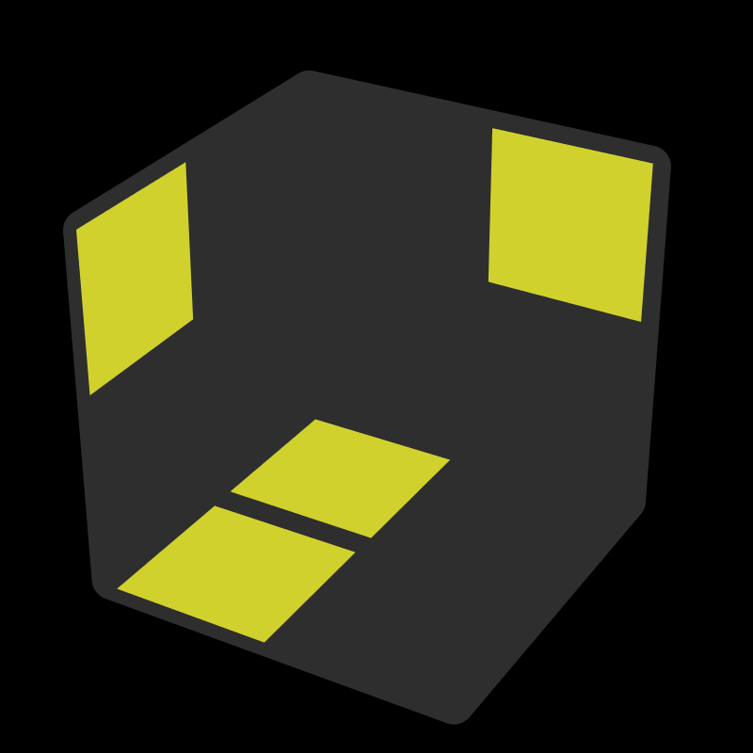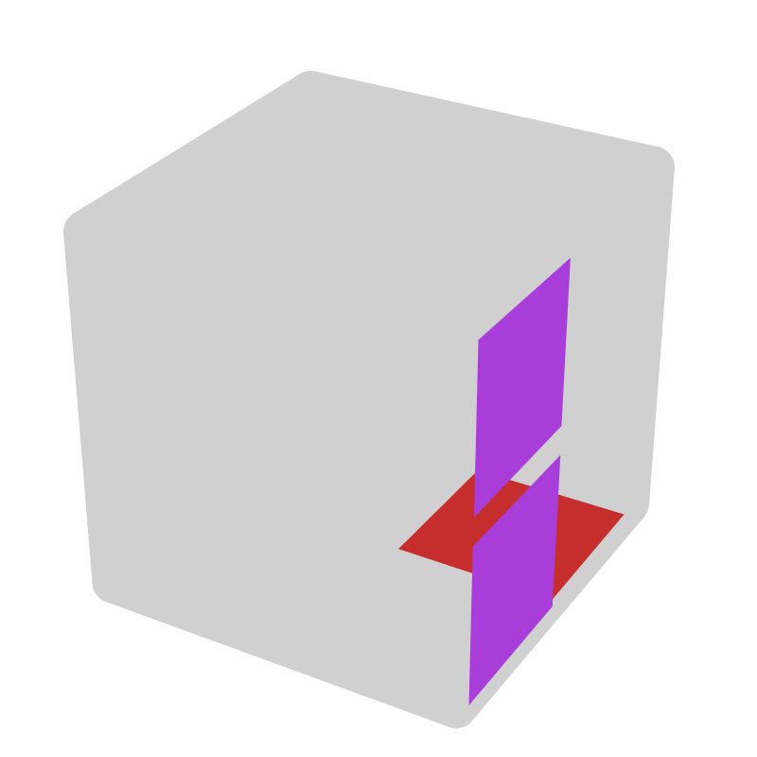 |  |  | 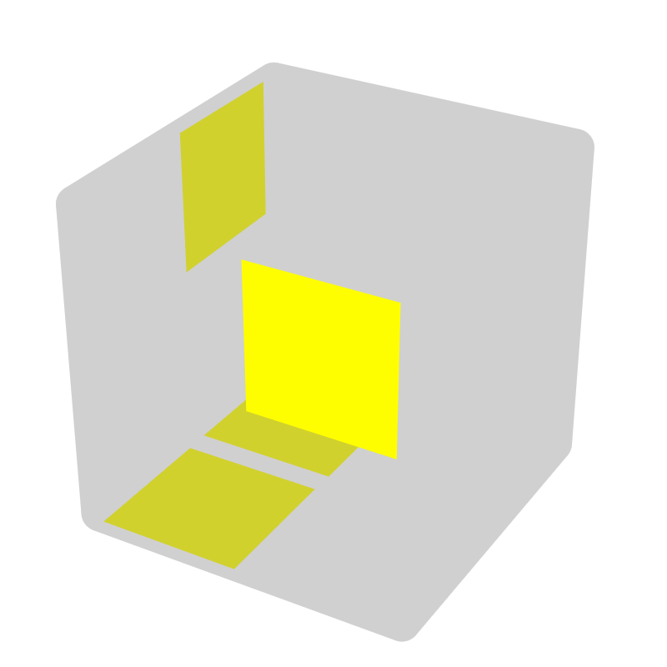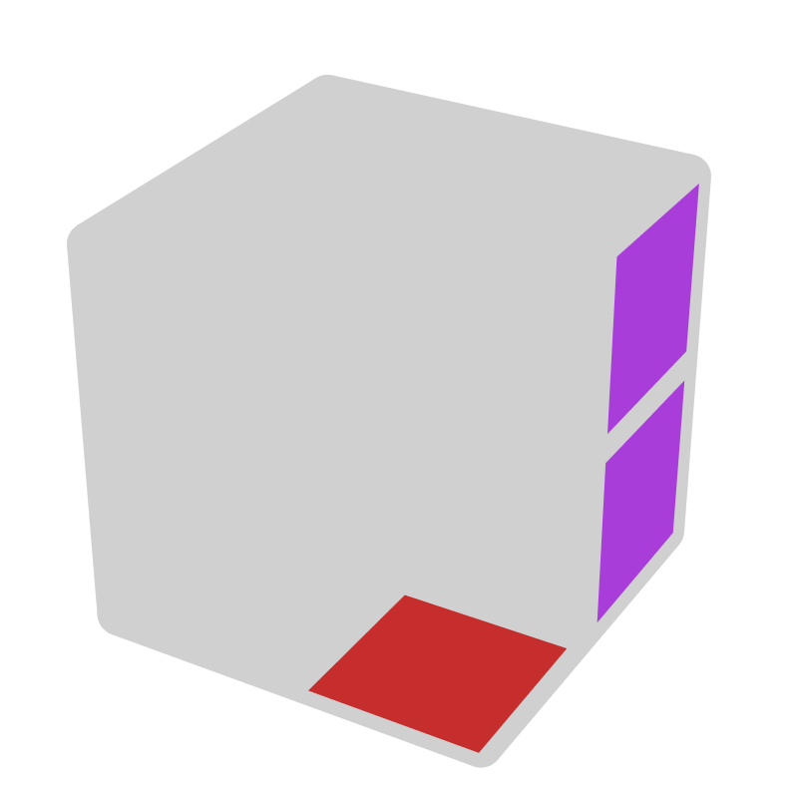* |  |  | 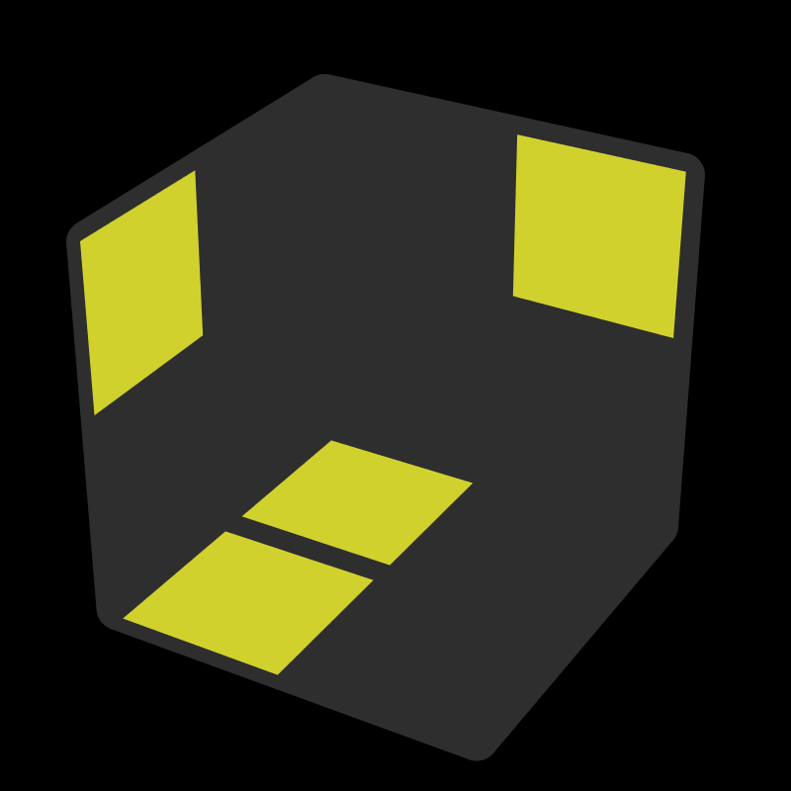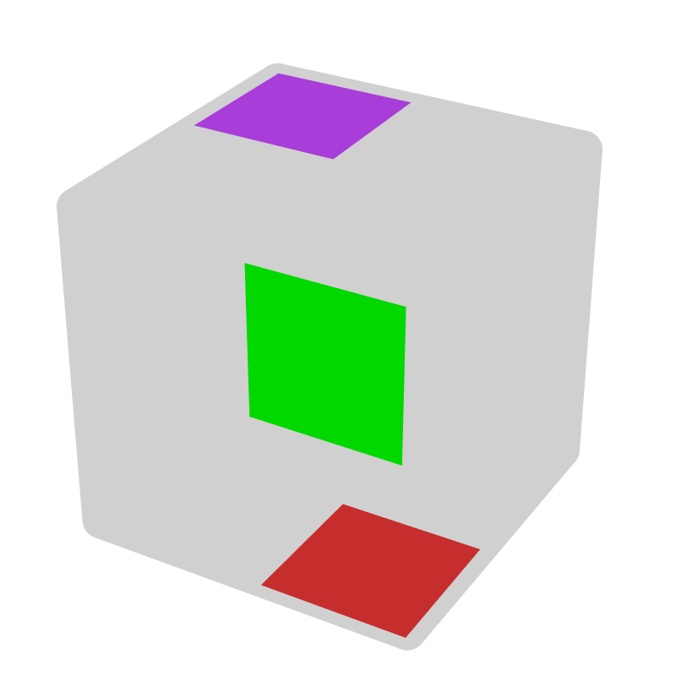* |  |  | 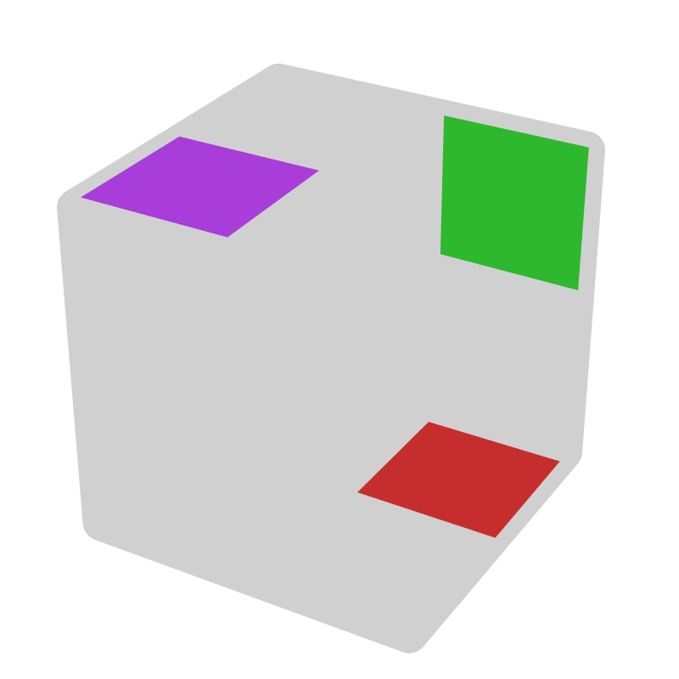*
R U R U2' R' | z' B |  | R' U' R' U2' R |  | z' F' | R2 U' R' | y' (+, B2) |  | R2' U R |  | y' (-, F2)
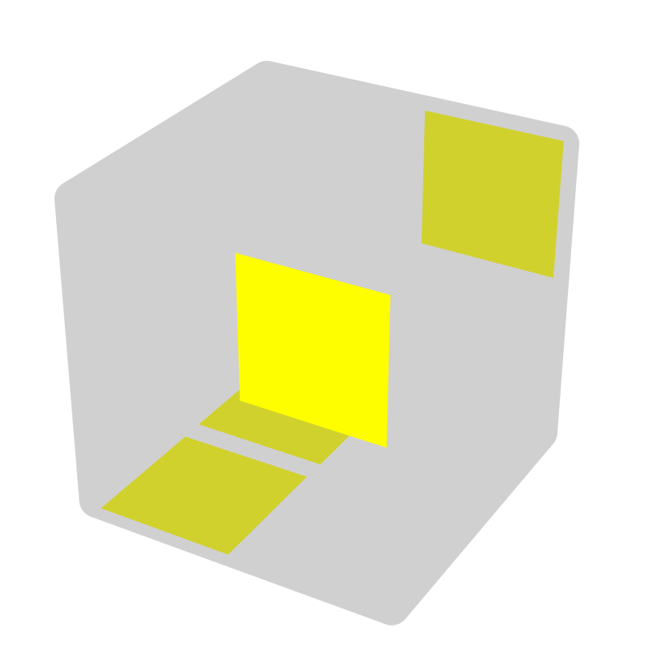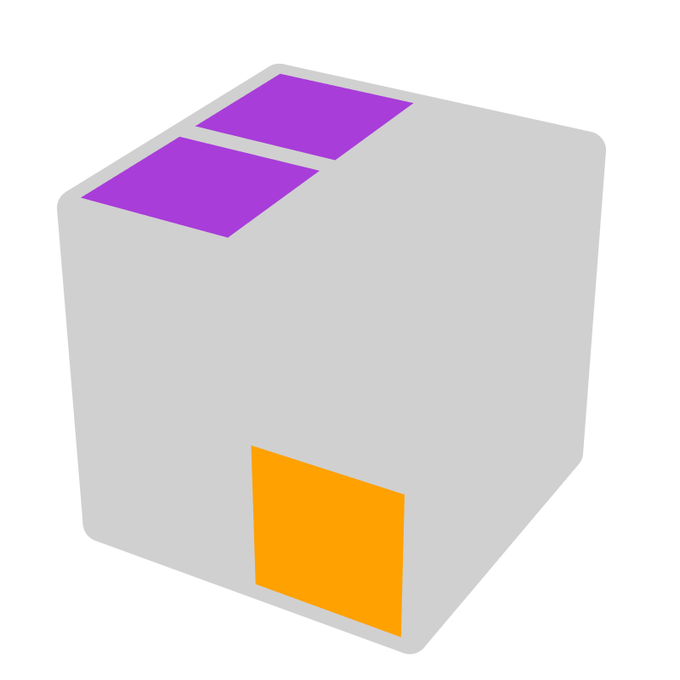 |  |  | 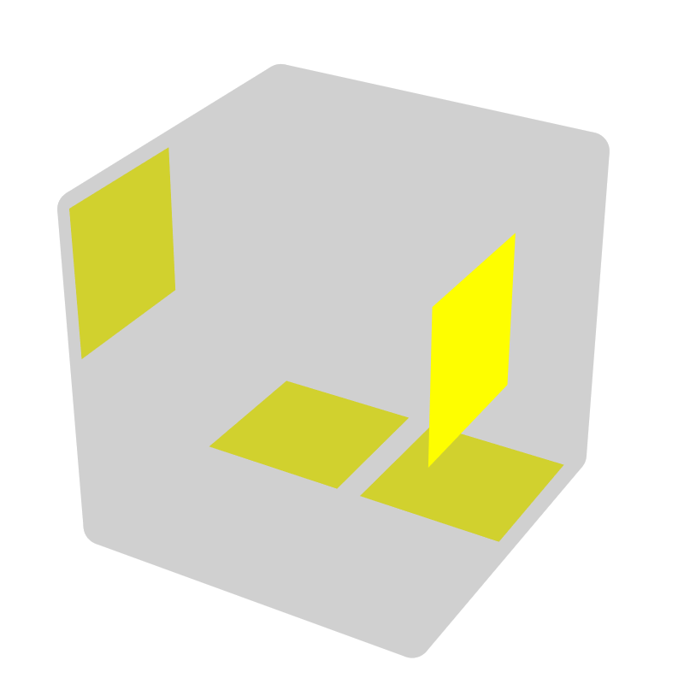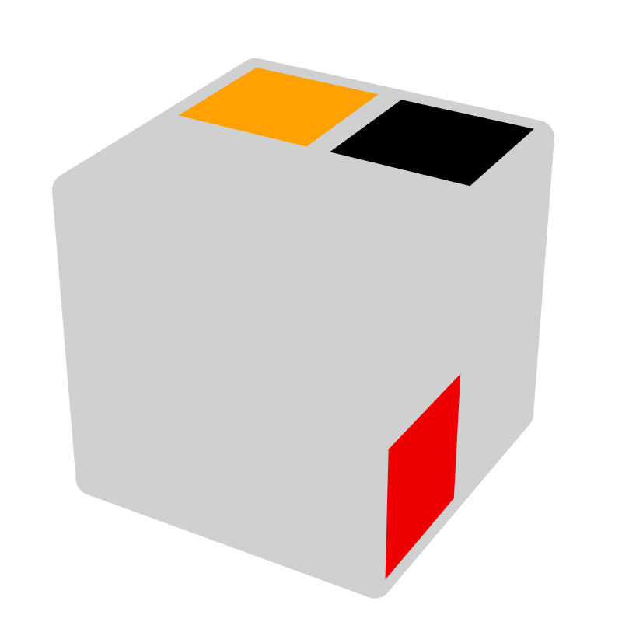* |  |  | 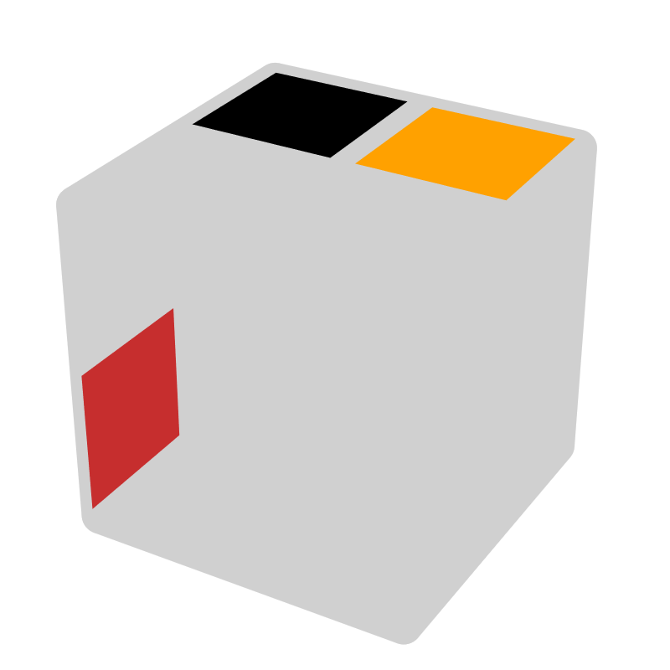* |  |  | 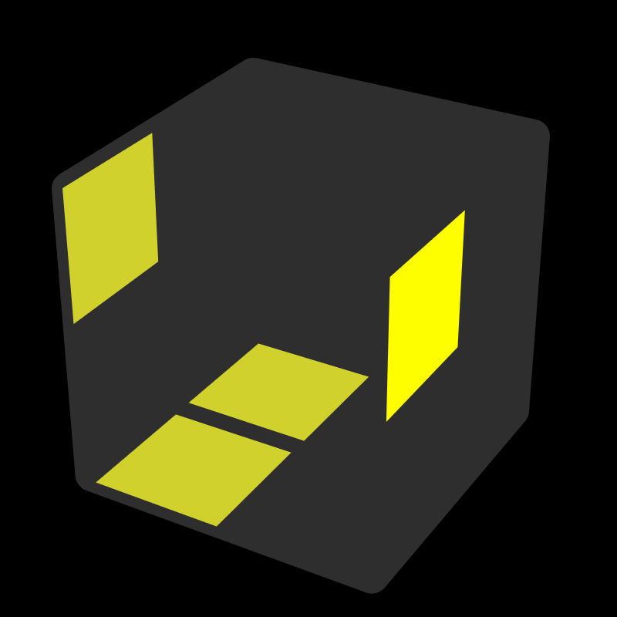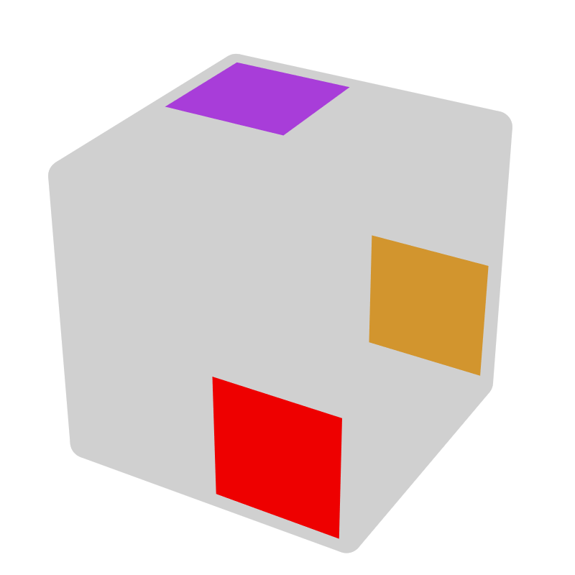*
R U2' R2' U' R2 | y2 L U' |  | F' R2 U' R2' |  | F', U' | F L2' U L2 | F, U |  | R U' R' U R' U' R |  | y' (B, B')
= R' U2' R2 U R2' |  |  |  |  |  |  |  |  | = R' U R U' R U R'
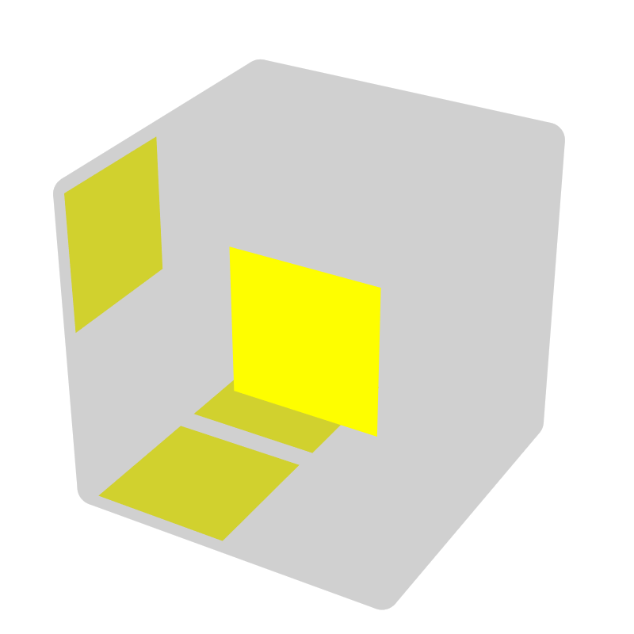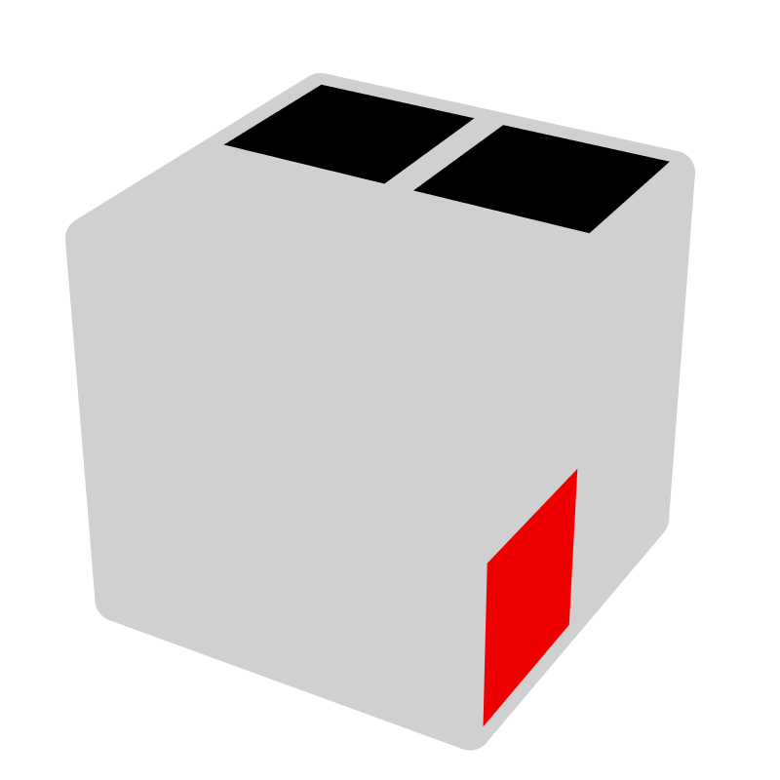 |  |  | 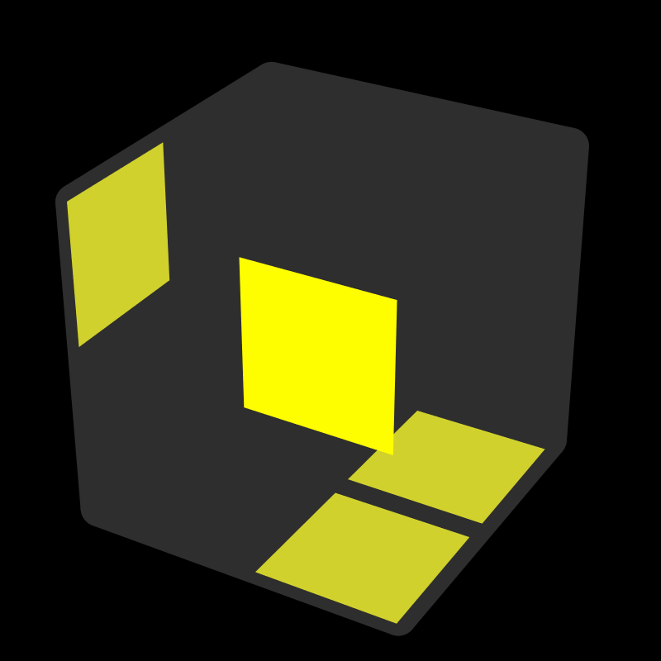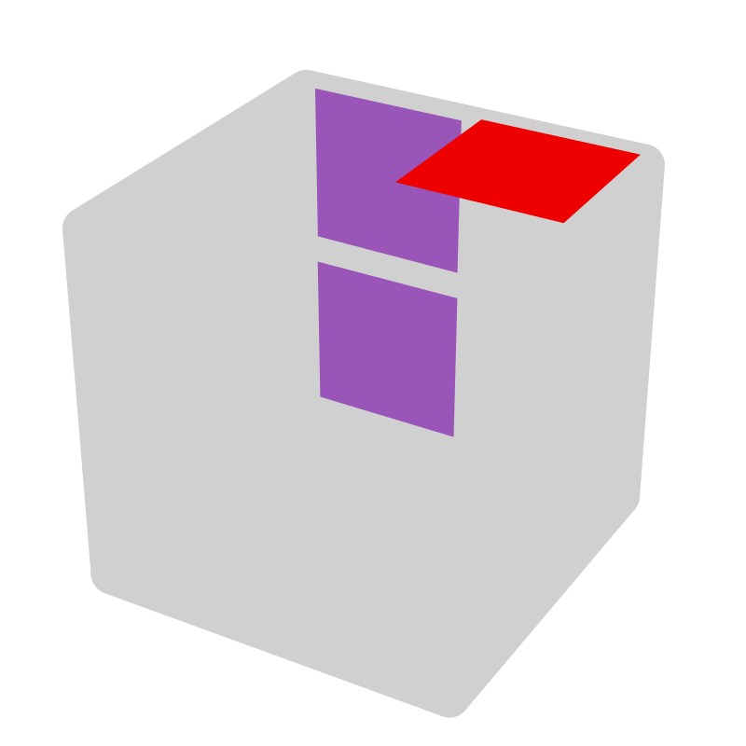* |  |  | 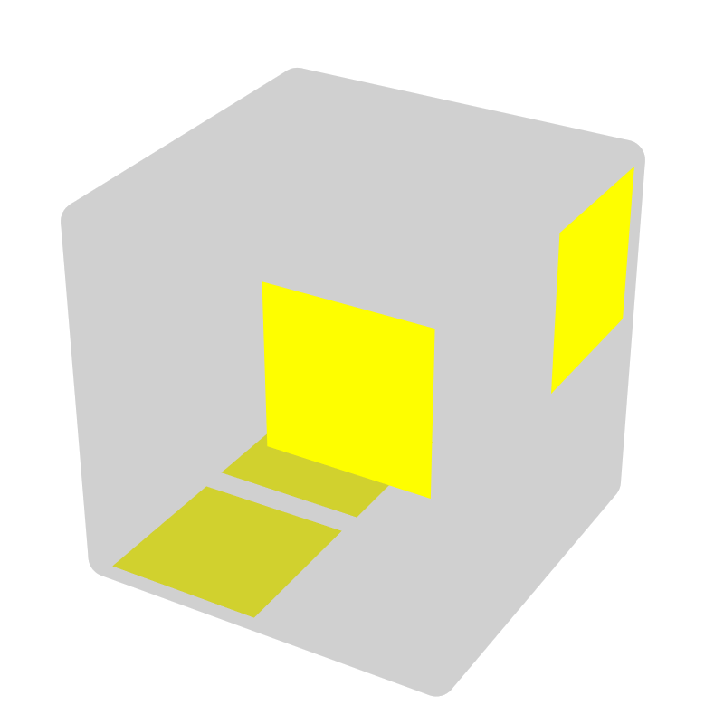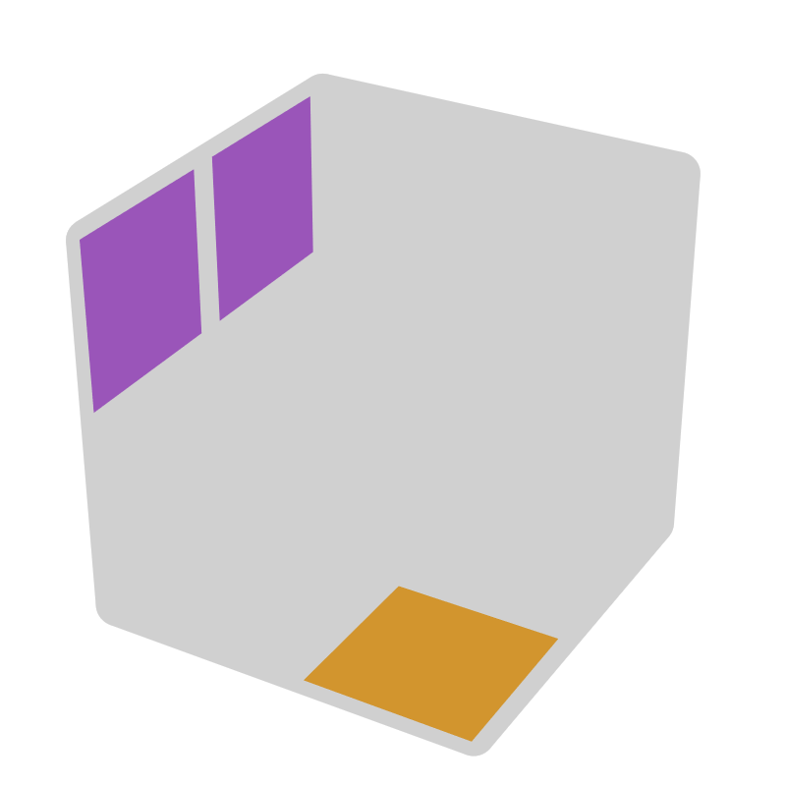* |  |  | 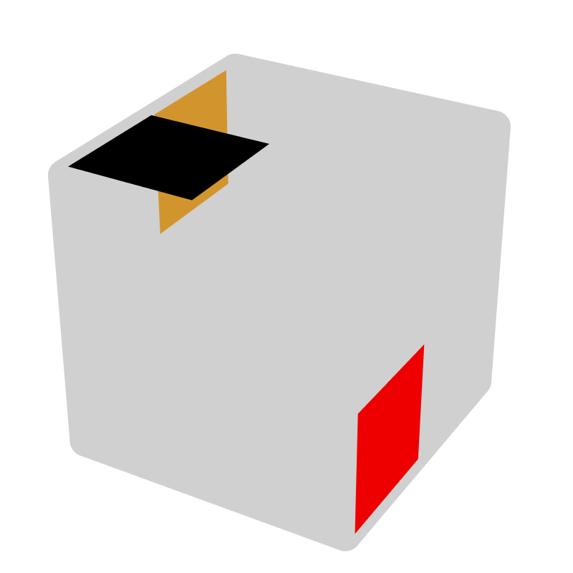*
R U' R U R2' | F' |  | L F' L' U L' U' L2 |  | x' R | R' U R' U2' R | z y' D' F |  | R' U' F R F' |  | F', B'
R' U2 R' U' R |  |  |  |  |  | R' U2 R' U R
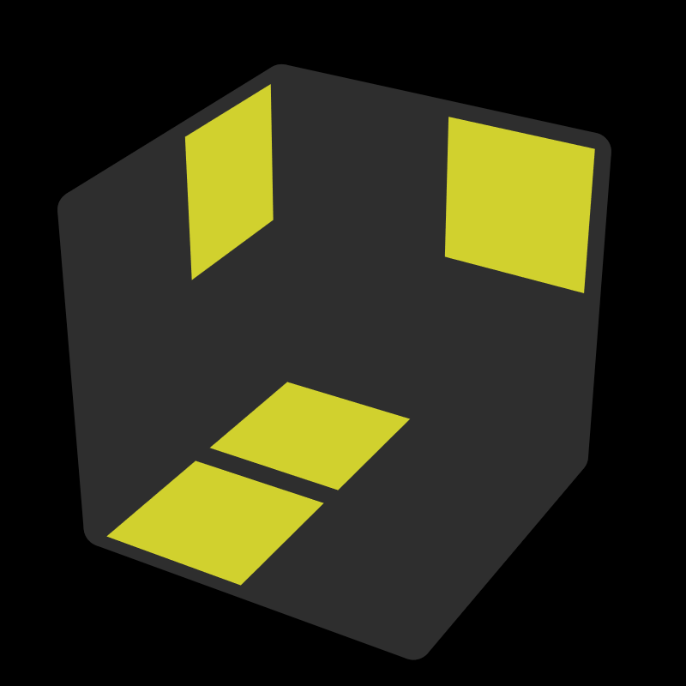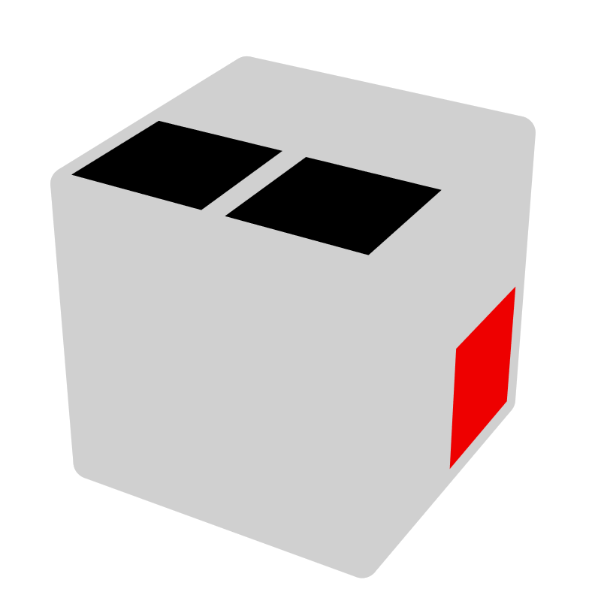 |  |  | 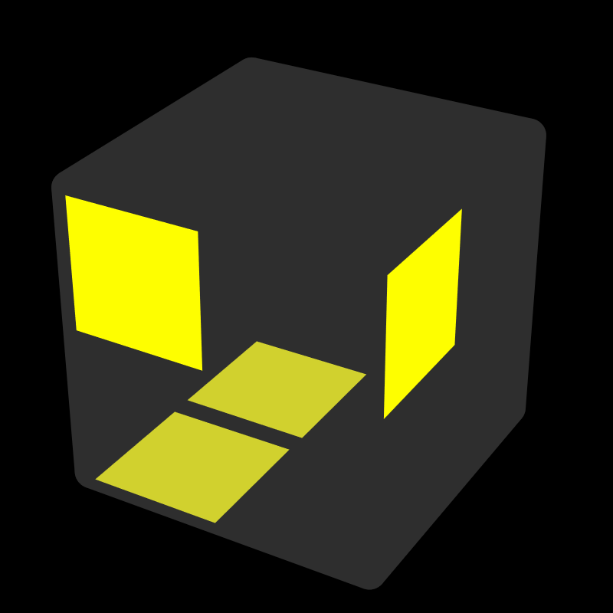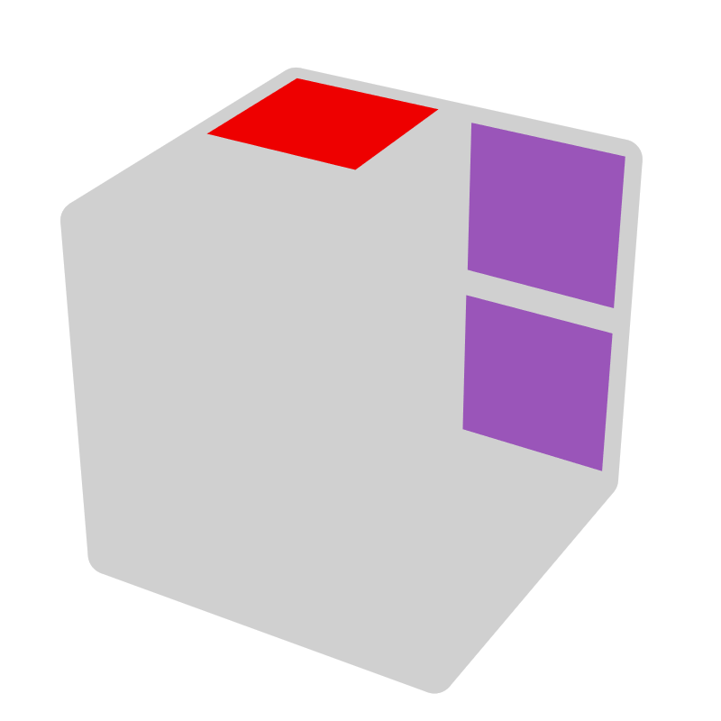* |  |  | 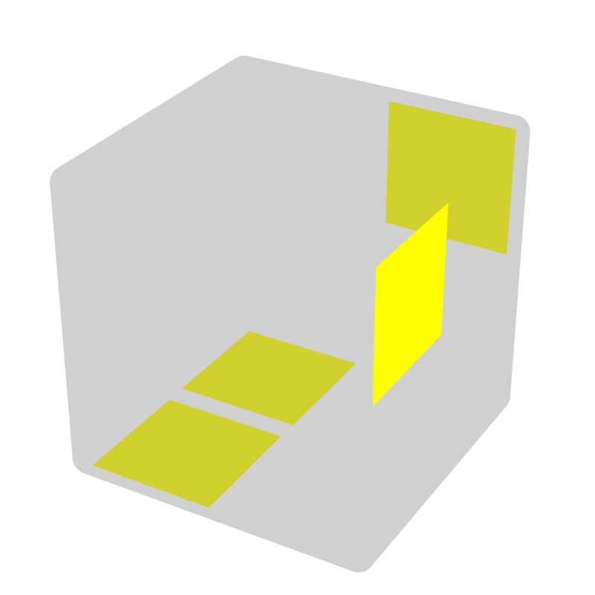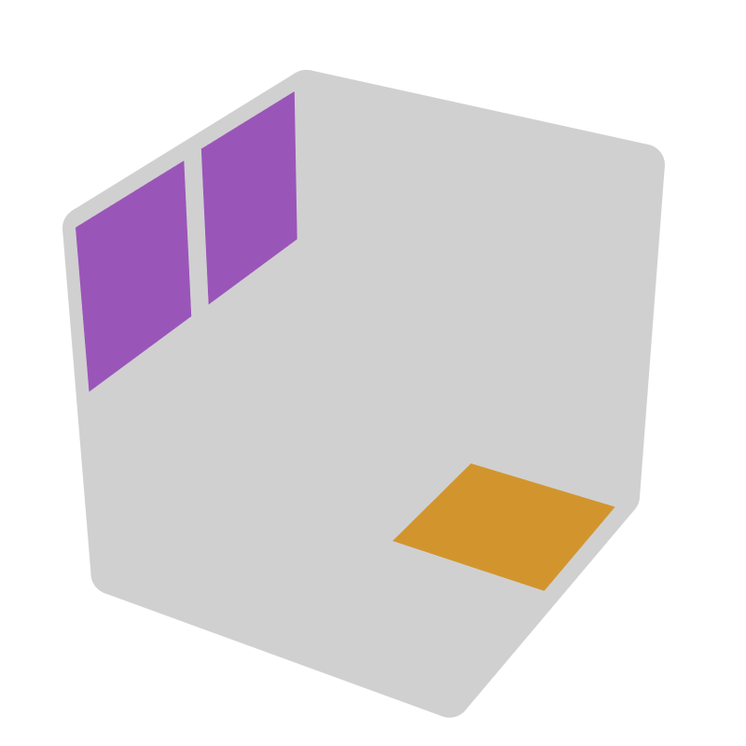* |  |  | 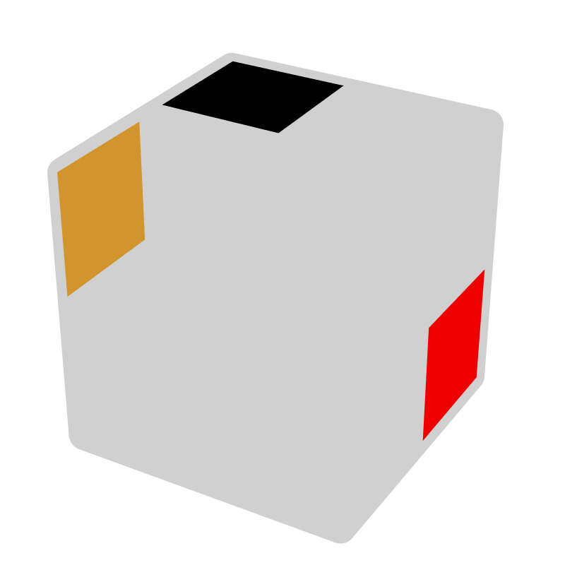*
R' U R' U' R2 | B |  | R' F R U' R U R2' |  | x' L' | R U' R U2' R' | z y D B' |  | R U F' U' F |  | B, F
R U2 R U R' |  |  |  |  |  | R U2 R U' R'
(T)CLL [4]
F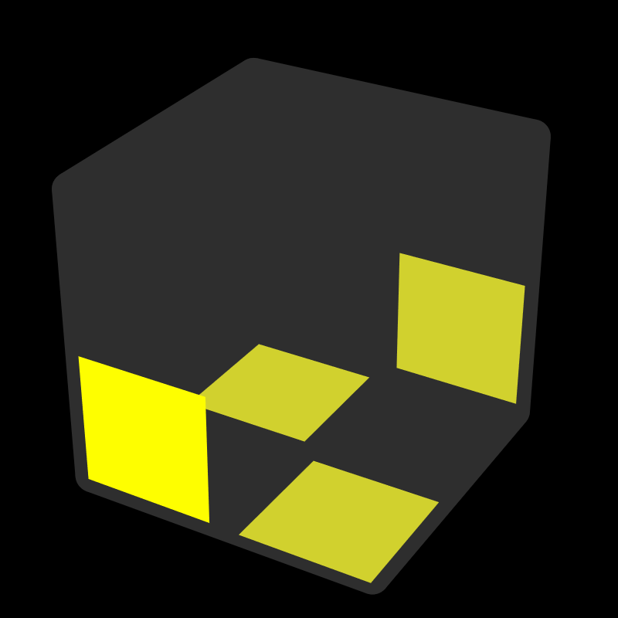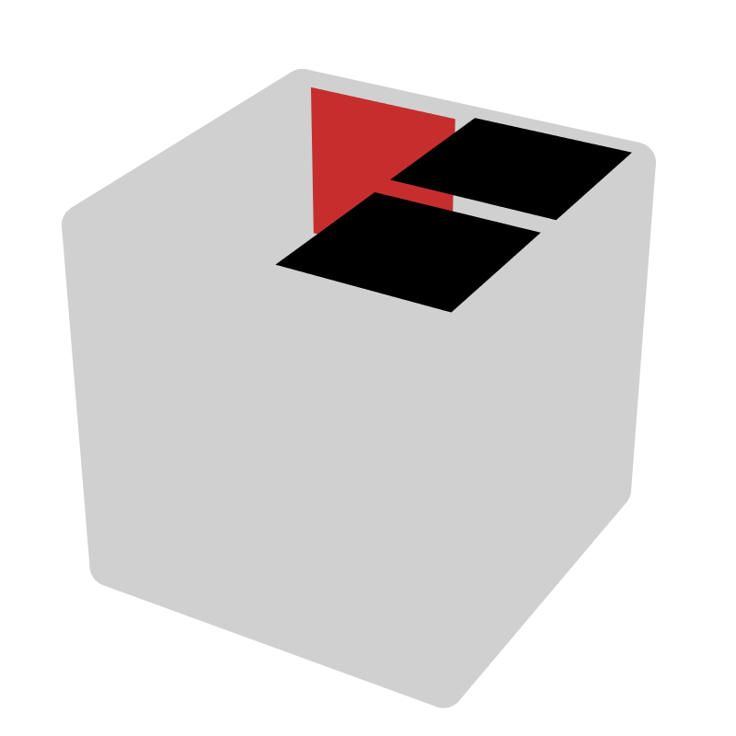 |  |  | F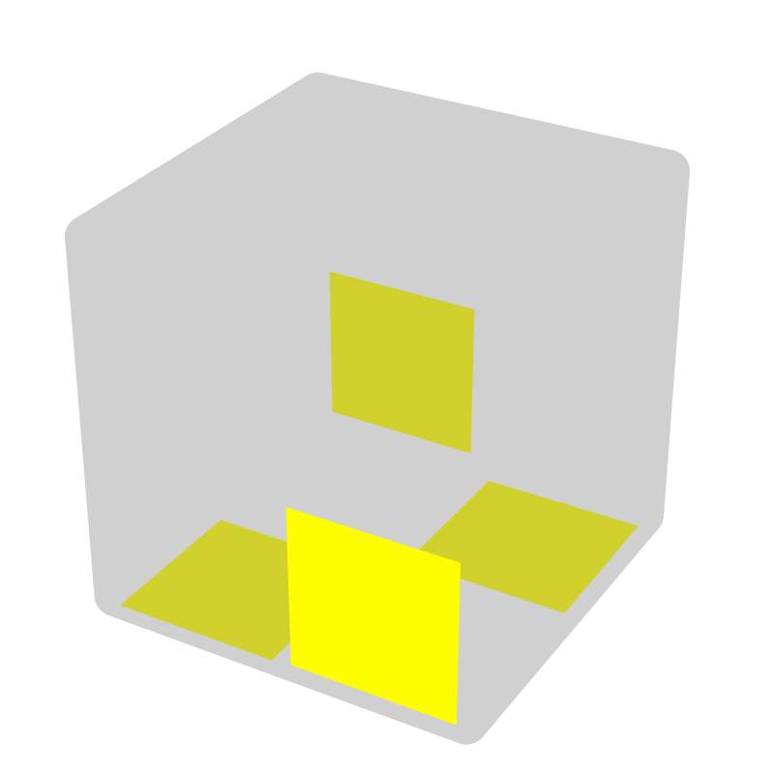 |  |  | L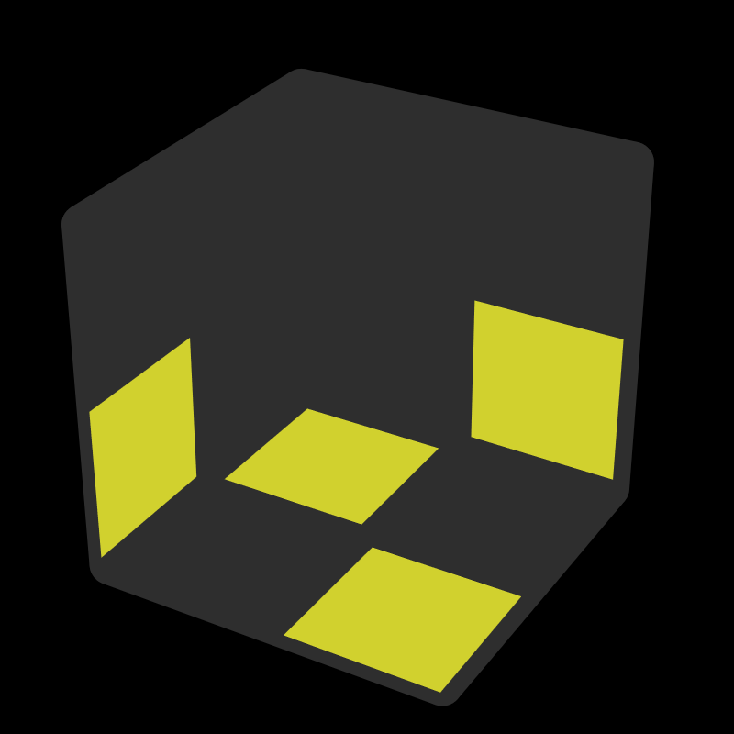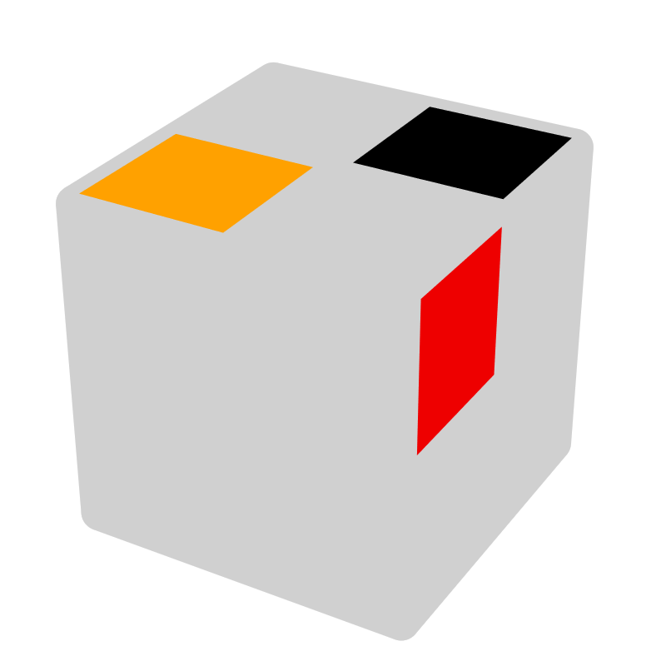 |  |  | S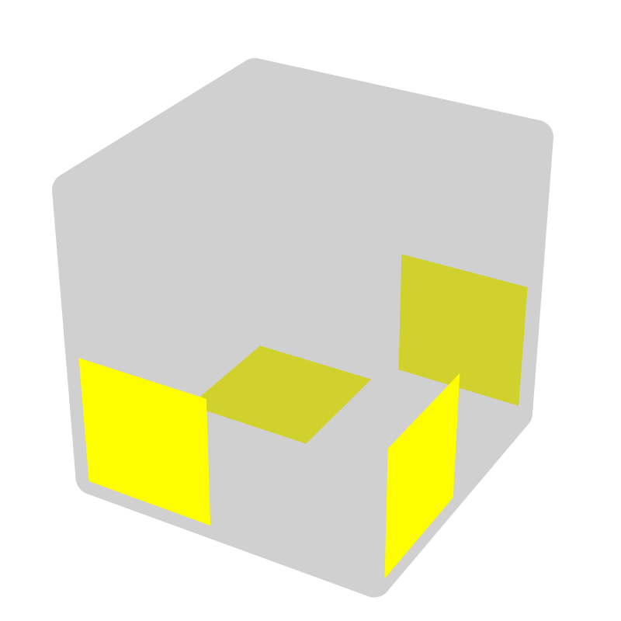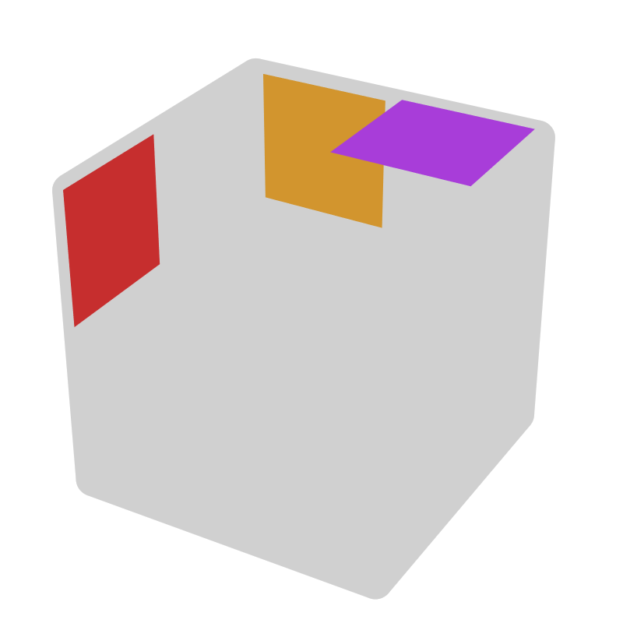
R2 U R' F' R' | L |  | L2' U' L F L |  | R' | R2 U R2' F' | F', U |  | F U2 R |  | y2 (B, R)
Easy Checker [12]
UD [6]
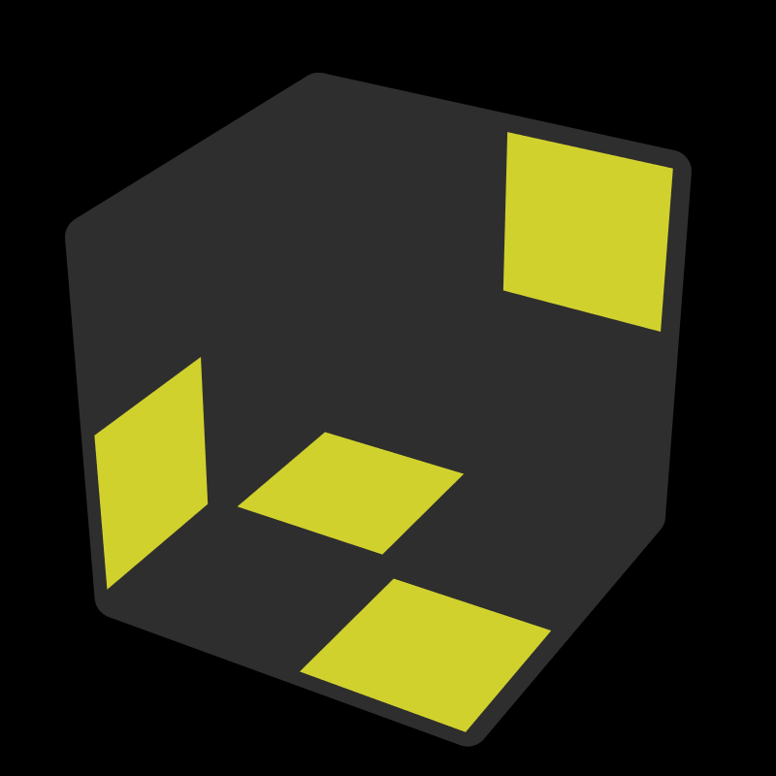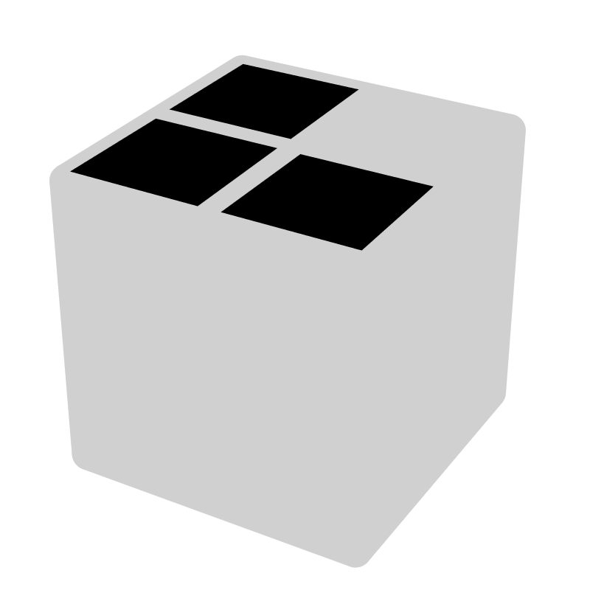 |  |  | 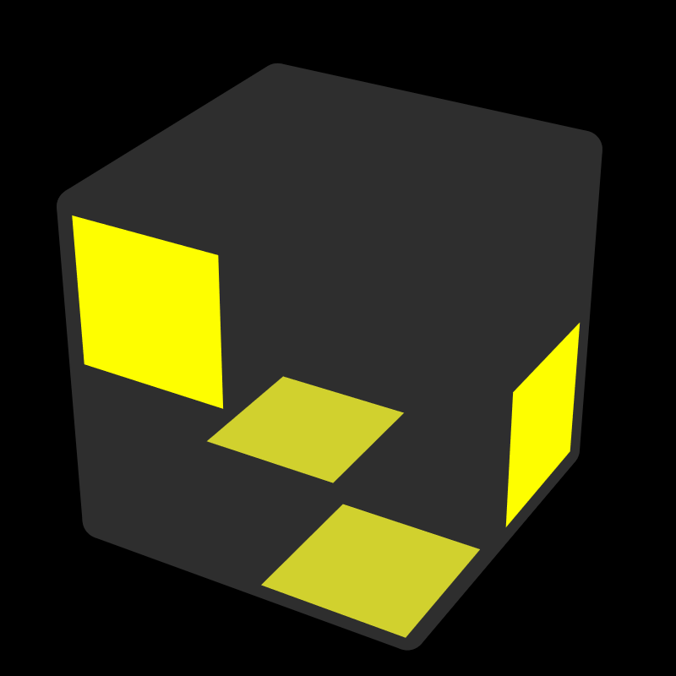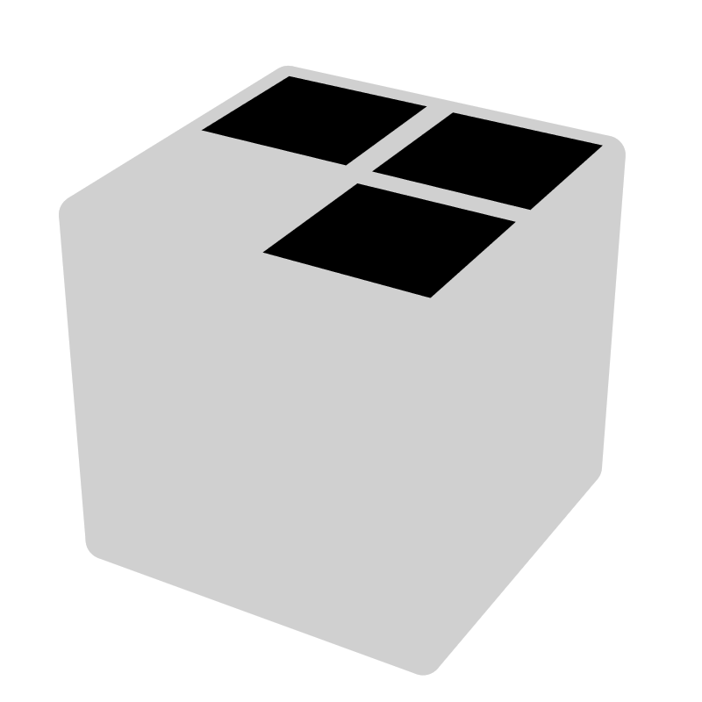 |  |  | 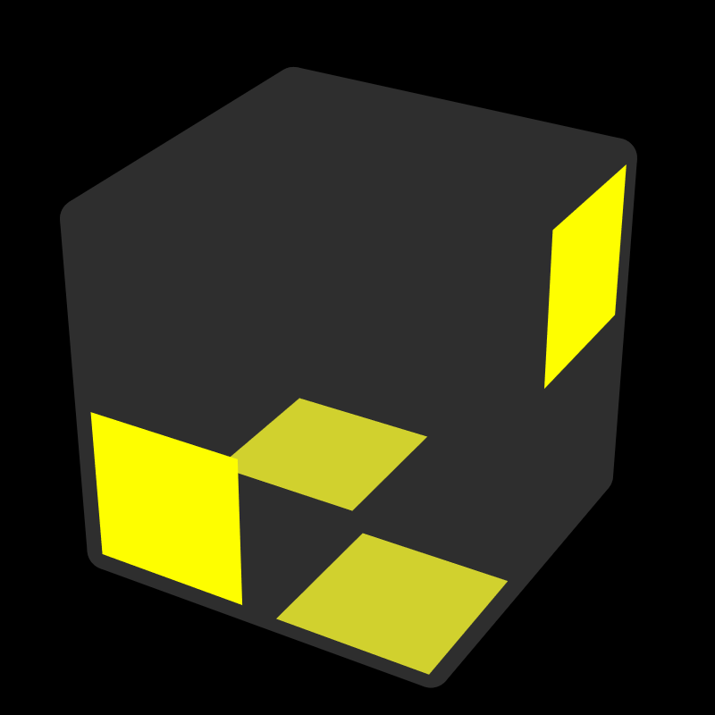 |  |  | 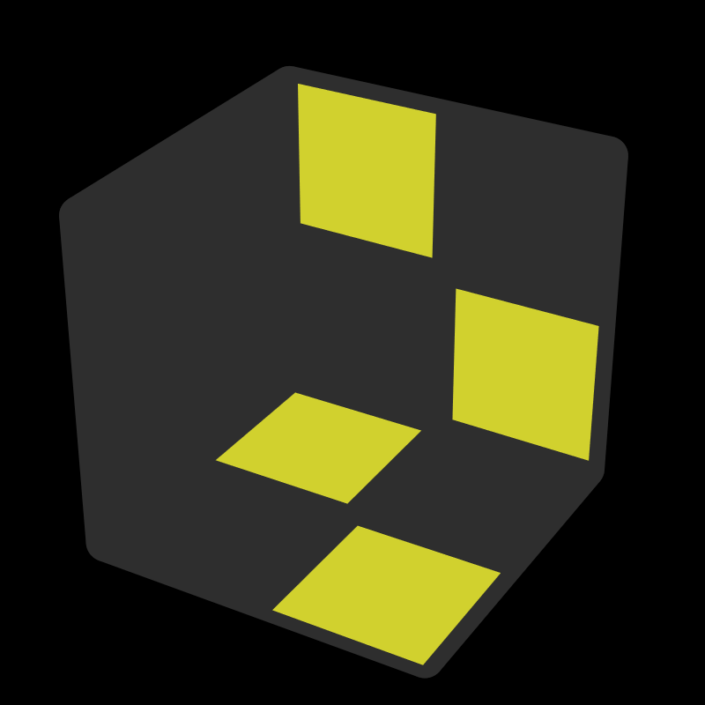
R D R' |  |  | R F R' |  |  | F' R' F |  |  | x R U R' F' R'
 |  |  | U' R F U R'
 |  |  | 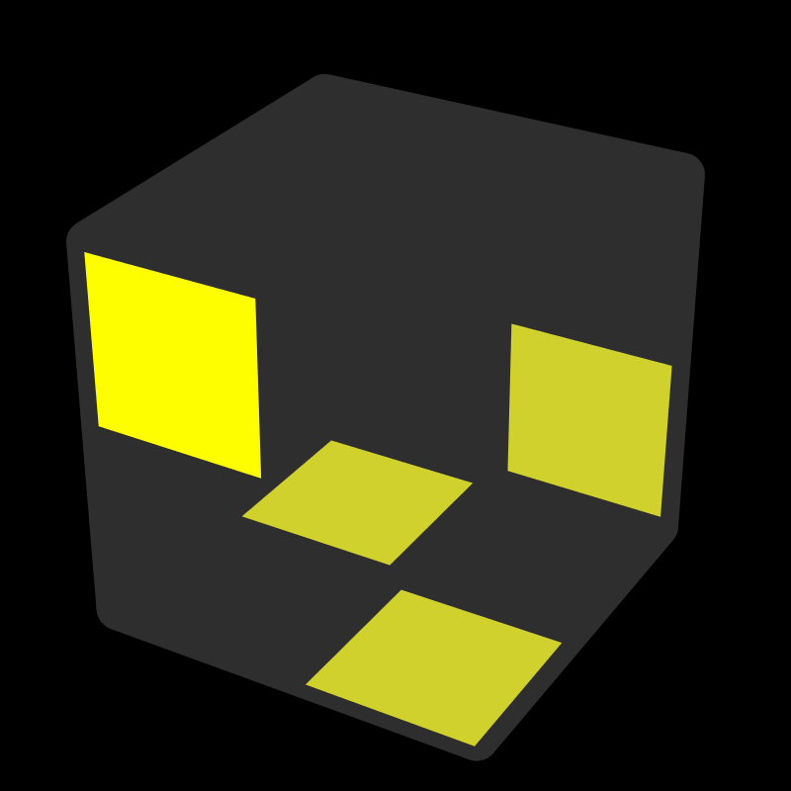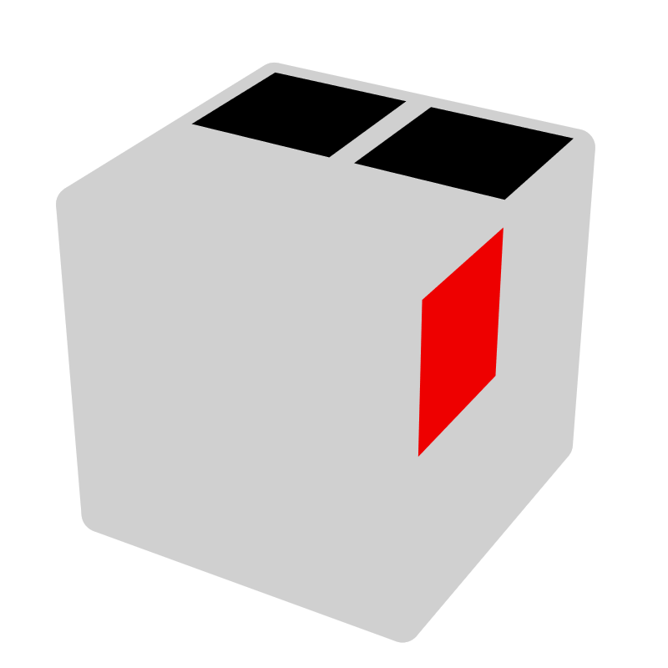 |  |  | 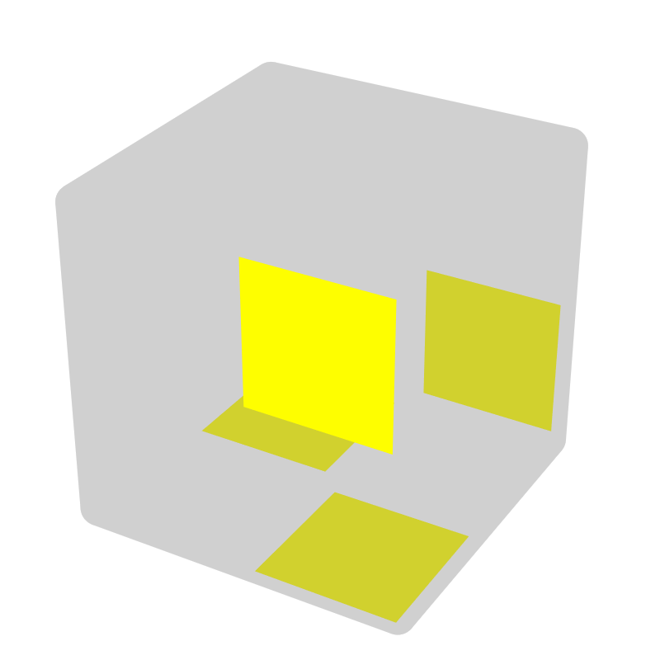
 |  |  | x U' R U' R' U x' |  | F' | x R U' R' U R' x' | R'
UU [6]
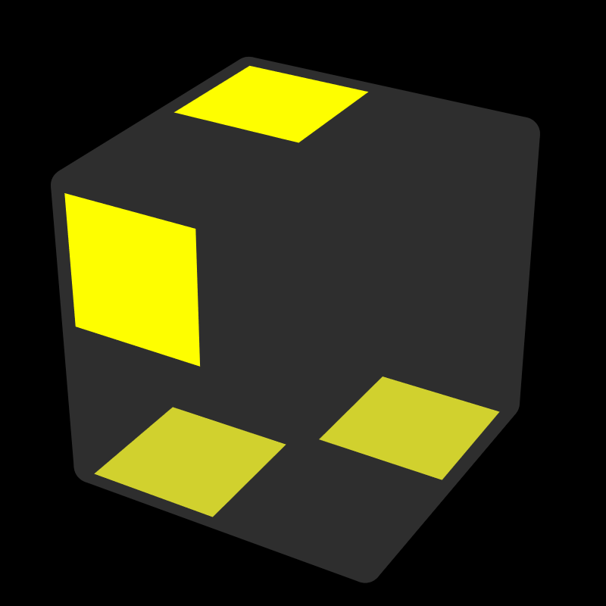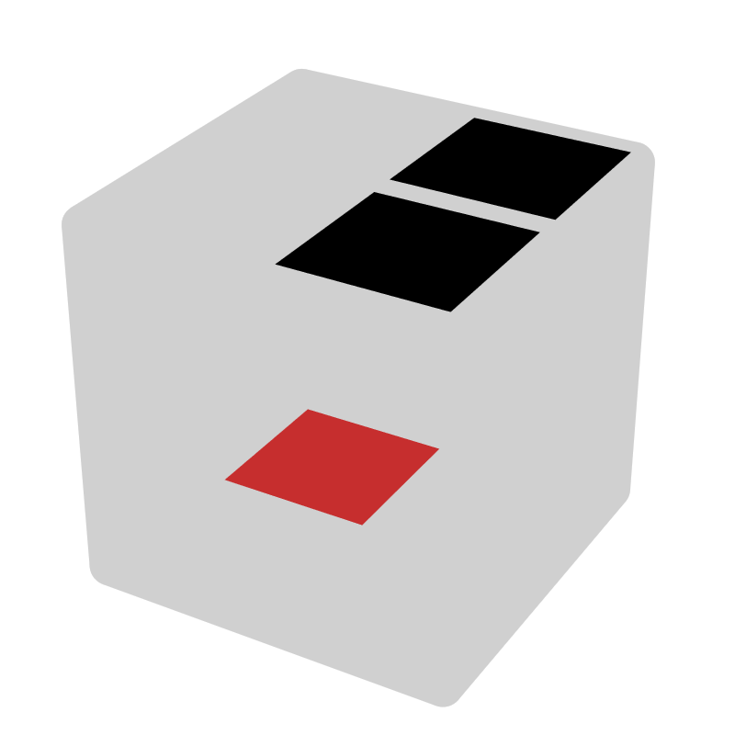 |  |  | 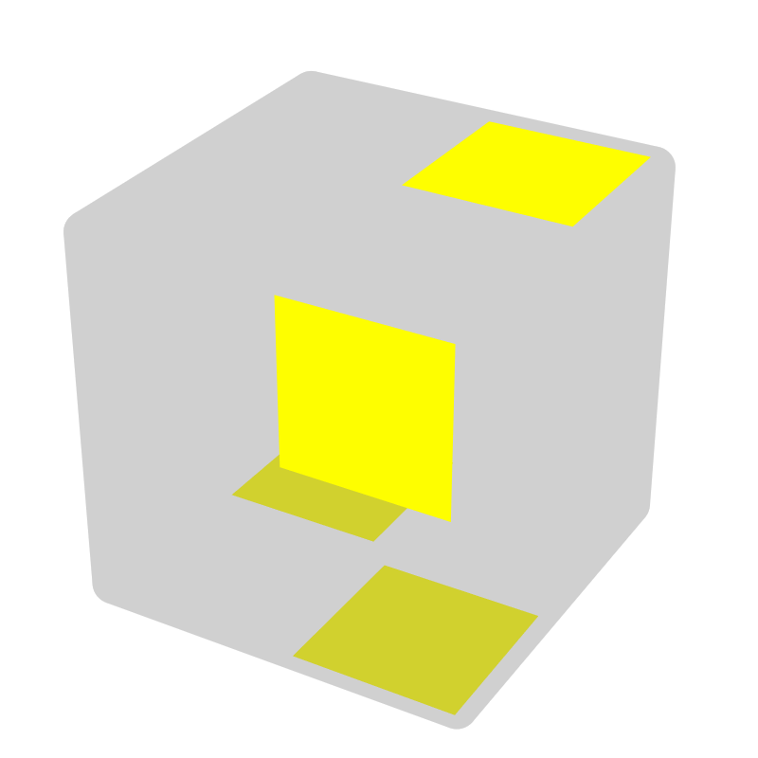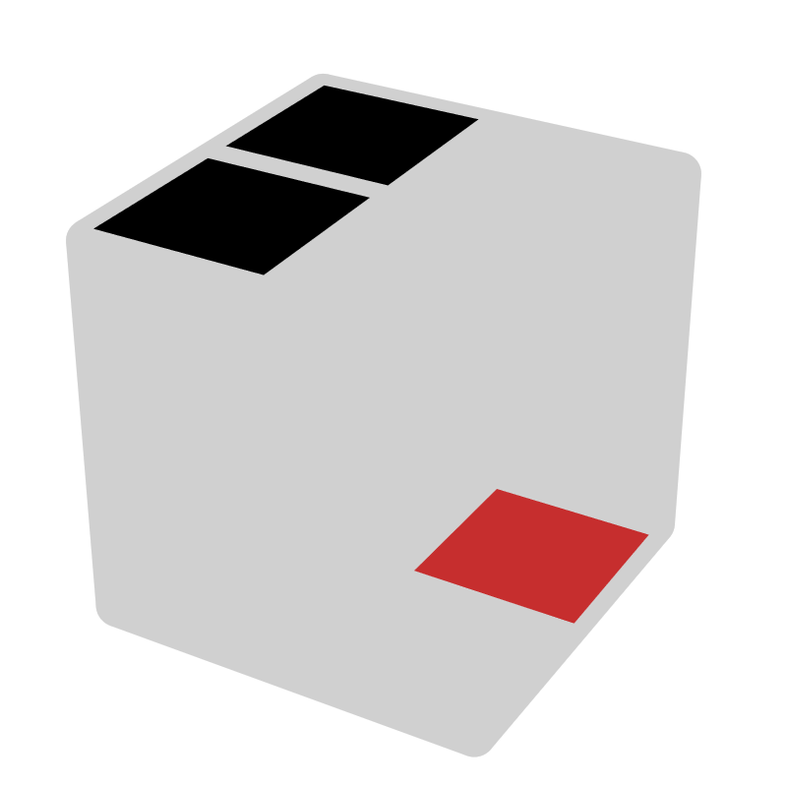 |  |  | 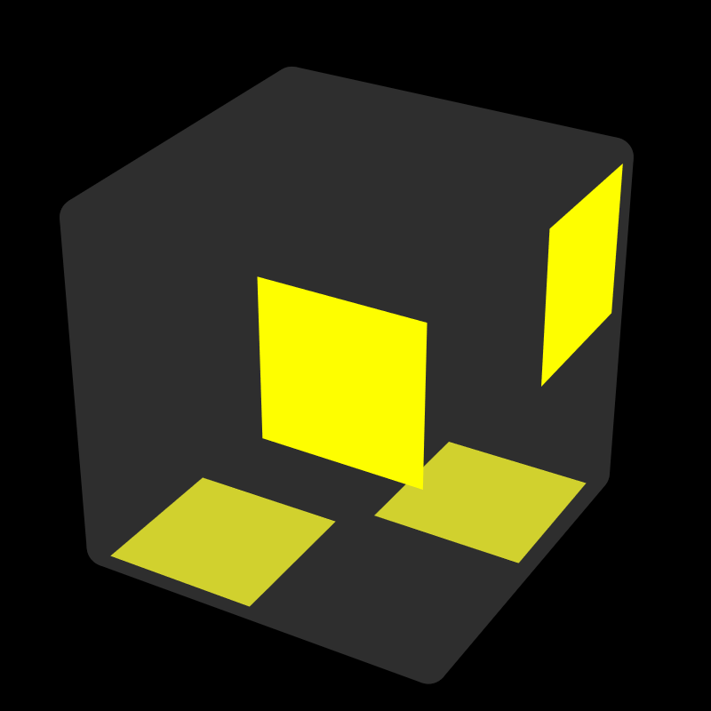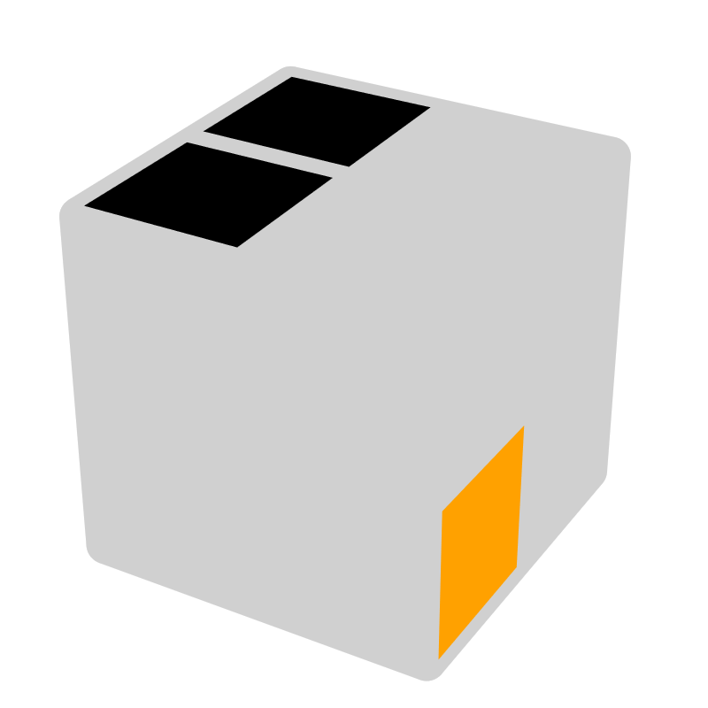 |  |  | 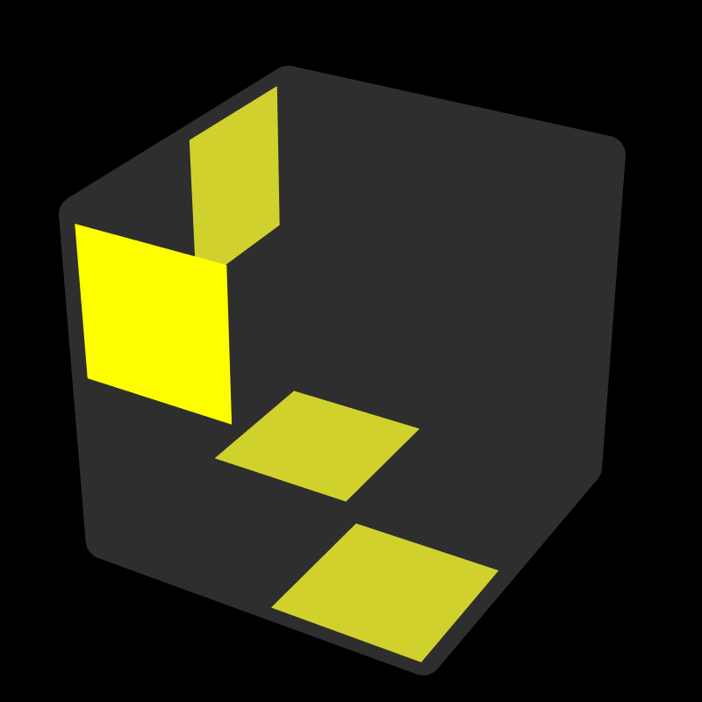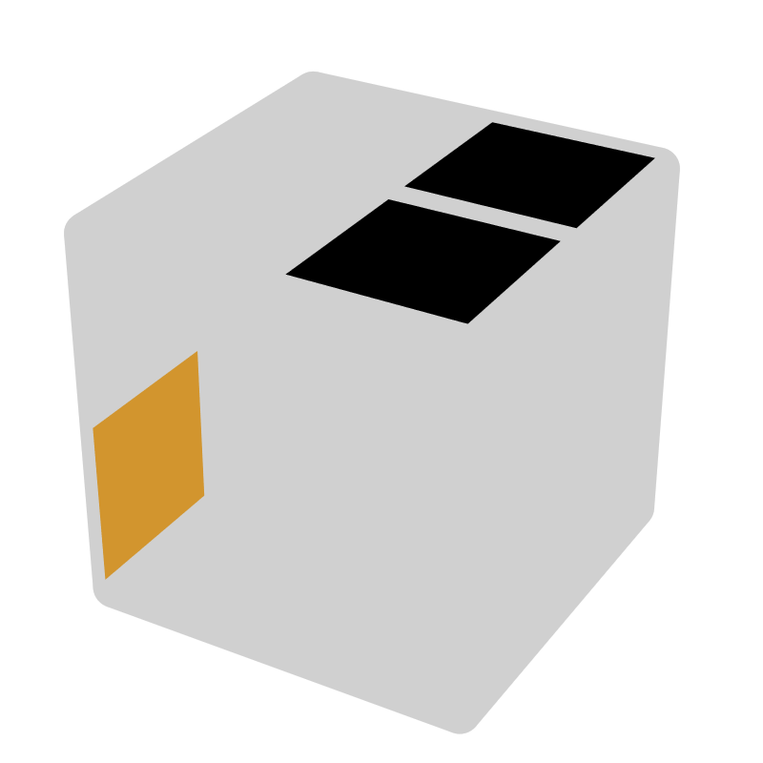
x U L U' L x' | L2 |  | x U' R' U R' x' |  | R2 | x2 R U' R' U L' x | D R' |  | x2 L' U L U' R x |  | D' L
 |  |  | 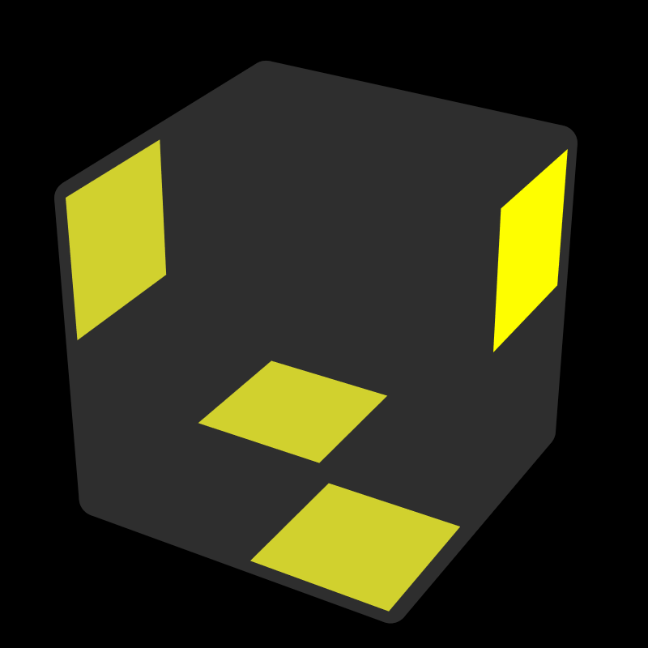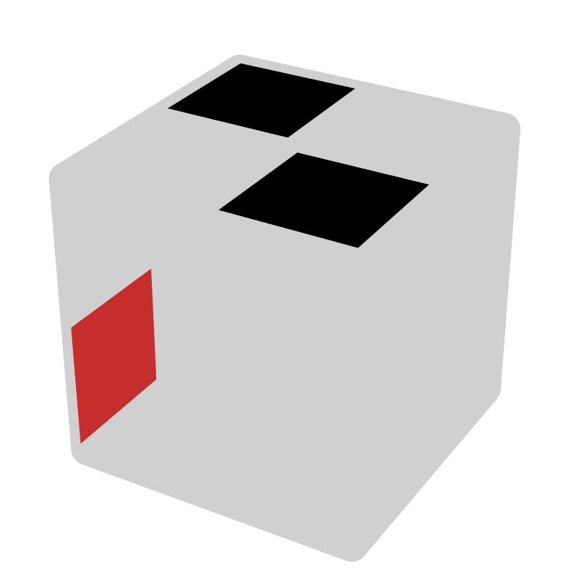 |  |  | 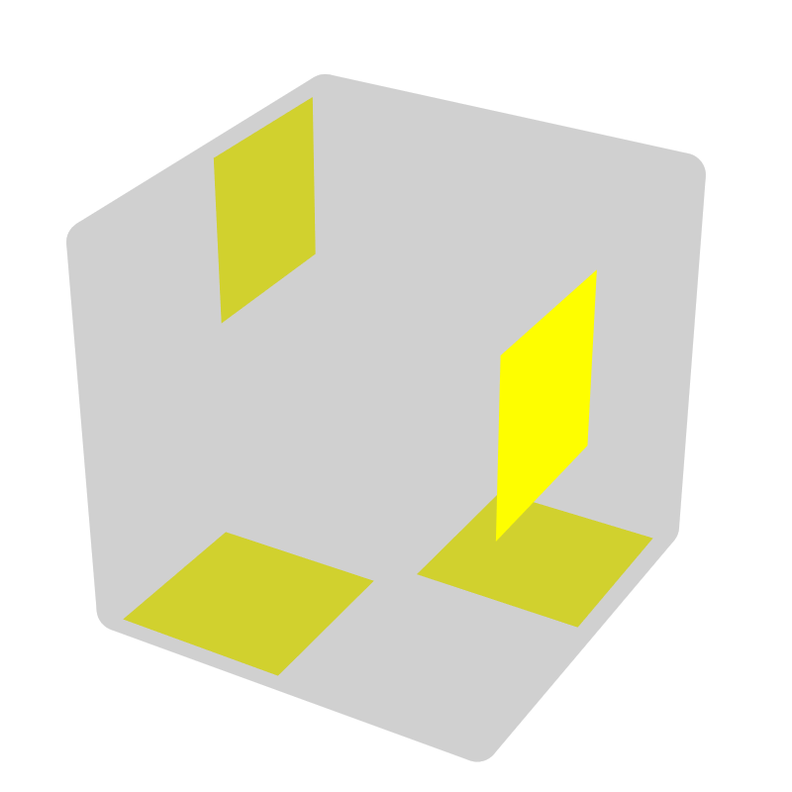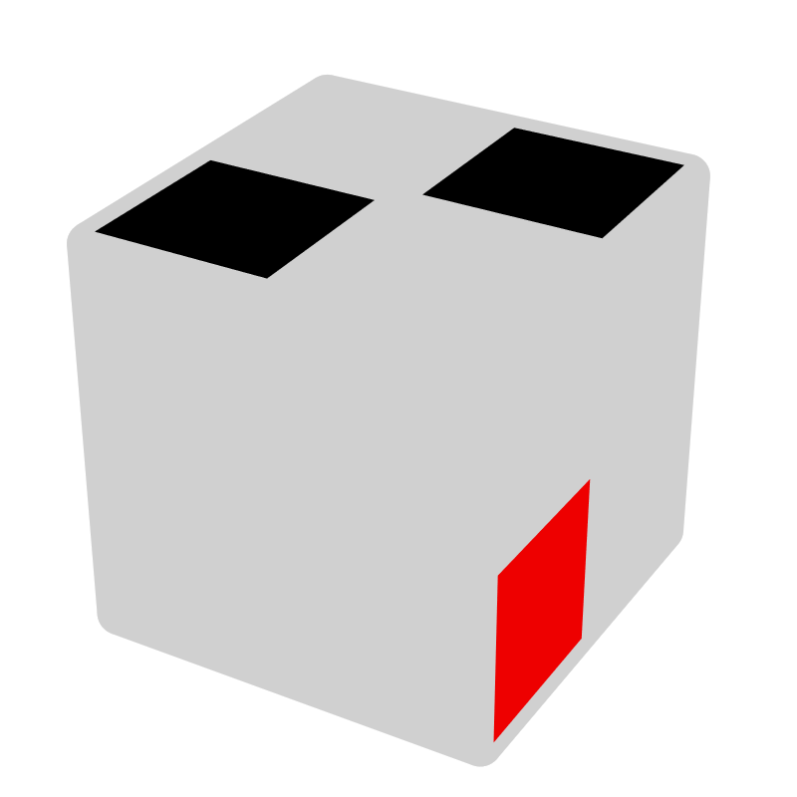
 |  |  | R2' F R2 |  | F | L2 F' L2 | F'
Others [7]
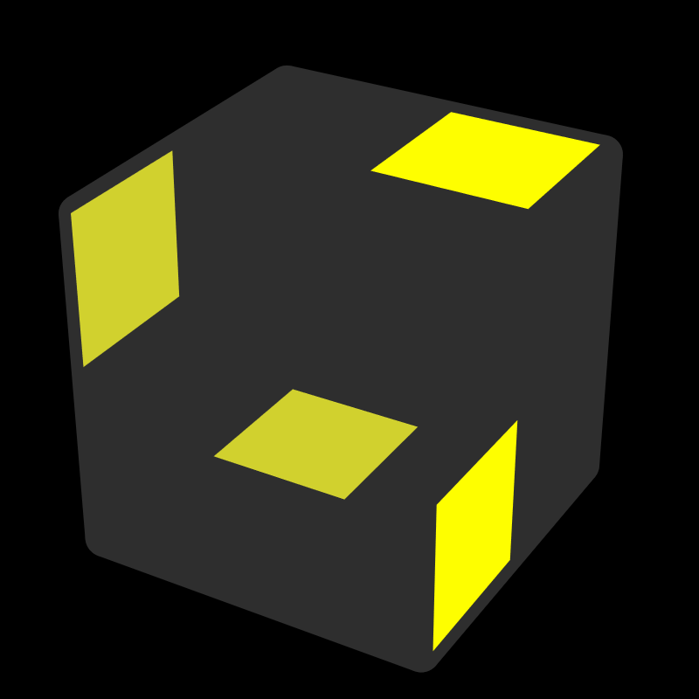 |  |  | 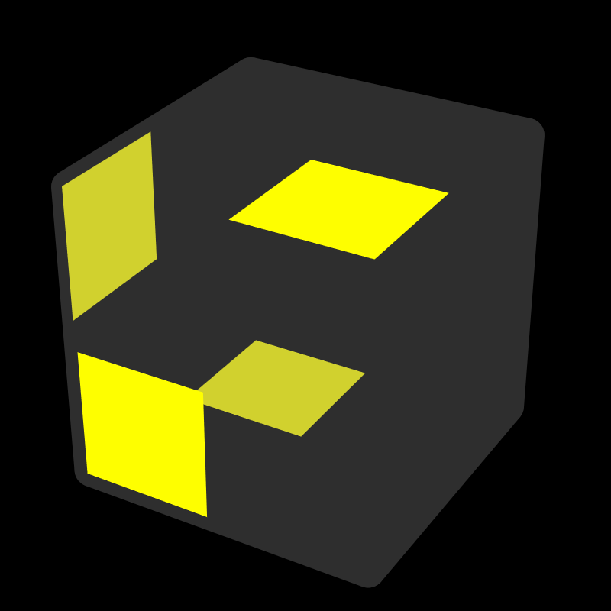 |  |  | 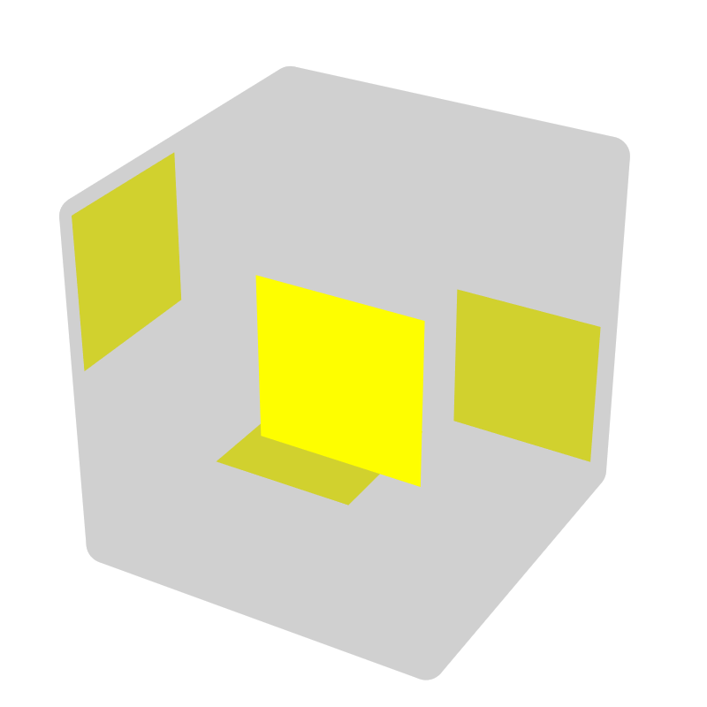 |  |  | 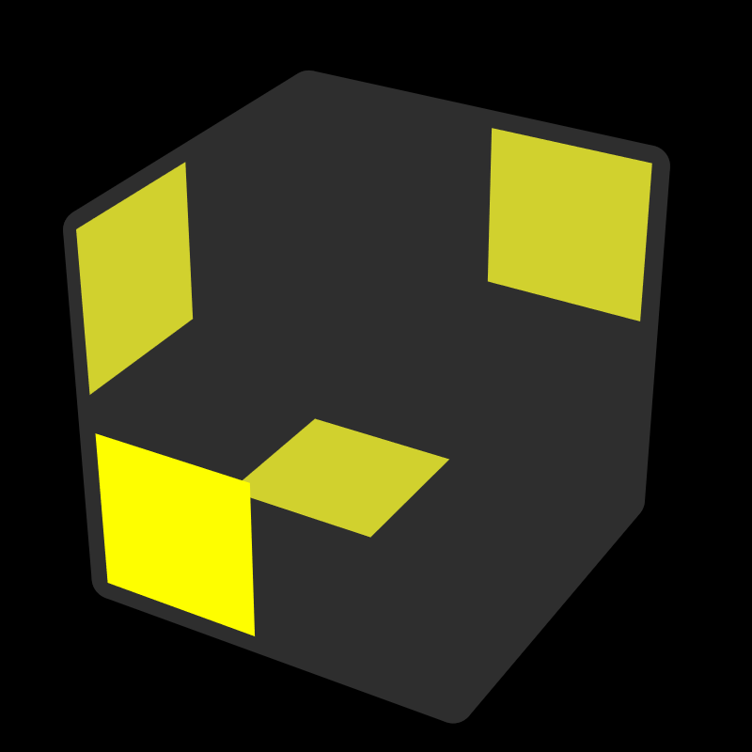
F R2 |  |  | R' F' R'  F' U' R' |  |  | F' U2 R |  |  | R2 F' R'
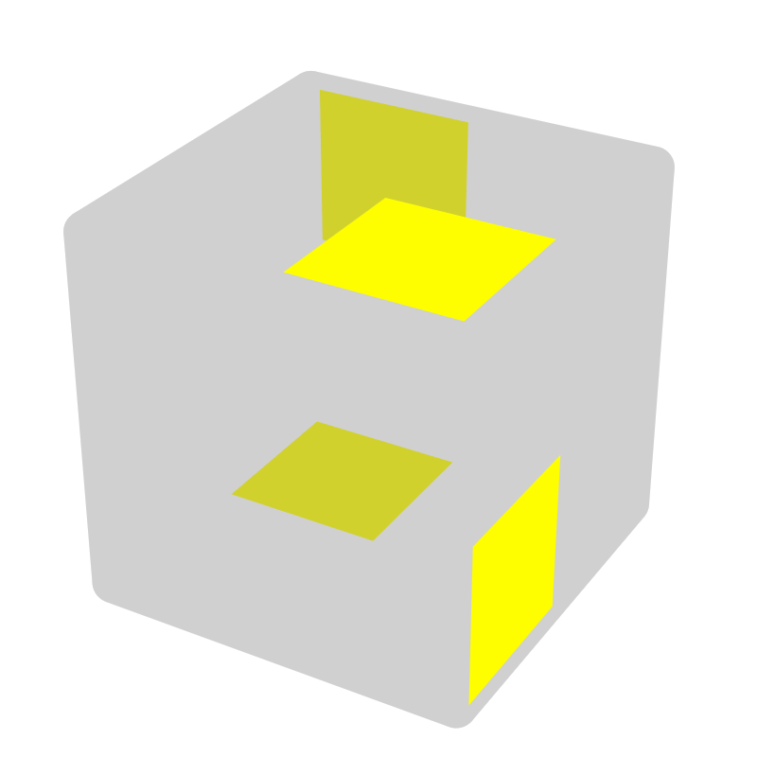 |  |  |  | 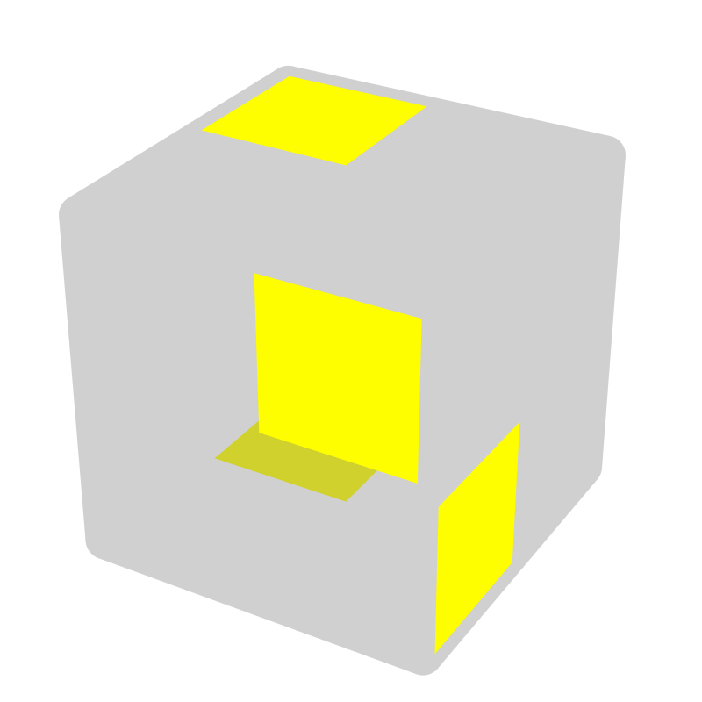 |  |  |  | 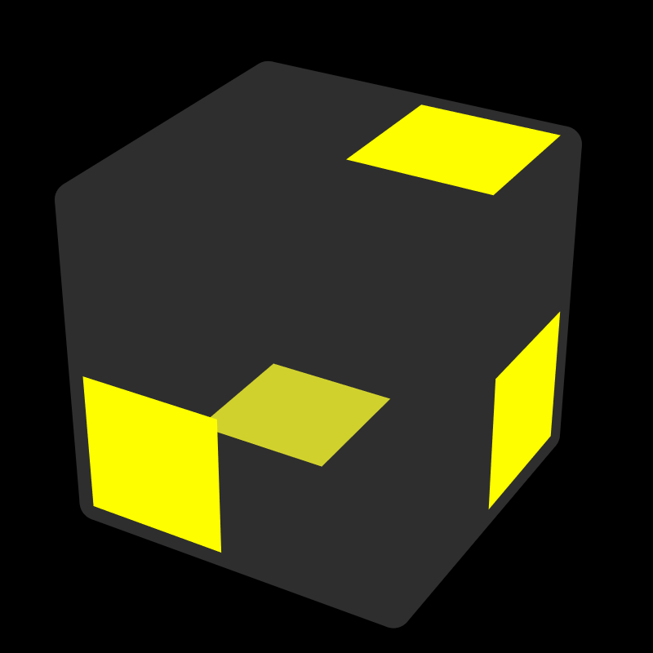
U' F' R2 |  |  |  | U F' R2 |  |  |  | R F U2 R

