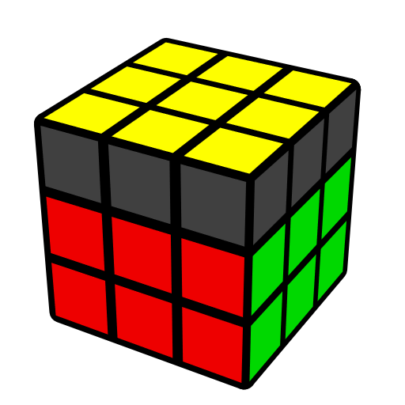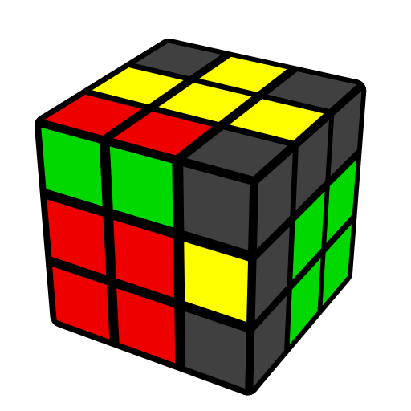**WV Algorithms (Winter Variation)**

Algorithms from Feliks Zemdegs, Lucas Winter

Inserting last connected basic F2L and orienting LL corners, assuming LL edges are oriented. Prerequisite: COLL.

WV [27] Algorithm types: Pure WV [16]; Insert to Sune variant [6]; Insert to OLL [5].

|  |  |  |  |
| --- | --- | --- | --- |
| **3 CO [1] & 2 CO [6]** | | | |
|  |  |  |  |
| **L' U2 (R U R') U2' L** | **R U' R'** | **(R U R' U') (R U' R')** | **U' (R' F R U) (R U' R' F')** |
|  |  |  |  |
| **R2 D (R' U' R D') R2'** | **U' (R U' R' U2)2 (R U R')** | **(R U' R' U) (R' U' R U' R' U2 R)** |  |
|  | | | |
| **1 CO [12]** | | | |
|  |  |  |  |
| **U R U2' R'** | **U (R U' R' U) (R U2' R')** | **R U (R2' U' R2 U')**  **(R2' U2' R)** | **U R2 D (R' U2 R D') R2'** |
|  |  |  |  |
| **U R' U' R2 U' R2' U2' R** | **U F' (R U2' R' U2')**  **(R' F R)** | **U' L' (U R U' R') L** | **U R U2'**  **(R2' U' R U' R' U2 R)** |
|  |  |  |  |
| **(R U' R' U2)**  **(r U R' U' r' F R F')** | **(R U' R')**  **(R2' D' R U2 R' D R U2 R)** | **(R U' R' U)**  **(R2 D R' U2 R D' R' U2 R')** | **(R U' R' U)**  **(r U R' U' r' F R F')** |
|  | | | |
| **0 CO [8]** | | | |
|  |  |  |  |
| **U (R U' R' U)2 (R U2' R')** | **(R U R' U')2 (R U' R')** | **R2 D (R' U R D') (R' U2 R')** | **(R U' R') U2 (R U2' R2' U' R2 U' R2' U2' R)** |
|  |  |  |  |
| **(R U' R' U')  (R U R' U R U2' R')** | **R U' (R2' U2' R U R' U R)** | **U R U2'**  **(R2' U2' R U R' U R)** | **R U' (R2' U' R U' R' U2 R)** |