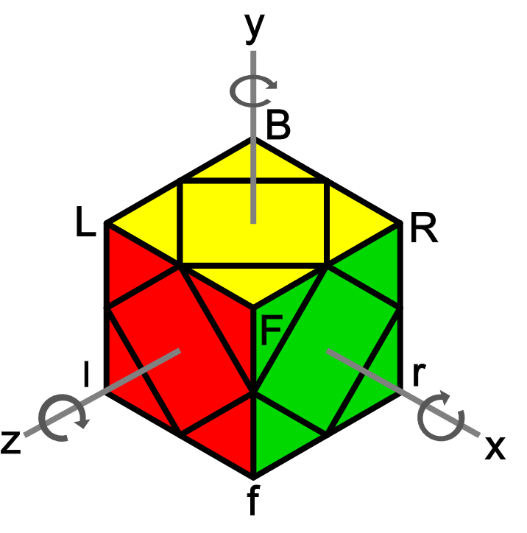**斜转L2L法 (二步法) (最后两层)**

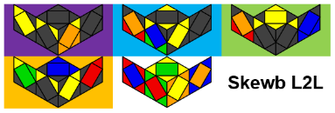公式来源Sarah Advanced - http://sarah.cubing.net/skewb/advanced-variation-by-case.pdf

L2L - <http://scribd.com/document/379738419/L2L-Skewb-1>

NS2.0 - <http://mofangshe.com/zb_users/upload/2016/4/NS%202.0.pdf>

**符号**

|  |  |  |
| --- | --- | --- |
| **Peanut** | **Pi** | S = r' R r R', H = R r' R' r.  Cancellation: H z' H = R r' R' r' z' r' R' r,  S z S = r' R r R z R r R'.  态 (情况): 一叠 [2] + 二叠 [14] + 三叠 [62] + 四叠 [43] + 五叠 [13] = L2L [134]. |
|  |  |

**FL (底层)**

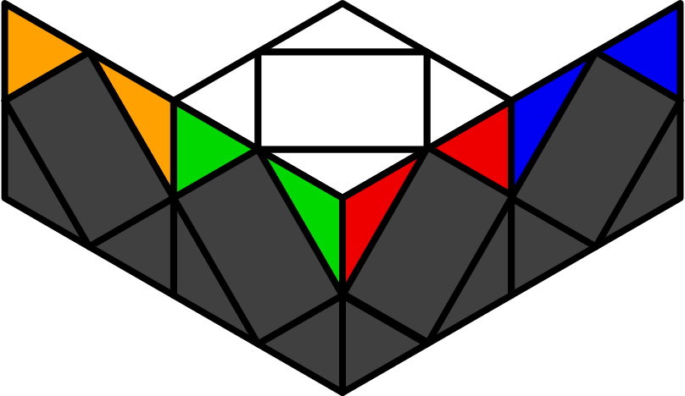

**LL (顶层)**

假设BL, FL, FR, BR面的底角分别为红, 绿, 橙, 蓝. 除了12个三叠外, 所有一二三叠都用SH叠加 (SH流); 所有四五叠都用纯公式 (即非SH叠加). 一般地, 观察顺序为:

|  |  |  |  |
| --- | --- | --- | --- |
|  |  |  |  |
| 1. 范畴 | 2. 同心 | 3. 对心 | 4. 箭头 |

|  |  |  |  |
| --- | --- | --- | --- |
| **L5C (后五心) [14]** | | | |
|  | | | |
| U1 | Z1 | H1 | H2 |
| **(S z2' S)** | **(r l' B' l) (B l r l' r)** | **r R' r R' y L' l L' l** | **x S S S** |
| U2 | U3 | Z2 | Z3 |
| **y' F (S z2' r' R r R)** | **y' L (r R' r' R y' H) F'** | **x R' b' r' R r z' r B r'** | **y x R r R' y' r' R' x y' r' R r** |
| X1 | X2 | W1 | W2 |
| **y2 x r' R' r B r' H B r' R** | **y' x B' r' R' r B r' R r z' r' R r R'** | **y2 x S r R y' r' R r B' r** | **x (H B r')2** |
|  | S1 | S2 |  |
|  | **y2 x r' R' r B r' R r z' r' S b'** | **y2 x r' R r b z' B' R r' R' B' r** |  |
| **Peanut - U [12]** | | | |
|  | | | |
| - | Z1 | Z2 | H |
| y' x S (S z S) S | **x R r' R r' R' z' r' R r B' R** | **y x r' R' r R r' R' r' z' r' R' r B** | **y x r' R' r R' B R B' H R** |
| **y2 x r' R' z' r B r' R r y' r' R' r** |  |  |  |
| U1 | U2 | U3 | U4 |
| **y x (H z' H) z' S** | **y' x S z H z H** | **x H z H z S** | **y2 x S z' (H z' H)** |
| R r' l r R' r' l' r | y2 x R r R' B R B' r' R r R r' | x r' z r R r' R' r' z' r' R r' | y2 x r R' r' B' r R r' B |
| U5 | U6 | U7 | U8 |
| **y x H z (S z S)** | **y' x S z' S z' H** | **x H z' S z' S** | **y2 x (S z S) z H** |
| z r' R r y r R' B' R r' | x r' R' z' r' R r z R r R r' R' | x R' B' R r' y' r' R' z' R r R' | x B' r R' r' B r R r' |
|  | | | |
| **Pi - U [12]** | | | |
|  | | | |
| - | Z1 | Z2 | H |
| **x S S** | **y x R r R' r' z' r' R r z R r' R'** | **y' x r' R' r B R B' R' r' R r** | **y2 x (S z2' S) z2 H** |
|  |  |  | y' x r B R B' r2' R r R |
| U1 | U2 | U3 | U4 |
| **y x S z' S z' S** | **y' x (S z S) z S** | x S S x' z2 (S z2' S) | x S S x' (S z2' S) |
| y2 x R B' r' R r z R' r R' | y' x R' r R' B b r' R r' | **y' f r' H B r'** | **y2 x l' B b' r B r' R' r** |
| U5 | U6 | U7 | U8 |
| **y x H z H z H** | **y' x (H z' H) z' H** | x S S x z2 (S z2' S) | x S S x (S z2' S) |
| x B R' B r' R' r B R' | y' x z' R B' R r' z' r' y r R' r | **x r B' S r B'** | **y2 z' r' R r B' r' b B' R** |
|  |  |  |  |
|  |  |  |  |
|  | | | |
| **Peanut - FR [12]** | | | |
|  | | | |
| O1 | O2 | O3 | S1 |
| y x S z H z2 S | y' x (H z' H) z2 S | y2 x S z2 H z' S S | y x H z (H z' H) z H |
| **y' r' R' r' R r z' r' R r** | **y2 x r' R' r R z R r R' r'** | **z' S z' R r R' r'** | **y2 x r' R' r R' z' H B'** |
| U1 | U2 | U3 | S2 |
| **y2 x S z' H z S** | **y2 x (S z S) z' S** | **x (S z S) S** | y' x S z' H z S z' H |
| y x R S z H R r' R' |  |  | **y x r2' R r R' z' r' R' r R'** |
| X1 | X2 | W1 | W2 |
| **y x S z' H** | **y' x H z H** | x S z2' (S z S) z S | x (S z2' S) z' H z' S |
|  |  | **y' r R' r' y' r l' B l B'** | **y x R' r' R r R z R r2' R' r** |
|  | | | |
| **Peanut - FL [12]** | | | |
|  | | | |
| O1 | O2 | O3 | S1 |
| x S z' S z2 H | y2 x H z' S z2 H | y x H z2 (S z S) S | y2 x S z' (S z S) z' S |
| **y2 x B R B' R' r' R' r R** | **y z' r' R' r l' r' R r R** | **y' R' r' R r z' S** | **y2 f S z R r' R r** |
| U1 | U2 | U3 | S2 |
| **y x (H z' H) z H** | **y x H z S z' H** | **y' x H z S S** | x H z S z' H z S |
|  | y2 x r' R' r R' B R' B' R z R r' R' |  | **y2 x R' r' R' r B R B' R** |
| X1 | X2 | W1 | W1 |
| **y2 x H z S** | **x S z' S** | y' x S z2' (S z S) z H | y' x (S z2' S) z' (H z' H) |
|  |  | **y2 x r R r' R' r' z' r' R' r R'** | **y' r' R r b' B r' z' r' R** |
|  |  |  |  |
|  |  |  |  |
|  |  |  |  |
|  |  |  |  |
|  |  |  |  |
| **Peanut - BR [12]** | | | |
|  | | | |
| O1 | O2 | O3 | S1 |
| x S z' H z2 S | y2 x H z H z2 S | y' x S z2 H z S S | y2 x S z H z' S z H |
| **y' R r R B R' B' R' r'** | **x z r R r' R' r' z' r' R r** | **y r' R' r R z' R r' R' r** | **x R r' R r z R r' R' r'** |
| U1 | U2 | U3 | S2 |
| **y' x S z H z' S** | **y' x S z' (S z S)** | **y x S z' S S** | x (H z' H) z (H z' H) |
| y' x R r R' S r z' r' R r |  |  | **y2 x r' z S z' R r' R' r'** |
| X1 | X2 | W1 | W2 |
| **x S z H** | **y2 x (H z' H)** | y x (S z2' S) z' S z' S | y x (S z2' S) z H z S |
|  |  | **x R' r' R' r z' r' R r z r R' r** | **x R r R' z' r' R r R** |
|  | | | |
| **Peanut - BL [12]** | | | |
|  | | | |
| O1 | O2 | O3 | S1 |
| y x (S z S) z2 H | y' x H z Sz 2 H | x H z2 S z' S S | y x H z' S z H z' S |
| **x R' r' R r R z R r' R'** | **y r R B R B' R' r' R'** | **y r R r' R' r' y' z' R r R'** | **x z r' R r' R' z' r' R r R** |
| U1 | U2 | U3 | S2 |
| **x H z (H z' H)** | **x H z' S z H** | **y2 x H z' S S** | y' x (S z S) z' (S z S) |
|  |  |  | **x r' S z H z' r** |
| X1 | X2 | W1 | W2 |
| **y x (S z S)** | **y' x H z' S** | y2 x (S z2' S) z' S z' H | y2 x (S z2' S) z (H z' H) |
|  |  | **x z r2' R r R' z' r' R r** | **y x R r' R' z S z' R r' R' r'** |
|  | | | |
|  | | | |
|  | | | |
|  | | | |
|  | | | |
|  | | | |
| **Pi - FL [12]** | | | |
|  | | | |
| O1 | O2 | O3 | S1 |
| **x H z (S z2' S)** | **y2 x S z' (S z2' S)** | x S S z' (S z2' S) | y2 x (H z' H) z H z' S |
| y x R r' R' S z' r' R r | y x r' R r H z R r' R' | **y2 (r' l r l') r' R' F r' R r** | **y2 R r' z' r' z r' R r' R r** |
| U1 | U2 | U3 | S2 |
| **y x (S z S) z H** | **y x S z (H z' H)** | **y x r' R r R r' z' r' R r z r R r'** | x (S z S) z' S z H |
|  | x r' R r R r' z' r' R r z r R r' |  | **x' r' R r x R' r' R B' R' r'** |
| X1 | X2 | W1 | W2 |
| y2 x (S z S) S S | x H z' S S S | y' x H z2 S z H z H | y' x S z2 H z' S z' S |
| **x R r R' z' R r z' r' R' r B** | **y2 x r' R' r l' y' z' S b'** | **y2 x r' R' r R' z' r R' r B r' R** | **y x S r R r' R' r' z' r' R r** |
|  | | | |
| **Pi - BR [12]** | | | |
|  | | | |
| O1 | O2 | O3 | S1 |
| **x H z' (S z2' S)** | **y2 x (S z S) z2' S** | x S (S z S) z2' S | y2 x H z (H z' H) z S |
| y2 z' l' r y r' R' r B' b' | y x r R' r B r' R f | **y2 x r B R' B' z' r' R' r B** | **y' x r' R r z R r R' z' r' R' r R'** |
| U1 | U2 | U3 | S2 |
| **y' x (S z S) z' H** | **y' x S z' H z H** | **y' x r R' r' z' r' R' r z r R' r' R' r** | x S z' (S z S) z' H |
|  |  |  | **y' x R r' R' z' r' R' r B R B' R** |
| X1 | X2 | W1 | W2 |
| x H z S S S | y2 x S z' S S S | y x H z2 S z' (H z' H) | y x S z2 H z (S z S) |
| **x b' S z2 r' R' r R'** | **y x r' R z' r' R r z r R r' R** | **y2 x R' r' R' z' r' R' B R' r'** | **x r2' R r B R r' R B** |
|  | | | |
| **Pi - FR [12]** | | | |
|  | | | |
| O1 | O2 | O3 | S1 |
| **x H y' z' (S z2' S)** | **x H y' z (S z2' S)** | **y2 x H z2 S** | y x (S z S) z' H z S |
| y' x B R B' S r' R' r | y' x B' R' r B' r' R r' |  | **y' z' r' R' r R' r b r R'** |
| U2 | U3 | U1 | S2 |
| x H y z' (S z2' S) | x H y z (S z2' S) | **x H** | y' x S z' S z H z' S |
| **x r B R B' r' B R' B'** | **y x r' R' r B' r' R r B** |  | **y x R r' R r B R' B' r' R' r** |
| X1 | X2 | W1 | W2 |
| **y2 x S y' z (S z2' S)** | **y2 x S y z (S z2' S)** | **x H x (S z2' S)** | **x H x' (S z2' S)** |
| x R r' R r z B R' B' R r | y' x r B R' B' R r z' r' R r |  |  |
|  | | | |
| **Pi - BL [12]** | | | |
|  | | | |
| O1 | O2 | O3 | S1 |
| **x H x z2 (S z2' S)** | **y2 x S y' z' (S z2' S)** | **x S z2 H** | y x (H z' H) z S z' H |
|  | x r R B' r z R r' R |  | **x R b R' z' R r' R' B' r** |
| U1 | U2 | U3 | S2 |
| x H x' z2 (S z2' S) | y2 x S y z' (S z2' S) | **y2 x S** | y' x H z H z' S z H |
| **y' x B' r' R' r B r' R r** | **y2 x B R B' r B R' B' r'** |  | **y' b R r' b R' r' R' r** |
| X1 | X2 | W1 | W2 |
| **y2 x S x' z2 (S z2' S)** | **y2 x S x z2 (S z2' S)** | **y2 x S x' (S z2' S)** | **y2 x S x (S z2' S)** |
| y' x R' r R' r' z' r' R' r z R' r | x B' S z2' r' R r' R' |  |  |