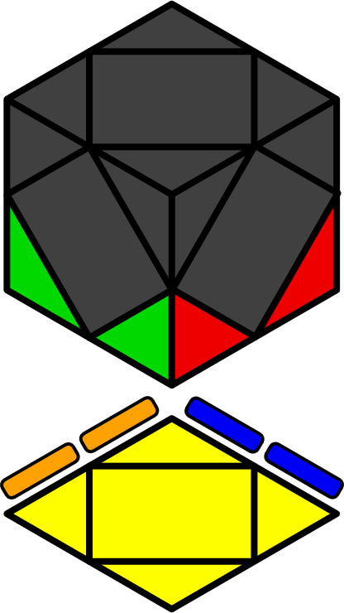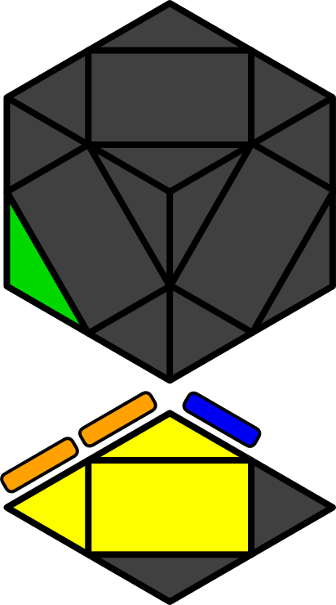**斜转FL公式 (底层)**

情况分类来自季默

本文包含至少2个底角已还原的所有做底情况 [72].

|  |  |  |  |  |  |  |  |
| --- | --- | --- | --- | --- | --- | --- | --- |
|  |  |  |  |  |  |  |  |
| **x r' R' r R** | **x R' r' R r** | **y' x R r' R'** | **x R r' R r** | **x R'** | **y' x r' R r' R'** | **x R** | **x r' R r** |
|  |  |  |  |  |  |  |  |
| **x R' r R r'** | **x r R' r R r** | **x r' R' r R r'** | **x R' r R r** | **x r R' r R** | **x R' r R** | **x r R' r R r'** | **x r R' r R r'** |
|  |  |  |  |  |  |  |  |
| **x r' R' r R r** | **x r R' r' R** | **x r R' r' R' r'** | **x R' r' R** | **x r' R' r' R r** | **x R' r' R r'** | **x r R' r' R r** | **x r' R' r' R** |
|  |  |  |  |  |  |  |  |
| **x R r R r' R'** | **x R' r R' r'** | **x R r'** | **x R' r' R'** | **y x B R r' R r** | **x r R' r R r' R** | **y x B r' R r** | **x R r** |
|  |  |  |  |  |  |  |  |
| **x R r' R' r' R r'** | **y x R' B r' R r** | **x r' R r R r' R'** | **x R' r' R r' R r** | **x r' R** | **x r' R r'** | **x R' r R r' R r** | **x r' R' r' R'** |
|  |  |  |  |  |  |  |  |
| **x r R r'** | **x r R' r' R'** | **x r' R' r R r' R** | **x r' R r R' r' R** | **x r R r** | **x r R** | **x R r R' r R r'** | **x R r' R' r R r** |
|  |  |  |  |  |  |  |  |
| **x r R r' R** | **x R' r R' r' R** | **x R r' R** | **x R' r' R' r' R r** | **x r' R r' R r** | **x r R r' R r** | **x r' R r' R** | **x R' r' R' r' R** |
|  |  |  |  |  |  |  |  |
| **x r R r R r** | **x R r R' r' R'** | **x R r R r** | **x R' r R' r R** | **y' x b' R r' R'** | **x R r R** | **x r' R r R r** | **y x r' R r B'** |
|  |  |  |  |  |  |  |  |
| **x R' r R r' R'** | **x r R' r'** | **y x B' R r' R r** | **x R' r'** | **x r' R'** | **x R' r**  x r R' | **x R' r' R r' R'** | **x r' R' r'** |