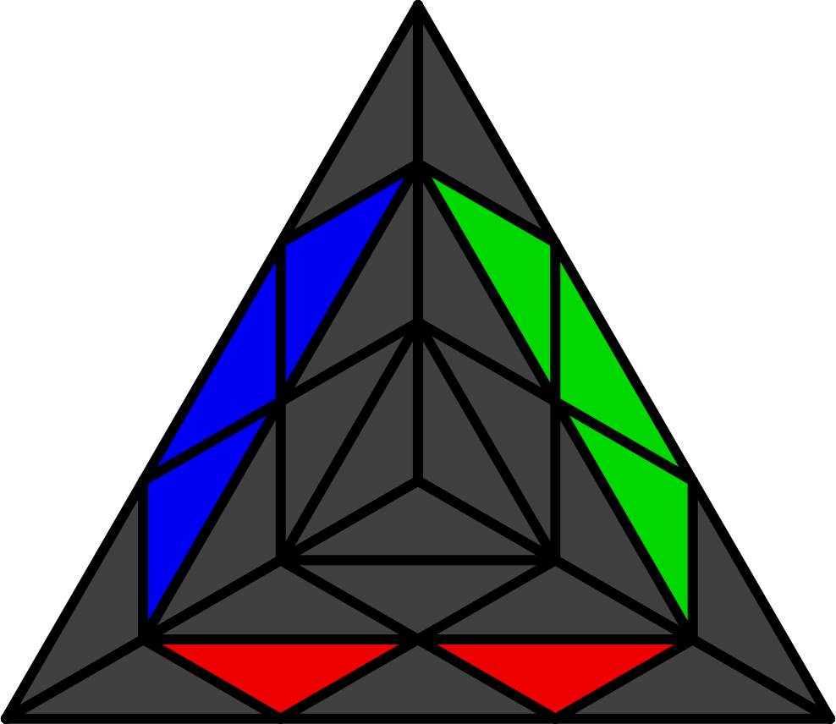**金字塔L4E法（四棱法）**

公式来自Jiaxuan Wang - http://jiaxuancubing.weebly.com/l4e.html

**"V"**

凭直觉还原3个心, 以及它们所夹的其中2个棱. 将所夹未还原棱放在FD出.



**L4E**

S = R' L R L', H = L R' L' R. 纯L4E = 还原当前的底棱 + L3E. 观察团或棒时，不能将黄棱另一侧算在内. 箭头表示底棱去向. 理解学习. 图片包含AUF信息, 做完公式后红面会朝前.

|  |  |  |  |  |  |
| --- | --- | --- | --- | --- | --- |
| **纯翻 [3]** | | | | | |
|  | |  | |  | |
| **S (U L' U' L)** | | **S (R U' R')**  U' H (L' U L) | | **((L' U L) (R U' R'))2** | |
|  | | | | | |
| **顶层 [4]** | | | | | |
|  |  | |  | |  |
| **R' (U' L' U L) R** | **L (U R U' R') L'** | | **R U' R' U' R U' R'** | | **L' U L U L' U L** |
|  | | | | | |
| **后三棱 [8]** | | | | | |
| **棒** | | | | | |
|  |  | |  | |  |
| **S** | **H** | | **H (R U' R')** | | **S (L' U L)** |
| **无棒** | | | | | |
|  |  | |  | |  |
| **R U R'** | **L' U' L** | | **L' U L** | | **R U' R'** |
|  |  | |  | |  |
|  |  | |  | |  |
|  |  | |  | |  |
|  |  | |  | |  |
|  |  | |  | |  |
| **反底棱 [4]** | | | | | |
|  |  | |  | |  |
| **(L' U L) (R U R')** | **(R U' R') (L' U' L)** | | **S U' S** | | **H U H** |
|  | | | | | |
| **纯四棱 [16]** | | | | | |
| **棒** | | | | | |
|  |  | |  | |  |
| **(R U' R') (L' U L)** | **(L' U L) (R U' R')** | | **H U' S** | | **S U H** |
|  |  | |  | |  |
| **H U' (R U' R')** | **S U (L' U L)** | | **(L' U' L U') H** | | **(R U R' U) S** |
|  | | | | | |
| **团 & 无棒** | | | | | |
|  |  | |  | |  |
| **(R U' R') S** | **(L' U L) H** | | **S U S** | | **H U' H** |
|  |  | |  | |  |
| **(R U' R' U') (R U R')** | **(L' U L U) (L' U' L)** | | **(L' U' L U') (R U' R')** | | **(R U R' U) (L' U L)** |