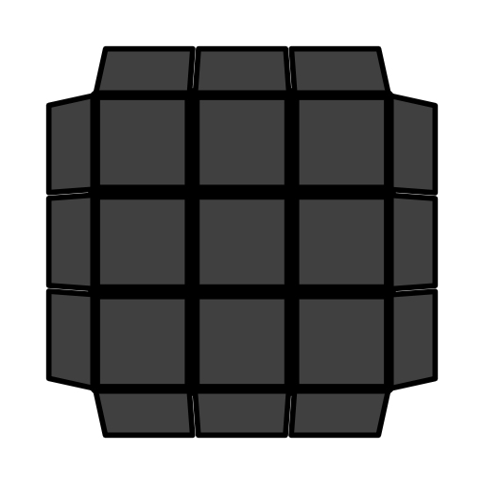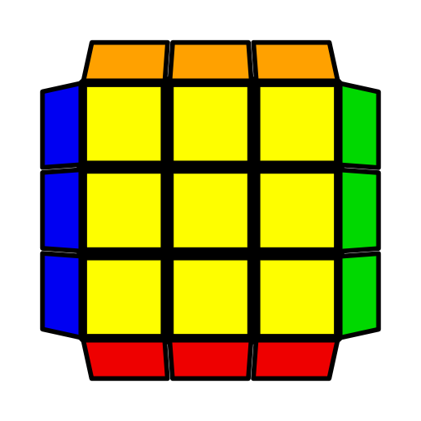**PLL Skip Prediction, Easy 1LLL Algorithms**

This page does not include OCLL (see ZBLL page). All **bold** algorithms are from OLL page. Suggested OLL.

|  |  |  |  |  |  |
| --- | --- | --- | --- | --- | --- |
| **T-Shapes** | | | | | |
|  |  |  |  |  |  |
| **(R U R' U') (R' F R F')** | **F (R U' R' U) (R U R' F')** | (R' U2' R U R' U R) (r U2' R' U' R U' r') | (R U2' R' U' R U' R') (r' U2' R U R' U r) | (r U' r' U') (r U r' U2) (r' D' r U') (r' D r) |  |
|  |  |  |  |  |  |
| **F (R U R' U') F'** | **F' (L' U' L U) F** | F U (R U' R' U)2 y' (R' U R U') (R' U R U2' R') |  |  |  |
|  | | | | | |
| **Squares** | | | | | |
|  |  |  |  |  |  |
| **r' U2' R U R' U r** | (R' U' R U') y x' R2 U' R' U l' | R' U' R U' y x' R2 U' R' U R' x | F U' R2 D (R' U R D') R2 U F' |  |  |
|  |  |  |  |  |  |
| **r U2' R' U' R U' r'** | R U R' U y' R2' F R F' R | F U' R2 D (R' U' R D') R2 U F' |  |  |  |
|  | | | | | |
| **C-Shapes** | | | | | |
|  |  |  |  |  |  |
| **(R U R2' U') (R' F R U) R U' F'** | **(R U R' U') (R' F R F') (R' U' R U' R' U2 R)** | **R' U' (R' F R F') U R** | R U l U' R' U x U' R' | R' D (R' U' R U D') R U' F (R2 U R' U') F' |  |
|  | | | | | |
| **W-Shapes** | | | | | |
|  |  |  |  |  |  |
| **(R' U' R U') (R' U R U) x' (R U' R' U) x** | **(R U R' F') (R U R' U') (R' F R U') (R' F R F')** | **(R U R' U) (R U' R' U') (R' F R F')** |  |  |  |
| **OELL** | | | | | |
|  |  |  |  |  |  |
| **(r U R' U') r' (R U R U' R')** | **(l' U' L U) l L' (U' L' U L)** | l (R U R' F') (R U R' U') R' F R2 U' R' U' l' | l' U' (R' U L' U2) (R U' R' U2 R) L l | **(R U R' U') r (R' U R U' r')** | **(L' U' L U) l' L (U' L' U l)** |
|  |  |  |  |  |  |
| **P-Shapes** | | | | | |
|  |  |  |  |  |  |
| **(R' U' F) (U R U' R') F' R** | **(r U' r') y' R U (R U R' U') (R U' R')** | **(r U2' R' U') (R2 U' L' U) R' U' x'** | (r U' r' U') (r U' r' U2)2 (r U r' U') (r U r') |  |  |
|  |  |  |  |  |  |
| **(R U B' U') (R' U R B) R'** | **S (R U R' U') (R' F R f')** | **x' (U' R U R') x U' (R' U' R U) (R' U R)** | **(r' U2' R U) (R2 U L U') R U x** | (F R U' R' U' R U R' F') (R U R' U' R' F R2 U R' U' F') |  |
|  |  |  |  |  |  |
| **R' U' F' U F R** | R' U' (F R' F' R) U R | (L' U R U' L) U2 R' F' (L' U' L F) | **f (R U R' U') f'** | L U (F' L F L') U' L' | (R U' L' U R') U2 L F (R U R' F') |
|  |  |  |  |  |  |
| **I-Shapes** | | | | | |
|  |  |  |  |  |  |
| **f (R U R' U')2 f'** | **R' U' (R' F R F') (R U' R' U2 R)** | **F' (U' L' U L)2 F** | **(r' U' r) (U' R' U R)2 (r' U r)** | **(r U r') (U R U' R')2 (r U' r')** | **F (R U R' U') R F' (r U R' U') r'** |
|  |  |  |  |  |  |
| **(R' U' R U' R' U) y' (R' U R B)** | **R' U2 (R2 u R' U) (R U' R u') R'** | **R' U' (R U' R' U) F' U F R** | (r' U2' R U R' U r) U' (R U R' U') (R' F R F') | (r U2 R' U' R U' r') (F R U R' U' F') |  |
|  |  |  |  |  |  |
|  |  |  |  |  |  |
|  |  |  |  |  |  |
| **(R' F R U) (R U' R2' F') (R2 U' R' U) (R U R')** | **(r U2' R' U') R2 (r' U R' U') (r U' r')** | F (R U' R' U') (R U R' U) (R U2 R' U2') (R U R' F') | R B' U' R' U (R2 B R2' U') (R U R') | R' F U (R U' R2' F') (R2 U R' U' R) | F U' R2 D (R' U2 R D') R2' U F' |
|  |  |  |  |  |  |
| (r U' r' U') (r U r') y' R2' D' (R U R' D R2) | (R U2' R2' U') (R U' R' U2') (F R F') |  |  |  |  |
|  |  |  |  |  |  |
| **Fish Shapes** | | | | | |
|  |  |  |  |  |  |
| **(R U R' U') R' F (R2 U R' U') F'** | **r' R2 U2' (R' U' R U') (R' U' r R')** | **(R' U' R) x' z' (R U' R' F) (R U l')** | **(R U R' U) (R' F R F') (R U2' R')** | **r R2' U2' (R U R' U) (R U r' R)** | **(R U R') y (R' F R U') (R' F' R)** |
|  |  |  |  |  |  |
| **F (R U' R' U') (R U R' F')** | **(F R' F' R) (U R U' R')** | **F' (L' U L U) (L' U' L F)** | (R U R' U') (R' F R2 U') (R' U R U R' F') | l' U (R U R' F') (R U R' U') (R' F R2 U') R' U2 l | (r U R' U R U2 r') U (R' U' R U' R' U2 R) |
|  |  |  |  |  |  |
| **(R U2') (R2' F R F') (R U2' R')** |  |  |  |  |  |
|  |  |  |  |  |  |
| **Knight Move** | | | | | |
|  |  |  |  |  |  |
| **(r U' r' U') (r U r') y' (R' U R)** | **F U (R U2 R' U') (R U R' F')** | **F U (R U' R2' F') (R U R U' R')** | **(R' F R U) (R' F' R) (F U' F')** | **(r U r') (R U R' U') (r U' r')** | **R' F (R U R' U') F' R (U' R' U2 R)** |
|  |  |  |  |  |  |
| **(r' U' r) (R' U' R U) (r' U r)** | **R' U2' (R U R' F) (U R U' R') F' R** |  |  |  |  |
|  |  |  |  |  |  |
| **Awkward Shapes** | | | | | |
|  |  |  |  |  |  |
| **(R U R' U') (R U' R') (F' U' F) (R U R')** | **M U (R U R' U') (R' F R F') M'** | **(R' F R F') (R U2' R' U') (F' U' F)** | **F U (R U2 R' U')2 F'** | **(F R' F) (R2 U' R' U') (R U R') F2** | **(R2' U R' B') (R U' R2' U) (R B R')** |
|  |  |  |  |  |  |
| **(R U R' U R U2' R') F (R U R' U') F'** | **x' (R U' R' U)2 x (R' U' R U)2** | **r R2' (F' U' F) (U R U' r') R** | **(R U' R' U2 R U) y (R U' R' U') F'** |  |  |
|  |  |  |  |  |  |
| **(R' U' R U' R' U2 R) F (R U R' U') F'** | **x' (U' R U R')2 x y (R U R' U')2** | **r' R2 y (R U R' U') y' (R' U r R')** | **(R' U R U2' R' U') (F' U F) U R** |  |  |
| **L-Shapes** | | | | | |
|  |  |  |  |  |  |
| **F (R U R' U')2 F'** | **L U (L F' L' F)2 U' L'** | **F' (L' U' L U)2 F** | **x (U R' U' R) x' U2' (R U' R' U) (R U2' R')** | **R' U' (R' F R F')2 U R** | (F R' F' R) U2' (R U' R' U) (R U2' R') |
|  |  |  |  |  |  |
| **r U' r2' U r2 U r2' U' r** | **(R' U2 R U R' U R) F (R U R' U') F'** | (R U' R' U) (R2 B' R2' U') R U B R' | (L' U2 L) (R U2' R' U' R U' R') U' (F R U R' F') | **r' U r2 U' r2' U' r2 U r'** | **(R U2 R' U' R U' R') F (R U R' U') F'** |
|  |  |  |  |  |  |
| (R' U R U') (R2' F R2 U) R' U' F' R | (F R U' R' F') U (R U R' U R U2' R') (L' U2 L) | **(r' U' R U') (R' U R U') R' U2 r** | **r' U2' (R U R' U') (R U R' U) r** | (R' F R F') U2' x' R2 U' R' U l' | R2' D' (R U' R' D R2) y (r U' r' U) (r U r') |
|  |  |  |  |  |  |
| **(r U R' U) (R U' R' U) R U2' r'** | **(r U2' R' U') (R U R' U') R U' r'** | l U' R' U x U2 R2 F R F' R | R2 D (R' U R D' R2') y (R' F R U') R' F' R |  |  |
| **Small Lightning Bolts** | | | | | |
|  |  |  |  |  |  |
| **r U R' U R U2' r'** | **r' U' R U' R' U2 r** | **(R U2 R' U2') (R' F R F')** | **r' (R2 U R' U R U2' R') U M'** | **F' (L' U' L U) F U' F' (L' U' L U) F** | **r (R2' U' R U' R' U2 R) U' R r'** |
|  |  |  |  |  |  |
| **F (R U R' U') F' U F (R U R' U') F'** |  |  |  |  |  |
| **Big Lightning Bolts 大闪电** | | | | | |
|  |  |  |  |  |  |
| **L F' (L' U' L d) R d' L'** | **F (R U R' U') F' (R' U' R U' R' U2 R)** | **(F R' F') U' F (U R U') F'** | **R' F (R U R' U') F' U R** | **F' (L' U' L U) F (L U L' U L U2 L')** |  |
|  |  |  |  |  |  |
| **Dot Cases** | | | | | |
|  |  |  |  |  |  |
| **R U2' (R2' F R F') U2' (R' F R F')** | **(R U' R2' D') (r U' r' D) (R2 U R')** | **(r' U' R U' R' U2' r) U (r U2' R' U' R U' r')** | **F (R U R' U') F' f (R U R' U') f'** | **(r U r') U2 R U2' R' U2 (r U' r')** | **(r' U' r) U2' R' U2' R U2' (r' U r)** |
|  |  |  |  |  |  |
| **f (R U R' U') f' U' F (R U R' U') F'** | **r' (R2 U R' U) (r U2' r' U) r R'** | **f (R U R' U') f' U F (R U R' U') F'** | **r' R U' (r U2' r' U') (R U' R2' r)** | **R U2' (R2' F R F') U2' r (R' U R U' r')** | **(r U R' U R U2 r') (r' U' R U' R' U2 r)** |
|  |  |  |  |  |  |
| **F (R U R' U) y' R' U2 (R' F R F')** | **r' R U (R U R' U') r (R2' F R F')** | **(r' U2' R U R' U) (r2 U2' R' U' R U' r')** | **F (R U' R' F) (R' F' R U) (R U R' U') F'** | **R' U2 F (R U R' U') F2 U2 F R** | **(R U R' U) (R' F R F') U2' (R' F R F')** |
|  |  |  |  |  |  |
| **r U' z U' R x' U2' R U' y (R U' R' F')** | **(F R' F' R) U2' R U' y (R U' R' F')** | **r' R U (R U R' U') r2 (R2' U R U' r')** |  |  |  |