F2L Lookahead Arrows

Lookahead is looking at next F2L while solving current F2L, rather than looking at current F2L. This page includes the suggested algorithms of all 2-gen F2L [18] cases except the case where edge and corner are in place. Arrow denotes the action of F2L algorithms on other pieces. left image shows FR-slot arrows, right shows corner arrows in U. Edge arrows in U can be derived by images. Purple arrows denote one single move (Study them first); Grey arrows denote at least two moves. For simplicity, there are pre-AUF in some cases. There is no arrow on the piece not moving.

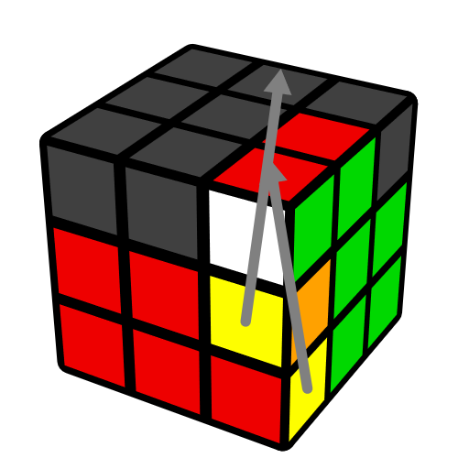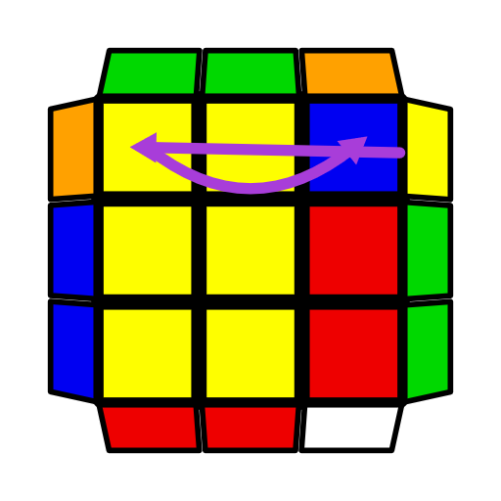 | 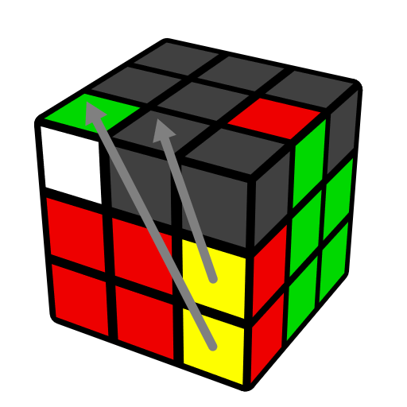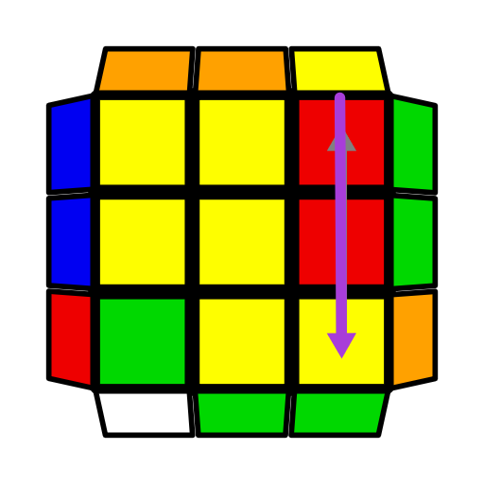 | 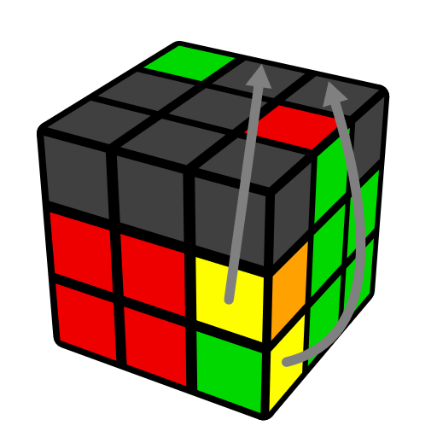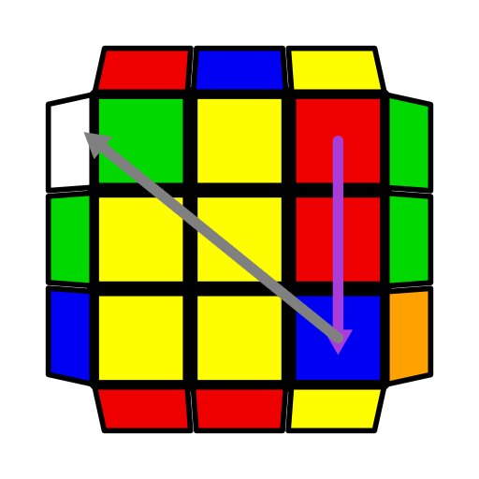
U R U' R' | U' R U R' | (R U' R' U') (R U R')
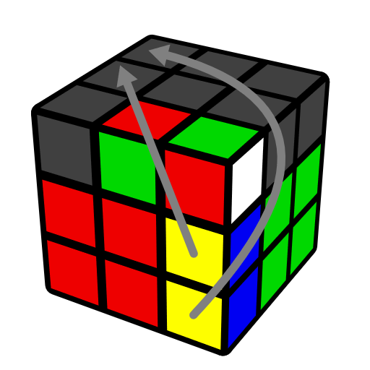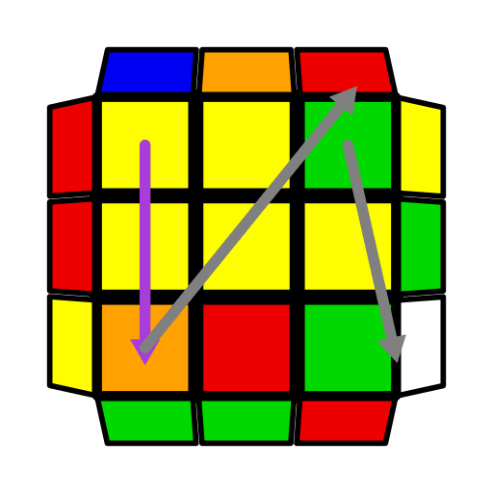 | 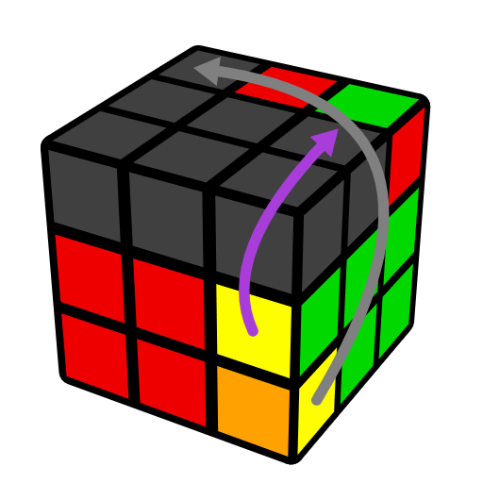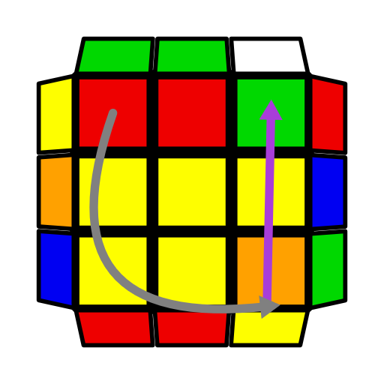 | 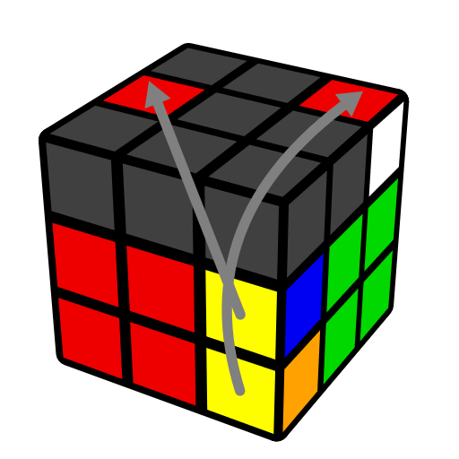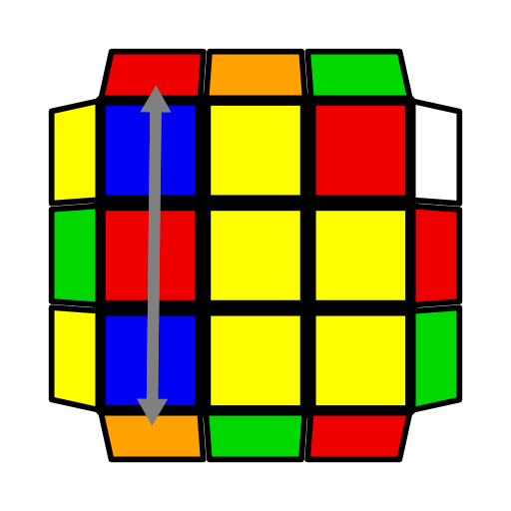
R' U2' R2 U R2' U R | (R U' R' U) (R U R') | (R U R' U2) (R U' R')
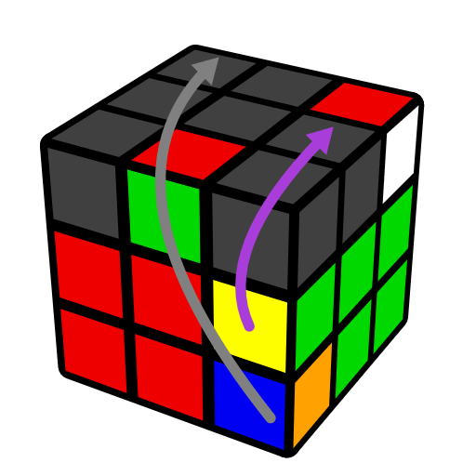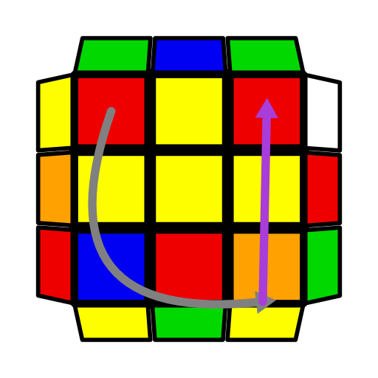 | 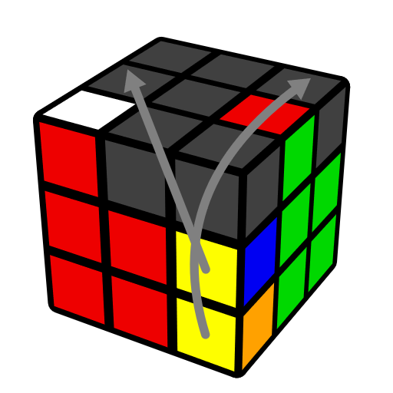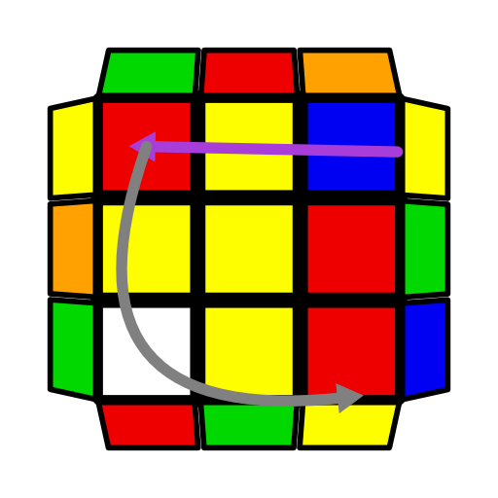 | 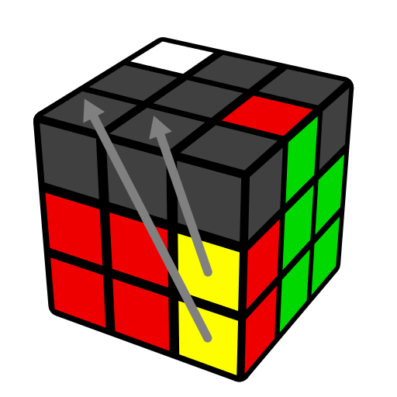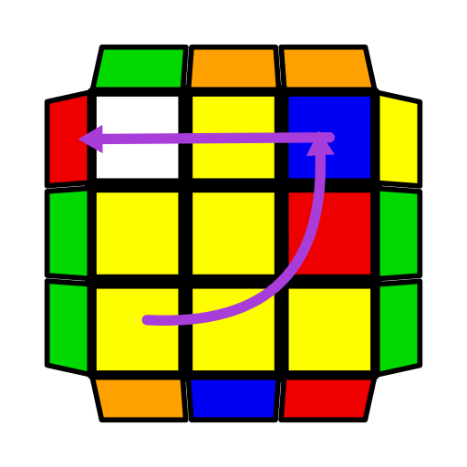
(R U2' R' U2) (R U' R') | (R U2' R' U) (R U' R') | (R U R' U) (R U' R')
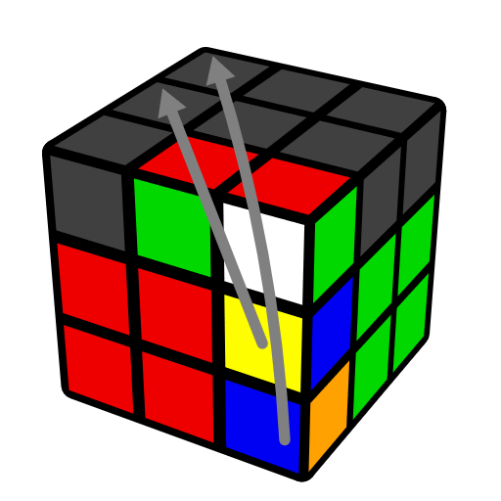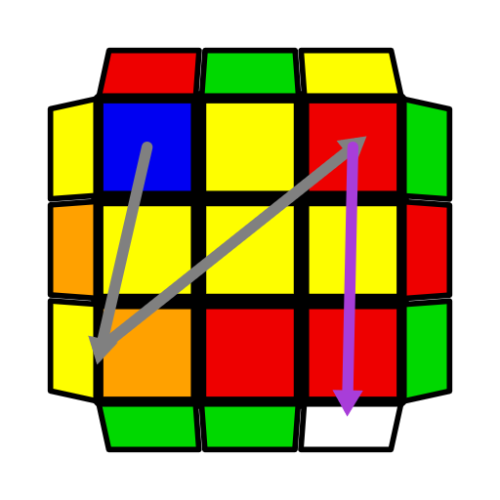 | 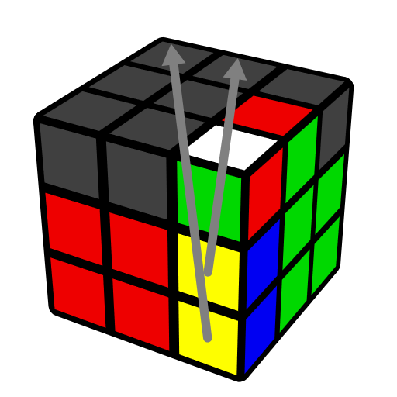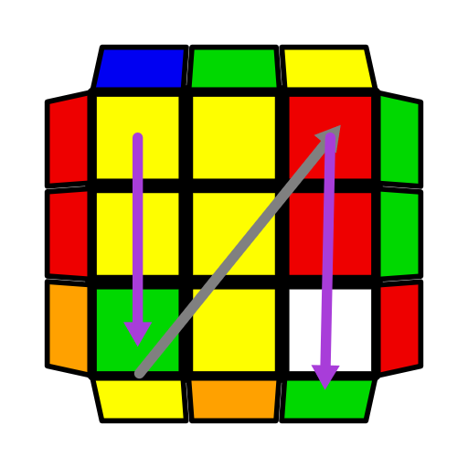 | 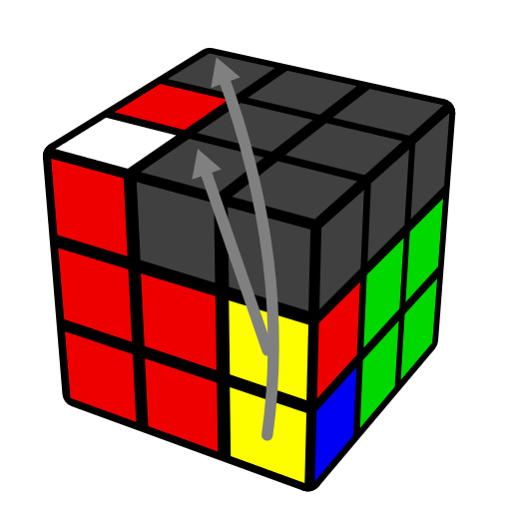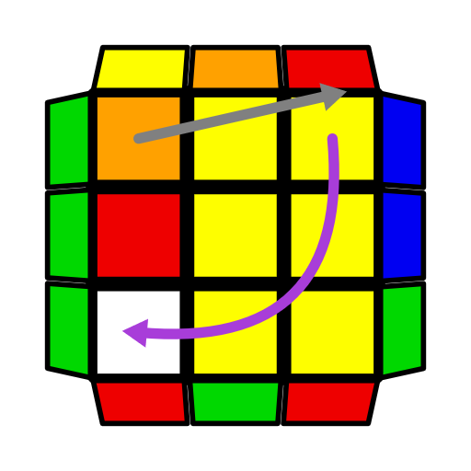
(R U R' U2') (R U' R' U) (R U' R') | (R U2' R' U') (R U R') | (R U' R' U') (R U' R' U) (R U' R')
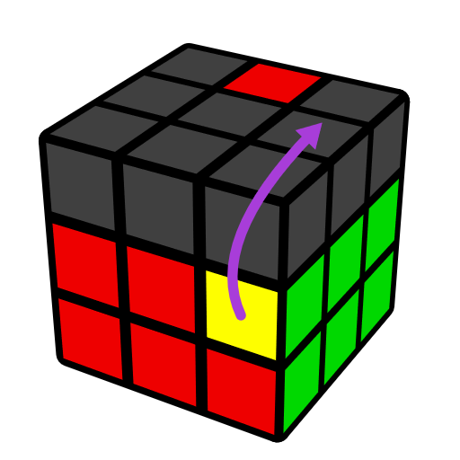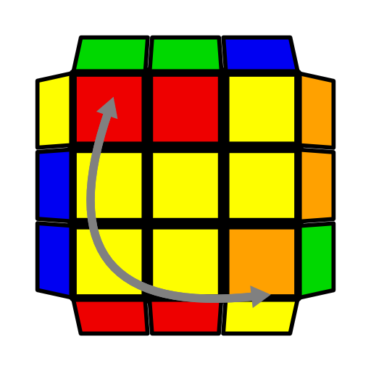 | 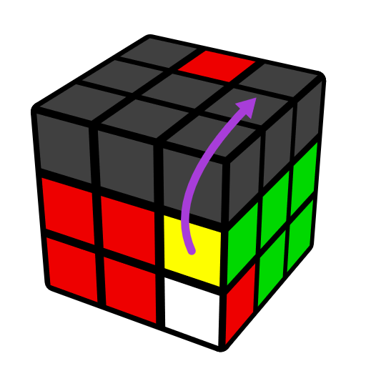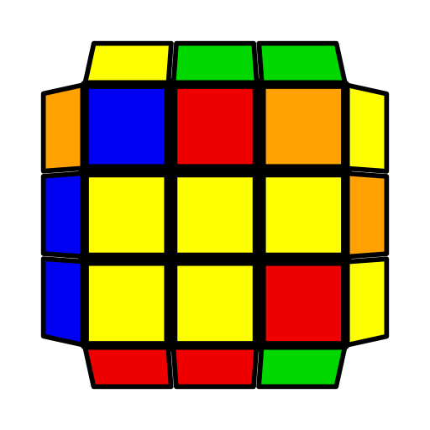 | 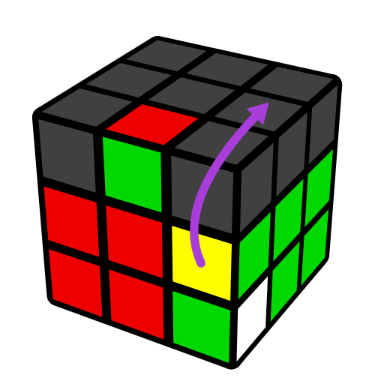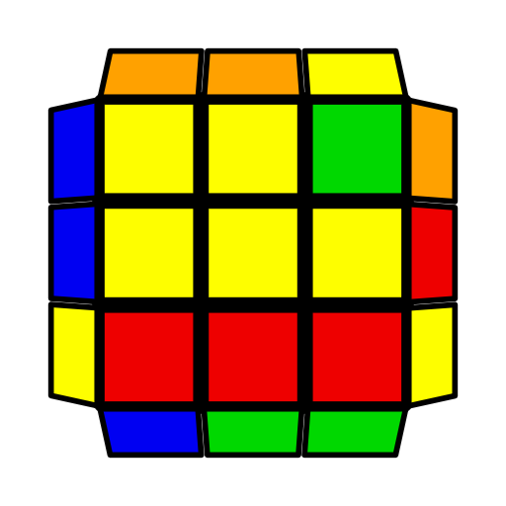
F' (R U R' U') (R' F R) | U (R U' R' U) (R U' R') | U' (R U R' U') (R U R')
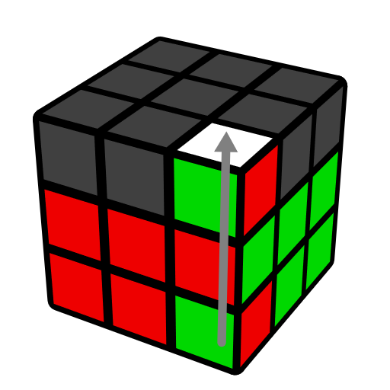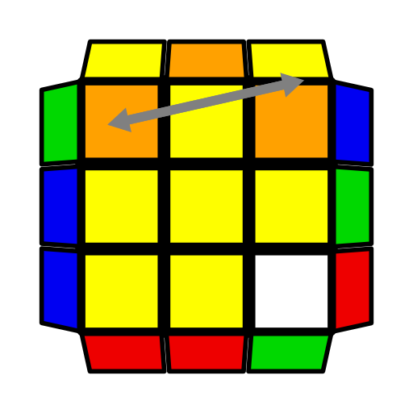 | 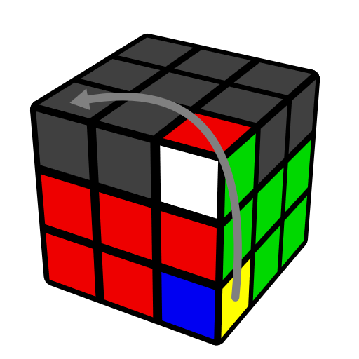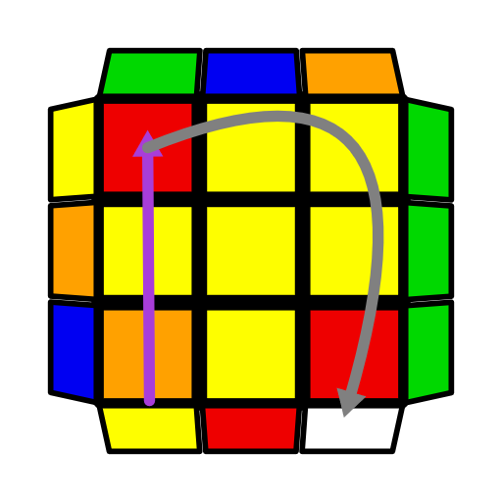 | 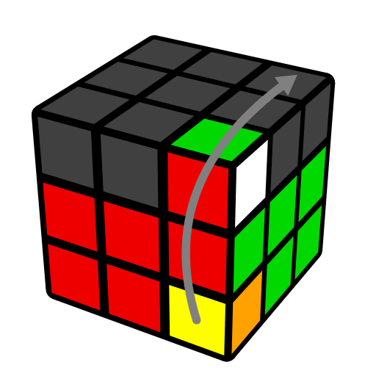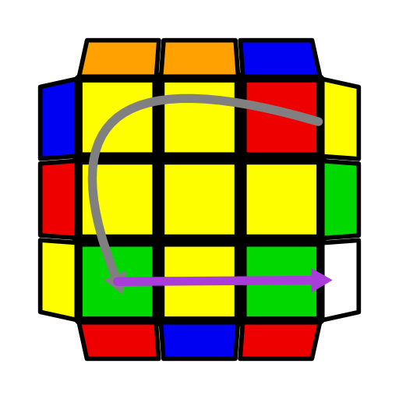
(U R U' R')3 | U' (R U' R' U2) (R U' R') | U (R U R' U2') (R U R')

Examples
Assume solving WGR-GR F2L first. Remark on Scramble 1: this F2L algorithm is (R U2' R' U') (R U R'). Analyze two arrows acting on the other F2L: Action of arrow on WBR-corner (action of F2L algorithm) is equivalent to R', which moves UBL corner to FUR; And action of arrow on BR-edge is equivalent to U', which moves UL edge corner to UF. One can predict that this F2L is connected basic insert. Remark on Scramble 2: this F2L algorithm is U' (R U' R' U2) (R U' R'). Analyze two arrows acting on the other F2L: Action of arrow on WGO-corner is equivalent to D' L', which moves RDF corner to UFL; And this F2L algorithm preserves GO-edge. One can predict that this F2L is top matched, wrong connected case.
Tip: Preserve UBR/UR | Scramble 1:  x2 y L' U' L R U' R' U R U2 R' | Scramble 2:  x2 y R' U' R U R' U' R U2 R' U R U2 R U R' U2 R U R' U
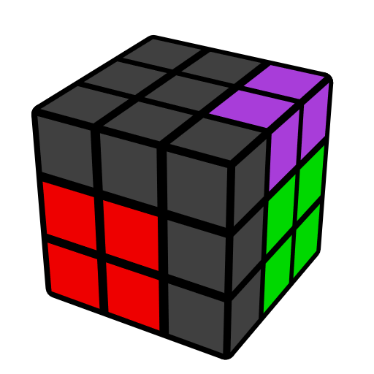 | 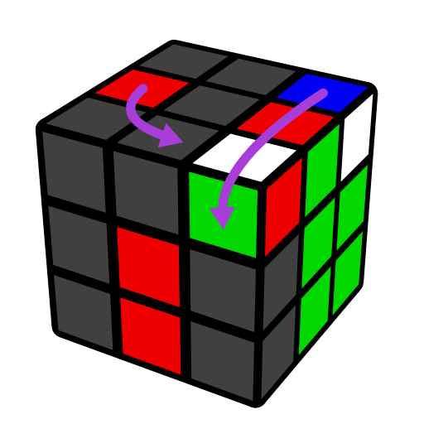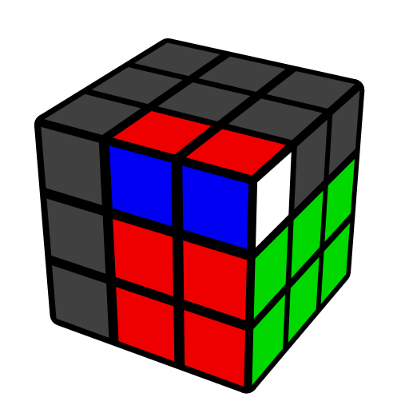 | 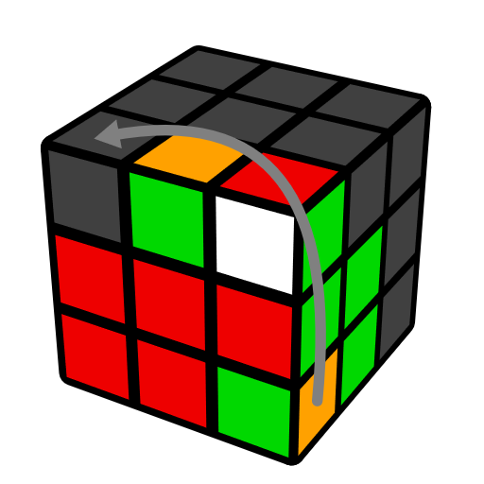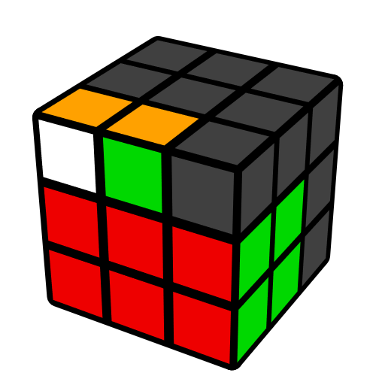
R U(n) R' (n=±1,2) | (R U2' R' U') (R U R') | U' (R U' R' U2) (R U' R')

