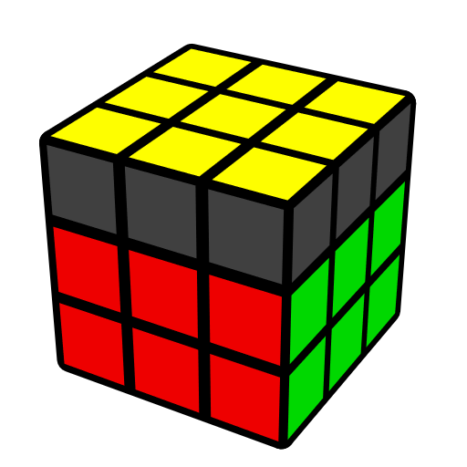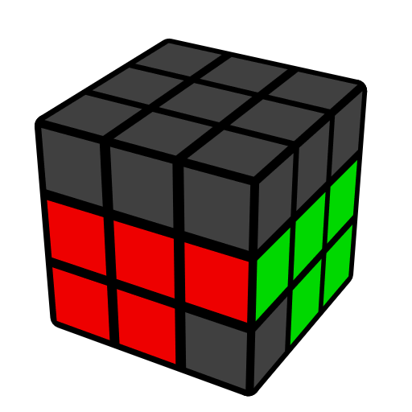**简单CLS公式 (角末槽)**

Feliks Zemdegs

CLS [44] 是在EO已还原时，还原末组F2L的角和CO. 很简单, 换位子.

|  |  |  |  |  |  |
| --- | --- | --- | --- | --- | --- |
| **角在U, 面朝F [12]** | | | | | |
|  |  | |  | |  |
| **y (R' D R) U' (R' D' R)** | **U' (R U' R' U') (R U2' R')** | | **y' U (R' U2 R U') (R' U' R)** | | **(U L U') R (U L' U') R'** |
|  |  | |  | |  |
| **(R U R' U') (R U' R' U)**  **(R U' R')** | **U' (R U' R' U2) (R U R' U') (R U' R')** | | **(R U' R U2') (R' U' R U' R2')** | | **U' (R U' R' U2) (R U' R')** |
|  |  | |  | |  |
| **U2 l (R U' R' U)3 l'** | **y' U' (R' U' R U2) (R' U' R)** | | **U' (R U' R' U') (R U' R' U) (R U2' R')** | | **U (R U2' R' U') (R U R' U) (R U R')** |
|  | | | | | |
| **角在U, 面朝R [10]** | | | | | |
|  |  | |  | |  |
| **U (R' D' R) U' (R' D R)** | **y' U (R' U R U) (R' U2 R)** | | **U' (R U2' R' U) (R U2' R' U) (R U2' R')** | | **U' (R U2' R' U) (R U R')** |
|  |  | |  | |  |
| **(R U R' U') (R' F' R U)**  **(R U' R' F)** | **U (R U L) U' (R' U L')** | | **U' (R U R' U') (R U' R' U')**  **(R U R')** | | **y' U (R' U R U2') (R' U' R U) (R' U R)** |
|  |  | |  | |  |
|  | **y' U (R' U R U2') (R' U R)** | | **U (R U R' U2') (R U R')** | |  |
|  | | | | | |
| **角在U, 面朝U [10]** | | | | | |
|  |  | |  | |  |
| **U' (R U' R' U) (R U2' R' U') (R U R')** | **y' U' (R' U2' R U)2**  **(R' U2' R)** | | **y' U (R' U' R U) (R' U' R U') (R' U R)** | | **y' U2 (R' U R U') (R' U' R U') (R' U R)** |
|  |  | |  | |  |
| **U2 (R U' R' U) (R U R' U)**  **(R U' R')** | **U' (R U R' U') (R U R' U)**  **(R U' R')** | | **U (R U2 R' U')2 (R U2 R')** | | **U (R U' R' U)2 (R U' R')** |
|  |  | |  | |  |
|  | **y' U' (R' U R U')2 (R' U R)** | | **U' (R U R' U') (R U R' U2')**  **(R U2 R')** | |  |
|  | | | | | |
| **角在槽, 面朝F [6]** | | | | | |
|  | |  | |  | |
| **L' (R U R' U') L (R U2 R' U') (R U R')** | | **(R U' R' U') (R U R' U2) (R U' R')** | | **(R U2 R' U2') (R U2 R' U') (R U R')** | |
|  | |  | |  | |
| **y' (R' U2 R U') (R' U R U') (R' U' R)** | | **(R U' R' U') (R U R' U') (R U2' R')** | | **U' (R U R' U') (R U2 R' U') (R U R')** | |
|  | | | | | |
| **角在槽, 面朝R [6]** | | | | | |
|  | |  | |  | |
| **U2 (R U' R' U) (R U2' R')**  **L' (U R U' R') L** | | **U (R U2' R U) (R' U R U2') R2'** | | **(R U' R' U) (R U2' R' U2) (R U2' R')** | |
|  | |  | |  | |
| **(R U2' R' U) (R U' R' U) (R U R')** | | **U (R U' R' U) (R U2' R' U) (R U' R')** | | **y' (R' U R U) (R' U' R U) (R' U2' R)** | |