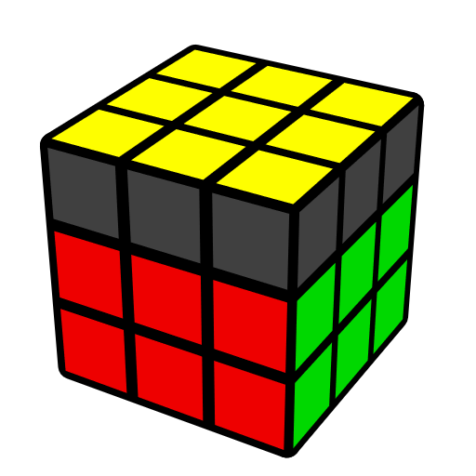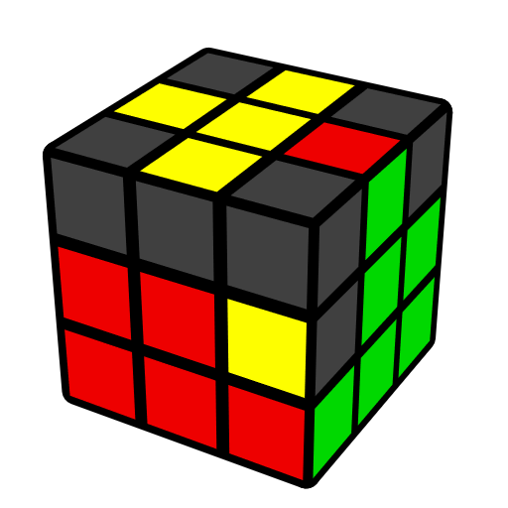**BLE公式 (布鲁克斯末棱)**

公式来自Feliks Zemdegs, Anthony Brooks

BLE [27] 在顶棱正向时, 插入末组F2L棱并还原顶角向. 预备: COLL.

BLE = 纯BLE; BLE = 破坏F2L角 + 还原F2L; BLE = 直接插入F2L棱 + OLL.

|  |  |  |  |
| --- | --- | --- | --- |
| **CO [1]** | | **H [2]** | |
|  | |  |  |
| **U (R U' R' U') (R U2' R' U R U R')**  R' U' (R' U' R' U) (R U R) | | **U' (R U' R' U') (R U R' U R U R')** | **(R U' R' U') (R U' R' U R U R')** |
|  | | | |
| **S [4]** | | | |
|  |  |  |  |
| **(R U R' U2') (R U R' U2' R U' R')** | **U' (R U' R' U R U R')**  **U (R U2' R' U R U R')** | **U (R U' R' U) (R U R' U2' R U R')** | **U' F' (R U R' U') (R' F R)**  **U R' U2' R U R' U R** |
|  | | | |
| **AS [4]** | | | |
|  |  |  |  |
| **U' F' (R U R2' U') (R' F R U R)** | **U' (R U' R' U2) (R U' R' U' R U R')** | **U' (R U R' U2') (R U' R' U2 R U' R')** | **U' F' (R U R' U') (R' F R)**  **U R U2' R2' U' R2 U' R2' U2' R** |
|  | | | |
| **L [4]** | | | |
|  |  |  |  |
| **U' F' (R U R' U') (R' F R)** | **U2 (R U2' R' U') y' (R' U2 R U' R' U' R)** | **U (R U' R' U) y' (R' U R U R' U2' R)** | **(R' F' R U) (R U' R' F)**  **U2 (r U R' U') (r' F R F')** |
|  | | | |
|  | | | |
|  | | | |
|  | | | |
|  | | | |
|  | | | |
|  | | | |
|  | | | |
| **T [4]** | | | |
|  |  |  |  |
| **(R' F' R U) (R U' R' F)** | **(R' F' R U) (R U' R' F)**  **U R' U2' R U R' U R** | **U' F' (R U R' U') (R' F R)**  **R2' D' (R U2 R' D) (R U2 R)** | **U' F' (R U R' U') (R' F R)**  **R' U' R U' R' U2 R** |
|  | | | |
| **U [4]** | | | |
|  |  |  |  |
| **U' (R' D' R U') (R' D R U) (R U R')** | **U (R U' R') (U' R' D' R) (U R' D R)** | **U' F' (R U R' U') (R' F R)**  **R U R' U R U2' R'** | **U' (F' R U R') (U' R' F R)**  **R2 D (R' U2 R D') (R' U2 R')** |
|  | | | |
| **Pi [4]** | | | |
|  |  |  |  |
| **(R U2' R' U) (R U2 R' U') (R U2 R')** | **(R U R' U2') (R U R' U') (R U2 R')** | **U2 (R U2' R' U) (R U' R' U2 R U' R')** | **U2' (R U R' U2') (R U2' R' U2 R U' R')** |