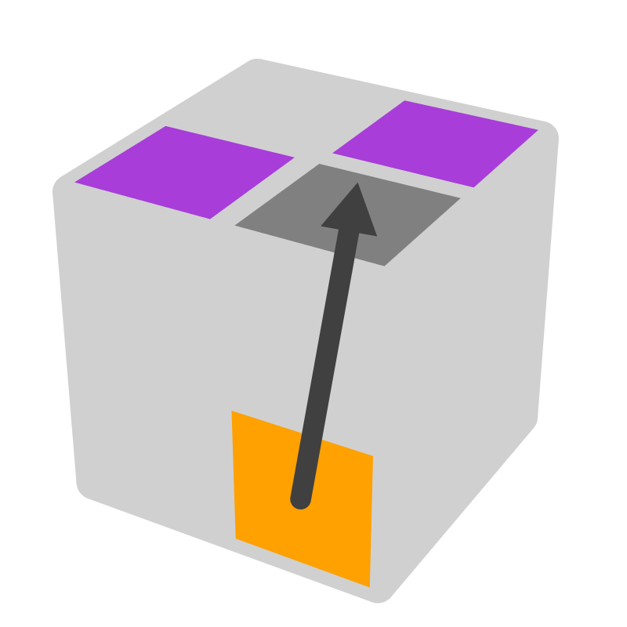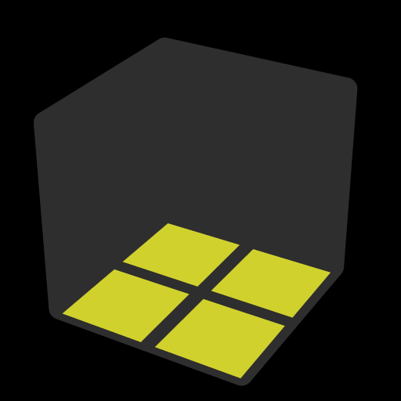**二阶FF公式 (底面), 全预判**

|  |  |  |
| --- | --- | --- |
|  |  |  |
| 同色面 | 对色面 | 邻色面 |

本文包括所有棒情况 [34], 部分棋盘情况 [15], 其他实用情况 [8]. 将仅差一个AUF的情况视为同一个情况. 预判底层只需确定底层任意2个侧面: 有2个同色面 => CLL; 有邻色面, 或1个同色面且另1个非同色面 => EG1; 有2个对色面 => EG2. 左图为情况图, 右图为推荐公式的预判图.预判顶层只需追踪任意3个含顶色的块. 箭头表示公式对块的作用. 颜色标记: 不动块或原地翻转块 (做完公式后紫色面朝上), 箭头起点块, 箭头终点块, 考察块, 就考察块而言与推荐公式等效的公式, 含有不少于2个的不动块的情况, 之前出现过的情况的另解情况, 破坏底面棒的公式. 直线箭头表示1步到达, 曲线箭头表示2步到达. 为简单起见，对一些情况做了预AUF. 先预判OLL, 再预判EG.

|  |  |  |  |  |  |  |  |  |  |
| --- | --- | --- | --- | --- | --- | --- | --- | --- | --- |
| **棒** | | | | | | | | | |
| **末块 [5]** | | | | | | | | | |
|  | |  | | |  | | |  | |
| **F' L' U L** | | **F R U' R'** | | | **L' U' L** | | | **R U R'** | |
|  | | | | | | | | | |
| **R2 U' R2'** | | | | | | | | | |
|  | | | | | | | | | |
| **2个在D [4]** | | | | | | | | | |
|  | |  | | |  | | |  | |
|  | **B' R' U2** |  | | **F R U2** |  | | |  | |
| **R' U2 R U' R'**  R' U' R U2' R' | | **R U2' R' U R**  R U R' U2 R | | | **R' U R2 U' R** | | | **U2 R U2' R2' U R2**  y F R2 U' R2' | |
|  | | | | | | | | | |
| **1个在D, 1个在U [12]** | | | | | | | | | |
|  | |  | | |  | | |  | |
| **R'** | | **R** | | | **U' R2 U R'**  F2 R2 F' | | | **U R2' U' R**  F2 R2 F | |
|  | |  | | |  | | |  | |
| **F' R F** | | **U F U' R'** | | | **R U R' U' R** | | | **R' U' R U R'**  U R2' F' R F | |
|  | |  | | |  | | |  | |
|  | **R'** |  | | **R** |  | | |  | |
| **R U' R2'**  U2 R' U R U' R' | | **R' U R2**  U2 R U' R' U R | | | **U R U' R** | | | **U' R' U R'** | |
|  | | | | | | | | | |
| **2个在U, 1或2个朝U [6]** | | | | | | | | | |
|  | |  | | |  | | |  | |
| **R2** | | **U R U R' U R2**  R' U' R U' R2' | | | **R2' U R U' R**  U2 R' U' R' | | | **R2 U' R' U R'**  U2 R U R | |
|  | |  | | |  | | |  | |
|  | |  | | |  | **U' R2** | |  | **U L2** |
| **R2 U R' U' R** | | **R2' U' R U R'** | | | **R2' F R U' R'** | | | **L2 F' L' U L** | |
|  | |  | | |  | | |  | |
|  | | **R' U R U' R**  U' R' U' R2  U R U2 R | | | **R U' R' U R'**  U R U R2'  U' R' U2 R' | | |  | |
|  | | | | | | | | | |
| **2个在U, 没有朝U [7]** | | | | | | | | | |
|  | |  | | |  | | |  | |
|  | |  | | |  | **z2** | |  | |
| **R U' R U R2'** | | **R' U R' U' R2** | | | **R2 U2' R'**  U2 R2' U2' R | | | **U2 R U2' R2' U' R2**  U' (R U' R' U) (R' U' R) | |
|  | | |  | | | |  | | |
| **R U' R U R'** | | | **R' U R' U' R** | | | | **U R2 U' R'** | | |
|  | | | | | | | | | |
| **棋盘 (简单)** | | | | | | | | | |
| **2个在D [3]** | | | | | | | | | |
|  | | |  | | | |  | | |
| **R2 U R2' F'** | | | **R2 U R' F' R'** | | | | **L2' U' L F L** | | |
|  | | | | | | | | | |
| **1个在D, 1个在U [6]** | | | | | | | | | |
|  | |  | | |  | | |  | |
| **R D R'** | | **R F R'**  U' R F U R' | | | **F' R' F** | | | **x R U R' F' R'** | |
|  | |  | | |  | | |  | |
|  | | **x U' R U' R' U x'** | | | **x R U' R' U R' x'** | | |  | |
|  | | | | | | | | | |
| **2个在U [6]** | | | | | | | | | |
|  | |  | | |  | | |  | |
| **x U L U' L x'** | | **x U' R' U R' x'** | | | **x2 R U' R' U L' x** | | | **x2 L' U L U' R x** | |
|  | |  | | |  | | |  | |
|  | | **R2' F R2** | | | **L2 F' L2** | | |  | |
|  | | | | | | | | | |
| **其他 [8]** | | | | | | | | | |
|  | |  | | |  | | |  | |
| **F R2** | | **R' F' R'**  F' U' R' | | | **F U2 R** | | | **F' U2 R** | |
|  | |  | | |  | | |  | |
| **U' F' R2** | | **U F' R2** | | | **R2 F' R'** | | | **R F U2 R** | |