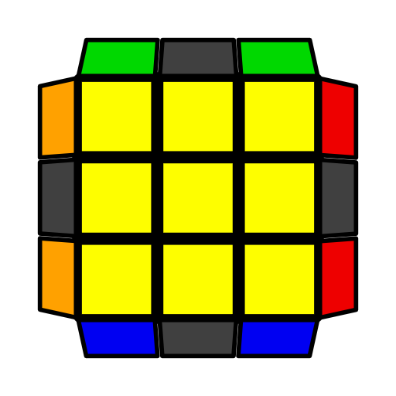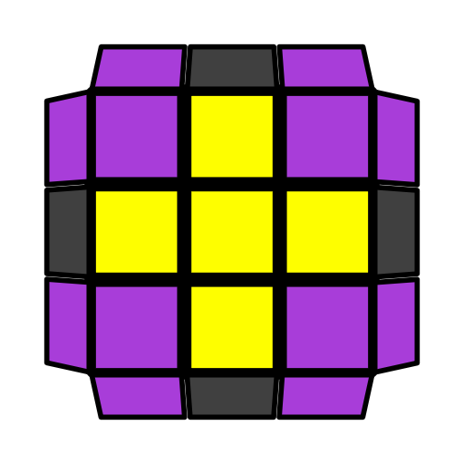**简版COLL公式（角块还原和顶层色向）**

COLL [40] 是在有顶十字棱时还原顶层角块. 对情况S, A，建议用OLL.

|  |  |  |  |  |  |
| --- | --- | --- | --- | --- | --- |
|  | H |  |  |  |  |
|  | **(R U R' U) (R U' R' U) (R U2' R')** | **F (R U R' U')3 F'** | **F (R U' R' U) (R U2 R' U') (R U R' U') F'** | **(R U R' U R U)**  **(L' U R' U' L)** |  |
| P |  |  |  |  |  |
| **R U2' R2' U' R2 U' R2' U2' R** | **(R U D') (R U R' D) (R2 U' R' U')**  **R2' U2' R** | **F U (R U' R' U) (R U' R2' F') (R U R U' R')** | **(R U R' U') R' F (R2 U R' U') (R U R' U') F'** | **(R U R' U) F' (R U2' R' U2') (R' F R)** | **F U (R U' R' U) (R U2' R' U') (R U R' F')** |
| U |  |  |  |  |  |
| **(R U R' U R U2' R2') (U' R U' R' U2 R)** | **F (R U' R' U) (R U R' U) (R U' R' F')** | **R2 D (R' U2 R D') (R' U2 R')** | **R2' D' (R U2 R' D) (R U2 R)** | **R' F (R U' R' U') (R U R' F') (R U R' U') (R' F R F' R)** | **(R' U2 R F) U' (R' U' R U) F'** |
| T |  |  |  |  |  |
| **(R U2' R' U' R U' R2') (U2' R U R' U R)** | **F (R U R' U') (R U' R' U') (R U R' F')** | **(R' U R U2') L'**  **(R' U R U') L** | **(R' U R2 D) (r' U2 r) (D' R2' U' R)** | **(l' U' L U) (R U' r' F)** | **(r U R' U') (r' F R F')** |
| L |  |  |  |  |  |
| **(R U R' U) (R U' R' U)2 (R U2' R')** | **r U2' (R2' F R F')**  **R U2' r'** | **(R U2 R D) (R' U2 R D') R2'** | **(R' U2 R' D') (R U2 R' D) R2** | **(F R' F' r) (U R U' r')** | **F' (r U R' U') (r' F R)** |
|  |  |  |  |  |  |
| S**C:\Users\Alienware\AppData\Local\Microsoft\Windows\INetCache\Content.Word\16-COLL 40-Ruimin_YAN.JPG** |  |  |  |  |  |
| **R U R' U R U2' R'** | F' (R U2' R' U2) R' F2 (R U R U') R' F' | **R U' L' U R' U' L** | L' (R U R' U') L  (U2 R U2' R') | (L' U2 L U2) R  (U' L' U L) R' | (R U R' U) (R U' R D) (R' U' R D') R2' |
| A |  |  |  |  |  |
| **R U2' R' U' R U' R'** | (R U' R' U2)2 (R' D' R) U (R' D R) | **L' U R U' L U R'** | R (L' U' L U) R'  (U2 L' U2 L) | (R U2 R' U2) L'  (U R U' R') L | (R' U' R U') (R' U R' D') (R U R' D) R2 |