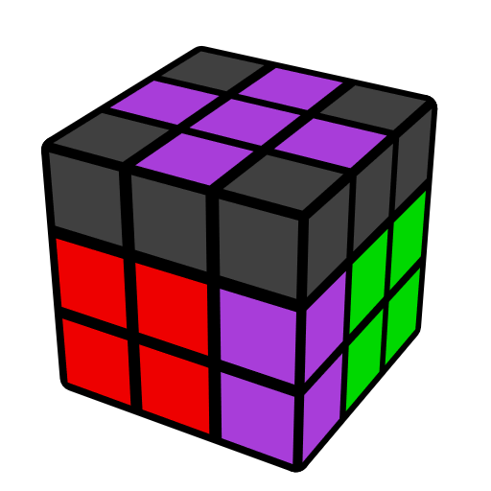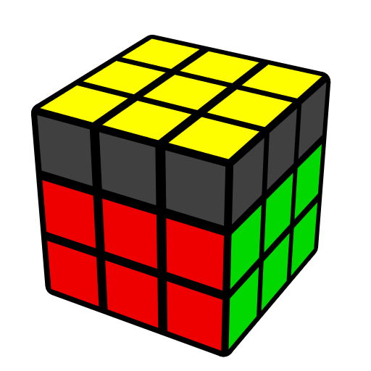**简单OLS公式 (末槽和顶层色向)**

OLS [68] 还原最后一组F2L和OLL. 本文主要包含了连接态的末组F2L且顶层大多棱正向的一些情况. 先导内容：EOLS.

|  |  |  |  |  |  |
| --- | --- | --- | --- | --- | --- |
| **基态 [4]** | | | | | |
|  |  | |  | |  |
| **U' r' D' (r U r') D r** | **(R U' R' U') (R U' R')** | | **(R U' R2' F R F')**  **U2 (R' F R F')** | | **R' D' (r U r' D)**  **(R2 U R')** |
|  | | | | | |
| **情况1 [10]** | | | | | |
|  |  | |  | |  |
| **y' (R U2' R' U) (R2 U' R' U) (R' U R')** | **y' U R2' D' (R U' R' D) R2** | | **(R' U2 R U') (R2' U R**  **U') (R U' R)** | | **U' R2 D (R' U R D') R2'** |
|  | |  | |  | |
| **y' (R U2' R2' U' R2 U' R')**  **U' (R U R' U R U2 R')** | | **y' U (R' U R U') (R U2' R2'**  **U' R2 U' R')** | | **y' U (R U2' R2' U' R2 U' R')**  **(U2 R' U2' R)** | |
|  | |  | |  | |
| **(R' U2' R2 U R2' U R) U2'**  **(R U2' R' U' R U' R')** | | **U' (R U' R' U) (R' U2' R2 U R2' U R)** | | **U' (R' U2' R2 U R2' U R)**  **(U2 R U2' R')** | |
|  | |  | |  | |
| **情况3 [2]** | | | | | |
|  | | |  | | |
| **(R U' R' U2) (R U R')** | | | **y' (R' U R U2') (R' U' R)** | | |
|  | | | | | |
| **错误连接 [24]** | | | | | |
|  |  | |  | |  |
| **R' D' (R U' R' D)**  **(R U R U' R')** | **(R U' R U2') (R2' U' R2 U' R2')** | | **y' (R' U R) U2'**  **y (R U R')** | | **(R U R') U2 (R U' R' U)**  **(R U' R')** |
|  |  | |  | |  |
|  | **l U (r U' r' U') l'** | | **M U (r U' r' U') M'** | |  |
|  |  | |  | |  |
| **y' U (R U R2' U R2 U2') (R' U R' U' R)** | **y' U R' U' (R2 U R2' U R2 U2') (R' U R' U' R)** | | **(R U2' R' U') (R U2' R' U) (R U2' R')** | | **y' R' U2 (R U R' U2)**  **(R U' R' U2 R)** |
|  |  | |  | |  |
| **U (R U' R' U') (R U' R' U) (R U' R')** | **U (R U R U2') (R' U' R U' R2')** | | **U (R U2' R' U') (R U' R' U2) (R U' R')** | | **(R U R' U2') (R U R' U') (R U R')** |
|  |  | |  | |  |
| **y' U' (R' U' R' U2)**  **(R U R' U R2)** | **y' U' (R' U2 R U) (R' U R U2) (R' U R)** | | **y' U' (R' U R U) (R' U R U') (R' U R)** | | **U' R U (R2' F R F')**  **(R U' R')** |
|  |  | |  | |  |
|  | **U' (R U' R' U') y' (R' U' R U' R' U R)** | | **(R U' R' U) (r U' R' U)**  **(R U r')** | |  |
| **角归位，棱顶层 [14]** | | | | | |
|  |  | |  | |  |
| **U' r (R' U R U')**  **r' (R U R')** | **U' F' (R U R' U') R' F R** | | **(R' F' R U) (R U' R' F)** | | **U F' U2' F U2' (R U R')** |
|  |  | |  | |  |
| **U (R U' R') (r U R' U') r' R** | **y' U x' (R U' R' U)**  **l' U' R** | | **U (R U' R') (F R' F' R)** | | **U' (R U2' R' U2)**  **(F' U' F)** |
|  |  | |  | |  |
| **y' (R' U R U') (R' U R)** | **(R U R' U') (F R' F' R)** | | **y' (R' U' R U) (R' U' R)** | | **(R' F R F') (U R U' R')** |
|  |  | |  | |  |
|  | **U' (F R' F' R2) U R'** | | **U' R d' (R U' R' U') F'** | |  |
|  | | | | | |
| **棱归位，角顶层 [3]** | | | | | |
|  | |  | |  | |
| **U' (R U R' d) (R' U' R)** | | **U M' U R U' r' (R U' R')** | | **U (R' U' R d') (R U R')** | |
|  | | | | | |
| **棱角归位 [11]** | | | | | |
|  |  | |  | |  |
| **(R' F R F') (R' U2' R2 U R2' U R)** | **(R' F R F') (R' U2' R2 U R2') F' U F R** | | **(R2 U2' R2' U') (R U R U2) R2' U' (F' U' F)** | | **(R U' R' d) (R' U2 R U2') (R' U R)** |
|  | |  | |  | |
| **(R U2' R' U)2 y' (R' U' R)** | | **(R U' R' U) (R U2' R' U)**  **(R U' R')** | | **(R U R' U2') (R U' R' U)**  **(R U R')** | |
|  |  | |  | |  |
| **(R U' R' U') (R U R' U2) (R U' R')** | **(R U R' U') (R U2' R' U') (R U R')** | | **(F' U F) U2 (R U R' U)**  **(R U' R')** | | **(R U' R') F (R U R' U') F' (R U' R')** |