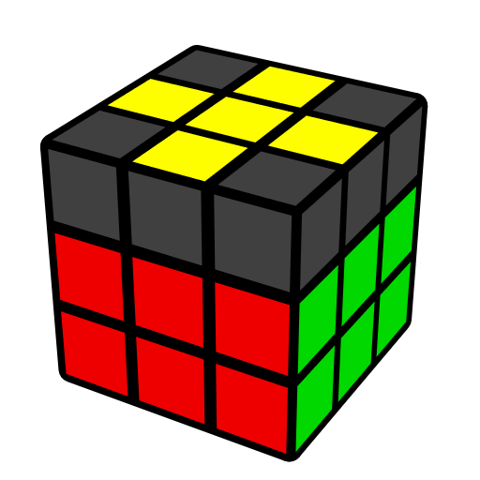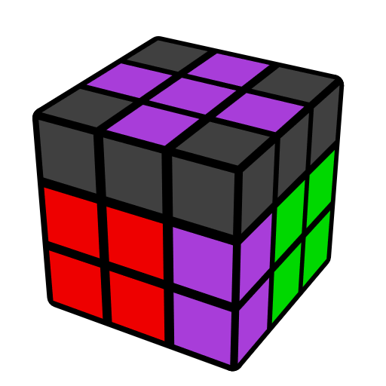**Easy EOLS Algorithms**

**(Edge Orientation Last Slot)**

EOLS solves last F2L pair and orient LL edges. For the case where there are last F2L edge and 3 oriented yellow edges in U, if F2L edge is oriented, use only R, U-gen; Otherwise use y move first, then use R, U-gen.

|  |  |  |  |  |  |
| --- | --- | --- | --- | --- | --- |
| **Case 1 [14]** | | | | | |
|  |  | |  | |  |
| **U' (R U' R' U) y' (R' U' R)** | **F (R U R' U') F' (R U' R')** | | **y' U (R' U R d') (R U R')**  U2 (r U' R' U') R U r' | | **y F' (L' U' L U) F (L' U L)** |
|  |  | |  | |  |
| **(R U R' U') y'**  **(R' U' R U)2** | **(R U R' U) (R U' R')**  **(F' U' F)** | | **U' (R U' R' U) (R U' R' U2) (R' F R F')** | | **y' (R' U' R U') (R' U R)**  **y (R U R')** |
|  | |  | |  | |
| **F' U (L' U2 L U2) F** | | **U' (R U2' R' U) (F' U' F)** | | **y' (R' U R U')2 (R B' R' B)** | |
|  | |  | |  | |
| **R d' (R U2' R' U2) F'** | | **y' U (R' U2' R) y (U' R U R')** | | **(R U' R' U)2 (R' F R F')** | |
|  | | | | | |
| **Case 2 [3]** | | | | | |
|  | |  | |  | |
| **U2 (r U R' U') (R U' R' U) R U r'** | | **U' (r U R' U') r' (R2 U2' R')** | | **U' (r U R' U') M U2' (R' F R F')** | |
|  | | | | | |
| **Case 3 [4]** | | | | | |
|  |  | |  | |  |
| **y F R U2 R' F'** | **F' L' U2 L F** | | **y' U2 R' F R' F' R2** | | **y' R' F' U2' F R** |
|  |  | |  | |  |
|  |  | |  | |  |
|  |  | |  | |  |
|  |  | |  | |  |
|  |  | |  | |  |
|  |  | |  | |  |
|  |  | |  | |  |
| **Incorrectly Connected Pieces [26]** | | | | | |
|  |  | |  | |  |
| **(F' U F) U2' (R U R')** | **(R U R' U2) R U'**  **(R2' F R F')** | | **(R U R' U2) (F' U' F)**  **(U2 R U' R')** | | **l U (r U' r' U') l'**  x' R U (r U' r' U') R' x *(OH)* |
|  |  | |  | |  |
| **U F (R U R' U') F'**  **(U R U' R')** | **(R U' R' U2) (F' U' F)** | | **(R2 B' R' B) (R' U2 R U' R')** | | **U (r U' r' U2) (r U r' U') (R U R')** |
|  | | | | | |
| **y' (R' U' R U2) R' U (R2 B' R' B)** | | | | | |
|  |  | |  | |  |
| **(F' U' F) U (R U' R' U)**  **(R U' R')** | **y' (R' U' R U) (R' U2 R)**  **y (R U2' R')** | | **y' (R' U' R U) (R' U' R U2) y (R U' R')** | | **U' (R U' R' U2) (R U2' R2' F R F')** |
|  |  | |  | |  |
| **(R U R' U') y' (R' U R U') (R' U R)** | **(R U R' U') (R U2' R' U) y' (R' U R)** | | **(R U R' U') (R U R' U2') (F' U F)** | | **y U (L' U L U2) (L' U2 L2 F' L' F)** |
|  |  | |  | |  |
| **U (F' U F) U (R U R' U)**  **(R U' R')** | **y' (R' U' R U') (R' U' R U2) y (R U' R')** | | **(F' U' F) U' (R U' R' U)**  **(R U' R')** | | **(R U R') (F' U F) (R U R')** |
|  | | | | | |
| **(F' U' F) U' R U' (R2' F R F')** | | | | | |
|  | | | | | |
|  | | | | | |
|  |  | |  | |  |
| **F (U R U' R') F' (R U' R')** | **(R U' R' U) (r U' R' U)**  **(R U r')** | | **(R U R' U) y' (R' U R U') (R' U R)** | | **(R U R' U) y' R' U**  **(R2 B' R' B)** |
|  | | | | | |
| **Corner in Place, Edge in U Face [40]** | | | | | |
|  |  | |  | |  |
| **U' (R' F R F') (R U R')** | **y U' L' U L y' U R U' R'** | | **y (U' L' U' L) U y' R U R'** | | **y R' F2 U' (F' U F2 R)** |
|  |  | |  | |  |
| **y' U x' R U' R' U x**  **R' U' R** | **U (R U' R') U' (F' U F)** | | **U (R U R') U' (F' U' F)** | | **r U2' z x' U (R U' R2' F')** |
|  |  | |  | |  |
| **U2 (R U' R') (F' U' F)** | **(R' F R F')2** | | **R' U' R2 U' R2' U2' R**  **(F' U' F)** | | **U (R' F R) y' (R2' U' R)** |
|  | |  | |  | |
| **(R U R' U2') y' (R' U R)** | | **(R U2' R' U) y' (R' U R)** | | **y' R' U (R2 B' R' B)** | |
|  | |  | |  | |
| **(F' U2' F) (R U2 R')** | | **R U' (R2' F R F')** | | **U r' R2 U' R' U r U' R'** | |
|  | |  | |  | |
| **U2 (F' U F) (R U R')** | | **y z U (R U2 R U2') R2' U' (F R F') z'** | | **U' (F R' F' R2) U R'** | |
|  | | |  | | |
| **U' R d' (R U2' R') F'** | | | **R U r' U' R U R2' r** | | |
|  | | | | | |
| **Edge in Place, Corner in U face [17]** | | | | | |
|  |  | |  | |  |
| **(R U' R' U) y' (R' U R)** | **U' (R' F R F') (R U' R')** | | **(F' U F) (R U2 R')** | | **(F' U2 F) U2 (R U' R')** |
|  |  | |  | |  |
| **(U R U' R')2 (R' F R F')** | **U' (F R' F' R) (U' R U R')** | | **(R U R' U) (F' U F)**  **(R U R')** | | **r R U (R2' U R2 U2') R' r'** |
|  | | | | | |
| **y U2 (R' F2 R U2') (R' F R U2') (R' F2 R)** | | | | | |
|  |  | |  | |  |
| **(U' R U R') d (R' U' R)** | **U2 (R U R') (F R' F' R)** | | **U2 (R U R' U') (F' U F)** | | **U2 (R U' R' U') (F' U' F)** |
|  |  | |  | |  |
| **U (F' U' F) (U' R U R')** | **U2 (F' U' F) (U R U' R')** | | **U2 (F' U' F) (R' F R F')** | | **U2 (F' U F) (U R U R')** |
|  |  | |  | |  |
| **Edge and Corner in Place [10]** | | | | | |
|  |  | |  | |  |
|  | **(R U2' R' U)2 y' (R' U' R)** | | **(R U' R' U) y' (R' U2 R U') x' (R U' R' U) x** | |  |
|  |  | |  | |  |
| **(R U' R' U') (R U R' U)**  **(R' F R F')** | **R U2 R U2 F R F' U2 R2** | | **y' (R' U R U) (R' U' R U')**  **(R B' R' B)** | | **(R U' R' U) R U2**  **(R2' F R F')** |
|  |  | |  | |  |
| **(F' U F) U2 (R U R' U)**  **(R U' R')** | **(r U' r') U2 (r U r')**  **(R U R')** | | **(R U R' U') (R U' R')**  **U2 y' (R' U' R)** | | **(R U' R') (r U' r' U2)**  **(r U r')** |