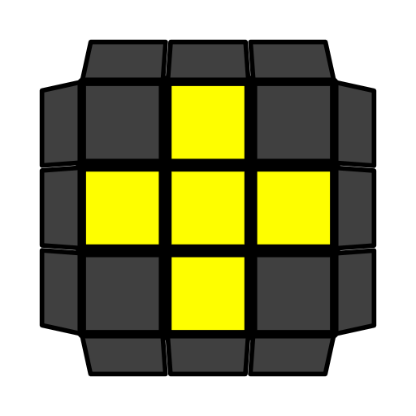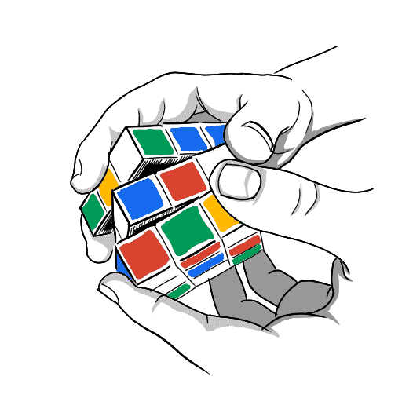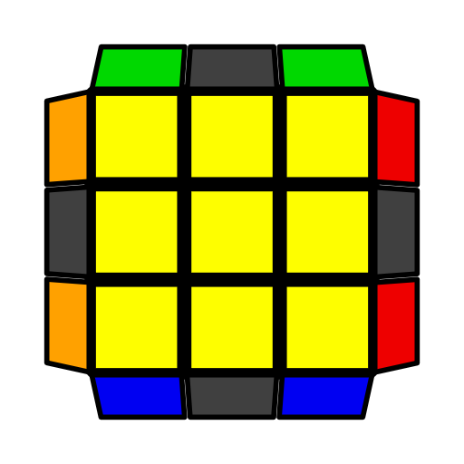**COLL公式和指法**

|  |  |  |
| --- | --- | --- |
| **推荐公式**  可选公式  **左单公式**  **高阶公式** | 右拇指, 右食指, 右无名指,右小指, 左食指  从**顶**, **底**层起手 | COLL在顶层有十字棱时复原顶层角块。若 或紫色文本不存在，左单或高阶公式将是第一条。 |

|  |  |  |  |  |
| --- | --- | --- | --- | --- |
| **COLL-H** | | | | |
|  | **(R U R' U) (R U' R' U) (R U2' R')**  **y (R U2' R' U') (R U R' U') (R U' R')** | | **F (R U R' U')3 F'** |  |
|  | **F (R U' R' U) (R U2 R' U') (R U R' U') F'** | | **(R U R' U) (R U L' U) R' U' L**  **(R' U' R U' R' U') (L U' R U L')**  **(R' F' R U2') (R U2' R' F) (U' R U' R')** |  |
| **COLL-Pi** | | | | |
|  | **R U2' R2' U' R2 U' R2' U2' R** | | **(R U D') (R U R' D) (R2 U' R' U') R2' U2' R**  (R U2' R') x (R' U R U')3 x' (R U2' R')  **(R U' R' U2') (L' U R U') (L R') U2' (R U R')**  **y (R U2 R' U') F' (R U2' R' U') (R U' R') (F R U' R')** |  |
|  | **F U (R U' R' U) (R U' R2' F') (R U R U' R')**  **(R U2' R' U' R U' R') (R' U L U' R U L')** | | **(R U R' U') R' F (R2 U R' U') (R U R' U') F'**  **y' (R' U2' R U R' U R) (R U' L' U R' U' L)** |  |
|  | **y (R U R' U) F' (R U2' R' U2') (R' F R)**  **(L' U R U' L U') (R' U' R U' R')** | | **F U (R U' R' U) (R U2' R' U') (R U R' F')** |  |
| **COLL-U** | | | | |
|  | **y' (R U R' U R U2' R2') (U' R U' R' U2 R)**  (L' U2 L U L' U L) (R U2' R' U' R U' R')  **(R U R' U') (R U' R' U2')2 (R U R')** | | **F (R U' R' U) (R U R' U) (R U' R' F')**  x' R2 D2 (R' U2 R D2) (R' U2 R') x |  |
|  | **R2 D (R' U2 R D') (R' U2 R')** | | **R2' D' (R U2 R' D) (R U2 R)** |  |
|  | **R' F (R U' R' U') (R U R' F') (R U R' U') (R' F R F' R)**  y F' (R U R' U) (R U R' F') (R U R' U')  (R' F R2 U') R' U2 (R U' R' F)  **y2 (R' U R U') x' z (R U' R U R2')**  **z' (R U' R' U) x** | | **(R' U2 R F) U' (R' U' R U) F'** |  |
|  |  | |  |  |
|  |  | |  |  |
|  |  | |  |  |
|  |  | |  |  |
|  |  | |  |  |
| **COLL-T** | | | | |
|  | **y (R U2' R' U' R U' R2') (U2' R U R' U R)**  (R U R' U R U2' R') (L' U' L U' L' U2 L)  **(R U R' U R U2' R') U' (R U2' R' U' R U' R')** | | **F (R U R' U') (R U' R' U') (R U R' F')**  x' (R U2 R D2) (R' U2 R D2) R2' x |  |
|  | **(R' U R U2') L' (R' U R U') L**  y2 (R U' R' U2) L (R U' R' U) L'  **y2 R' F (R U R' U') (R' F' R2 U') (R' U2 R)** | | **(R' U R2 D) (r' U2 r) (D' R2' U' R)**  **y2 (R U' R2' D') (r U2 r') (D R2 U R')**  (R U2' R' U) (L U' R U L2' U) R' U' L  **y2 R' U' (R U' R' U) (R U R' F') (R U R' U') R' F R2** |  |
|  | **y2 (l' U' L U) (R U' r' F)**  **(r' U' R U) (L U' R' U) x**  **y' x' (R U R' D) (R U' R' D') x** | | **(r U R' U') (r' F R F')**  **(r U R' U') (L' U R U') x'**  **y' x' (D R U' R') (D' R U R') x** |  |
| **COLL-L** | | | | |
|  | **(R U R' U) (R U' R' U)2 (R U2' R')**  **(R U2' R' U') (R U R' U')2 (R U' R')** | | **r U2' (R2' F R F') R U2' r'**  **y' R U2' (L' U L) U2' R' (L' U L)**  y2 L' U2' (R U' R' U2') L (R U' R')  **y2 R' U' (R U R' F') (R U R' U') R' F R2** |  |
|  | **(R U2 R D) (R' U2 R D') R2'** | | **(R' U2 R' D') (R U2 R' D) R2** |  |
|  | **(F R' F' r) (U R U' r')**  **L' (R U R' U') L (U R U' R')**  **y' (R U R' U') (R' F R U) (R U' R' F')**  **y' x' (R U' R' D) (R U R' D') x** | | **F' (r U R' U') (r' F R)**  **y2 x' (U' R U L') (U' R' U r)**  **y F (R U' R' U') (R U2 R' U') F'**  **y x' (D R U R') (D' R U' R') x** |  |
| **COLL-S** | | | | |
| **C:\Users\Alienware\AppData\Local\Microsoft\Windows\INetCache\Content.Word\16-COLL 40-Ruimin_YAN.JPG** | **R U R' U R U2' R'** | **F' (R U2' R' U2) R' F2 (R U R U') R' F'**  **R' U2' (L U' R U) L' (U R' U R)**  **y2 (R U R' F') (R U R' U R U2' R') (F R U' R')** | |  |
|  | **R U' L' U R' U' L**  y2 L U' R' U L' U' R | **L' (R U R' U') L (U2 R U2' R')** | |  |
|  | **(L' U2 L U2) R (U' L' U L) R'**  **(R U R2' F') (R U2 R U2') (R' F R U' R')** | **(R U R' U) (R U' R D) (R' U' R D') R2'**  **y2 (R' U' R U') (R2' F' R U) (R U' R' F) U2 R** | |  |
| **COLL-AS** | | | | |
|  | **R U2' R' U' R U' R'** | **(R U' R' U2)2 R' D' (R U R' D) R**  **y2 (R' U' R U') L (U' R' U L') U2' R**  **y2 (R U R' F') (R U2 R' U' R U' R') (F R U' R')** | |  |
|  | **L' U R U' L U R'**  y2 R' U L U' R U L' U' | **R (L' U' L U) R' (U2 L' U2 L)**  **(R U R' F') (R U2 R' U2') (R' F R2 U' R')** | |  |
|  | **(R U2' R' U2) L' (U R U' R') L** | **(R' U' R U') (R' U R' D') (R U R' D) R2** | |  |