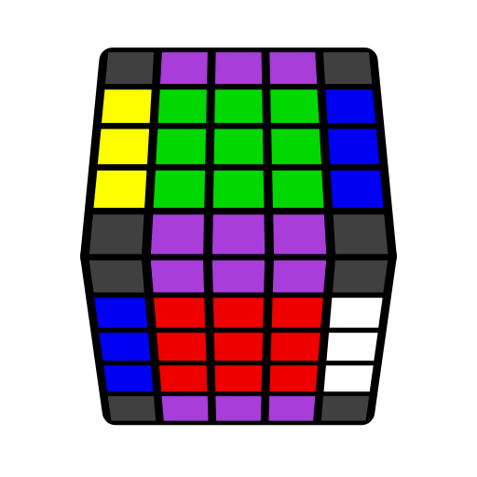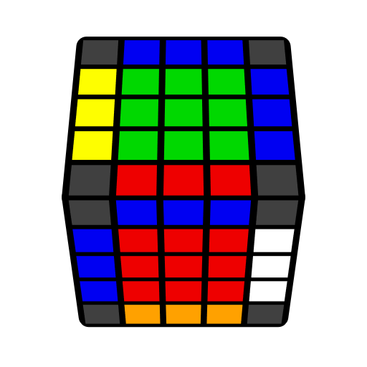**五阶L4E公式（后四棱）**

紫棱表自由棱。[Flip 1] = U' R' U R' F R F'; [Flip 2] = R U R' F R' F' R; A: B = A B A'.

|  |  |  |  |
| --- | --- | --- | --- |
|  |  |  |  |
| **M' U2 M**  y2 M U2 M' | **M' U2 M** | **M' U2 M** | **M: [Flip 1]**  z' y' E: [Flip 2] |
|  |  |  |  |
|  |  |  |  |
| **r': [Flip 1]**  z' y' u': [Flip 2] | **r' [Flip 1]**  z' y' u' [Flip 2] u | **3l [Flip 1] r'**  z' y' 3d [Flip 2] u' | **3l [Flip 1] r'**  z' y' 3d [Flip 2] u' |
|  |  |  |  |
|  |  |  |  |
|  | **z' y' (R' U R u') U (R U' R' u)** *(3-cycle)* | **r' l': [Flip 1]** |  |