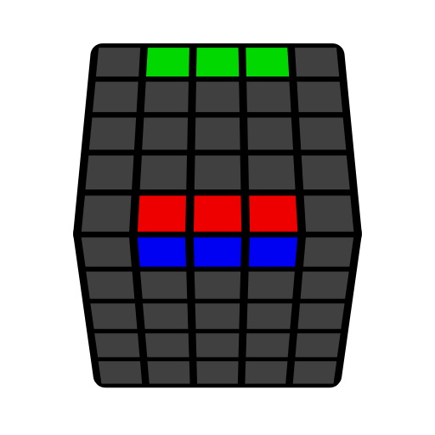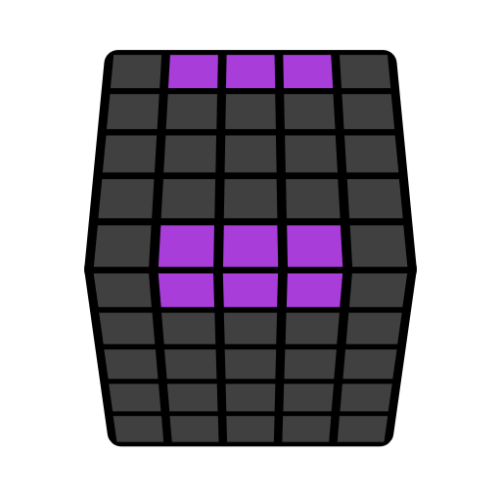**五阶L2E公式（后二棱）**

A: B = A B A'; [Flip 1] = U' R' U R' F R F'; [Flip 2] = (R U R' F) (R' F' R).

先学所有无特情况和棱特前两种情况。

|  |  |  |  |  |
| --- | --- | --- | --- | --- |
| **无特** | | | | |
|  |  |  |  | |
| **r': [Flip 1]**  z' y' u': [Flip 2] | **3l [Flip 1] r'**  z' y' 3d [Flip 2] u' | **(r2' F2 U2') (r2' U2' F2) r2** | **(U R U' B) (r2' F2 U2') (r' U2' F2) r2** | |
|  |  |  |  | |
|  | | | | |
| **r' l: [Flip 1]**  z' y' u' d: [Flip 2] | | | | |
|  | | | | |
| **棱特** | | | | |
|  |  |  |  |
| **r U2 x r U2 (r U2' r' U2) (l U2 3r' U2') (r U2 r' U2') r'** | **r U2 r U2' x U2 r U2' 3r' U2 l U2' r2** | **F2 (r U2 r U2') r' F2 (r' U2 r' U2') (r U2 r' U2') r2** | **B2 (r' U2 r' U2') r B2 (r U2 r U2') (r' U2 r U2') r2'** |
|  |  |  |  |
|  |  |  |  |
| **(r U2 r2 U2') (r' U2 r U2') (r' U2 r2 U2') r** | **(r' U2' r2 U2') (r U2' r' U2) (r U2' r2 U2') r'** | **(r' U2 r U2') 3l' U2 (r U2 r U2') (r' U2 r U2') r2'** | **r2 B2 r' U2 r' U2' x' U2 (r' U2' r U2) r' U2' r2** |