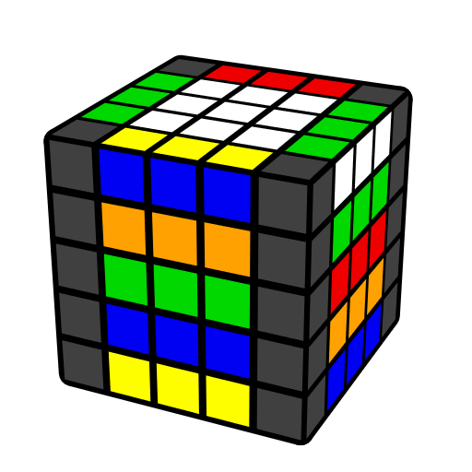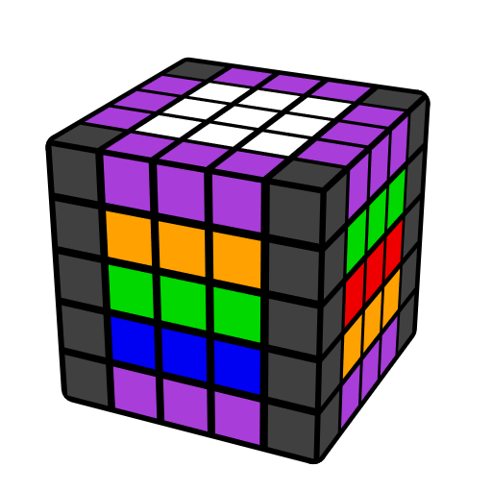**5x5 F8E Algorithms (First Eight Edges)**

This sheet includes the typical edge pairing cases in **Freeslice method** on 5x5. Purple edge denotes free edge. [Flip 1] = U' R' U R' F R F'; [Flip 2] = (R U R' F) (R' F' R).

|  |  |  |  |
| --- | --- | --- | --- |
| **2 Edge Pieces** | | | |
|  |  |  |  |
| **u** | **R' U' R u**  U2 R' U R u  L' U L u' | **[Flip 2] u** | **R U' R' u'** |
|  |  |  |  |
| **F R' F' R u'**  y' U' R' U R u | **Dw' R U' R' u**  Dw R U R' u' | **Uw' R U R' u** | **(R' U R2 U' R') u'** |
|  |  |  |  |
| **R2 u'** | **(R U' R' U) (R' U' R u)**  U R U' R2' U' R u | **(R U' R' u) (R U' R' u')** | **(R U' R') y (R U' R' u)** |
|  |  |  |  |
| **3 Edge Pieces** | | | |
|  |  |  |  |
| **E [Flip 2] E'**  z' M' [Flip 1] M | **(R U' R' d) (R' U R E')** | **(F R' F' R) U' (R' U R E')** | **u2 (R' U R2 U' R') 3u'** |